THE BOSTON MASSACRE ENGRAVING

Primary Source Document
Bloody Massacre Perpetrated in Kings Street in Boston by Paul Revere, March 1770
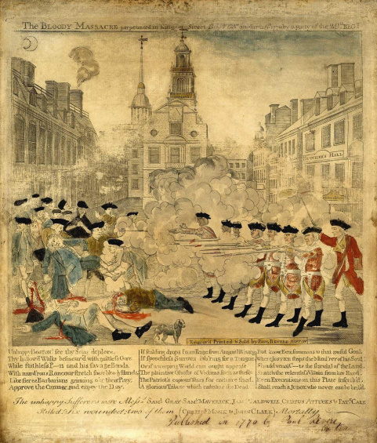

Revere, P. (1770). Bloody massacre perpetrated in Kings Street in Boston [Engraving]. Paul Revere Heritage Project. http://www.paul-revere-heritage.com/boston-massacre-engraving.html#google_vignette

