Exploring Ribbonwork (Part A)

# Completing the Pattern

Below is part of an Osage ribbonwork pattern. Part of the arrow pattern is the unshaded preimage (*image 1*) and two new images: *image 2* and *image 4*, each in their respective quadrants. Use image 2 or image 4 to complete the pattern in Quadrant III. Label this new image as image 3.

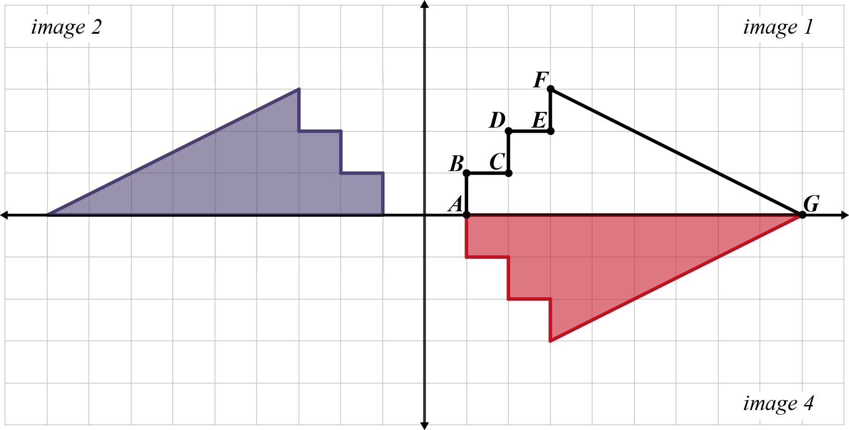

1) How did you complete the pattern?

2) Do your best to describe how the preimage (*image 1*) transformed into *image 2*.

3) Do your best to describe how the preimage (*image 1*) transformed into *image 4*.