HOW ARE GMOS MADE?

Directions: Work with a partner to analyze the diagram "How to Build a Better Plant." Use evidence from the diagram to answer the questions below.

Part 1: Compare the Methods
      - What are the key differences between conventional crossbreeding and genetic modification?

      - Which method appears to take more time? Explain using evidence from the diagram.

Part 2: Trace the Process
      - How does DNA move from one organism to another in genetic modification?
- Describe the role of:
  - Agrobacterium method:

  - DNA Particle gun (a.k.a Gene gun) method:

Part 3: Cause and Effect
      - How do these methods lead to changes in plant traits (ex: disease resistance or fruit quality)?

      - What role does DNA play in determining traits?

Part 4: Scale of Change
      - Which method changes many genes? Which changes specific genes? How do you know?

Part 5: Advantages and Limitations
      - Identify one advantage and one limitation of each method:
Method | Advantage | Limitation
Crossbreeding
Genetic Modification

Part 6: Think Like a Scientist
      - Which method seems more controlled? Why?

      - Which method seems more natural? Why?

      - If you were a farmer, which method would you trust more? Explain your reasoning.

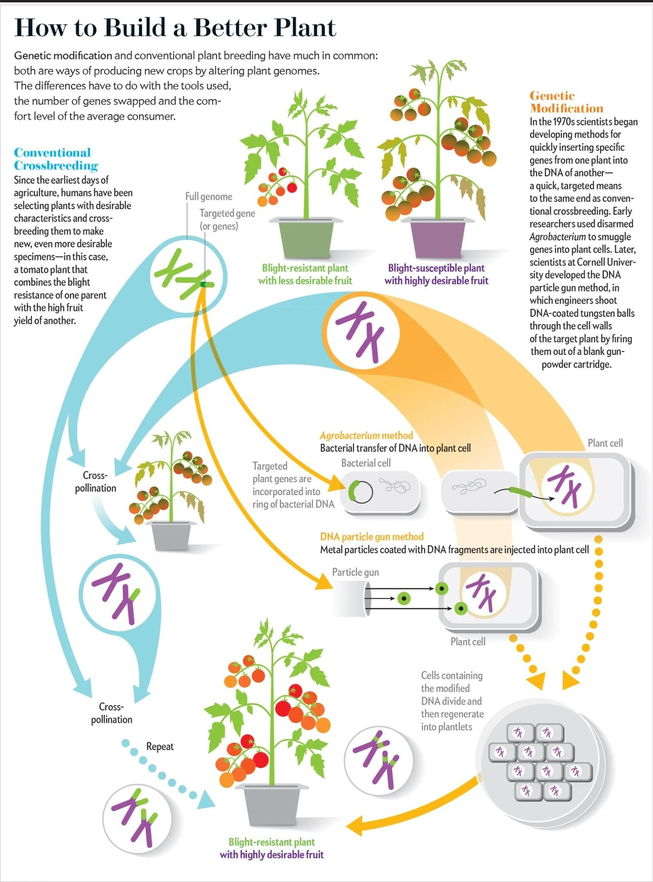

Source: Christiansen, J. (2013). How to Build a Better Plant. [Image]. Scientific American. https://www.scientificamerican.com/article/the-truth-about-genetically-modified-food/

