CARD SORT: Category Cards
Shonen | Seinen
Kodomomuke

CARD SORT: Sorting Cards
Shojo is the girl version of Shonen. Defined as “young woman and made for girls between ages 10 and 18, it’s all about romance and friendships. | To name a few titles, there’s the classic Sailor Moon, Emma, Ouran High School Host Club.
This type of manga is geared towards young teens between the ages 12 to 18. Literally standing for “young boy”, it’s full of action, adventure, fancy martial arts, and comic relief. | You may have heard of Dragon Ball or Naruto. Along with the first two mentioned, other popular titles include One Piece, Bleach, and the series that took the manga and anime community by storm, Attack on Titan
Those are classified as kodomomuke which stands for “directed at children. Also short for “kodomo”, this manga type is catered for kids. Think of it as children’s comics. Its goal is to teach morals and values for children. | Doraemon and Hello Kitty, other famous works include Anpanman and Astroboy.
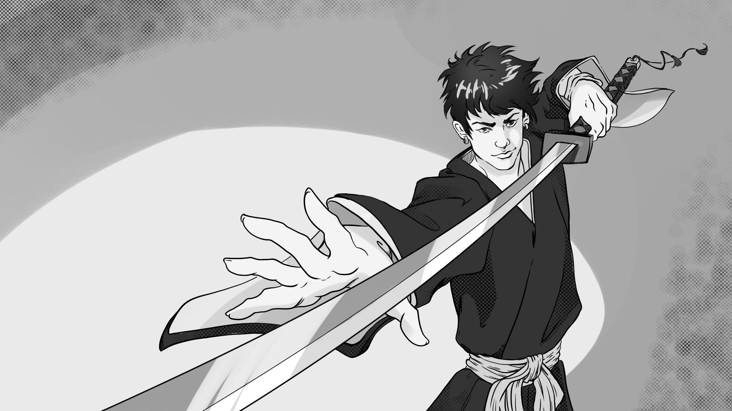 | 
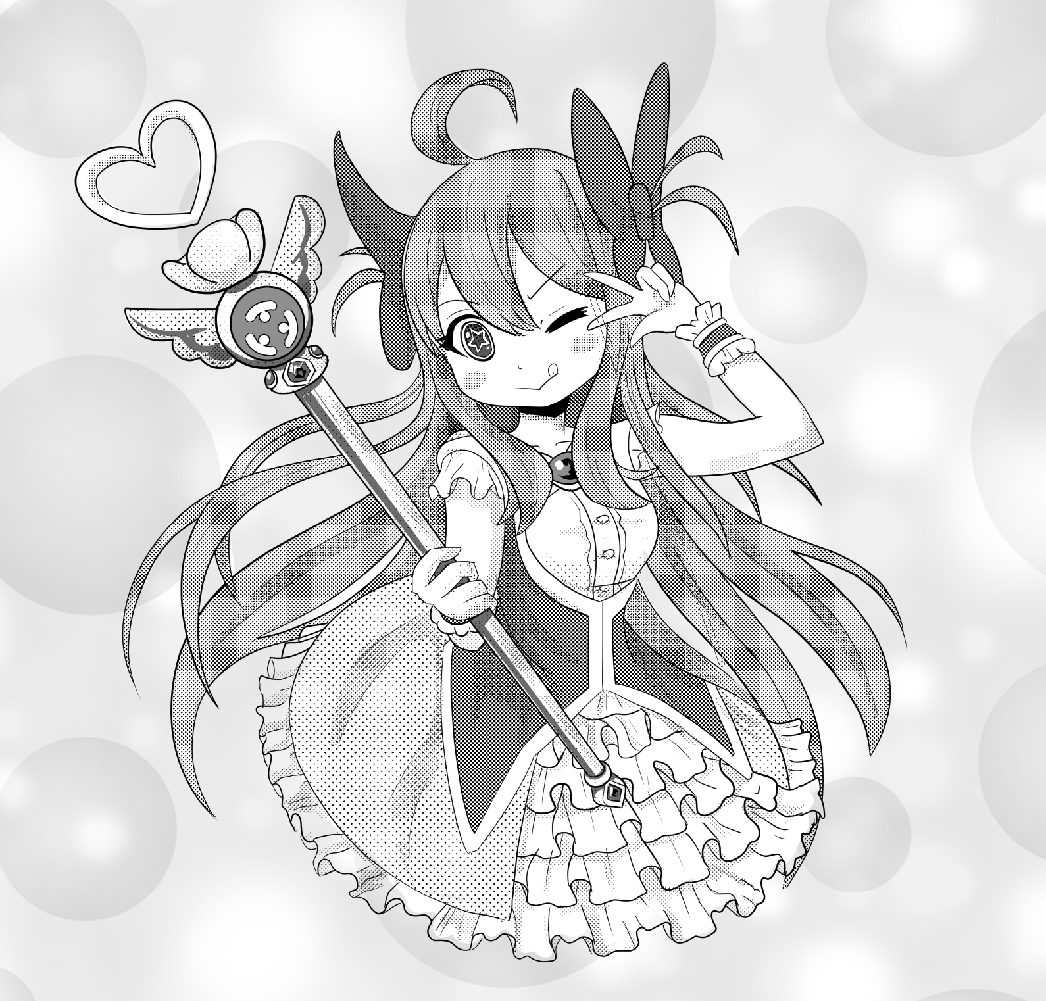 | 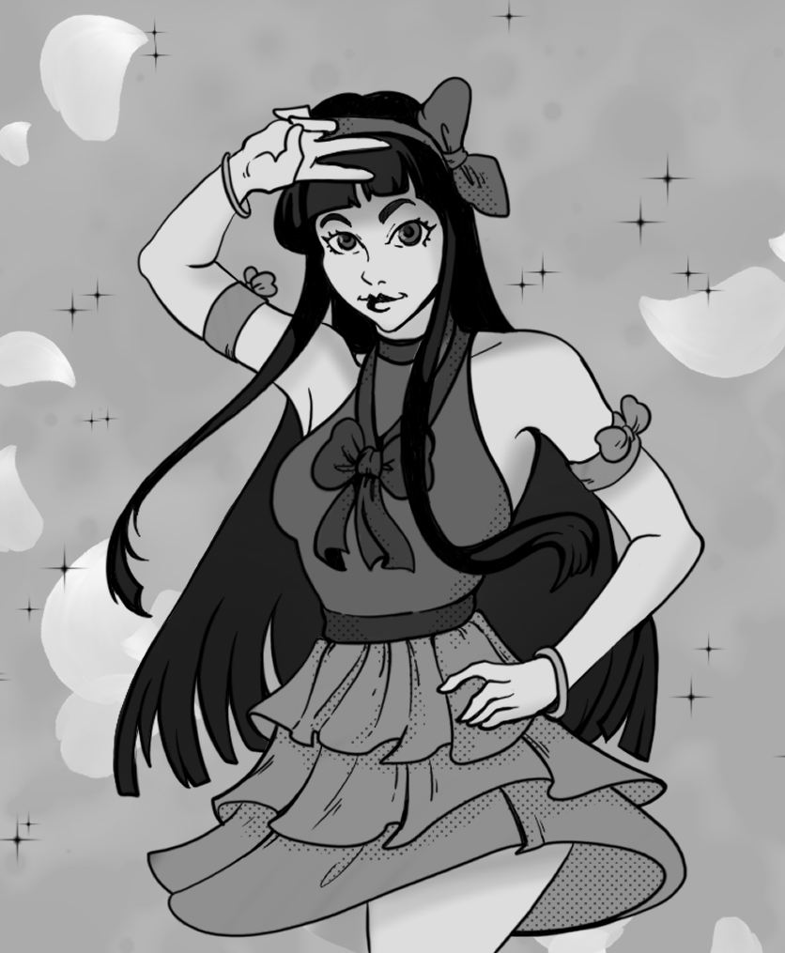
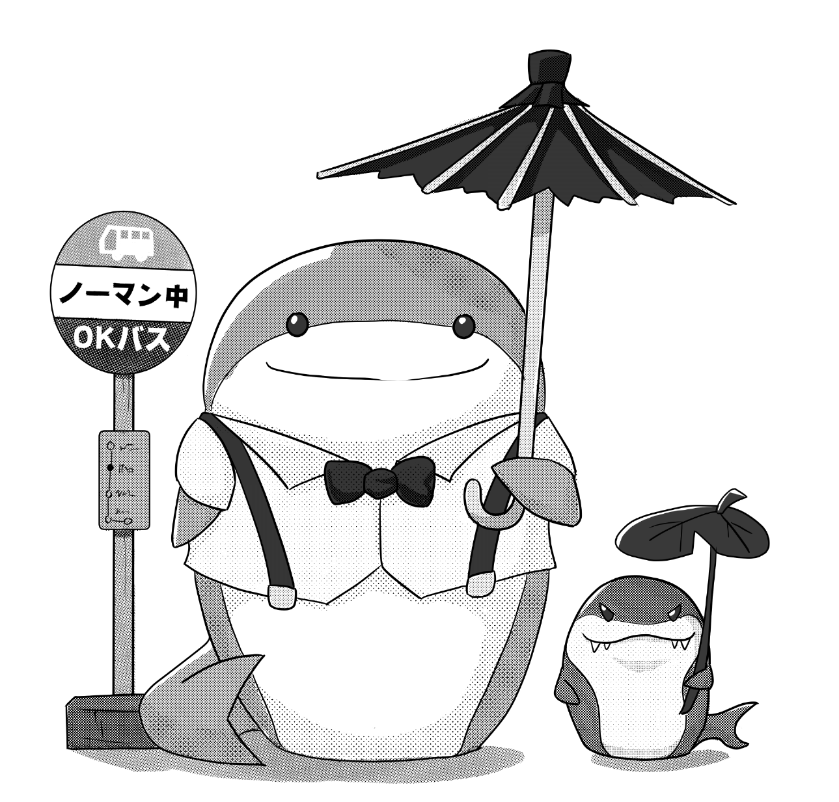 | 