Describing Scatter Plots: Guided Notes
- scatter plots: a graph of data points used to investigate a relationship, or association, between 2 quantities
Direction: Is there a positive, negative, or no association?
As x is increasing, what is y doing?
 | 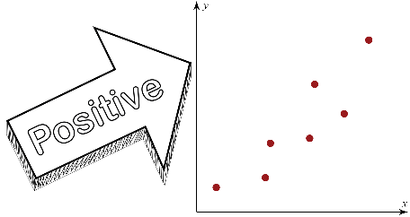 | 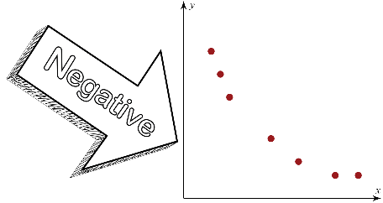 | 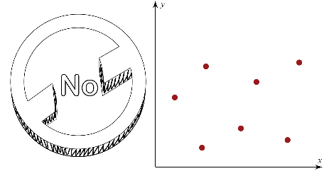

Form: Is the association linear or nonlinear?
Do the points form a pattern (or trend) that has the shape of a line or a curve?
 | 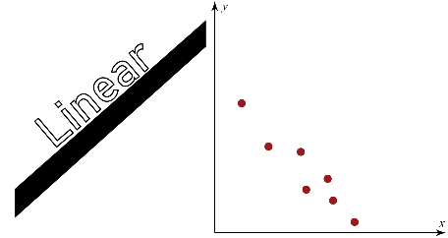 | 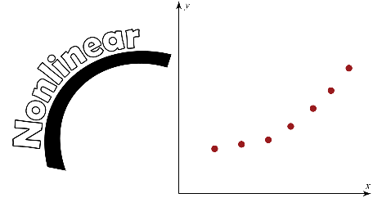

Strength: Is the association strong, moderate, or weak?
How close are the points along the trend?
 | 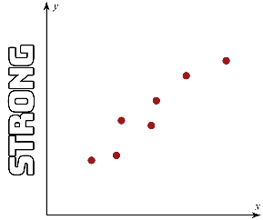 | 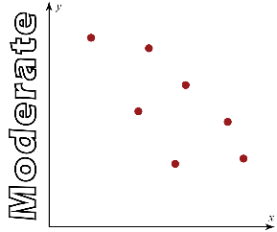 | 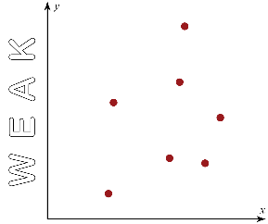

Outliers: Which point(s) seem to be unusually far away from the rest of the points?
Are there any points that lie outside of the rest of the data?
 | 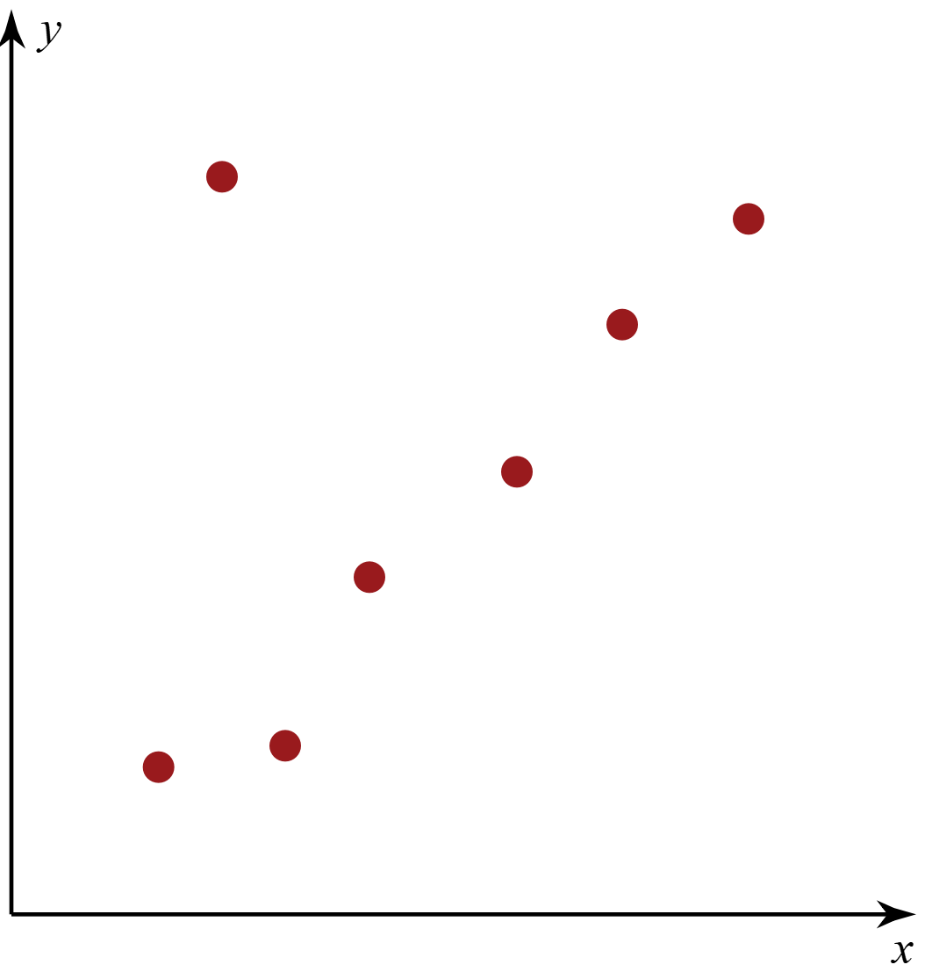 | 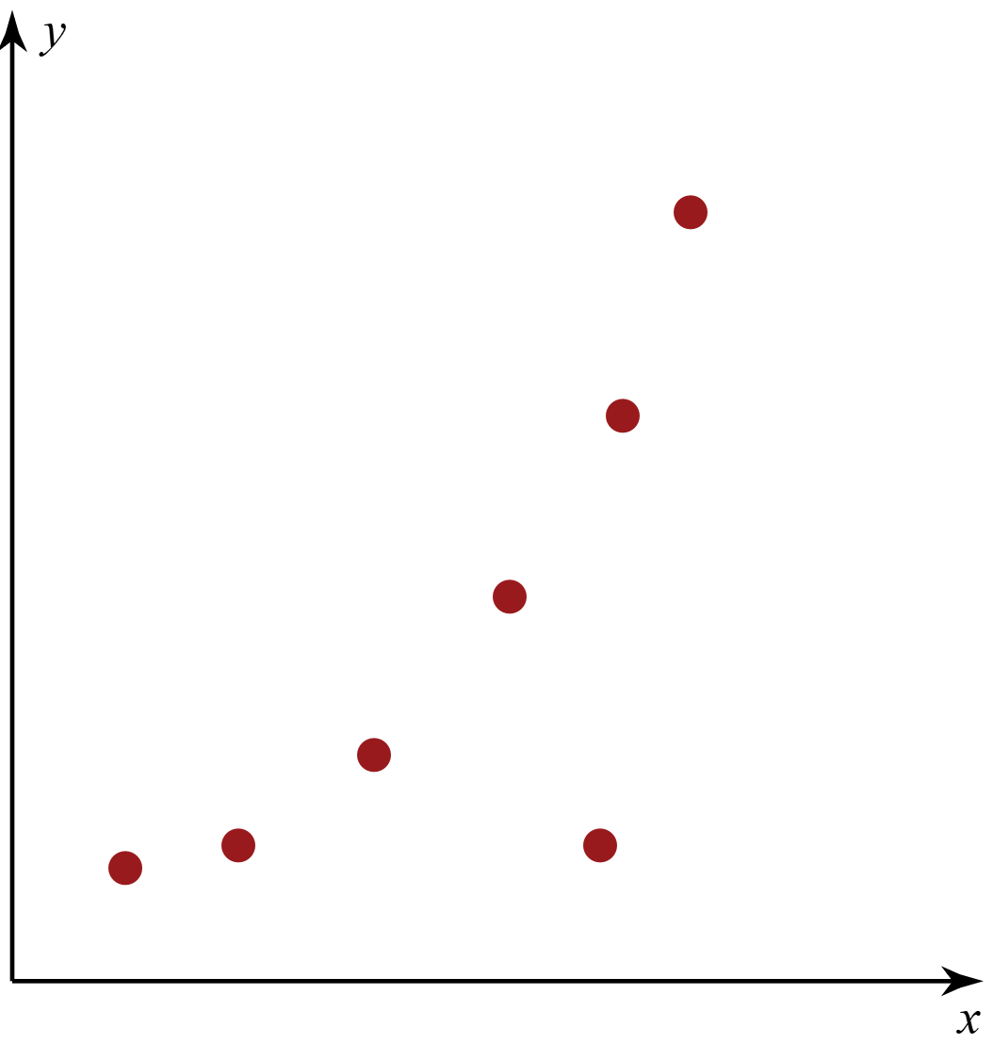

Examples
For each scatter plot below, describe the relationship between x and y. If the scatter plot contains an outlier, circle the point and explain your reasoning.

1)
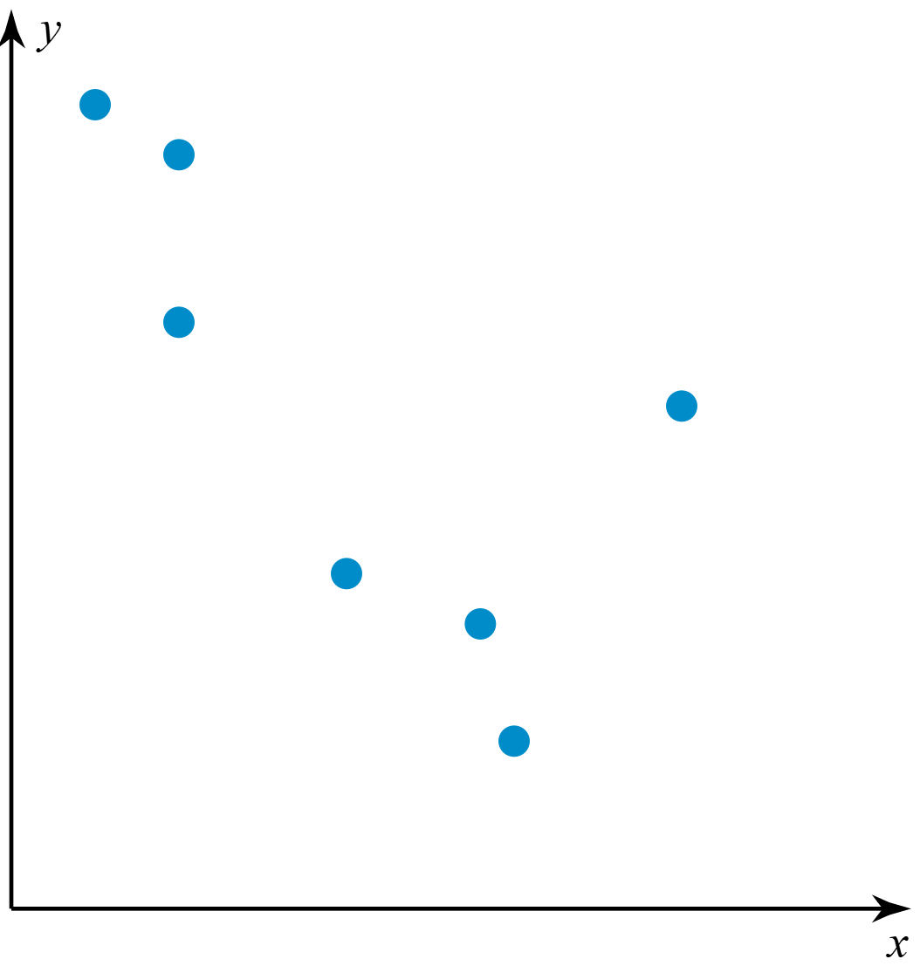

2)
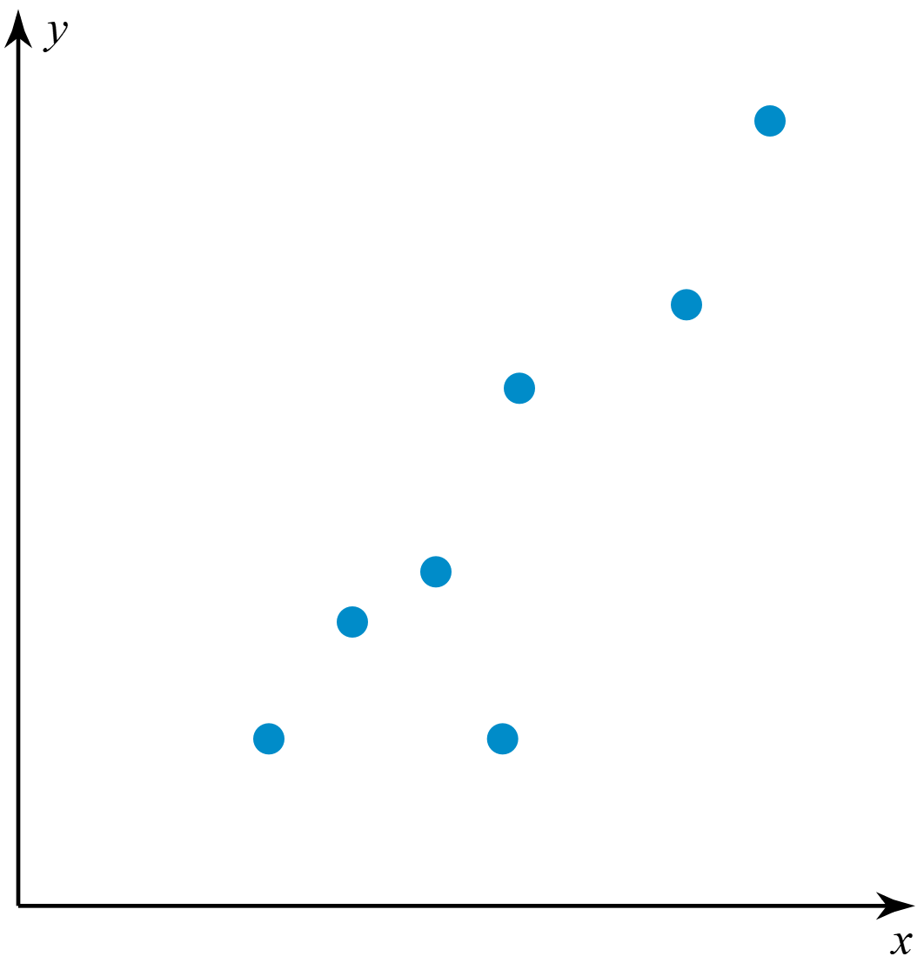

3)
