Ferris Wheel Mathematics and Desmos

Objective
To enter your data points that you recorded from your Ferris wheel into Desmos and create a sinusoidal graph of best fit.

Directions
- Go to http://tinyurl.com/myferriswheel.
- After logging in, you will see an equation and a graph that look like this:
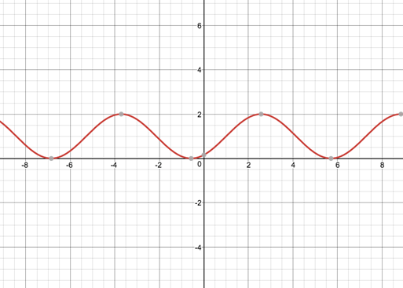
(Don’t mess with the graph quite yet, you’ll get to play with it in a second.)
- Next, you’ll need to input the data points you recorded. To do this, go down to the first available blank on the left-hand side of your screen where it says 6. Click there and your cursor will begin blinking.
- To type in a data point, you will need to use parentheses. For example, if your first data point was (1, 2), just type that in directly, remembering to use parentheses.
- Now, type in all of your data point in separate blanks on the left-hand side of the screen.
- Once all data points are entered, the goal is to fit an equation through those points.
- Using the sliders from the given equation, click and hold down on the slider. You’ll notice the graph changing. Move all of the sliders, so that your graph fits your data points as nicely as possible. Remember, though, this is just an approximation. Things won’t be perfect, but your goal is to get it close.

Now, write down what values you have for A, B, C, and D from the sliders.

These represent different transformations for the sine function.

Please answer the following questions:
- What was the height of your Ferris wheel?

- Divide the height by 2. Does this closely resemble the number represented by the letter ‘A’ in your Desmos graph? If yes, then that’s a good thing. This is your amplitude. If not, go back to your graph and check for mistakes.

The number that represents letter ‘A’ in your Desmos equation is what we call amplitude and is the same as a vertical dilation in algebraic transformations.

- Approximately how many seconds did it take for your Ferris wheel to make one complete rotation? Jot this down.

Now, take 2$π$ and divide it by the number represented by the letter ‘B’ in your Desmos equation. Does this approximately equal how long it took your Ferris wheel to make one rotation?

The amount of time it takes for your Ferris wheel to make a complete rotation is call the period of your sinusoidal equation.

- Next, type into Desmos the equation y=D on the next blank space on the left-hand side.
This line should divide your graph into equal parts above and below the line. This line is called the sinusoidal axis and represents the vertical shift or vertical translation of your equation. Therefore, D is the location of the sinusoidal axis or vertical shift.

- Finally, look at the number represented by the letter ‘C’. This number is what we refer to as phase displacement or phase shift. A standard sine function crosses the origin
(0, 0). So ‘C’ tells you how far from the origin your sinusoidal graph is located. Jot this down.

- Given the equation $y=2\sin\left(3\left(x-4\right)\right)+1$, please answer the following.
- What is the amplitude?

- What is the period of the sinusoid?

- What is the phase displacement?

- What is the equation of the sinusoidal axis (vertical shift)?

- Create an equation that has an amplitude of 3, a period $4π$, a phase displacement of 1, and a sinusoidal axis of $y=-2$.

