Presentation Note Catcher
Presenter Name:
Song:
Artist:

How poetic this song is:

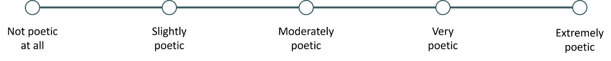
Presenter Name:
Song:
Artist:

How poetic this song is:

Presenter Name:
Song:
Artist:

How poetic this song is:

Presenter Name:
Song:
Artist:

How poetic this song is:

