CONCEPT SPEED DATING
Create your dating profile by analyzing your song lyrics and filling out the table below.
Dating Profile
Name (your SONG):
Poetic Scale - How poetic is the song?
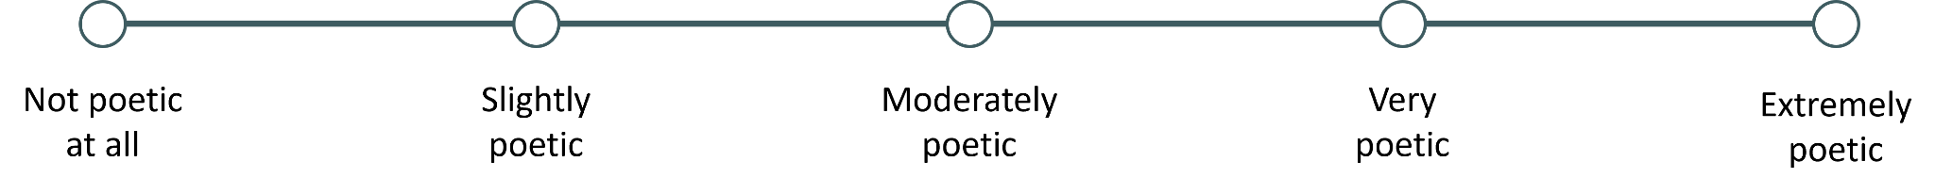
Elements of Poetry - What makes it poetic?
Structure - How does the structure of the lyrics in this song affect the meaning?
Priority - Does this song prioritize storytelling, emotion, rhythm, or something else?
Patterns - What patterns do you notice in the way this song approaches lyrics?

