CASE CARDS



Case Study #1

Canine Caper

**Weather Report**

Daytime temperatures have been variable over the past three weeks, ranging from 75° to 94° F. Skies have been sunny.

**Name:** Terry

**Weight:** 45 lbs.

**Height:** 21“

**Age:** 3 yrs.



**Observations**

* No immediate signs of struggle or forced entry.
* Body found lying on its side near the center of the basement.

I don’t understand… She was just here this morning. Why did this happen?

* Eyewitness

She was my best friend. She never hurt anybody. Who would do this? *This isn’t fair.*

* Owner

**Police Report**

The body of a large pit bull terrier was found inside a walk-in basement at a home in Cary. Maggots were found concentrated in the head and region behind the shoulder. The windows were closed, although the open curtains allowed sunlight to enter, and the air conditioner was set at 72° F.



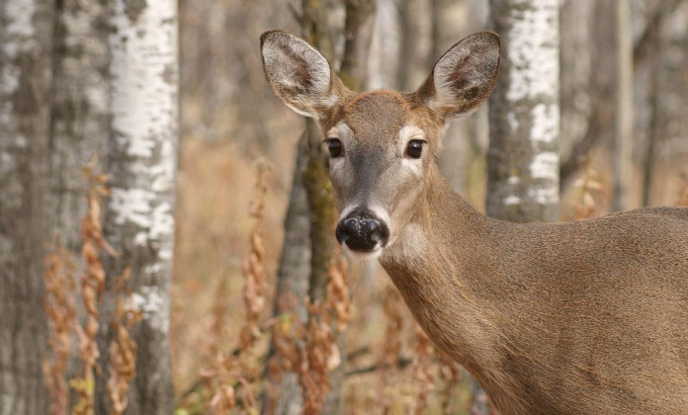

**Observations**

* The body was lying on its right side, partially concealed by tall grass and debris.
* The ground surrounding the deer showed no significant signs of struggle.

Case Study #2

Oh, Deer

The deer appears to have no visible wounds or signs of predation. Given the location and lack of external injuries, it’s possible the animal was struck by a vehicle and later moved or stumbled off the roadway before succumbing to internal injuries.

* Animal Control

**Weather Report**

Daytime temperatures have been fairly consistent for the past three weeks, ranging from 70° to 74° F.

**Police Report**

The body of a female deer was found behind a fence along a busy two-lane road on the edge of the city limits of Charlotte. Animal Control was called and reported no apparent wounds on the body. It was not hunting season.

**Name:** Jane Doe

**Weight:** 98 lbs.

**Height:** 6‘

**Age:** 5 yrs.



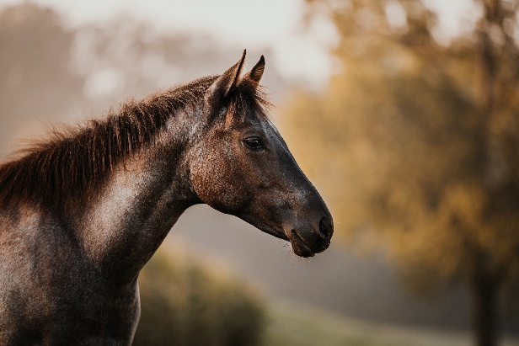

Case Study #3

Dandy’s Death

**Weather Report**

Daytime temperatures have been unusually warm over the past three weeks, ranging

from 84° to 86° F.

**Name:** Charlie

**Weight:** 950 lbs.

**Height:** 15 hands high

**Age:** 18 months



The horses in the pasture fidgeted with anticipation when they heard Mr. Johnson’s lawn mower nearby. Little did anyone know that soon one of them would end up dead as a result.

* Eyewitness

**Observations**

* No visible external injuries.
* Found lying on its left side near the center of the pasture.

**Police Report**

The body of a young male horse was found in a pasture in a small town near Wilmington. The autopsy from the vet school reveals that the cardiac glycoside, oleandrin (a powerful heart stimulant), was present in the body. Oleander is found in the oleander plant. Oleander is a common ornamental shrub in this area, but none grows within 200 feet of the pasture.



****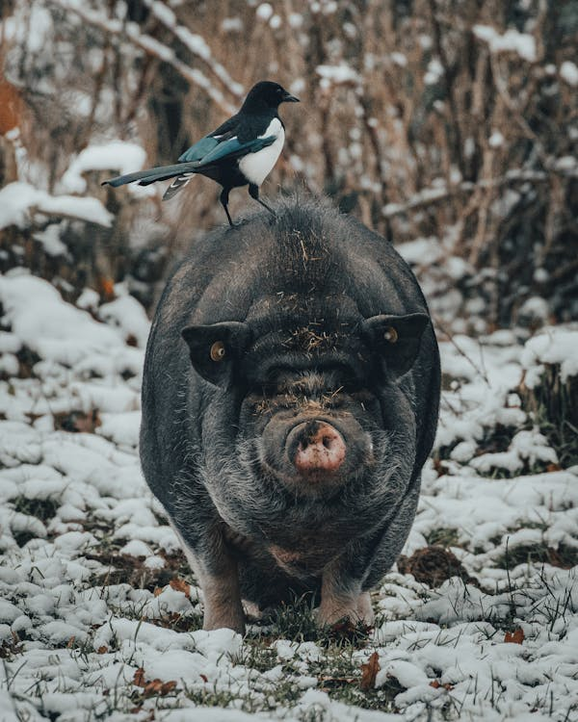****

**Observations**

* No immediate signs of predation or scavenging.
* Lying on its side, partially obscured by fallen branches.

This is an unusual and troubling discovery for our community. We take matters of animal welfare seriously. I have full confidence in our investigators and forensic experts to determine what happened.

- Mayor

**Weather Report**

Daytime temperatures have been average over the past three weeks, ranging from 70° to 73° F. Temperatures in the woods would be approximately 5 degrees cooler due to the lack of sun in the shady environment.

Case Study #4

Porky’s Peril

**Police Report**

The body of a large pot-bellied pig was found in a dense stand of evergreen trees far from any urban area in Buncombe County. Hairs round the pig’s neck were worn away in a band pattern.

**Name:** Hamlet

**Weight:** 150 lbs.

**Height:** 15“tall 3’ long

**Age:** 10 yrs.