

CASE RESOURCES
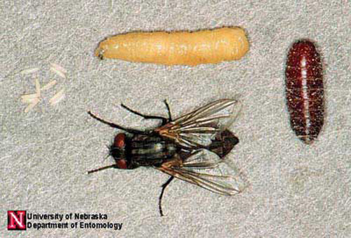
What do we know about flies?

KEY
Musca domestica | House fly | Blue
Calliphora vomitoria | Blow fly | Yellow
Sarcophaga carnaria | Flesh fly | White
Piophila nigriceps | Skipper fly | Pink
Pupae | Species of pupae can’t be determined except by size | Brown
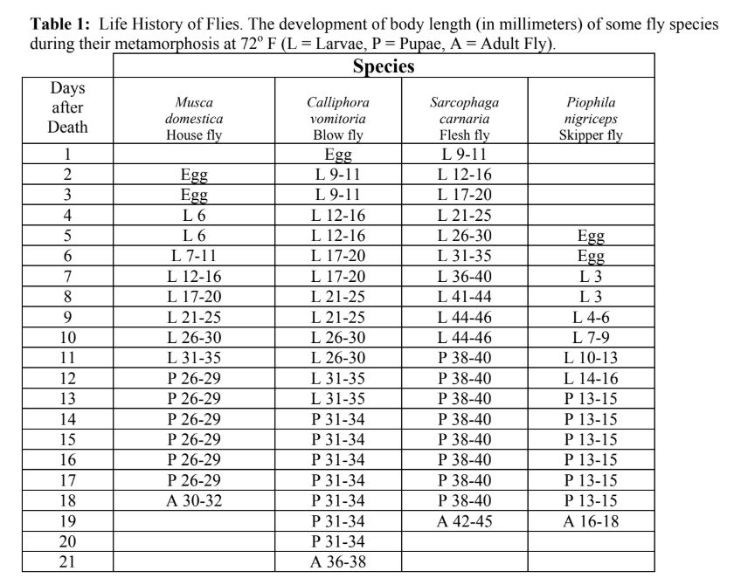
Life Cycle of the House Fly
(Musca domestica)
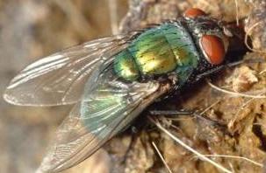
What else do we know about flies?
SPECIES
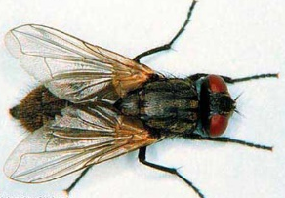
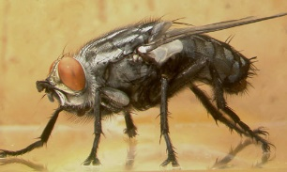
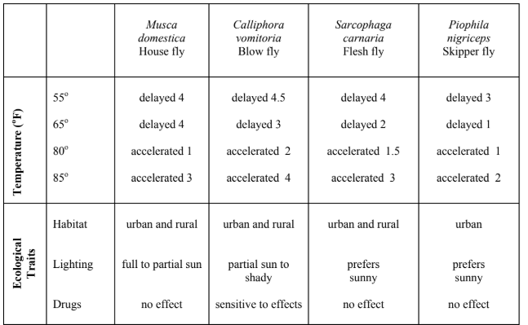
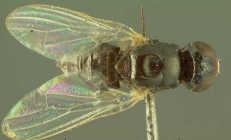

Sources:

Materials adapted from: Bambara, S., & Carloye, L. (2006). Crime Solving Insects. North Carolina Cooperative Extension Service. https://fyi.extension.wisc.edu/wi4hstem/files/2015/02/CSIfinal.pdf
Anderson, M., & Kaufman, P. (n.d.). Common green bottle fly - lucilia sericata (meigen). Featured Creatures. https://entnemdept.ufl.edu/creatures/livestock/flies/lucilia_sericata.htm
Diaz , L., & Kaufman, P. (2013, January). Sarcophaga crassipalpis Macquart - a flesh fly. Featured Creatures. https://entnemdept.ufl.edu/creatures/misc/flies/sarcophaga_crassipalpis.htm

Lewis , C., Kaufman, P. E., & Entomology and Nematology Department. (2010, January). Cheese skipper - piophila casei (linnaeus). Featured Creatures. https://entnemdept.ufl.edu/creatures/urban/flies/cheese_skipper.htm
Sanchez-Arroyo, H., & Capinera, J. (2017, April). House fly - musca domestica linnaeus. Featured Creatures. https://entnemdept.ufl.edu/creatures/urban/flies/house_fly.htm

Table 2: Ecological information for certain species of flies. The developmental delays/accelerations are given in number of days relative to the developmental schedule in Table 1 above.

