CASE RESOURCES

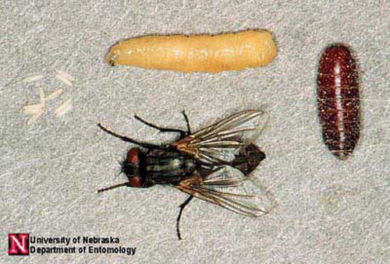

What do we know about flies?



KEY

|  |  |  |
| --- | --- | --- |
| *Musca domestica* | House fly | Blue |
| *Calliphora vomitoria* | Blow fly | Yellow |
| *Sarcophaga carnaria* | Flesh fly | white |
| *Piophila nigriceps* | Skipper fly | Pink |
| Pupae | species of pupae can’t be determined except by size | Brown |

Life Cycle of the House Fly

(*Musca domestica)*

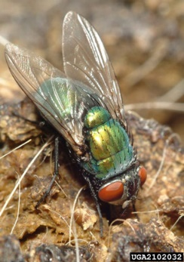****

What *else* do we know about flies?

SPECIES

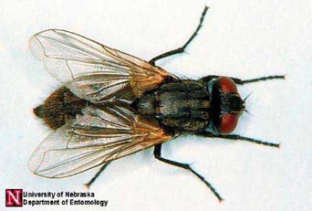 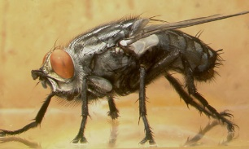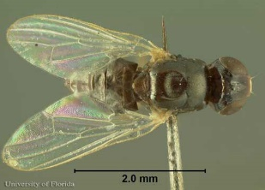

## Sources:

## Materials adapted from: Bambara, S., & Carloye, L. (2006). Crime Solving Insects. North Carolina Cooperative Extension Service. <https://fyi.extension.wisc.edu/wi4hstem/files/2015/02/CSIfinal.pdf>

*Anderson, M., & Kaufman, P. (n.d.). Common green bottle fly - lucilia sericata (meigen). Featured Creatures.* [*https://entnemdept.ufl.edu/creatures/livestock/flies/lucilia_sericata.htm*](https://entnemdept.ufl.edu/creatures/livestock/flies/lucilia_sericata.htm)

*Diaz , L., & Kaufman, P. (2013, January). Sarcophaga crassipalpis Macquart - a flesh fly. Featured Creatures. https://entnemdept.ufl.edu/creatures/misc/flies/sarcophaga_crassipalpis.htm*

## Lewis , C., Kaufman, P. E., & Entomology and Nematology Department. (2010, January). Cheese skipper - piophila casei (linnaeus). Featured Creatures. https://entnemdept.ufl.edu/creatures/urban/flies/cheese_skipper.htm

*Sanchez-Arroyo, H., & Capinera, J. (2017, April). House fly - musca domestica linnaeus. Featured* *Creatures.* *https://entnemdept.ufl.edu/creatures/urban/flies/house_fly.htm*

**Table 2:** Ecological information for certain species of flies. The developmental delays/accelerations are given in number of days relative to the developmental schedule in Table 1 above.