DESIGNING THE CASE FOLDERS

Use this guide to help prepare the Case Folders used in the Explain and Extend sections of the “Crime Solving Insects” lesson. While there are only four different cases (one being used as a whole-class model), you may wish to make multiple copies of each depending on your class size and the amount of groups you expect to be at each station.

# Materials Needed

* Case Resources handout (attached; pages 2-3; one per folder)
* Case Cards handout (attached; pages 4-7; one case per folder)
* Rulers (one per folder)
* Colored pipe cleaners (at least 5 different colors)
* Plastic bags filled with appropriately measured lengths of colored pipe cleaners (1 for each case)
* Scissors to cut pipe cleaners
* Forceps or tweezers for each folder (optional)
* Plastic or latex gloves for each group (optional)
* Folders

**Preparing for the Lesson**

Prepare Case Folders for each case (see examples below). Consider making multiple copies of cases based on classroom needs.

## Case Folders contain:

* Bug Bag of cut pipe cleaners (use Table 1 page 8). Label each bag with a case number.
* Case Cards handout (print one-sided)
* Case Resources handout (can be printed one-sided or double-sided)
* Ruler measuring millimeters
* Forceps or tweezers (optional)
* Several yellow folders with papers in them

  AI-generated content may be incorrect.Plastic or latex gloves for each group (optional)

CASE RESOURCES

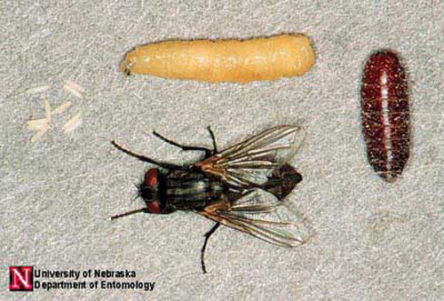

What do we know about flies?



KEY

|  |  |  |
| --- | --- | --- |
| *Musca domestica* | House fly | Blue |
| *Calliphora vomitoria* | Blow fly | Yellow |
| *Sarcophaga carnaria* | Flesh fly | white |
| *Piophila nigriceps* | Skipper fly | Pink |
| Pupae | species of pupae can’t be determined except by size | Brown |

Life Cycle of the House Fly

(*Musca domestica)*

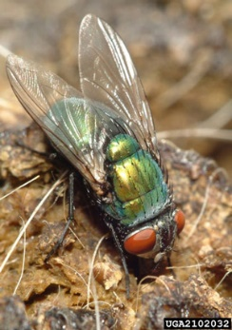****

What *else* do we know about flies?

SPECIES

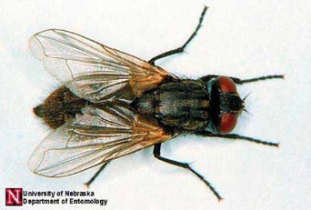 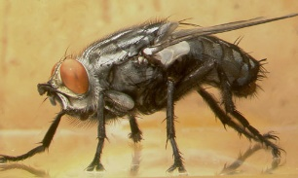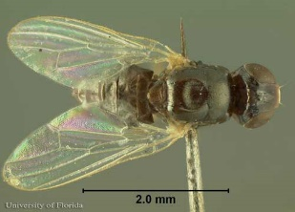

## Sources:

## Materials adapted from: Bambara, S., & Carloye, L. (2006). Crime Solving Insects. North Carolina Cooperative Extension Service. <https://fyi.extension.wisc.edu/wi4hstem/files/2015/02/CSIfinal.pdf>

*Anderson, M., & Kaufman, P. (n.d.). Common green bottle fly - lucilia sericata (meigen). Featured Creatures.* [*https://entnemdept.ufl.edu/creatures/livestock/flies/lucilia_sericata.htm*](https://entnemdept.ufl.edu/creatures/livestock/flies/lucilia_sericata.htm)

*Diaz , L., & Kaufman, P. (2013, January). Sarcophaga crassipalpis Macquart - a flesh fly. Featured Creatures. https://entnemdept.ufl.edu/creatures/misc/flies/sarcophaga_crassipalpis.htm*

## Lewis , C., Kaufman, P. E., & Entomology and Nematology Department. (2010, January). Cheese skipper - piophila casei (linnaeus). Featured Creatures. https://entnemdept.ufl.edu/creatures/urban/flies/cheese_skipper.htm

*Sanchez-Arroyo, H., & Capinera, J. (2017, April). House fly - musca domestica linnaeus. Featured* *Creatures.* *https://entnemdept.ufl.edu/creatures/urban/flies/house_fly.htm*

**Table 2:** Ecological information for certain species of flies. The developmental delays/accelerations are given in number of days relative to the developmental schedule in Table 1 above.

case cards



Case Study #1

Canine Caper

**Weather Report**

Daytime temperatures have been variable over the past three weeks, ranging from 75° to 94° F. Skies have been sunny.

**Name:** Terry

**Weight:** 45 lbs.

**Height:** 21“

**Age:** 3 yrs.



**Observations**

* No immediate signs of struggle or forced entry.
* Body found lying on its side near the center of the basement.

I don’t understand… She was just here this morning. Why did this happen?

* Eyewitness

She was my best friend. She never hurt anybody. Who would do this? *This isn’t fair.*

* Owner

**Police Report**

The body of a large pit bull terrier was found inside a walk-in basement at a home in Cary. Maggots were found concentrated in the head and region behind the shoulder. The windows were closed, although the open curtains allowed sunlight to enter, and the air conditioner was set at 72° F.



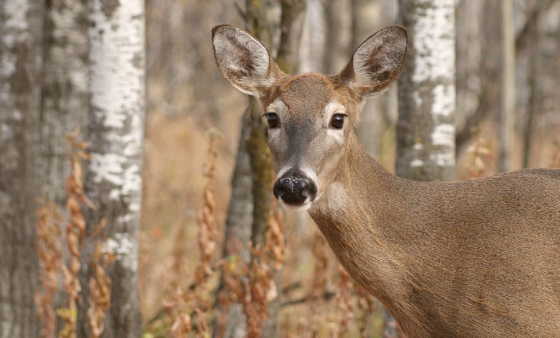

**Observations**

* The body was lying on its right side, partially concealed by tall grass and debris.
* The ground surrounding the deer showed no significant signs of struggle.

Case Study #2

Oh, Deer

The deer appears to have no visible wounds or signs of predation. Given the location and lack of external injuries, it’s possible the animal was struck by a vehicle and later moved or stumbled off the roadway before succumbing to internal injuries.

* Animal Control

**Weather Report**

Daytime temperatures have been fairly consistent for the past three weeks, ranging from 70° to 74° F.

**Police Report**

The body of a female deer was found behind a fence along a busy two-lane road on the edge of the city limits of Charlotte. Animal Control was called and reported no apparent wounds on the body. It was not hunting season.

**Name:** Jane Doe

**Weight:** 98 lbs.

**Height:** 6‘

**Age:** 5 yrs.



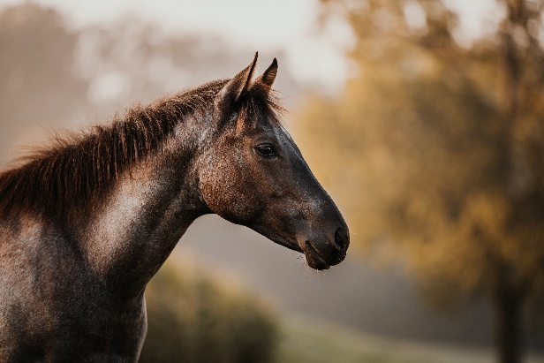

Case Study #3

Dandy’s Death

**Weather Report**

Daytime temperatures have been unusually warm over the past three weeks, ranging

from 84° to 86° F.

**Name:** Charlie

**Weight:** 950 lbs.

**Height:** 15 hands high

**Age:** 18 months



**Observations**

* No visible external injuries.
* Found lying on its left side near the center of the pasture.

I saw him yesterday, running around like normal. Nothing seemed wrong at all.

* Eyewitness

I trusted that he was safe out here. If someone did this, they need to be held accountable.

* Owner

**Police Report**

The body of a young male horse was found in a pasture in a small town near Wilmington. The autopsy from the vet school reveals that the cardiac glycoside, oleandrin (a powerful heart stimulant), was present in the body. Oleander is found in the oleander plant. Oleander is a common ornamental shrub in this area, but none grows within 200 feet of the pasture.



****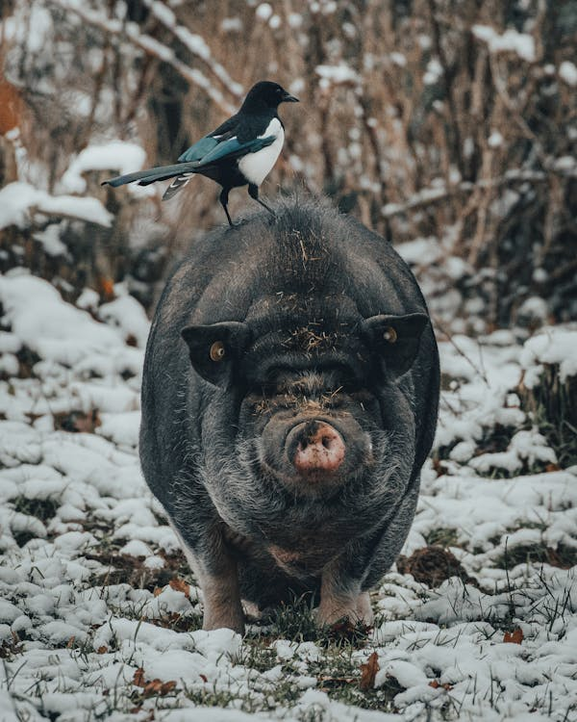****

**Observations**

* No immediate signs of predation or scavenging.
* Lying on its side, partially obscured by fallen branches.

This is an unusual and troubling discovery for our community. We take matters of animal welfare seriously. I have full confidence in our investigators and forensic experts to determine what happened.

- Mayor

**Weather Report**

Daytime temperatures have been average over the past three weeks, ranging from 70° to 73° F. Temperatures in the woods would be approximately 5 degrees cooler due to the lack of sun in the shady environment.

Case Study #4

Porky’s Peril

**Police Report**

The body of a large pot-bellied pig was found in a dense stand of evergreen trees far from any urban area in Buncombe County. Hairs round the pig’s neck were worn away in a band pattern.

**Name:** Hamlet

**Weight:** 150 lbs.

**Height:** 15“tall 3’ long

**Age:** 10 yrs.

**Table 1.** *Bug Bag content.* Cut pipe cleaners in lengths (in mm) to represent maggots and pupae collected from each body in each case. Cut several (2-3) of each length to make up the “sample” collected from the body. Remember, you may choose whatever colors you want for each as long as they are different, but all pupae are one color and the fly species for each pupae can’t be determined except by size. Also, be sure to update the “Key” on the Case Resources handout (attached in lesson resources and on page 2) to reflect the colors you chose.

|  |  |  |  |  |  |
| --- | --- | --- | --- | --- | --- |
| **Case Number** | **House Fly**  **(mm)** | **Blow Fly**  **(mm)** | **Flesh Fly**  **(mm)** | **Skipper Fly**  **(mm)** | **Pupae**  **(mm)** |
| Case #1 | 29 & 20 | 25 & 29 | 29 | 9 | 39 |
| Case #2 | 6 | __ | 15 | __ | __ |
| Case #3 | 28 | 35 | 45 | __ | 33 |
| Case #4 | 6 & 19 | 18 | 9 & 15 | 5 | __ |

# Teacher Tips

After trying different materials to represent the maggots and pupae (e.g. yarn and curling ribbon), we highly recommend using pipe cleaners for a few reasons:

1. They keep their shape which helps avoid confusion when students try measuring them (i.e. the yarn can be pulled taut vs loose)
2. The curling ribbon, when cut small, can be confusing to find the correct length vs width
3. Also, the flat curling ribbon can be harder to pick up and work with.

Additionally, consider laminating the Case Cards and/or Case Resources handouts for longevity and durability especially if you plan to use these resources in the future.