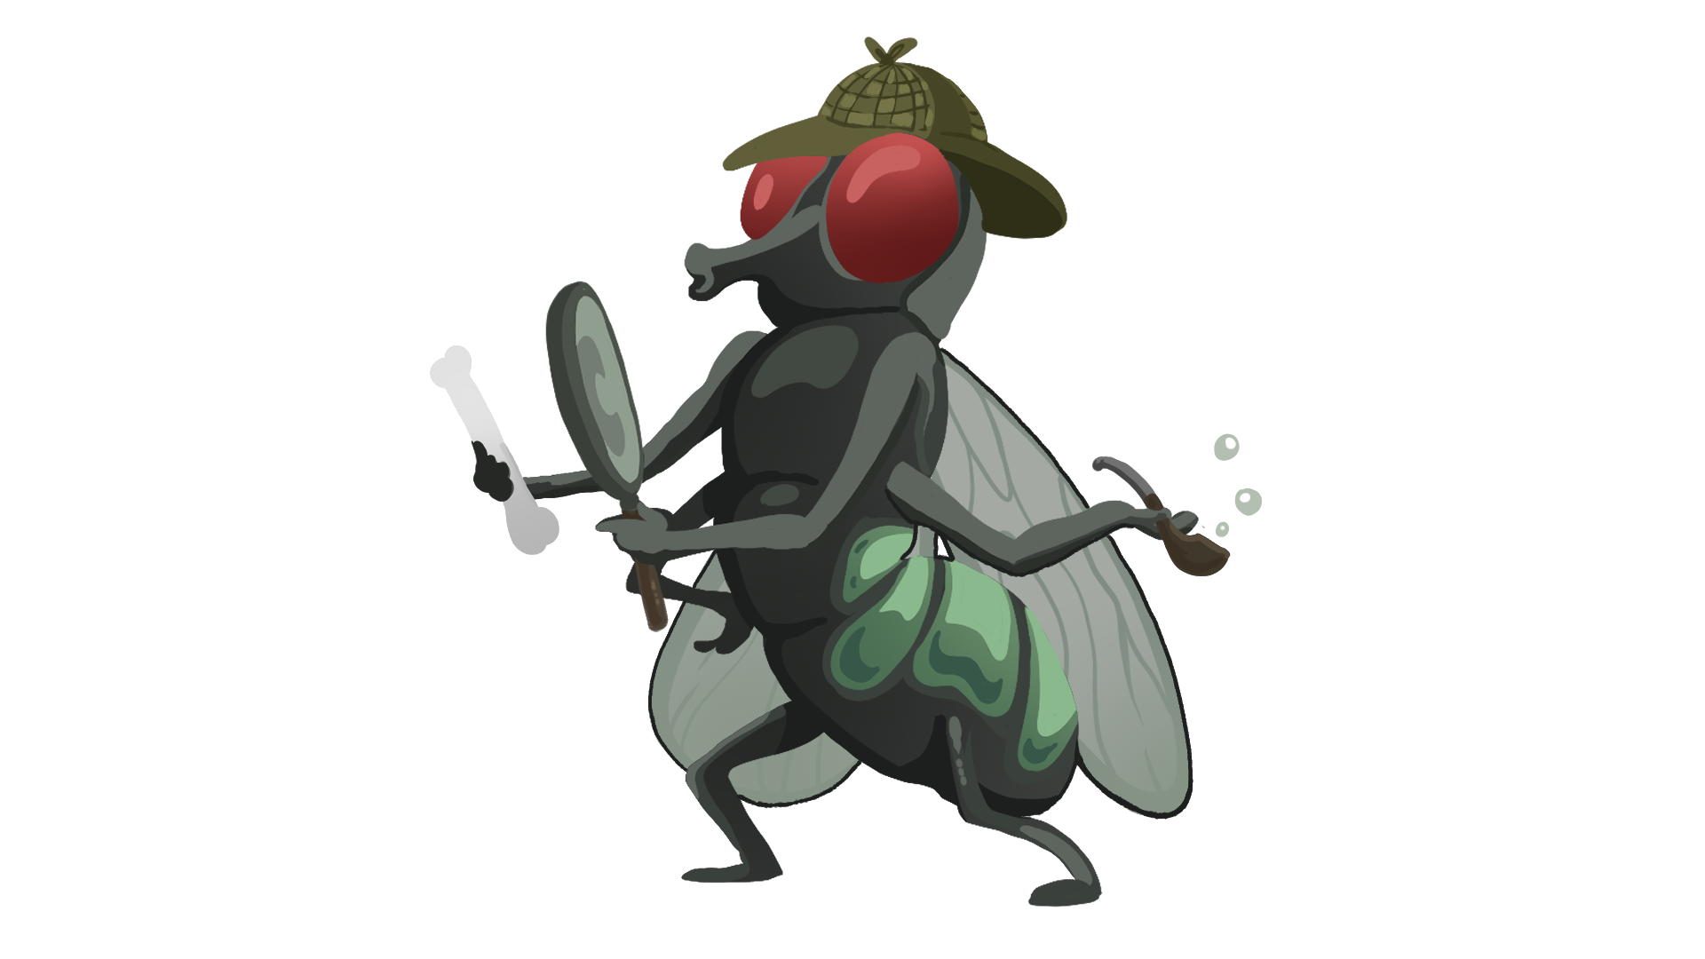FORENSIC ENTOMOLOGY GUIDED NOTES

**Directions.** Use your Life Cycle Card Sort and the slides to complete the following.

# Blow Fly Life Cycle

Blow flies are attracted to dead bodies and often arrive within _____________________ of the death of an animal. They have a ___________________ life cycle that consists of egg, larva, pupa, and adult stages.

## Label the life cycle diagram.

## Fill in the blanks below.

1st – Adult flies lay eggs on the carcass.

2nd – Eggs hatch into larva (maggots) in ___ - ___ hours.

3rd – Larvae continue to grow and molt (shed their exoskeletons) as they pass through the various instar stages.

1st Instar – __ mm long after ___ days.

2nd Instar – __ mm long after ___ days.

3rd Instar – _______ mm long after ___ days.

4th – The larvae (___ mm) develop into pupa after burrowing in surrounding soil.

5th – Adult flies emerge from pupa cases after ___ - ___ days.

# What do they do?

* Forensic ______________________ apply their knowledge of entomology to provide information for criminal investigations.
* A forensic entomologist’s job may include:
* Identification of insects at various stages of their __________ _____________, such as eggs, larva, pupa, and adults.
* Collection and preservation of insects as ________________.
* Determining as estimate for the postmortem interval or ______________ (the time between death and the discovery of the body) using factors such as insect evidence, weather conditions, location and condition of the body, etc.
* ____________________________ in court to explain insect-related evidence found at a crime scene.

*Video Reflection*

|  |  |
| --- | --- |
| **I Notice** | **I Wonder** |
|  |  |

# Stages of Decomposition

*Summary: What happens during each stage of decomposition?*

________________________________________________________________________________________________________________________________________________________________________________________________________________________________________________________________________________________________________________________

# Insects as Evidence

Forensic entomologists use their knowledge of insects and their life cycles and __________________ to give them clues about a crime.

Most insects used in investigations are in two major orders: _____________ (flies) and _______________ (beetles).

Species ____________________________ may also provide clues for investigators. Some species may feed on a _______________ corpse, while another species may prefer to feed on one that has been dead for two weeks. Investigators will also find other insect species that ________________ on the insects feeding on the corpse.

# Other Factors

_________________ data is also an important tool in analyzing insect evidence from a corpse. Investigators will make note of the temperature of the ____________, ground surface, the interface area between the body and the ground, and the ____________ under the body as well as the temperature inside any ________________ masses. They will also collect weather data related to daily ________________ (highs/lows) and ________________ for a period of time before the body was discovered to the time the insect evidence was collected.

What are some other factors that could affect a forensic entomologist’s estimate of PMI? ____________

_________________________________________________________________________________________________________________________________________________________________________________________________________________________________________________________________________________________________________________________________________________________________________________________________________________________________________

_____________________________________________________________________________________

