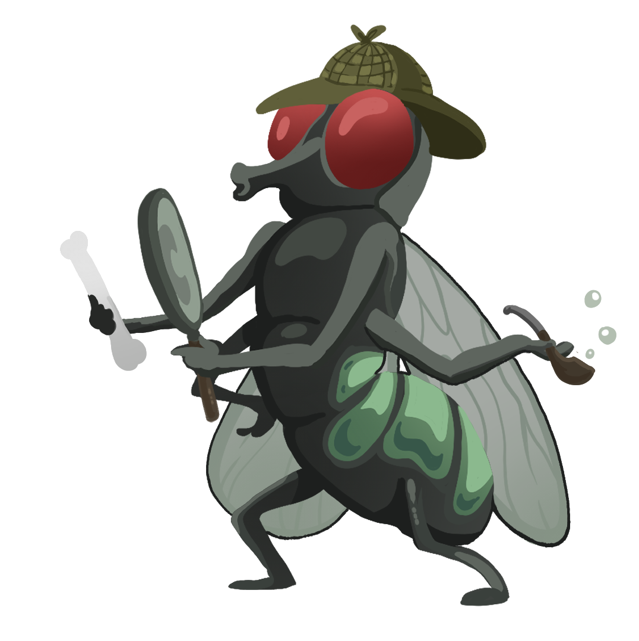
GUIDED NOTES

Directions. Use your Life Cycle Card Sort and the slides to complete the following.

Blow Fly Life Cycle
Blow flies are attracted to dead bodies and often arrive within _____________________ of the death of an animal. They have a ___________________ life cycle that consists of egg, larva, pupa, and adult stages.

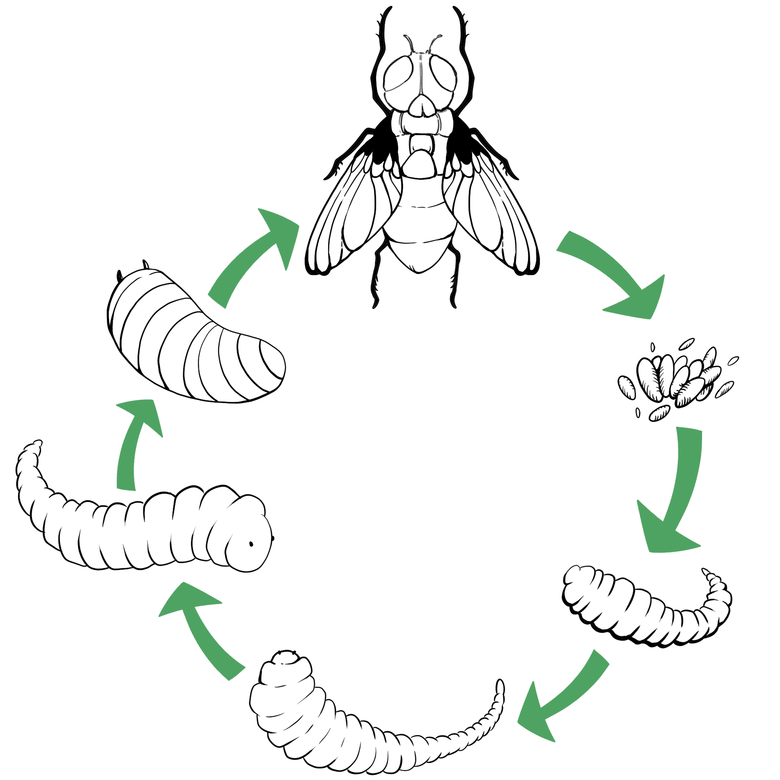
Label the life cycle diagram and fill in the blanks below.
1st – Adult flies lay eggs on the carcass.

2nd – Eggs hatch into larvae (maggots) in ___–___ hours.
3rd – Larvae continue to grow and molt (shed their exoskeletons) as they pass through the various instar stages.

1st Instar – __ mm long after ___ days.

2nd Instar – __ mm long after ___ days.

3rd Instar – _______ mm long after ___ days.
4th – The larvae (___ mm) develop into pupae after burrowing in surrounding soil.
5th – Adult flies emerge from pupae cases after ___–___ days.

What do they do?
- Forensic ______________________ apply their knowledge of entomology to provide information for criminal investigations.
- A forensic entomologist’s job may include:
  - Identification of insects at various stages of their __________ _____________, such as eggs, larvae, pupae, and adults.
  - Collection and preservation of insects as ________________.
  - Determining as an estimate for the postmortem interval or ______________ (the time between death and the discovery of the body) using factors such as insect evidence, weather conditions, location and condition of the body, etc.
  - ____________________________ in court to explain insect-related evidence found at a crime scene.

Video Reflection
I Notice | I Wonder

Insects as Evidence
Forensic entomologists use their knowledge of insects and their life cycles and ______________ to give them clues about a crime.
Most insects used in investigations are in two major orders: ________________ (flies) and __________________ (beetles).
Species ____________________________ may also provide clues for investigators. Some species may feed on a _______________ corpse, while another species may prefer to feed on one that has been dead for two weeks. Investigators will also find other insect species that ________________ on the insects feeding on the corpse.

Stages of Decomposition: What occurs during each stage of decomposition?

___________ stage
___________ stage
___________ stage
___________ stage

Other Factors
_________________ data are also important tools in analyzing insect evidence from a corpse. Investigators will make note of the temperature of the ____________, ground surface, the interface area between the body and the ground, and the ____________ under the body as well as the temperature inside any ________________ masses. They will also collect weather data related to daily ________________ (highs/lows) and ________________ for a period of time before the body was discovered to the time the insect evidence was collected.
What are some other factors that could affect a forensic entomologist’s estimate of PMI?
________________________________________________________________________________________________________________________________________________________________________________________________________________________________________________________________________________________________________________________
