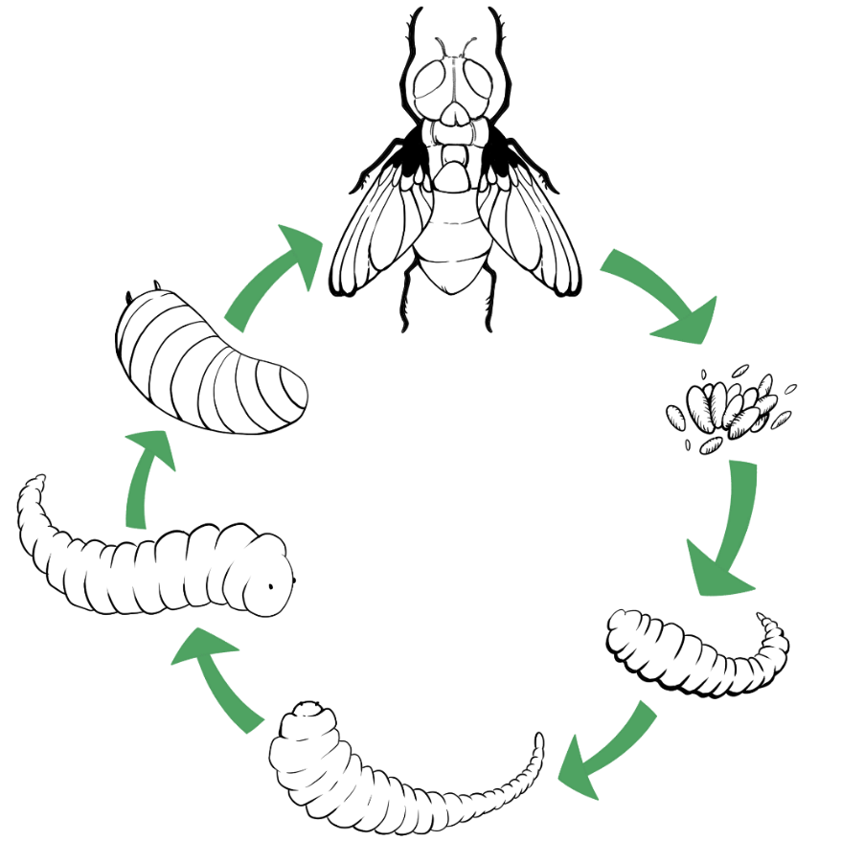
LIFE CYCLE MAP
STAGE
SIZE
TIME
STAGE
SIZE
TIME
SIZE
TIME
STAGE
SIZE
TIME
STAGE
TIME
SIZE
STAGE
TIME
SIZE
STAGE

