COLOR BY NUMBERS

1. Engage
- Open your bag of M&Ms and record the distribution on the frequency table. 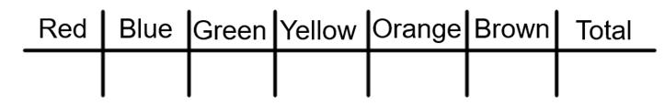

- What color’s sample proportion seems the most unusual to you?
According to Mars, Inc., the distribution of the population of milk chocolate M&Ms are:

__ __ __ __ __ __

- Assuming Mars, Inc.’s distribution is correct, use the binomial distribution to determine the probability of observing a sample proportion like yours or one more severe.

2. Explore

a. Write appropriate hypotheses and choose an alpha level.
H₀:
H_{A}:
Alpha:
b. Check the necessary assumptions and conditions.
Random:
10%:
S/F:
Is our sample large enough to test the company's claim that p₀ = .2?
What sample size would allow us to use the normal model without being cut off for at least 3 standard deviations?
np ≥ 10, so when I divide both sides by p I get n ≥ 10p
Our minimum sample size to be able to use a 1-Proportion Z-Test would be n = ___.

3. Explain
Input first trial data into the data sheet to calculate totals and generate a scatterplot of the cumulative relative frequency of orange M&Ms vs. sample size.

Record the total number of orange M&Ms and the total number of M&Ms sampled after the first trial.

Orange Freq. = n =

What is your sample proportion? p̂ =

There are supposed to be 20% orange candies. Does our data provide statistically significant evidence to contradict the company's claim?
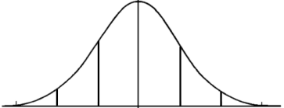
- Perform the mechanics of the test (find the z-score and p-value) and fill in the sampling distribution model to the right.
- Explain carefully what the p-value means in context.
- What is your conclusion?

4. Extend

Let us eat more chocolate! I mean, let’s gather more data! Input your data by your name in the data sheet for the second trial.

Record the total number of orange M&Ms and the total number of M&Ms sampled after the second trial.

Orange Freq. = n =

What is your sample proportion? p̂ =

There are supposed to be 20% orange candies. Does our data provide statistically significant evidence to contradict the company's claim?
- Perform the mechanics of the test (find the z-score and p-value) and fill in the sampling distribution model to the right.
- Explain carefully what the p-value means in context.
- What benefit do we get from increasing our sample size?
- Did increasing our sample size change our conclusion?
- Write a 90% confidence interval from our data.

5. Evaluate
Let’s investigate: At which point, if any, did our sample cross the threshold of significance?
a. At what point, if any, could we have had a p-value significant enough to reject our null hypothesis?
We are going to graph the margin of error from our p₀ = .2 to see if at any point during our simulation we could have rejected the null.
If we are doing a 2-sided test with an alpha level of α = .1 then we will need a confidence interval with 5% on each tail. This would be a 90% CI with a z* = 1.65
Put the following equations into your calculator. Then press Zoom + 9.

b. At any point would we have had enough evidence to reject the H₀?
c. Try it again with an alpha level of α = .05 then we will need a confidence interval with 2.5% on each tail. This would be a 95% CI with a critical value z* = 1.96.
- Does our sample proportion appear to be converging to the p₀ = .2 as we opened more bags of candy?

