VISUALIZE CUMULATIVE DATA

Help students visualize how cumulative data narrows the margin of error and changes the p-value—potentially crossing the significance threshold.

# Key Columns:

* 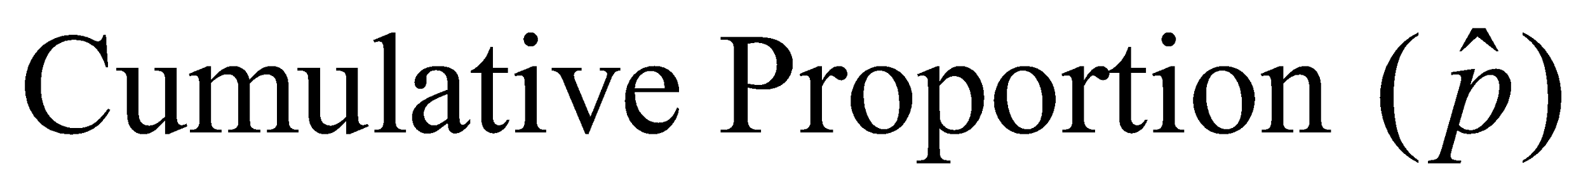= Cumulative Orange / Cumulative Total
* 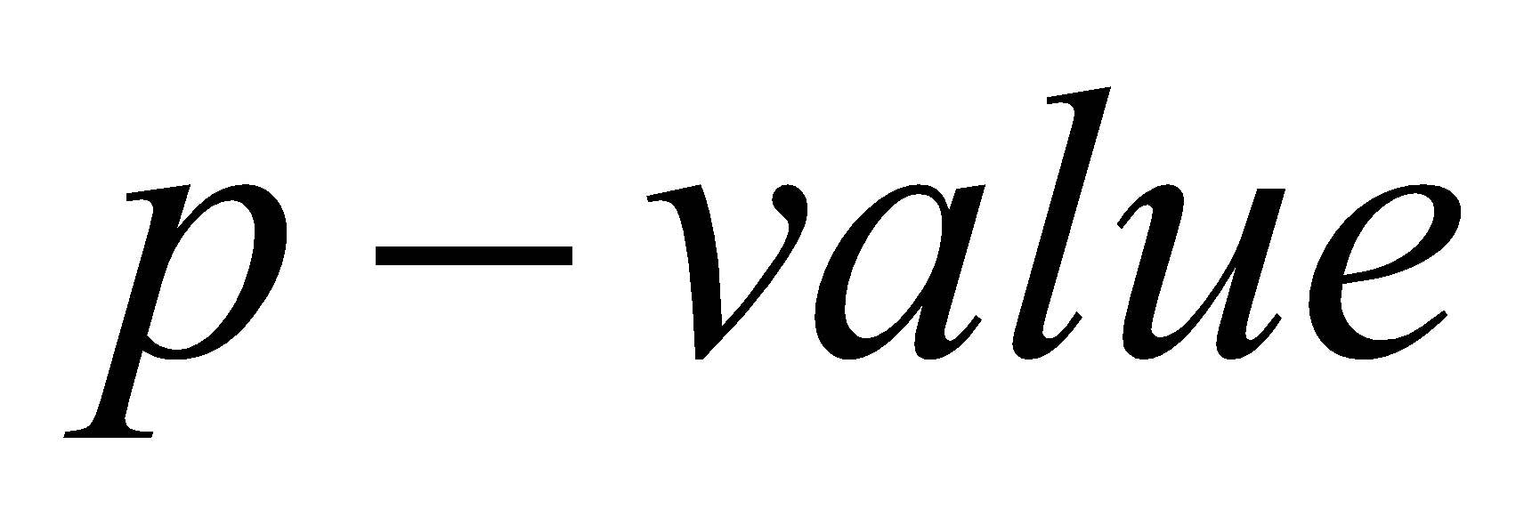from 1-proportion Z-test (explained below)
* ****for 1-prop CI:

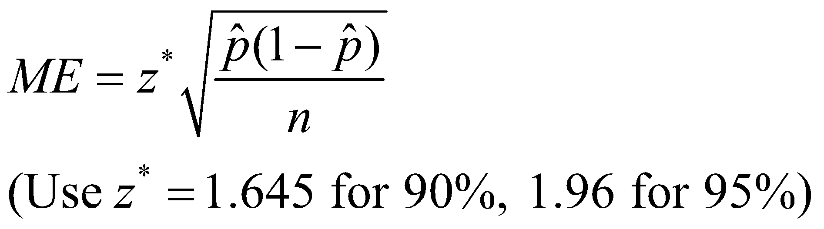

* Confidence Interval =
  + Lower Bound: = Cumulative Proportion - ME
  + Upper Bound: = Cumulative Proportion + ME

# Create Two Graphs:

|  |  |
| --- | --- |
| **Excel** | **Ti-Calculator** |
| 1. **Graph 1: Cumulative Sample Proportion vs. Target (0.20)**    * **X-axis**: Total M&Ms (or Bag #)    * **Y-axis**: Cumulative Proportion    * Add a horizontal line at 0.20 (claimed value)    * Add confidence bands if desired (CI bounds) 2. **Graph 2: p-value vs. Total Sample Size**    * **X-axis**: Cumulative Total M&Ms    * **Y-axis**: p-value    * Add a horizontal line at | 1. **Graph 1: Cumulative Sum vs. Cumulative Proportion**    * **X-axis**: Total M&Ms (or Bag #)    * **Y-axis**: Cumulative Proportion    * Add a horizontal line at 0.20 (claimed value)    * Add confidence bands if desired (CI bounds) 2. **Graph 2: ME vs. n functions**    * **X-axis**: ME    * **Y-axis**: n function    * Add a horizontal line at |

As students keep adding data and updating the spreadsheet:

* Watch the p-value column. The moment the p-value drops below α, point out:

"We now have enough evidence to reject the null hypothesis."

* In the graph, you’ll see the p-value line dip below 0.05, and the sample proportion diverge significantly enough from 0.20.

Also, look at the confidence interval bounds:

* If 0.20 is no longer inside the interval, it means the observed proportion is statistically different from the claimed 20%.