Case evidence cards
Set 1
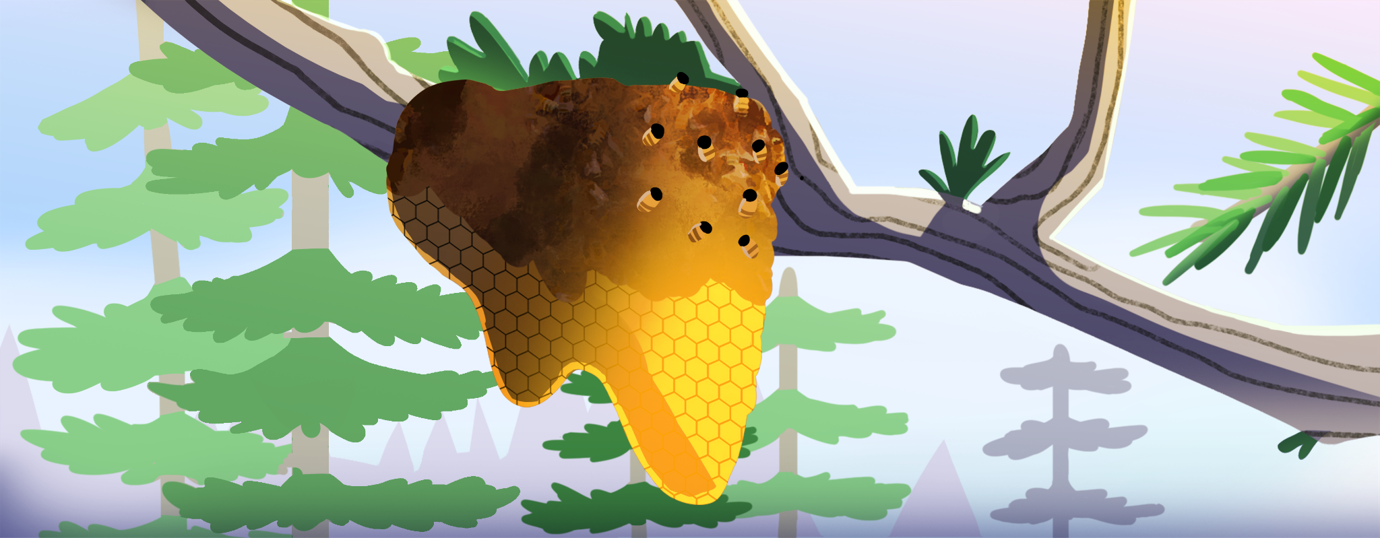
Bee colonies have been mysteriously dying out in North America, and experts worry that it will have big effects on their ecosystems.
American farmers are dependent on pesticides to protect their crops from destructive insects. | While meant to kill other insects, many pesticides can also be lethal to bees.
Bees rely on pollen from a wide variety of weeds and their flowers to survive. | Many American landowners use herbicides to kill weeds on their property and plant grass lawns without flowers.

Varroa mites are tiny arachnids that feed on and kill honeybees. | Varroa mites are an invasive species to the United States that now infest the majority of honeybee colonies here.
A single honeybee colony can produce over 100 pounds of honey per year. | The first written records of beekeeping are from ancient Egypt.
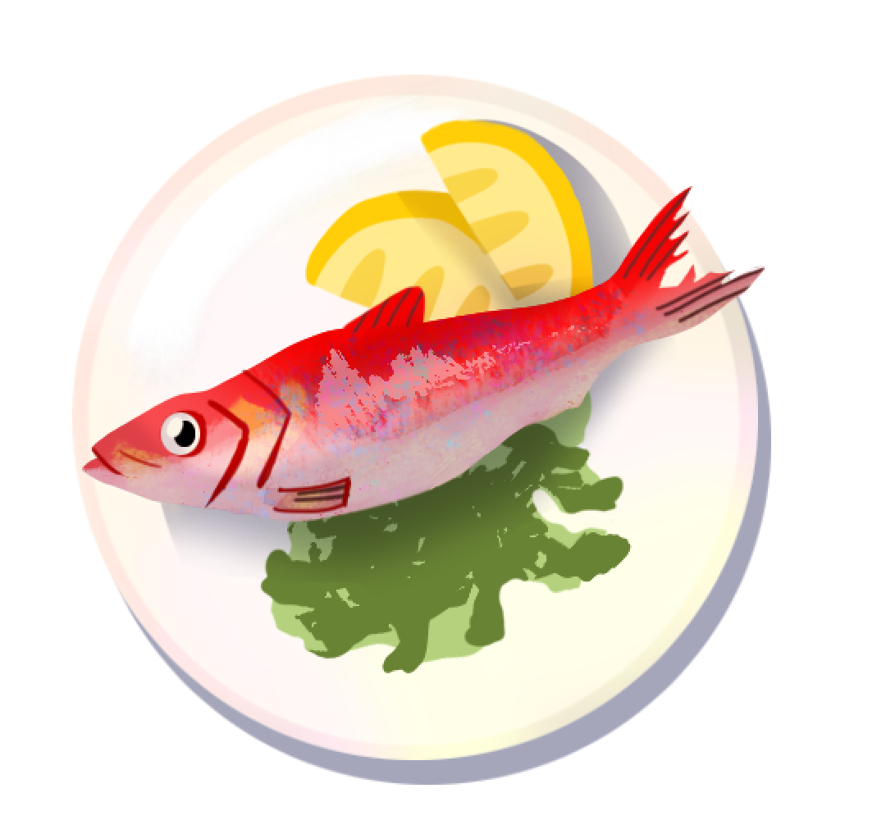
A red herring is a type of herring that has been cured in brine or smoked until it's red and strong-smelling.

Set 2
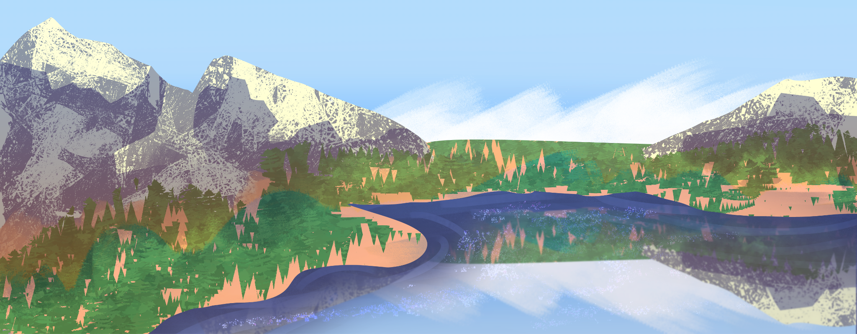
Hundreds of fish species are disappearing in the Great Lakes.
Zebra mussels are an invasive species that likely arrived in the Great Lakes from ships from Europe in the 1980s. They grow almost five times faster than native mussels. | Zebra mussels take algae and plankton that native species need for food.
Sea lampreys are parasitic fish from the Atlantic Ocean that feed by attaching to other fish and sucking their blood. These fish arrived in the Great Lakes in the 1920s through shipping canals. | While fish in the ocean have adapted to survive the lamprey, in the Great Lakes, the sea lamprey usually kill the fish they feed on. An individual lamprey can kill up to 40 pounds of fish during its life.

Rain washing fertilizers from lawns and crops into lakes can cause algal blooms, where algae grow out of control. Algal blooms in the Great Lakes have increased since the 1990s. | Many water species eat algae, but too much in an environment can be lethal to fish by poisoning them or removing all the oxygen from an area of water.
Lake Superior is the largest freshwater lake in the world. | More than 20% of all the world’s fresh water is in the Great Lakes.
A red herring is a type of herring that has been cured in brine or smoked until it's red and strong-smelling

Set 3
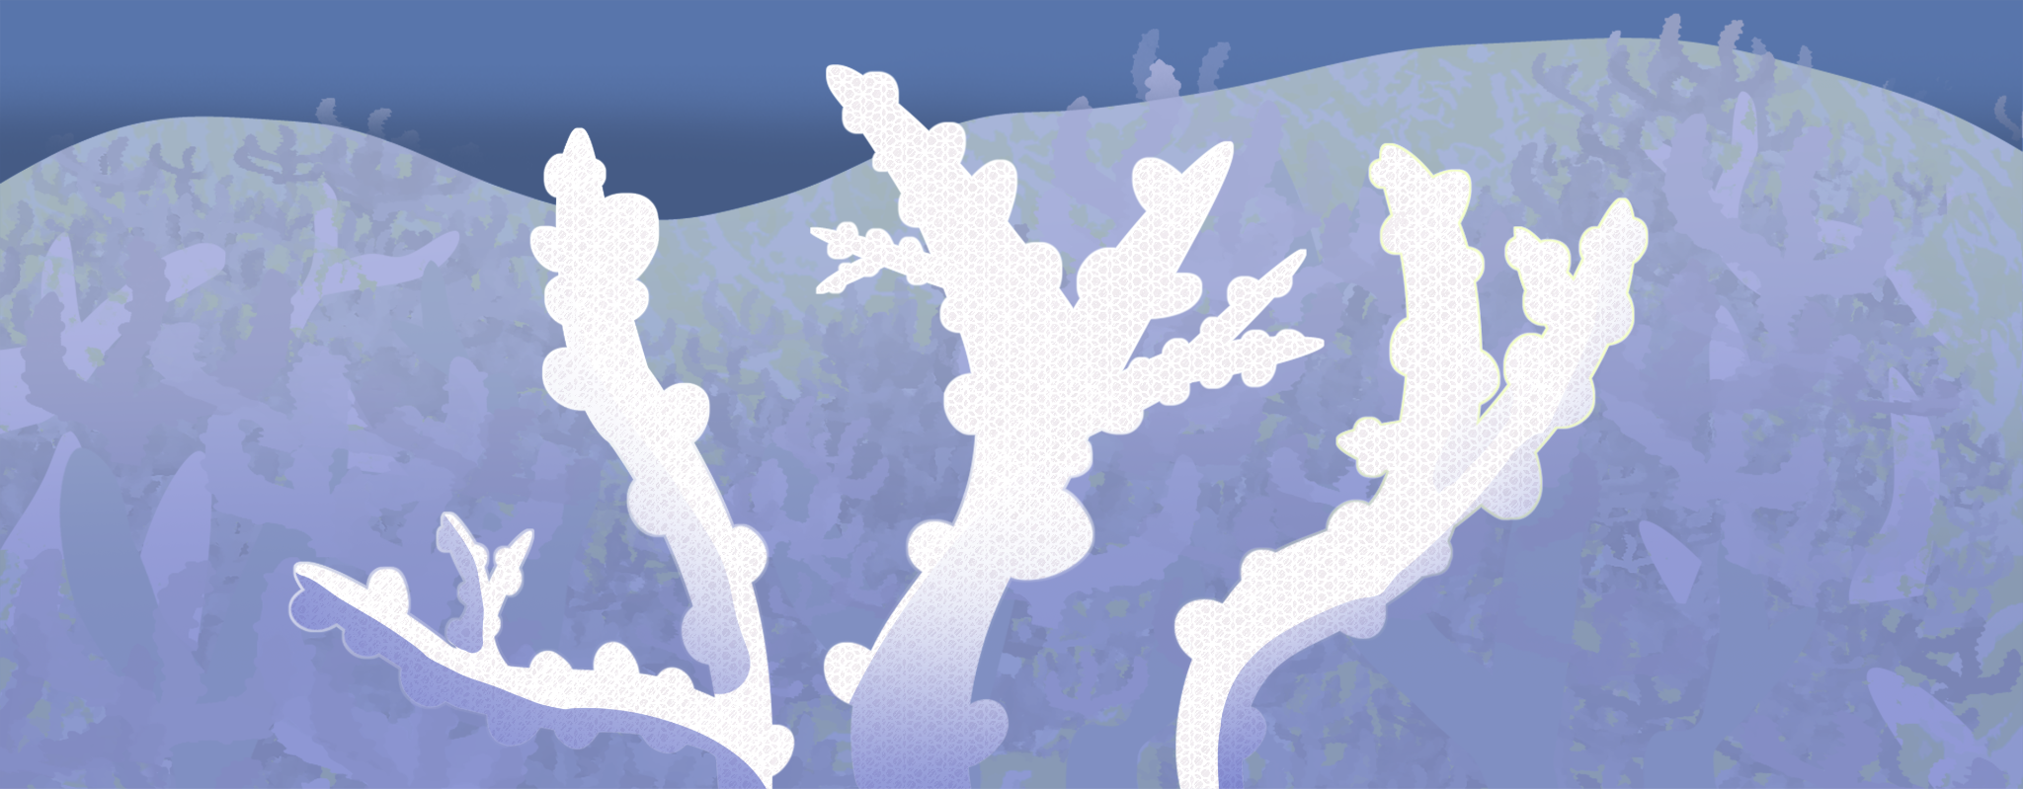
Even though they are home to over 4,000 species of fish, coral reefs around the planet are disappearing.
Scientists have measured ocean temperature for many years and found it has risen by about 1.5°F (0.8°C) since the late 1800s. | Coral bleaching happens when the water in the ocean gets too warm, and the tiny colorful algae that live on corals leave, making the corals turn white.
Without algae, corals lose their main source of food and can get sick or die if the water stays too hot for too long. | Increased carbon dioxide in the air, from things like cars and factories burning fuel, makes the oceans more acidic.

Ocean acidification makes it difficult for coral to grow their skeletons. | Without their skeletons, corals can’t protect themselves, and they become more fragile.
The movie Finding Nemo centers around fish living in a coral reef off the coast of Australia. | Surgeons use coral as a bone replacement in surgeries such as spinal fusions, dental procedures, and facial surgeries.
A red herring is a type of herring that has been cured in brine or smoked until it's red and strong-smelling.

Set 4
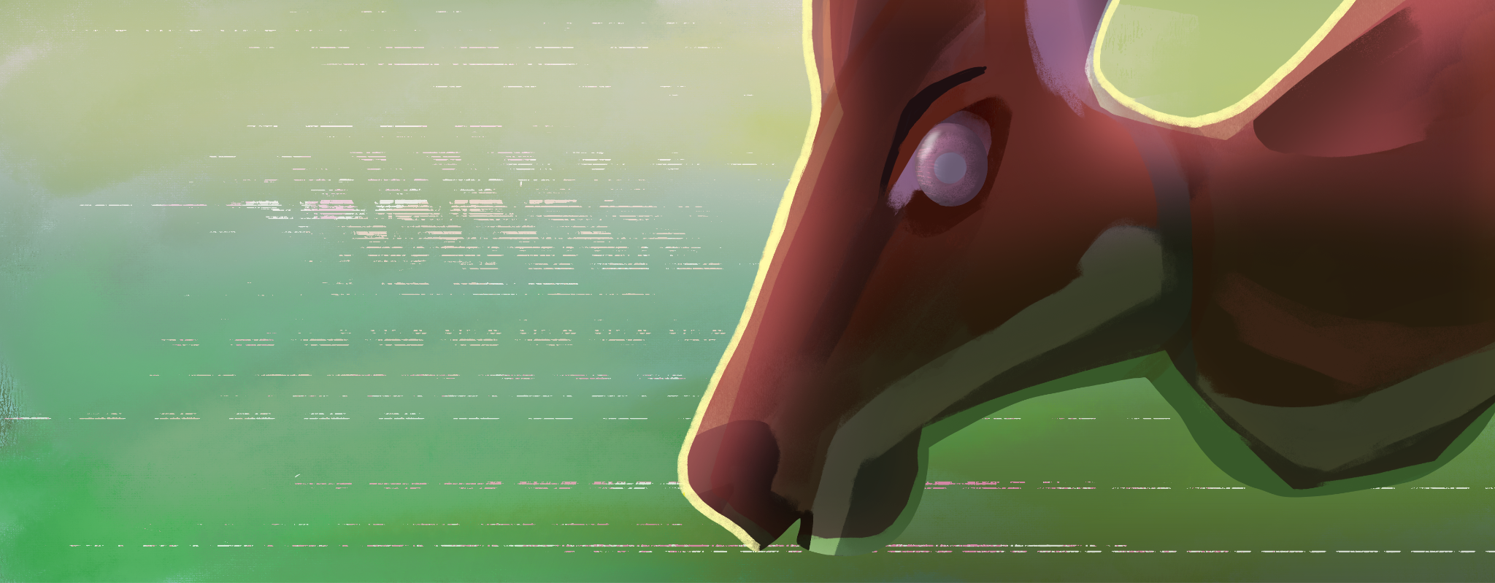
Deer in certain areas of North America have been observed acting “out of it” and show no fear of people.
Deer are social animals that like to live in groups called herds, where they stay together for safety and comfort. | Herd behavior in deer includes finding food and water together and licking each other to groom and show affection.
A prion is a bad protein in living bodies that can make other healthy proteins change into harmful ones, which can cause brain diseases. | Chronic wasting disease (CWD) is a disease that can spread among members of the deer family, including deer, moose, and elk.

CWD is believed to be caused by prions that infect the brain, causing the infected animal to lose weight, walk strangely, and act confused or sick. | Prions are spread mainly through direct contact between animals, like when they lick each other, share food or water, or come into contact with saliva or other bodily fluids.
Deer have cloven hooves, which means their hooves are split into two parts. | Antarctica and Australia are the only two continents on Earth without native deer.
A red herring is a type of herring that has been cured in brine or smoked until it's red and strong-smelling.

