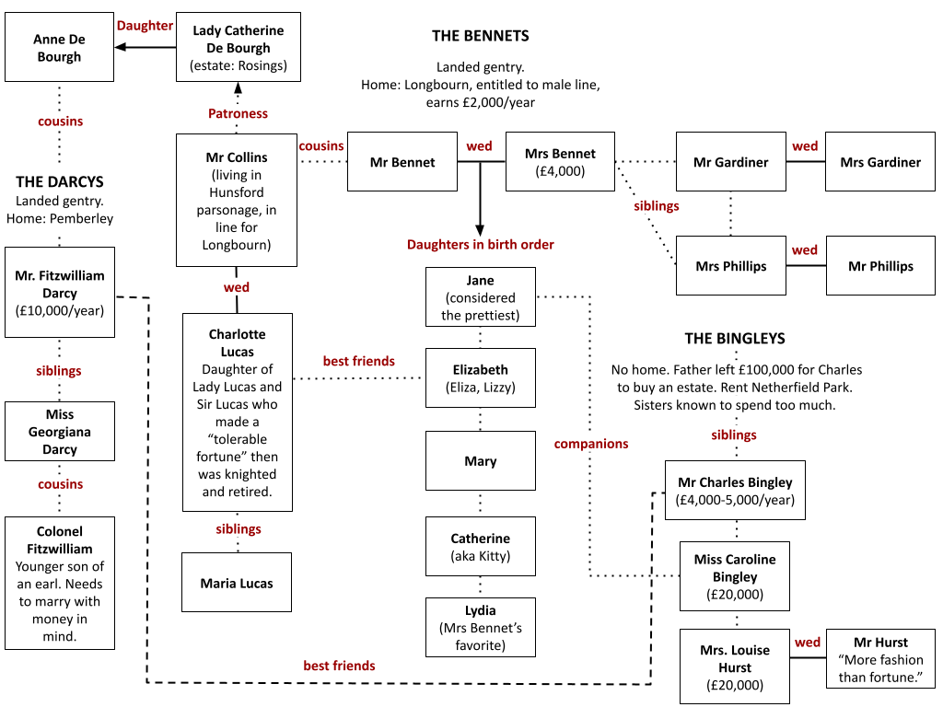

PLOT SUMMARY
Between October 1796 and August 1797, Jane Austen completed the first version of Pride and Prejudice, originally titled First Impressions. Though not published until 1813 under its now-famous name, the novel was an immediate success—selling out its first edition within a year—and has remained in print ever since.
The novel begins with the iconic line: “It is a truth universally acknowledged, that a single man in possession of a good fortune, must be in want of a wife.” This reflects the mindset of Mrs. Bennet, who is eager to see one of her daughters married to the wealthy newcomer, Mr. Bingley. At a ball, Bingley quickly becomes interested in the gentle and reserved Jane. His friend Mr. Darcy, however, makes a less favorable impression on Elizabeth, Jane’s spirited sister. While both Darcy and Elizabeth are intrigued by each other, their mutual pride and prejudice keep them distant: Darcy looks down on Elizabeth’s lower social standing, while Elizabeth resents his arrogance.
Soon after, Mr. Collins, a pompous clergyman and the Bennet family’s heir, visits with hopes of marrying one of the daughters. Encouraged by Mrs. Bennet, he proposes to Elizabeth, who refuses him. He then proposes to her friend Charlotte, who accepts for practical reasons. Around this time, Elizabeth also meets the charming Mr. Wickham, who claims that Darcy unfairly denied him an inheritance, deepening her dislike of Darcy.
When Bingley suddenly leaves for London, Elizabeth assumes Darcy is behind the separation from Jane. Meanwhile, Darcy's feelings for Elizabeth grow, and during a visit to Charlotte, now Mrs. Collins, he unexpectedly proposes. Elizabeth, shocked and angry, rejects him, accusing him of hurting Jane and mistreating Wickham. In response, Darcy writes her a letter, revealing that he separated Bingley and Jane because he believed Jane did not return Bingley’s love. He also explains that Wickham squandered his inheritance and tried to elope with Darcy’s young sister for her fortune.
These revelations begin to change Elizabeth’s view of Darcy. Soon after, news breaks that the youngest Bennet sister, Lydia, has eloped with Wickham, creating a scandal that could damage the whole family’s reputation. Darcy secretly intervenes, persuading Wickham to marry Lydia by offering financial support. Elizabeth later learns of Darcy’s efforts and is moved by his generosity.
Encouraged by Darcy, Bingley returns and proposes to Jane, who happily accepts. Eventually, Darcy proposes once more to Elizabeth, and this time, she accepts, having come to understand and admire his true character.

