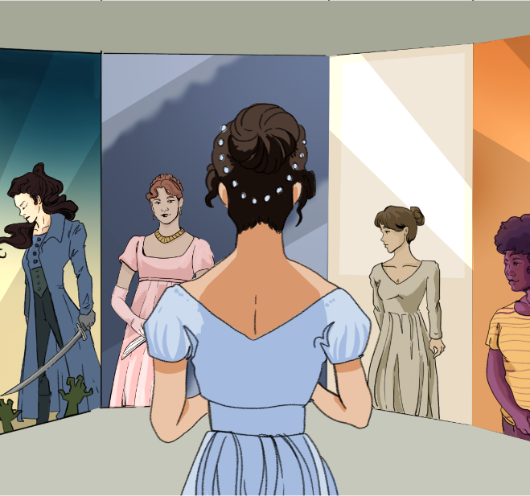

CHARACTER KEY (write names and highlight them in the color you will use to highlight the text)

Chapter 14
During dinner, Mr. Bennet scarcely spoke at all; but when the servants were withdrawn, he thought it time to have some conversation with his guest, and therefore started a subject in which he expected him to shine, by observing that he seemed very fortunate in his patroness. Lady Catherine de Bourgh's attention to his wishes, and consideration for his comfort, appeared very remarkable. Mr. Bennet could not have chosen better. Mr. Collins was eloquent in her praise. The subject elevated him to more than usual solemnity of manner, and with a most important aspect he protested that he had never in his life witnessed such behaviour in a person of rank—such affability and condescension, as he had himself experienced from Lady Catherine. She had been graciously pleased to approve of both the discourses, which he had already had the honour of preaching before her. She had also asked him twice to dine at Rosings, and had sent for him only the Saturday before, to make up her pool of quadrille in the evening. Lady Catherine was reckoned proud by many people he knew, but he had never seen any thing but affability in her. She had always spoken to him as she would to any other gentleman; she made not the smallest objection to his joining in the society of the neighbourhood, nor to his leaving his parish occasionally for a week or two, to visit his relations. She had even condescended to advise him to marry as soon as he could, provided he chose with discretion; and had once paid him a visit in his humble parsonage; where she had perfectly approved all the alterations he had been making, and had even vouchsafed to suggest some herself,—some shelves in the closets up stairs.
"That is all very proper and civil, I am sure," said Mrs. Bennet, "and I dare say she is a very agreeable woman. It is a pity that great ladies in general are not more like her. Does she live near you, sir?"
"The garden in which stands my humble abode, is separated only by a lane from Rosings Park, her ladyship's residence."
"I think you said she was a widow, sir? has she any family?"
"She has one only daughter, the heiress of Rosings, and of very extensive property."
"Ah!" cried Mrs. Bennet, shaking her head, "then she is better off than many girls. And what sort of young lady is she? is she handsome?"
"She is a most charming young lady indeed. Lady Catherine herself says that in point of true beauty, Miss De Bourgh is far superior to the handsomest of her sex; because there is that in her features which marks the young woman of distinguished birth. She is unfortunately of a sickly constitution, which has prevented her making that progress in many accomplishments, which she could not otherwise have failed of; as I am informed by the lady who superintended her education, and who still resides with them. But she is perfectly amiable, and often condescends to drive by my humble abode in her little phaeton and ponies."
"Has she been presented? I do not remember her name among the ladies at court."
"Her indifferent state of health unhappily prevents her being in town; and by that means, as I told Lady Catherine myself one day, has deprived the British court of its brightest ornament. Her ladyship seemed pleased with the idea, and you may imagine that I am happy on every occasion to offer those little delicate compliments which are always acceptable to ladies. I have more than once observed to Lady Catherine, that her charming daughter seemed born to be a duchess, and that the most elevated rank, instead of giving her consequence, would be adorned by her.—These are the kind of little things which please her ladyship, and it is a sort of attention which I conceive myself peculiarly bound to pay."
"You judge very properly," said Mr. Bennet, "and it is happy for you that you possess the talent of flattering with delicacy. May I ask whether these pleasing attentions proceed from the impulse of the moment, or are the result of previous study?"
"They arise chiefly from what is passing at the time, and though I sometimes amuse myself with suggesting and arranging such little elegant compliments as may be adapted to ordinary occasions, I always wish to give them as unstudied an air as possible."
Mr. Bennet's expectations were fully answered. His cousin was as absurd as he had hoped, and he listened to him with the keenest enjoyment, maintaining at the same time the most resolute composure of countenance, and except in an occasional glance at Elizabeth, requiring no partner in his pleasure.
By tea-time however the dose had been enough, and Mr. Bennet was glad to take his guest into the drawing-room again, and when tea was over, glad to invite him to read aloud to the ladies. Mr. Collins readily assented, and a book was produced; but on beholding it, (for every thing announced it to be from a circulating library,) he started back, and begging pardon, protested that he never read novels.—Kitty stared at him, and Lydia exclaimed.—Other books were produced, and after some deliberation he chose Fordyce's Sermons. Lydia gaped as he opened the volume, and before he had, with very monotonous solemnity, read three pages, she interrupted him with,
"Do you know, mama, that my uncle Philips talks of turning away Richard, and if he does, Colonel Forster will hire him. My aunt told me so herself on Saturday. I shall walk to Meryton to-morrow to hear more about it, and to ask when Mr. Denny comes back from town."
Lydia was bid by her two eldest sisters to hold her tongue; but Mr. Collins, much offended, laid aside his book, and said,
"I have often observed how little young ladies are interested by books of a serious stamp, though written solely for their benefit. It amazes me, I confess;—for certainly, there can be nothing so advantageous to them as instruction. But I will no longer importune my young cousin."
Then turning to Mr. Bennet, he offered himself as his antagonist at backgammon. Mr. Bennet accepted the challenge, observing that he acted very wisely in leaving the girls to their own trifling amusements. Mrs. Bennet and her daughters apologised most civilly for Lydia's interruption, and promised that it should not occur again, if he would resume his book; but Mr. Collins, after assuring them that he bore his young cousin no ill will, and should never resent her behaviour as any affront, seated himself at another table with Mr. Bennet, and prepared for backgammon.

When the household staff left the room, as was customary after dinner so the family and guests could talk privately
A wealthy or influential woman who supports someone, often with money or social connections
Able to express ideas clearly and beautifully, especially in speech
Seriousness or formality, often in behavior or speech
Someone with a high social status, often connected to nobility or titled families
Friendliness; being easy to talk to and kind
Behavior that shows a person feels superior to others, even when trying to be kind
Formal or serious conversations or speeches
A popular dance for four couples, often performed at balls during this time period
The local upper-class people one would socialize with; the social scene
The area served by a local church, often referring to both the church and its community
The house provided for a parish priest or clergyman
To give or offer something to someone in a gracious or condescending way (often used when someone feels they are doing a favor by offering something)
A home or place where someone lives
A formal way of referring to or addressing a woman of high rank (like a countess or baroness)
A woman who is set to inherit money or property, usually from her family
She has more money, support, or opportunities than many women of her time
The woman who oversaw or managed her schooling
Kind, pleasant, and easy to get along with.
Has she been formally introduced at court (a social debut), which was a tradition for upper-class young women entering society
Staying in London, which was often referred to simply as “town,” especially during the social season
A noblewoman of the highest rank below a queen, often married to a duke
Her character is so impressive that even the highest title would be honored by her, rather than the other way around
Strongest or most intense (as in feelings, emotions, or intelligence)
Determined and unwavering
Facial expression or appearance
The time in the afternoon when tea is traditionally served, usually between 3 and 5 p.m.
The room where guests were received and entertained; similar to a living room
A library where people could borrow books for a fee, popular before public libraries existed
At the time, novels were considered less serious than other types of reading, especially by men
A real book of moral and religious lectures aimed at young women, often used in their education
Dull and repetitive; lacking in variety or interest
Offering a benefit, especially in terms of wealth or status
To beg or ask someone persistently and annoyingly
The person one is playing against in a game of backgammon (a classic board game)
Unimportant or trivial
An insult or action that offends someone

