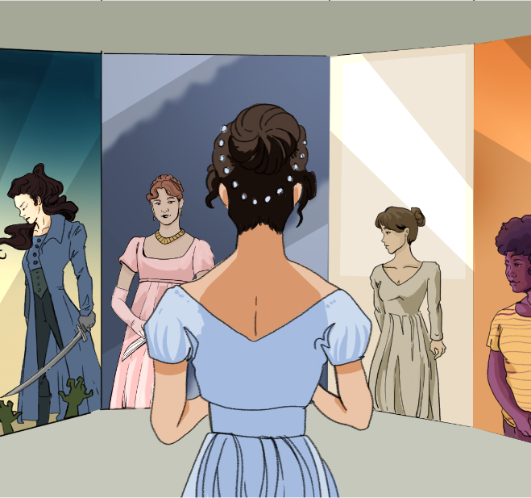

CHARACTER KEY (write names and highlight them in the color you will use to highlight the text)

Chapter 15
Mr. Collins was not a sensible man, and the deficiency of nature had been but little assisted by education or society; the greatest part of his life having been spent under the guidance of an illiterate and miserly father; and though he belonged to one of the universities, he had merely kept the necessary terms, without forming at it any useful acquaintance. The subjection in which his father had brought him up, had given him originally great humility of manner, but it was now a good deal counteracted by the self-conceit of a weak head, living in retirement, and the consequential feelings of early and unexpected prosperity. A fortunate chance had recommended him to Lady Catherine de Bourgh when the living of Hunsford was vacant; and the respect which he felt for her high rank, and his veneration for her as his patroness, mingling with a very good opinion of himself, of his authority as a clergyman, and his rights as a rector, made him altogether a mixture of pride and obsequiousness, self-importance and humility.
Having now a good house and very sufficient income, he intended to marry; and in seeking a reconciliation with the Longbourn family he had a wife in view, as he meant to chuse one of the daughters, if he found them as handsome and amiable as they were represented by common report. This was his plan of amends—of atonement—for inheriting their father's estate; and he thought it an excellent one, full of eligibility and suitableness, and excessively generous and disinterested on his own part.
His plan did not vary on seeing them.—Miss Bennet's lovely face confirmed his views, and established all his strictest notions of what was due to seniority; and for the first evening she was his settled choice. The next morning, however, made an alteration; for in a quarter of an hour's tête-à-tête with Mrs. Bennet before breakfast, a conversation beginning with his parsonage-house, and leading naturally to the avowal of his hopes, that a mistress for it might be found at Longbourn, produced from her, amid very complaisant smiles and general encouragement, a caution against the very Jane he had fixed on.—"As to her younger daughters she could not take upon her to say—she could not positively answer—but she did not know of any prepossession;—her eldest daughter, she must just mention—she felt it incumbent on her to hint, was likely to be very soon engaged."
Mr. Collins had only to change from Jane to Elizabeth—and it was soon done—done while Mrs. Bennet was stirring the fire. Elizabeth, equally next to Jane in birth and beauty, succeeded her of course.
Mrs. Bennet treasured up the hint, and trusted that she might soon have two daughters married; and the man whom she could not bear to speak of the day before, was now high in her good graces.
Lydia's intention of walking to Meryton was not forgotten; every sister except Mary agreed to go with her; and Mr. Collins was to attend them, at the request of Mr. Bennet, who was most anxious to get rid of him, and have his library to himself; for thither Mr. Collins had followed him after breakfast, and there he would continue, nominally engaged with one of the largest folios in the collection, but really talking to Mr. Bennet, with little cessation, of his house and garden at Hunsford. Such doings discomposed Mr. Bennet exceedingly. In his library he had been always sure of leisure and tranquillity; and though prepared, as he told Elizabeth, to meet with folly and conceit in every other room in the house, he was used to be free from them there; his civility, therefore, was most prompt in inviting Mr. Collins to join his daughters in their walk; and Mr. Collins, being in fact much better fitted for a walker than a reader, was extremely well pleased to close his large book, and go.
In pompous nothings on his side, and civil assents on that of his cousins, their time passed till they entered Meryton. The attention of the younger ones was then no longer to be gained by him. Their eyes were immediately wandering up in the street in quest of the officers, and nothing less than a very smart bonnet indeed, or a really new muslin in a shop window, could recal them.
But the attention of every lady was soon caught by a young man, whom they had never seen before, of most gentleman-like appearance, walking with an officer on the other side of the way. The officer was the very Mr. Denny, concerning whose return from London Lydia came to inquire, and he bowed as they passed. All were struck with the stranger's air, all wondered who he could be, and Kitty and Lydia, determined if possible to find out, led the way across the street, under pretence of wanting something in an opposite shop, and fortunately had just gained the pavement when the two gentlemen turning back had reached the same spot. Mr. Denny addressed them directly, and entreated permission to introduce his friend, Mr. Wickham, who had returned with him the day before from town, and he was happy to say had accepted a commission in their corps. This was exactly as it should be; for the young man wanted only regimentals to make him completely charming. His appearance was greatly in his favour; he had all the best part of beauty, a fine countenance, a good figure, and very pleasing address. The introduction was followed up on his side by a happy readiness of conversation—a readiness at the same time perfectly correct and unassuming; and the whole party were still standing and talking together very agreeably, when the sound of horses drew their notice, and Darcy and Bingley were seen riding down the street. On distinguishing the ladies of the group, the two gentlemen came directly towards them, and began the usual civilities. Bingley was the principal spokesman, and Miss Bennet the principal object. He was then, he said, on his way to Longbourn on purpose to inquire after her. Mr. Darcy corroborated it with a bow, and was beginning to determine not to fix his eyes on Elizabeth, when they were suddenly arrested by the sight of the stranger, and Elizabeth happening to see the countenance of both as they looked at each other, was all astonishment at the effect of the meeting. Both changed colour, one looked white, the other red. Mr. Wickham, after a few moments, touched his hat—a salutation which Mr. Darcy just deigned to return. What could be the meaning of it?—It was impossible to imagine; it was impossible not to long to know.
In another minute Mr. Bingley, but without seeming to have noticed what passed, took leave and rode on with his friend.
Mr. Denny and Mr. Wickham walked with the young ladies to the door of Mr. Philips's house, and then made their bows, in spite of Miss Lydia's pressing entreaties that they would come in, and even in spite of Mrs. Philips' throwing up the parlour window, and loudly seconding the invitation.
Mrs. Philips was always glad to see her nieces, and the two eldest, from their recent absence, were particularly welcome, and she was eagerly expressing her surprise at their sudden return home, which, as their own carriage had not fetched them, she should have known nothing about, if she had not happened to see Mr. Jones's shop boy in the street, who had told her that they were not to send any more draughts to Netherfield because the Miss Bennets were come away, when her civility was claimed towards Mr. Collins by Jane's introduction of him. She received him with her very best politeness, which he returned with as much more, apologising for his intrusion, without any previous acquaintance with her, which he could not help flattering himself however might be justified by his relationship to the young ladies who introduced him to her notice. Mrs. Philips was quite awed by such an excess of good breeding; but her contemplation of one stranger was soon put an end to by exclamations and inquiries about the other, of whom, however, she could only tell her nieces what they already knew, that Mr. Denny had brought him from London, and that he was to have a lieutenant's commission in the ——shire. She had been watching him the last hour, she said, as he walked up and down the street, and had Mr. Wickham appeared Kitty and Lydia would certainly have continued the occupation, but unluckily no one passed the windows now except a few of the officers, who in comparison with the stranger, were become "stupid, disagreeable fellows." Some of them were to dine with the Philipses the next day, and their aunt promised to make her husband call on Mr. Wickham, and give him an invitation also, if the family from Longbourn would come in the evening. This was agreed to, and Mrs. Philips protested that they would have a nice comfortable noisy game of lottery tickets, and a little bit of hot supper afterwards. The prospect of such delights was very cheering, and they parted in mutual good spirits. Mr. Collins repeated his apologies in quitting the room, and was assured with unwearying civility that they were perfectly needless.
As they walked home, Elizabeth related to Jane what she had seen pass between the two gentlemen; but though Jane would have defended either or both, had they appeared to be wrong, she could no more explain such behaviour than her sister.
Mr. Collins on his return highly gratified Mrs. Bennet by admiring Mrs. Philips's manners and politeness. He protested that except Lady Catherine and her daughter, he had never seen a more elegant woman; for she had not only received him with the utmost civility, but had even pointedly included him in her invitation for the next evening, although utterly unknown to her before. Something he supposed might be attributed to his connection with them, but yet he had never met with so much attention in the whole course of his life.

Extremely stingy with money; unwilling to spend even when appropriate
He technically attended a university but only did the minimum required to earn a degree and didn’t make any meaningful connections or friends
Being under the control or authority of someone else
A church position (with income and housing) assigned to a clergyman
Deep respect, often almost like reverence
A wealthy or powerful woman who supports someone, usually by giving them a job or social advantage
A clergyman in charge of a parish in the Church of England
Overly eager to please or obey someone important; excessive flattery
Making up for a wrong or mistake
Impartial; not influenced by personal gain or bias (not the same as “uninterested”)
A private conversation between two people (French, literally “head-to-head”)
The home provided for a parish clergyman; same as "parsonage"
An open and honest statement of something, often a feeling or intention
A woman who is in charge of a household or, more generally, a woman of some social standing (not necessarily the modern romantic connotation)
Willing to please others; agreeable and polite (not to be confused with “complacent”)
A preconceived opinion or prejudice, often positive or favorable
The person currently holding a particular office or position
An old-fashioned word meaning “to that place”
In name only; officially or formally, but not necessarily in reality
Large books made by folding full sheets of paper once, used for important or scholarly works
A stopping or pause of something
Disturbed, upset, or flustered
Foolishness or lack of good sense
An overly high opinion of oneself; vanity or arrogance
Acting self-important or overly formal and grand
A fashionable hat worn by women
A new dress made of muslin, a light cotton fabric; wearing new clothes was a mark of good appearance and social standing
Begged or asked earnestly
Agreed to become an officer in a military group or regiment
He would be completely charming if he were wearing a military uniform
Main or most important
Confirmed or supported with evidence or information
A formal gesture of respect or greeting, common in polite society
Stopped or caught off guard by seeing something surprising or striking
One person appeared pale (often from shock or fear), while the other blushed (from emotion or embarrassment)
Reluctantly agreed to do something, as if it were beneath one’s dignity
A sitting room or reception room in a home, often used for entertaining guests
A young male assistant working in a store, typically of lower social status
A board game similar to checkers
A military officer’s position in a regiment from a certain county (e.g., Derbyshire or Hertfordshire, which are blanked out)
Literally tickets for a game of chance; here possibly symbolic of gambling or risky behavior
A cooked evening meal, often served late after social events
Credited or assigned a cause or source (e.g., “She attributed his actions to kindness”)

