CARD SORT 1: Category Cards

PHYSICAL ADAPTATIONS | BEHAVIORAL ADAPTATIONS

CARD SORT 1: Sorting Cards

Thick fur for insulation | Migration for seasonal survival
Long legs for running | Hibernation for energy conservation
Pouched reproduction for carrying young | Social hunting in packs
Sharp teeth for carnivory | Social behavior (herd or pod structure)
Nocturnal vision for night activity | Echolocation for hunting
Webbed feet for swimming | Blubber for heat retention

Hooves for traveling long distances
Large ears for heat dissipation
Thermoregulation

CARD SORT 2: Category Cards
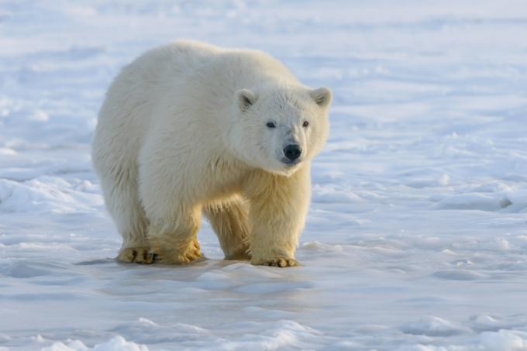 | 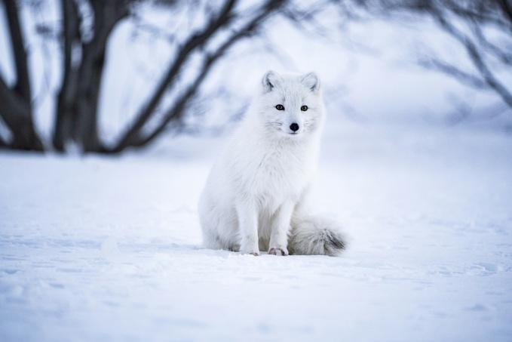
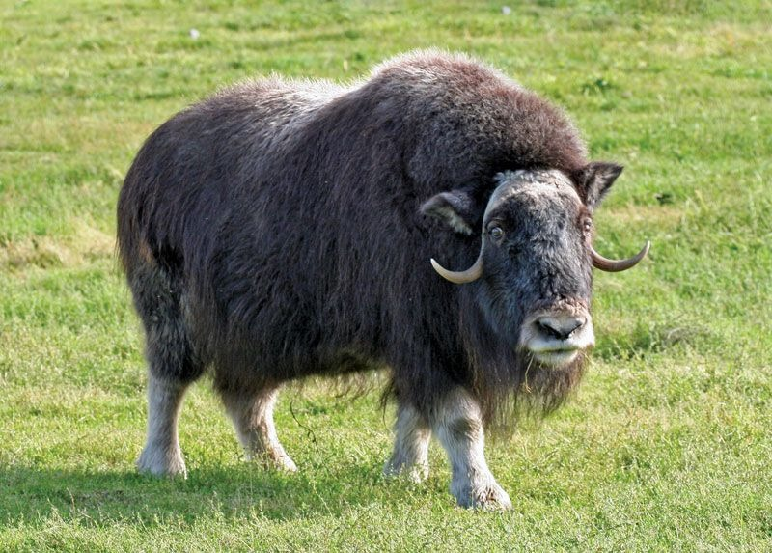 | 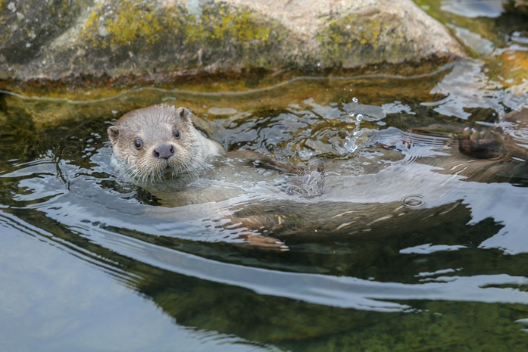
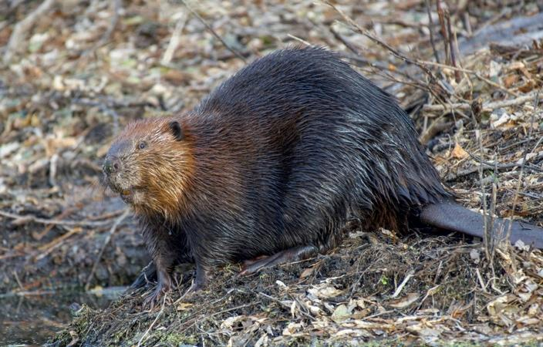 | 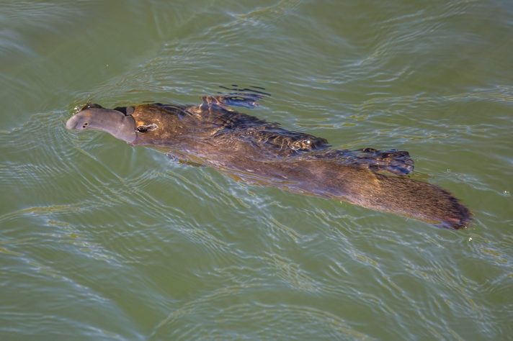

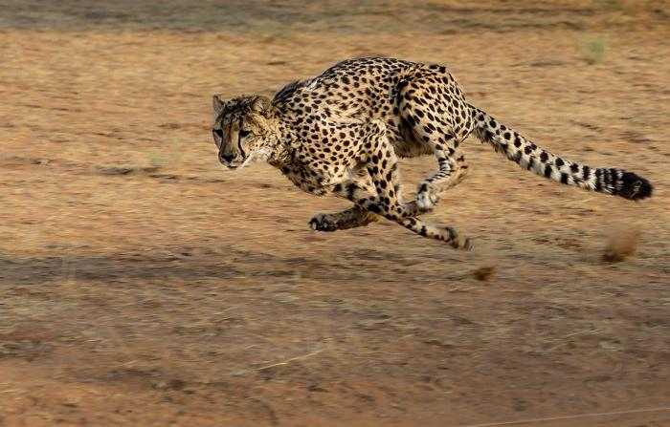 | 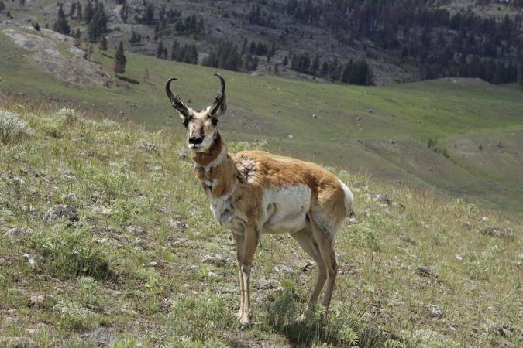
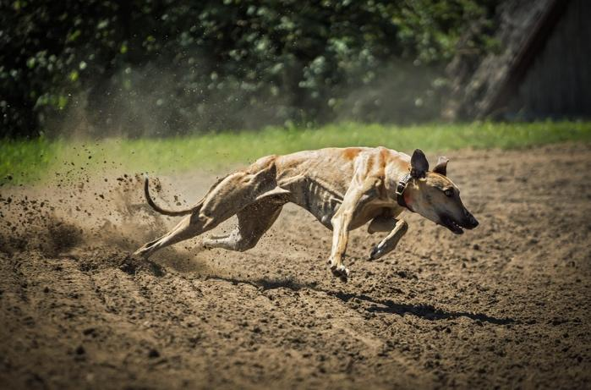 | 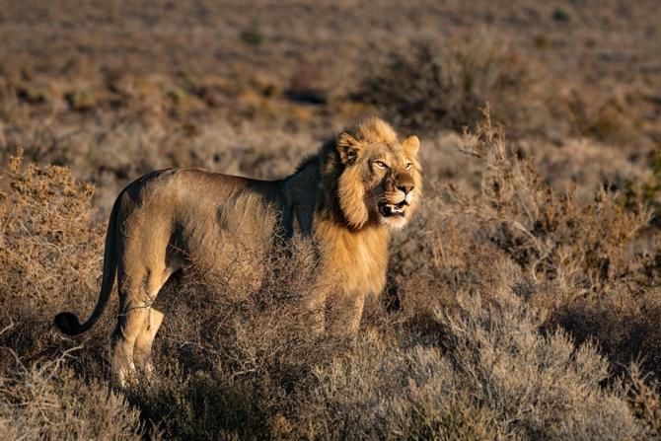
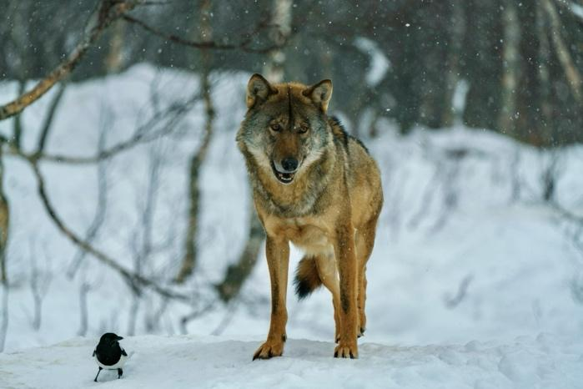 | 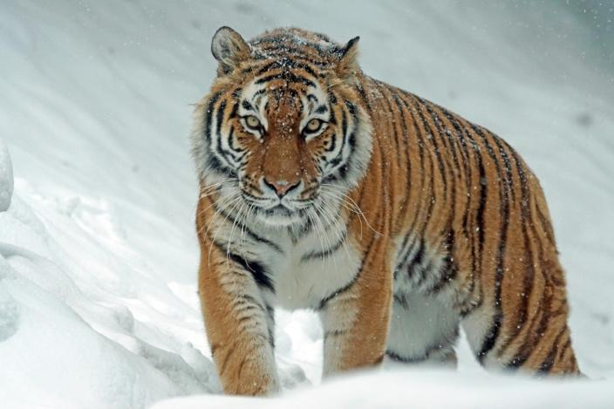

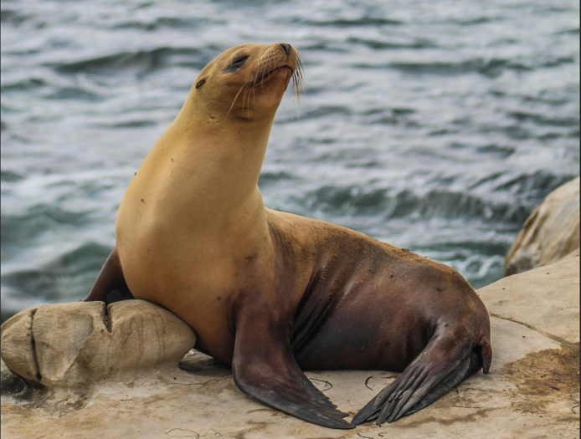 | 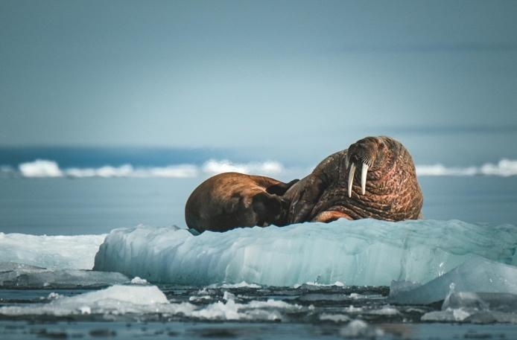
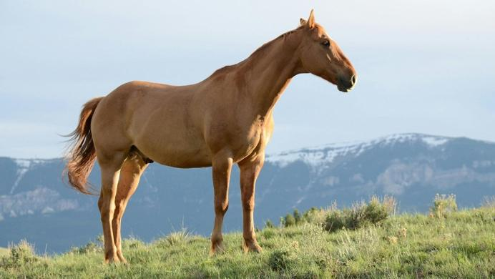 | 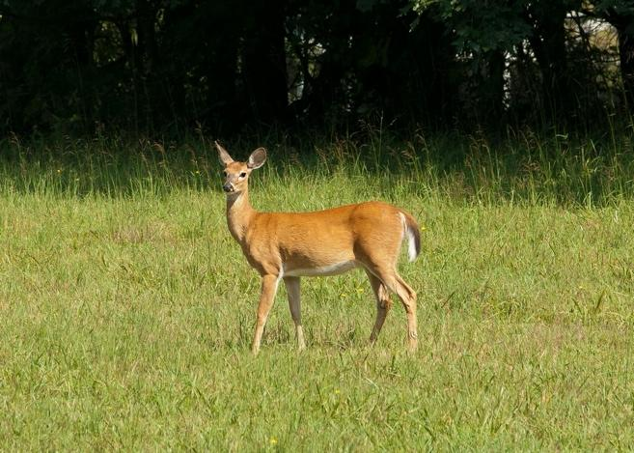
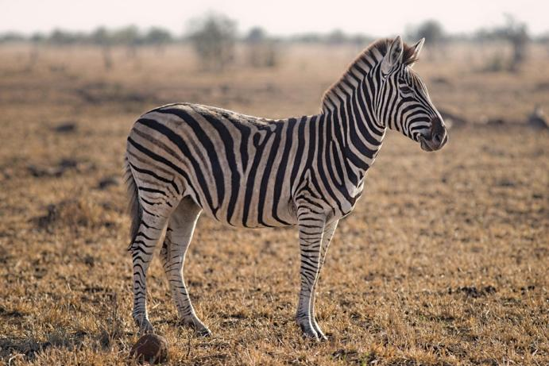 | 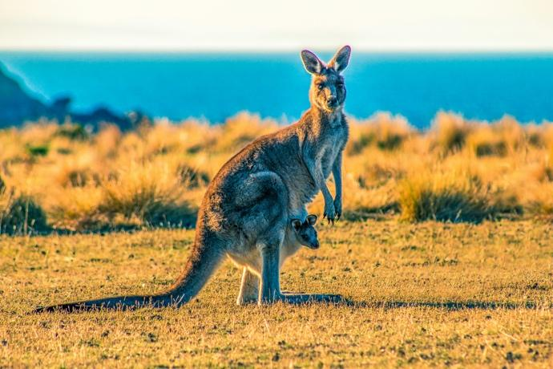

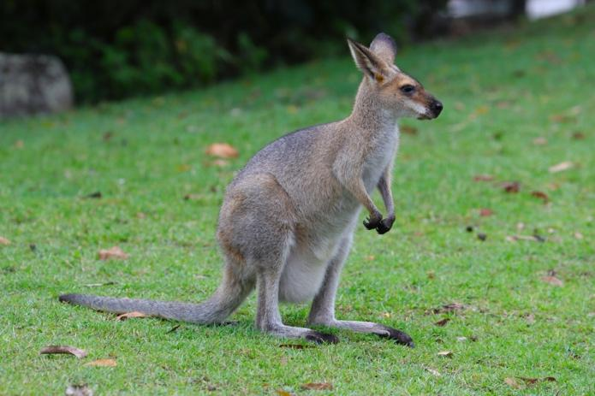 | 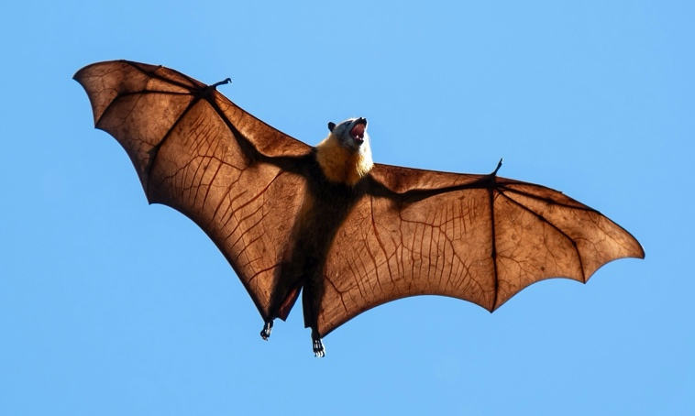
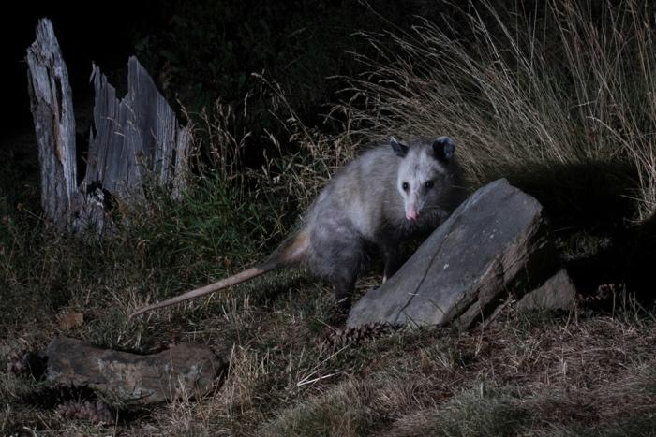 | 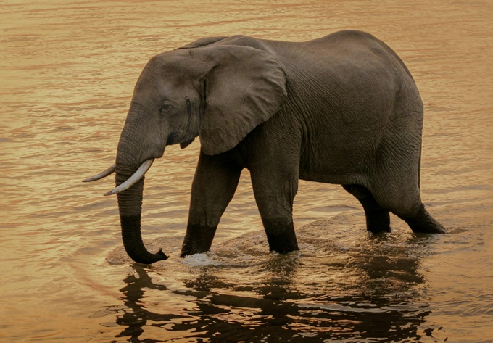
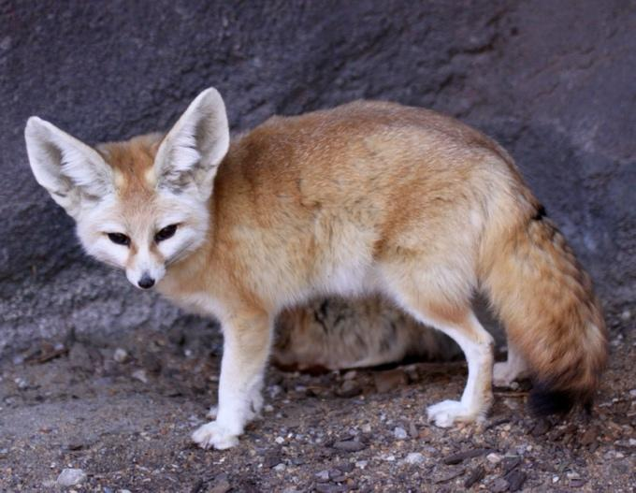 | 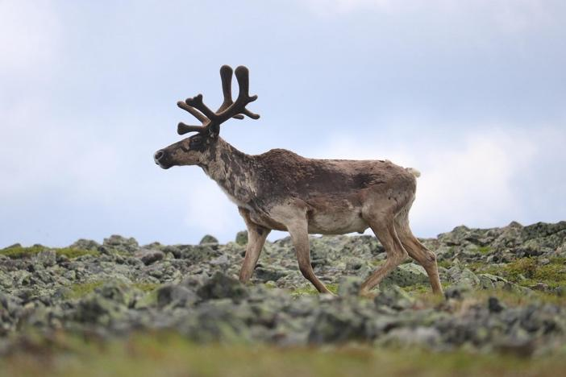

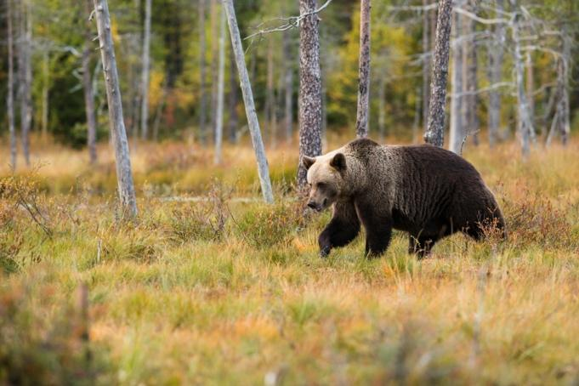 | 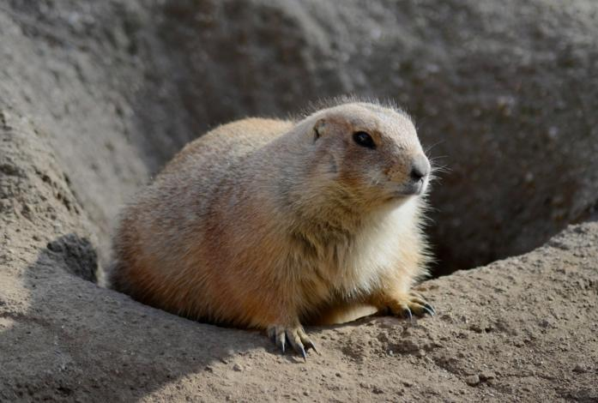
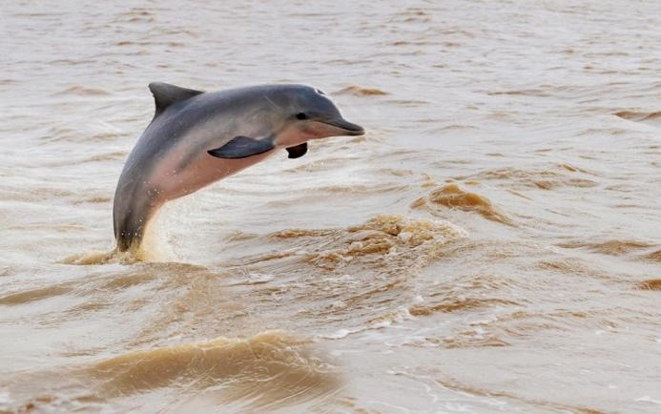 | 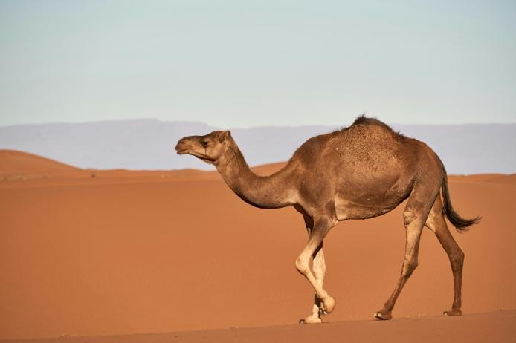
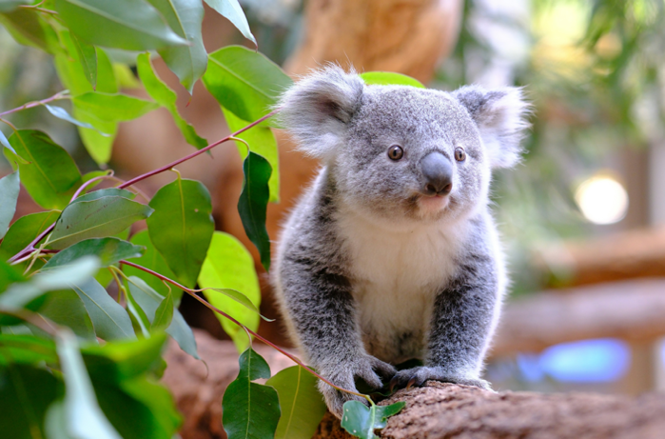 | 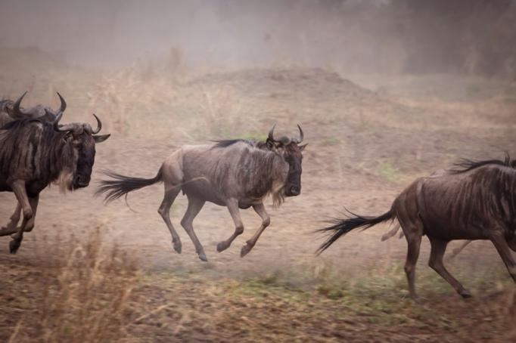

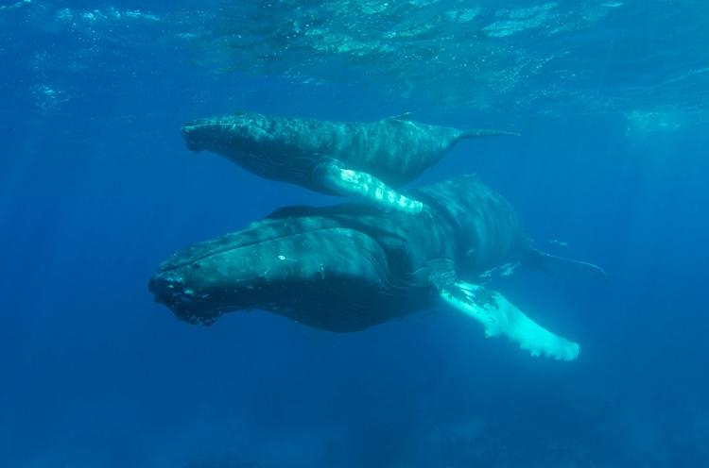 | 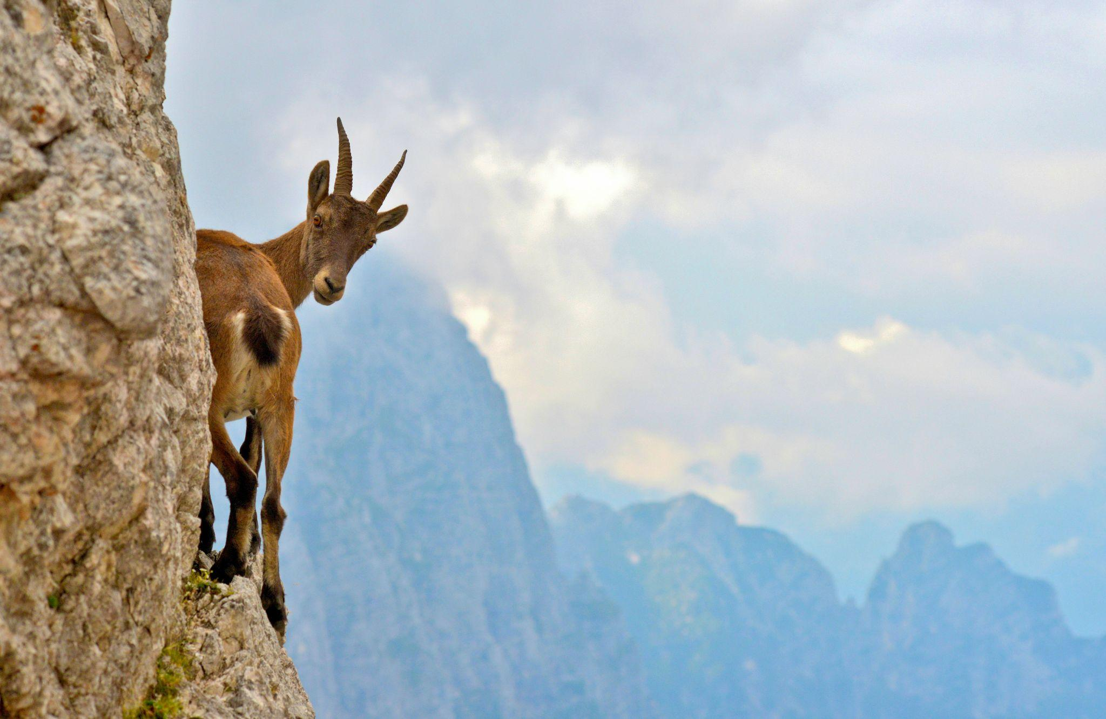

Sources:
Avery, D. (2010, January 28). Fennec Fox Vulpes zerda. [Photograph]. Flickr. https://commons.wikimedia.org/w/index.php?curid=17919493
Balog, R. (2015, July 27). Greyhound [Photograph]. Pixabay. https://pixabay.com/photos/dog-greyhound-hungarian-greyhound-859394/
Blessing, E. (2019, January 16). Lion [Photograph]. Pexels. https://www.pexels.com/photo/photo-of-lion-on-grass-field-2674052/
Bulmer, J. (2022, July 15). Foraging Oppossum [sic] [Photograph]. Unsplash. https://unsplash.com/photos/a-raccoon-sitting-on-a-rock-b5Kj1jl5MFI
Dibert, D. (n.d.). Brown horse on grass field [Photograph]. Pexels. https://www.pexels.com/photo/brown-horse-on-grass-field-635499/
Dietrich, I. (2016, December 14). Close-up shot of a prairie dog [Photograph]. Pexels. https://www.pexels.com/photo/close-up-shot-of-a-prairie-dog-7103880/
DrZoltan. (2017, October 16). Cheetah [Photograph]. Pixabay. https://pixabay.com/photos/cheetah-africa-namibia-cat-run-2859581/
Encyclopædia Britannica. (n.d.). Musk ox [Photograph]. https://www.britannica.com/animal/bovid#/media/1/399336/144206
Fawns, J. (2011, August 20). Brown deer [Photograph]. Pexels. https://www.pexels.com/photo/brown-deer-756758/
Greyling, A. (2014, August 23) Selective focus photography of zebra [Photograph]. Pexels. https://www.pexels.com/photo/selective-focus-photography-of-zebra-750539/
Hasselmann, W. (2020, August 22). Brown camel on desert during daytime [Photograph]. Unsplash. https://unsplash.com/photos/brown-camel-on-desert-during-daytime-YAIGmqV4dFc
Holtshausen, G. (2024, October 25). A large bat flying through a blue sky. Unsplash. https://unsplash.com/photos/a-large-bat-flying-through-a-blue-sky-gMK4V2EWP-U
Jutzeler, S. (2023, October 11). Close-up of a wolf in snowy winter landscape [Photograph]. Pexels. https://www.pexels.com/photo/close-up-of-a-wolf-in-snowy-winter-landscape-30890411/
Lee, H. (2019, July 8). Brown seal [Photograph]. Pexels. https://www.pexels.com/photo/brown-seal-3187036/
Machart, O. (2019, December 7). Kangaroo [Photograph]. Unsplash. https://unsplash.com/photos/kangaroo-with-joey-on-grass-field-during-day-QnFVTob4HHE
Mager, H.-J. (2021, March 2). Polar bear on snow covered ground during daytime [Photograph]. Unsplash. https://unsplash.com/photos/polar-bear-on-snow-covered-ground-during-daytime-bySoVNCijy4
May, H. (2019, March 2). Pronghorn in Lamar Valley [Photograph]. Unsplash. May, H. (n.d.). Brown and white deer on green grass field during daytime. Unsplash. https://unsplash.com/photos/brown-and-white-deer-on-green-grass-field-during-daytime-7t57VCTlzV0
Moeslan, S. (n.d.). Grey dolphin jumping over the water [Photograph]. Pexels. https://www.pexels.com/photo/grey-dolphin-jumping-over-the-water-8867193/
Patrick, A. Photo of a beaver [Photograph]. (n.d.). https://www.pexels.com/photo/photo-of-a-beaver-6920878/
Pfisterer, H. (2024, March 21). A herd of wild animals running across a field {Wildebeest} [Photograph]. Unsplash. https://unsplash.com/photos/a-herd-of-wild-animals-running-across-a-field-u9eNzDu-q20
Phillips, B. (n.d.). Blue whales swimming together underwater [Photograph]. Pexels. https://www.pexels.com/photo/blue-whales-swimming-together-underwater-4781938/
Pie, J. (2017, January 13). Snow fox on snowfield [Photograph]. Unsplash. https://unsplash.com/photos/snow-fox-on-snowfield-NBvcQRdRSeQ
Pixabay. (n.d.). Canada travel America caribou [Photograph]. Pixabay. https://pixabay.com/photos/canada-travel-america-caribou-5149417/
Dinoia, S. (2024, Sep 15.). A small koala sitting on a tree branch [Photograph]. Unsplash. https://unsplash.com/photos/a-small-koala-sitting-on-a-tree-branch-5HARtft3rXU
Pixabay. (n.d.). Tiger. Pexels. https://www.pexels.com/photo/tiger-302304/
Rae, A. (2022, January 7). A small kangaroo [sic {wallaby}] standing on top of a lush green field [Photograph]. Unsplash. https://unsplash.com/photos/a-small-kangaroo-standing-on-top-of-a-lush-green-field-skhJhcsaJkA
Sapir, H. (n.d.). An elephant walking on water [Photograph]. Pexels. https://www.pexels.com/photo/an-elephant-walking-on-water-1054654/
Sharp, C. J. (2023, November 14). Duck-billed Platypus [Photograph]. Wikimedia Commons. https://commons.wikimedia.org/w/index.php?curid=143656029
Stæhr, B. (n.d.). An otter in the water [Photograph]. Pexels. https://www.pexels.com/photo/an-otter-in-the-water-9356811/
Ungaro, F. (2023, August 23). Sea lion [sic {walrus}] lying on ice [Photograph]. Pexels. https://www.pexels.com/photo/sea-lion-lying-on-ice-27047492/
Unsplash. (2019, June 7). Black bear near trees. Unsplash. https://unsplash.com/photos/black-bear-near-trees-Pt3asvL65Mg
Zocca, S. (2020, April 16). Brown deer on rocky mountain during daytime [sic {ibex}] [Photograph]. Unsplash. https://unsplash.com/photos/brown-deer-on-rocky-mountain-during-daytime-WCspLqRy5MU

