SAFETY SYMBOLS CARD MATCHING
Flammable | 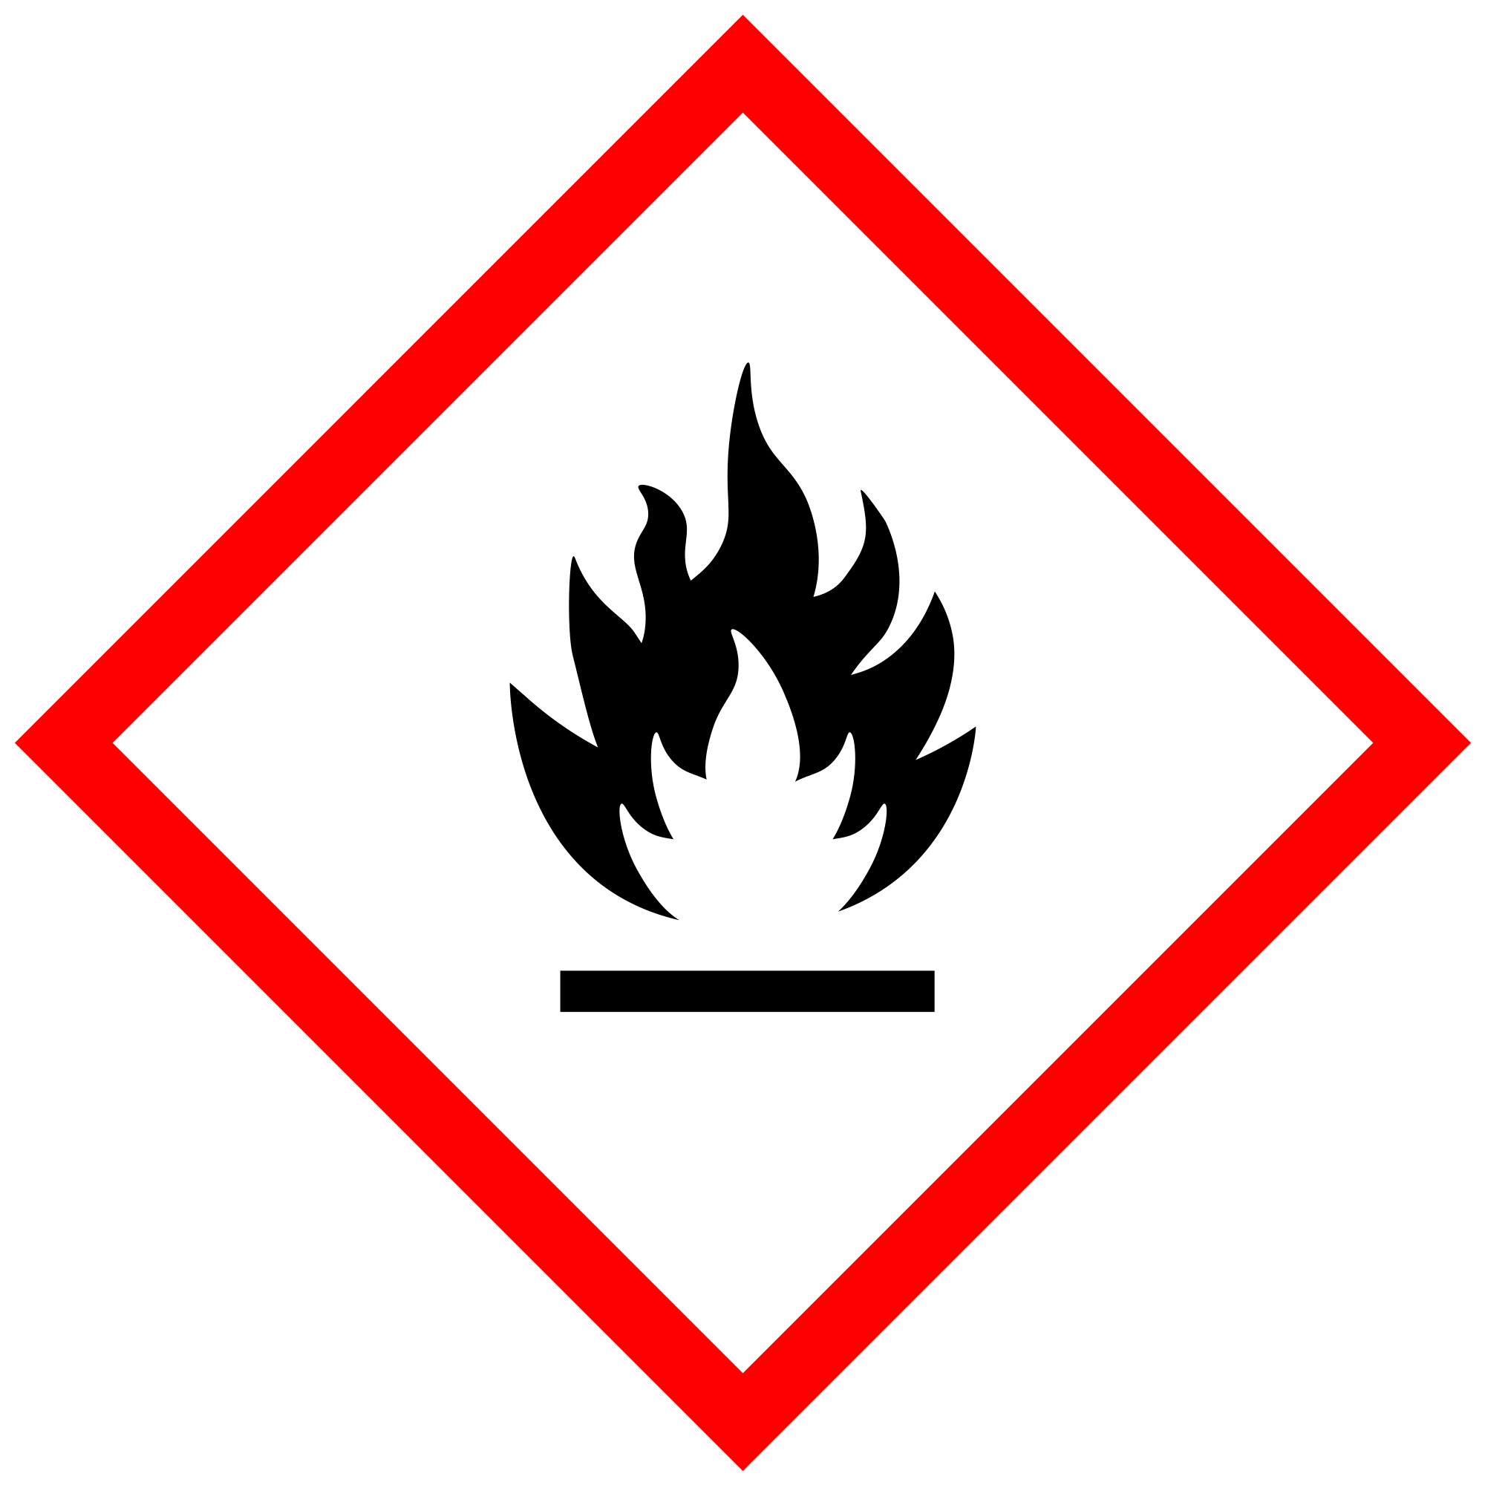 | Flammable when exposed to heat, fire, or sparks. Could give off flammable gases when reacting with water. Ignition sources should be avoided.
Corrosive | 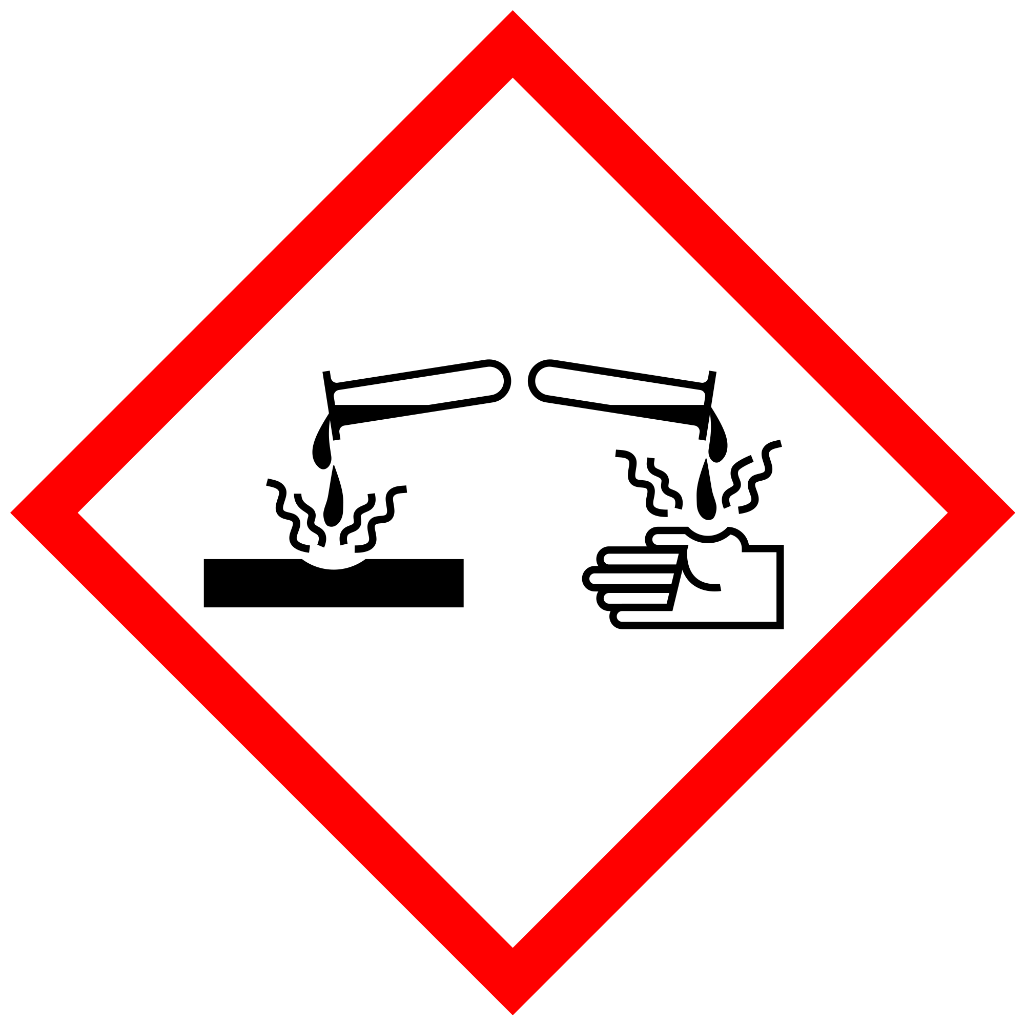 | May cause burns to skin and damage to eyes. May also corrode metals. Avoid skin and eye contact, and do not breathe vapors.
Explosive | 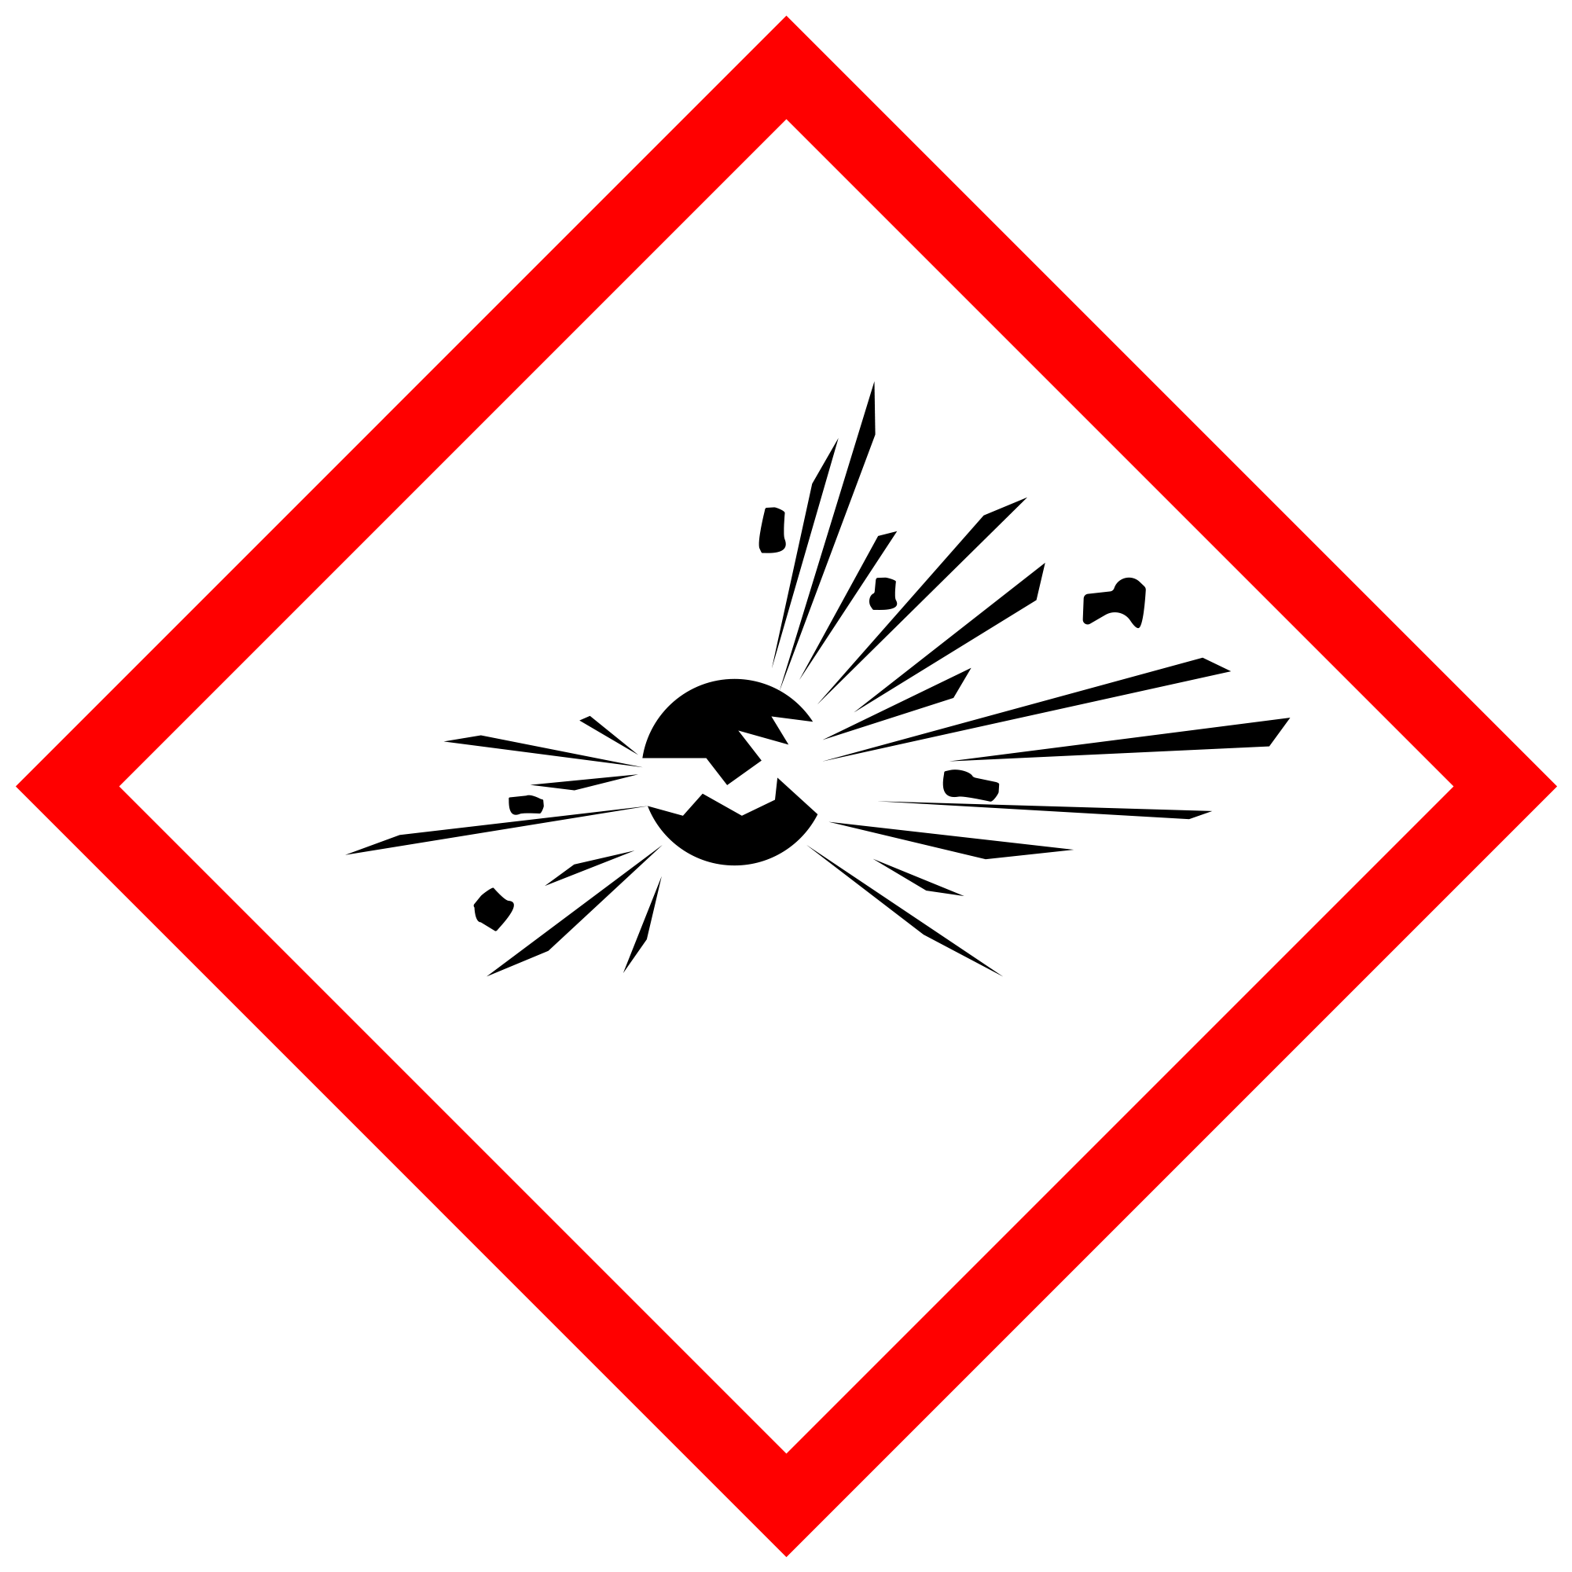 | May explode as a consequence of fire, heat, shock, or friction. Chemicals with this label should be kept away from potential ignition sources.
Compressed Gas | 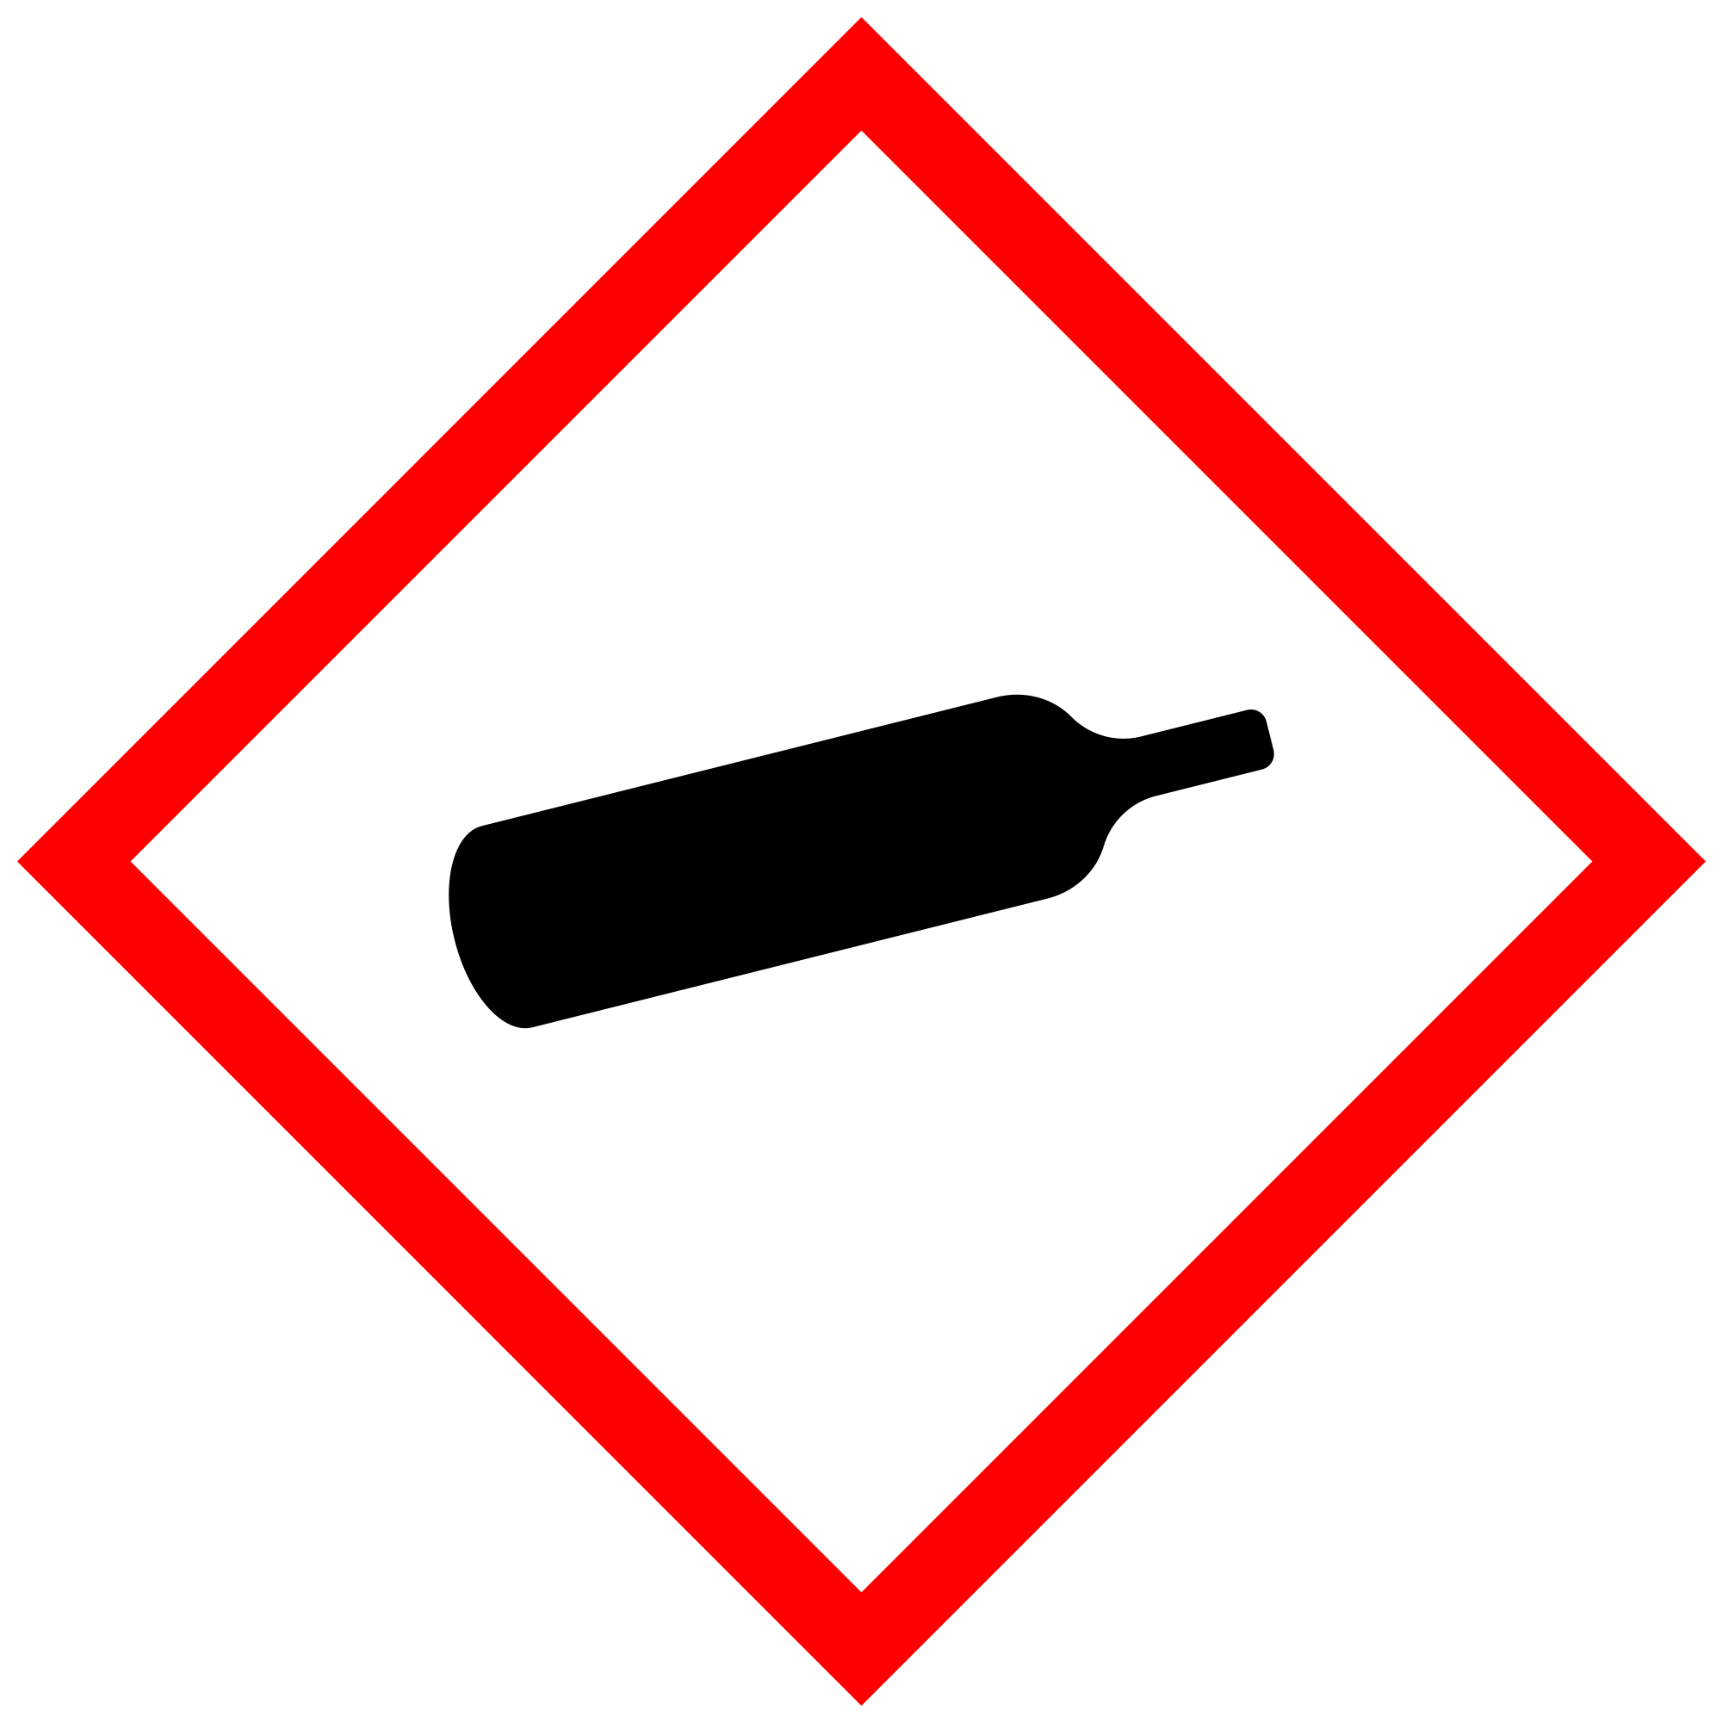 | Container contains pressurized gas. This may be cold when released and explosive when heated. Containers should not be heated.
Oxidizing | 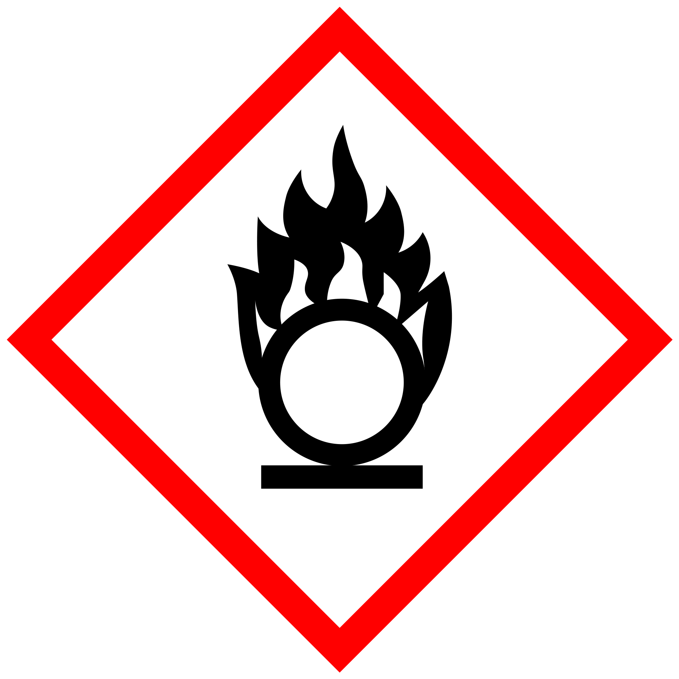 | Burns even in the absence of air. Can intensify fires in combustible materials. Should be kept away from ignition sources.
Toxic | 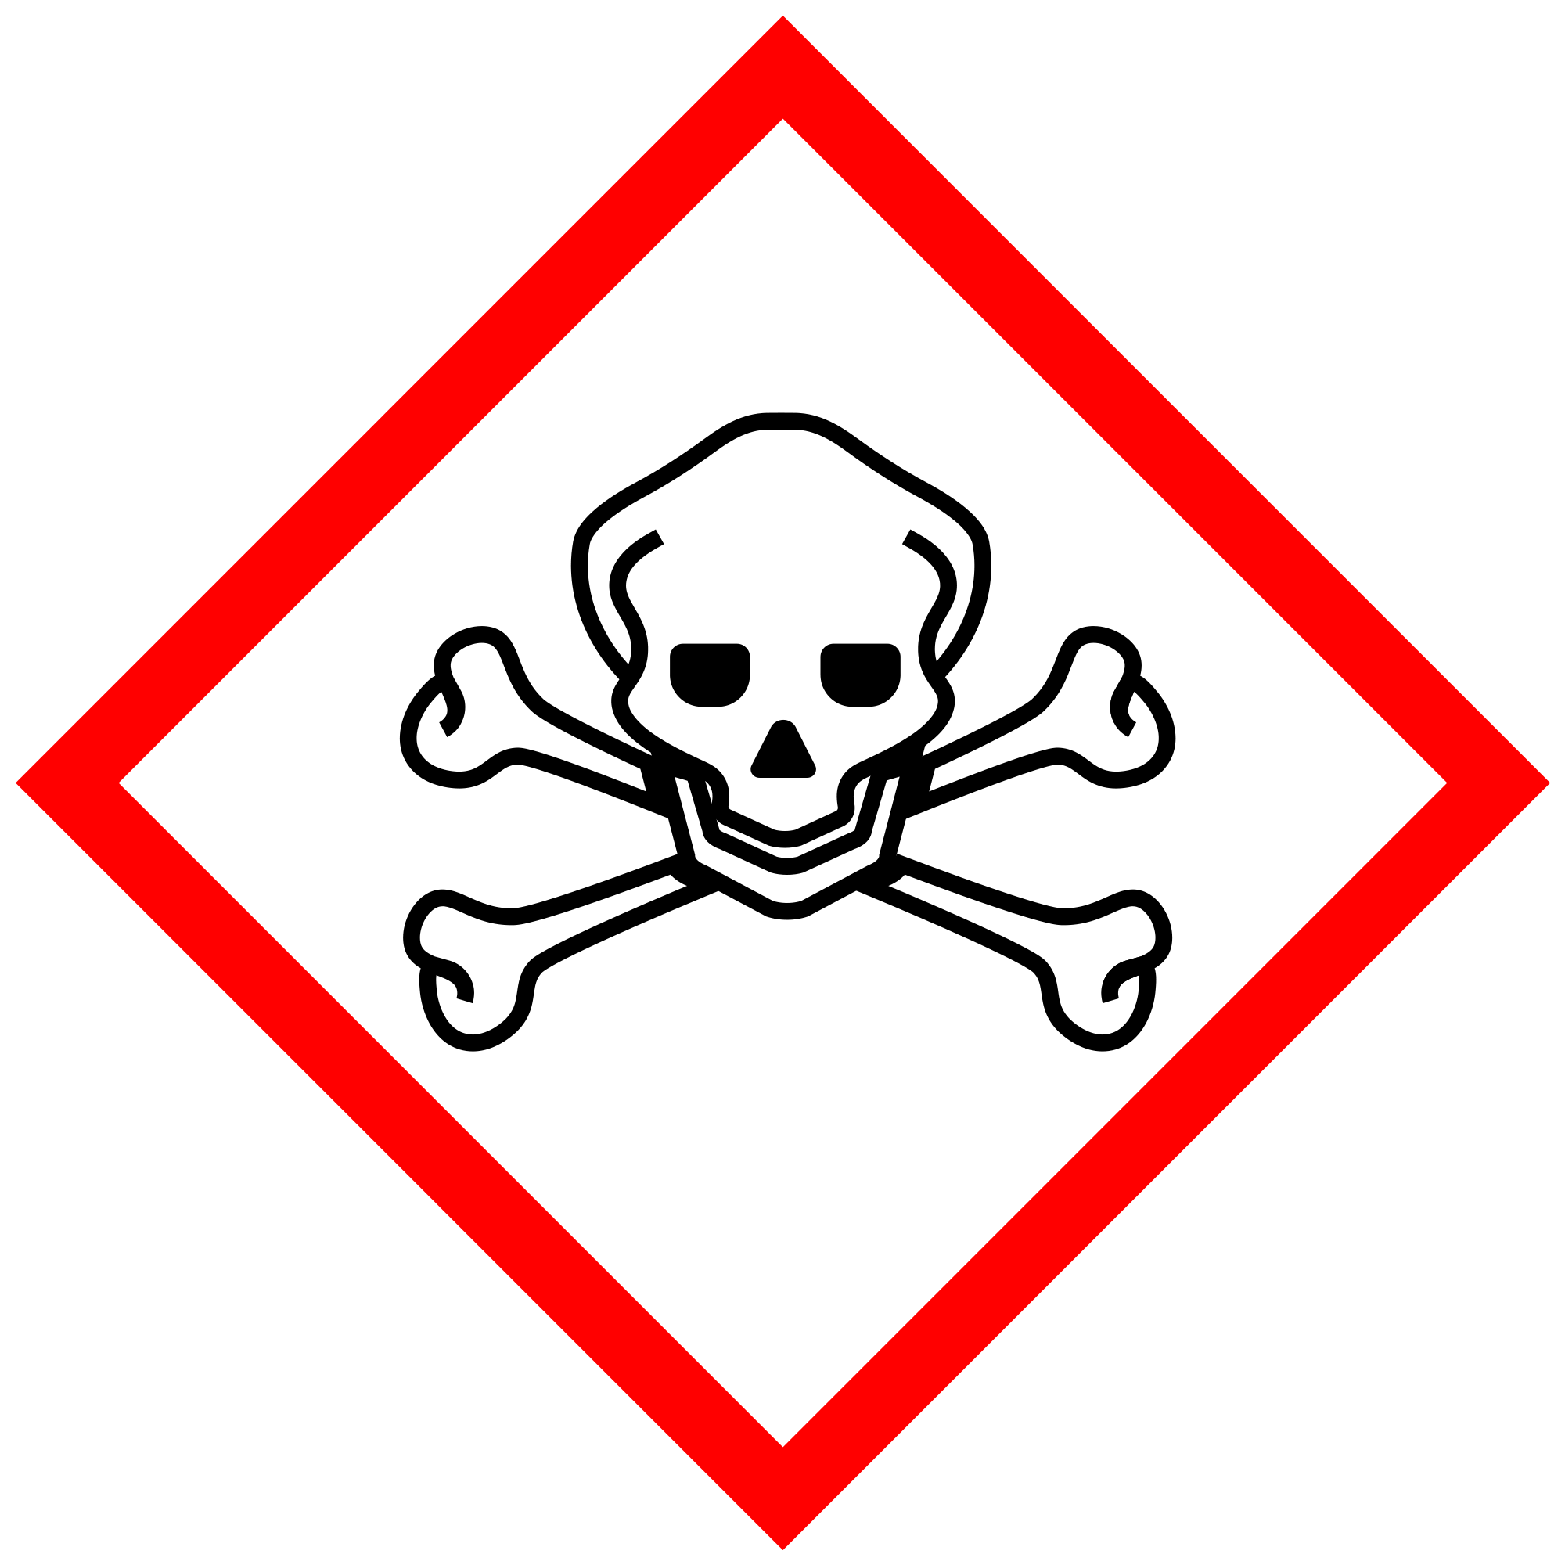 | Indicates life-threatening effects, in some cases even after limited exposure. Any form of ingestion and skin contact should be avoided.
Health Hazard | 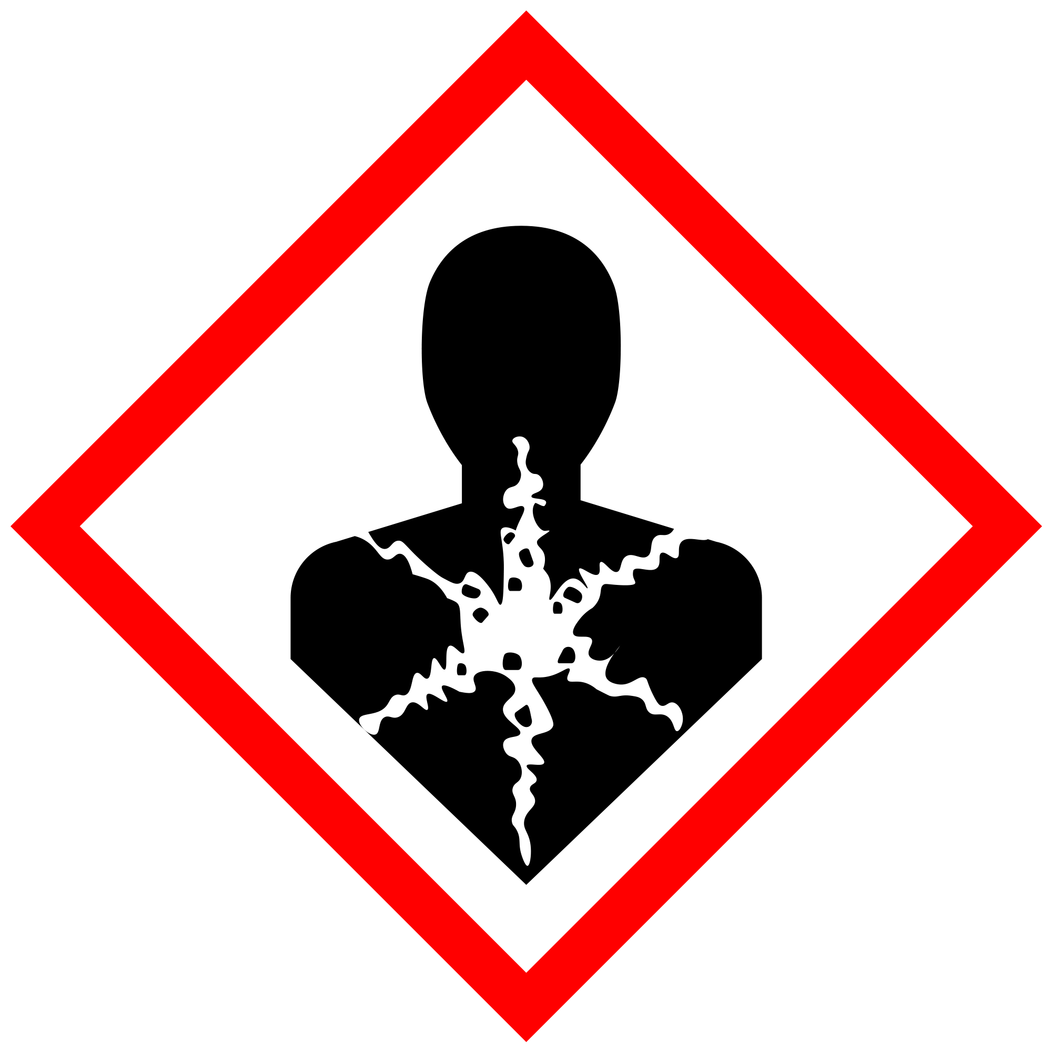 | Short or long-term exposure could cause serious long-term health effects. Skin contact and ingestion of this material should be avoided.
Harmful/Irritant | 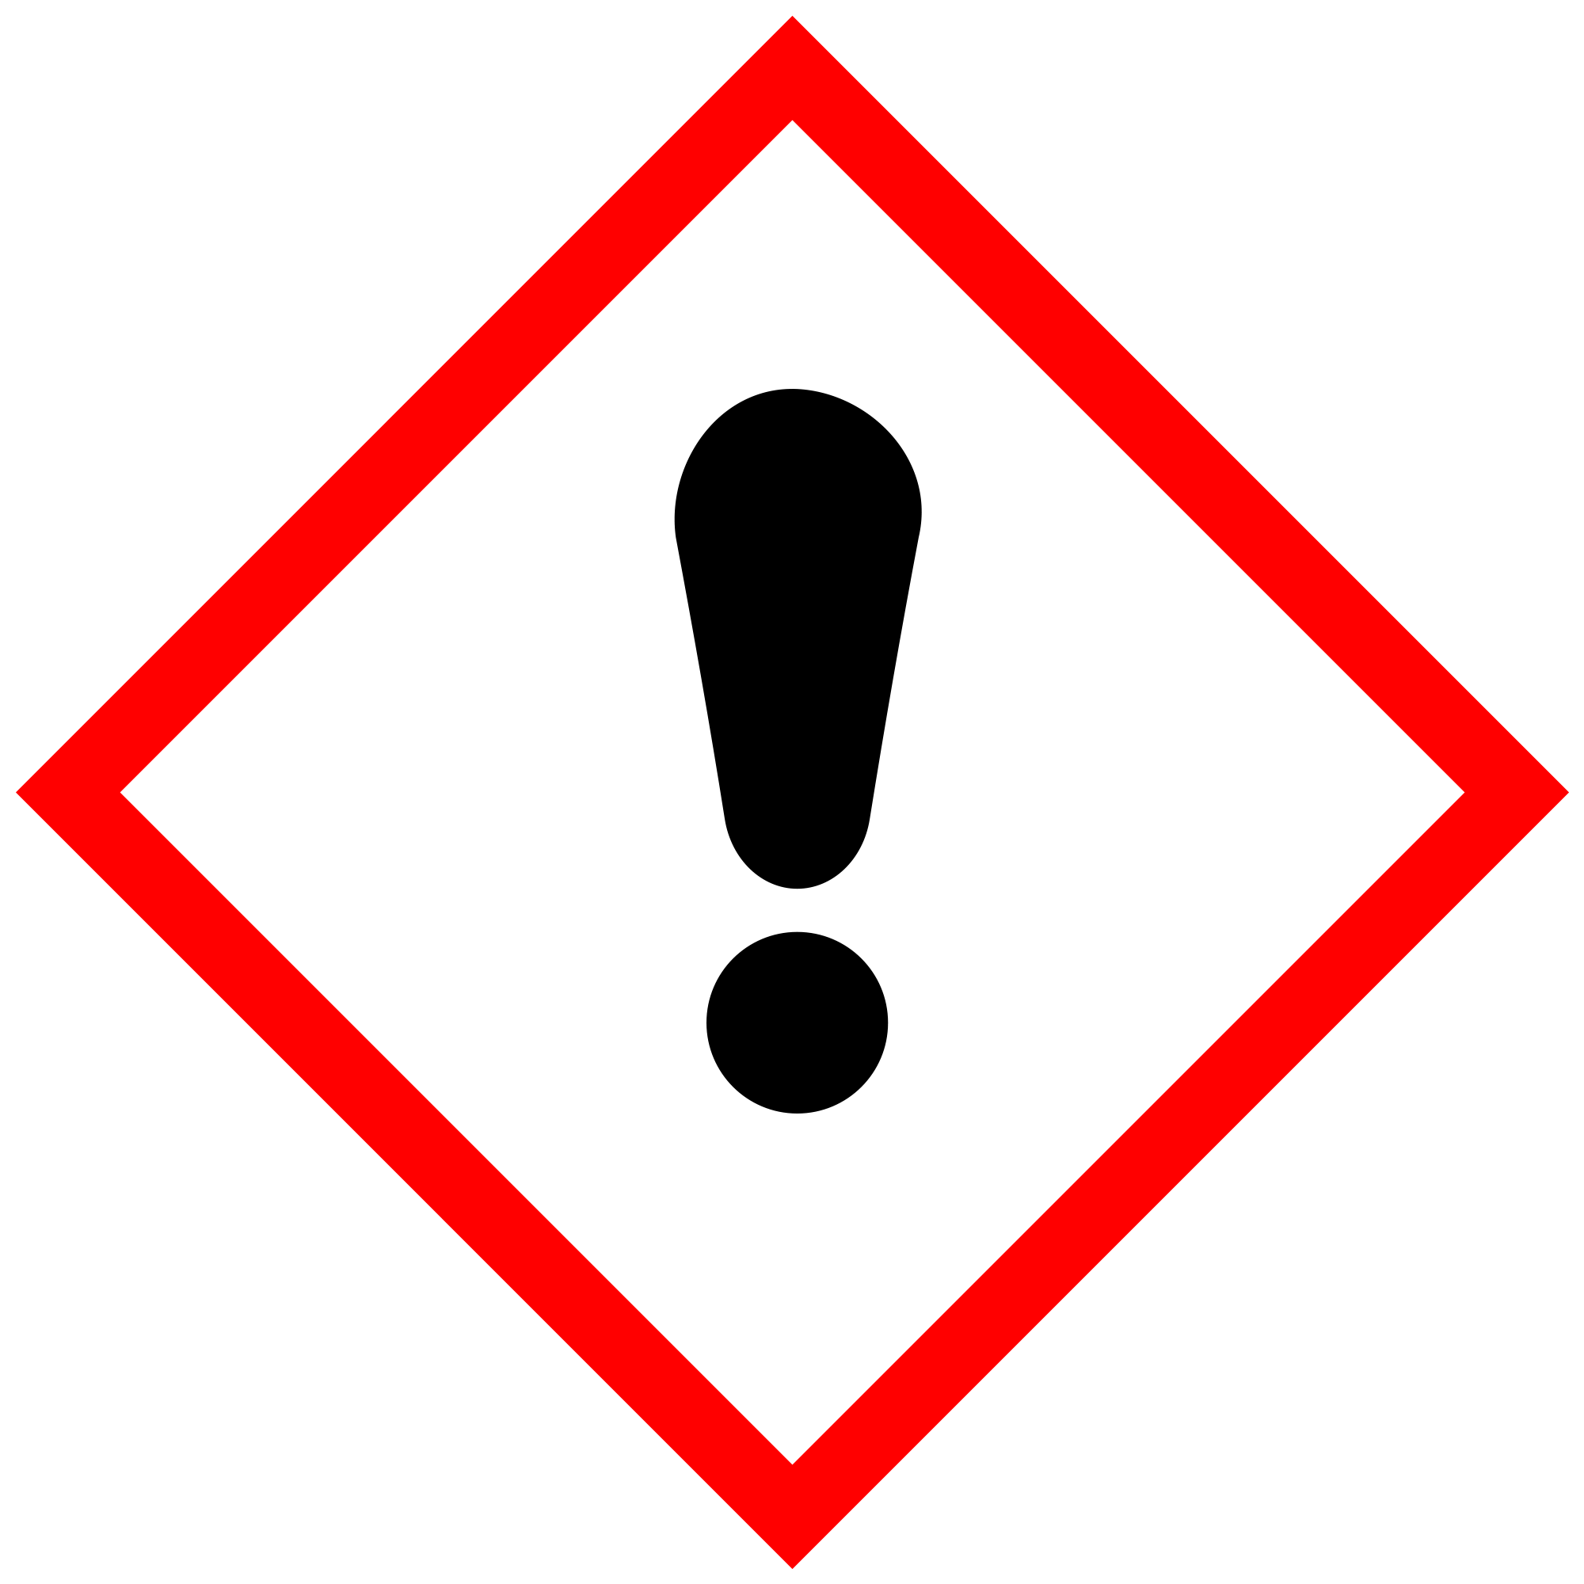 | May irritate the skin or exhibit minor toxicity. The material should be kept away from the skin and the eyes as a precaution.
Dangerous for the Environment | 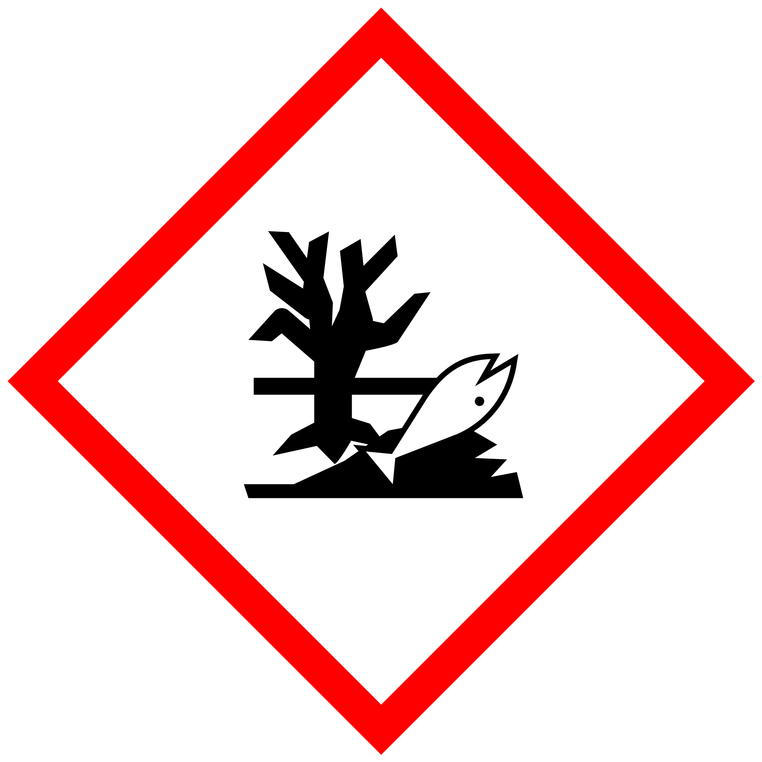 | Indicates substances that are toxic to aquatic organisms, or substances that can cause long-lasting environmental effects. They should be disposed of responsibly.

