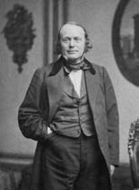
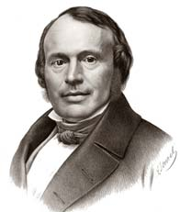
LOUIS AGASSIZ (1807-1873)
Agassiz was born in Montier, a French speaking region of Switzerland. Agassiz, was a professor of natural history at Neuchâtel, Switzerland. He was a naturalist, which means that he studied nature. Agassiz specifically studied geology. He trained in the universities of Switzerland and Germany as a physician. He traveled to Paris in 1831 to study anatomy under Georges Cuvier (1769-­‐1832) one of the most famous naturalists in Europe. He succeeded Cuvier as the preeminent authority on fossil fish with publication of his 5‐volume work, Recherches sur les poissons fossiles (1833-­‐43) (Research on Fossil Fishes).

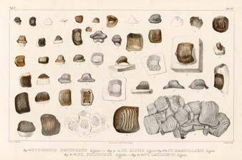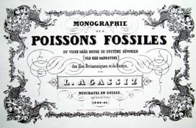

Given his background, it was therefore a surprise when his opening speech as President of the Swiss Society of Natural History in 1837 consisted not of a review of the past year’s work (as was traditional) on fossil fish, but of an exposition of evidence of glaciation. Agassiz would go on to shake up the world of geology with his theory on glaciers and ice ages. He published his controversial theory in his 1840 book Etudes sur Les Glaciers (Studies on Glaciers).
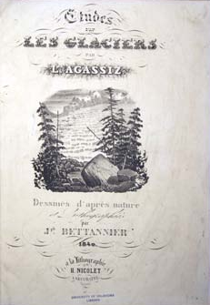
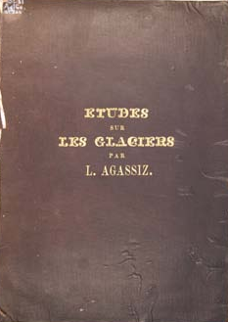

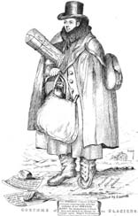
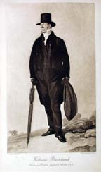
REVEREND DR. WILLIAM BUCKLAND (1784-­‐1856)

According to his son, Buckland’s interest in geology could be traced to his early years at Axminster, Devon, where he was born on 12 March 1784. In 1801 Buckland entered Corpus Christi College, Oxford, from which he obtained a Bachelor of Arts degree in 1804, followed by a Masters of Arts degree in 1808. As a student at Oxford, Buckland attended the lectures on mineralogy and chemistry. Buckland was appointed to the first chair of geology at Oxford University in 1814. Buckland was said to have “eaten his way through the animal kingdom” and often invited friends over for huge dinners, sometimes with the dining table placed inside the ribcage of a mastodon, where he would serve any kind of animal imaginable, he even served his guests extinct mammoth meat that had been found frozen in a glacier. When he taught at Oxford his classrooms were crammed full of rocks and fossils.

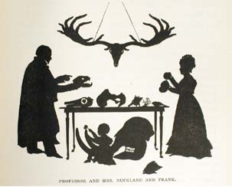
Professor Buckland, Mrs. Buckland, and son Frank
He had a “flair for lecturing and created a stir whenever he spoke.” Henry Acland, a student, described Buckland’s lectures: “He paced like a Franciscan preacher up and down... He had in his hand a huge hyena’s skull. He suddenly dashed down the steps—rushed skull in hand at the first student on the front bench and shouted, What rules the world? The youth, terrified, threw himself against the seatback, and answered not a word. He rushed then to me, pointing the hyena full in my face—What rules the world? Haven’t an idea, I said. The stomach, sir, he cried rules the world. The great ones eat the less, the less the lesser still.”
Buckland originally a supporter of Diluvial Theory (Flood Theory) eventually became a supporter of Agassiz’s glacial theory when he accompanied Agassiz on an expedition into the Swiss Alps to investigate first hand the evidence for glaciers.

REFERENCES:
The University of Oklahoma History of Science Collection: Geology Exhibit.
Montgomery, Keith, University of Wisconsin. (2010). Episode: Neuchatel, Switzerland 1837-1838. Ships Resource Center, University of Minnesota. http://www1.umn.edu/ships/glaciers/Agassiz.htm
Montgomery, Keith, University of Wisconsin. (2010). A Puzzle: The Science of the Diluvialists.
http://www1.umn.edu/ships/religion/diluvial.htm
Hallam, A., & Hallam, A. (1989). Great Geologic Controversies (Vol. 2): Oxford University Press.
Imbrie, J. & Imbrie, K. P. (1986). Ice Ages: solving the Mystery: Harvard University Press.

