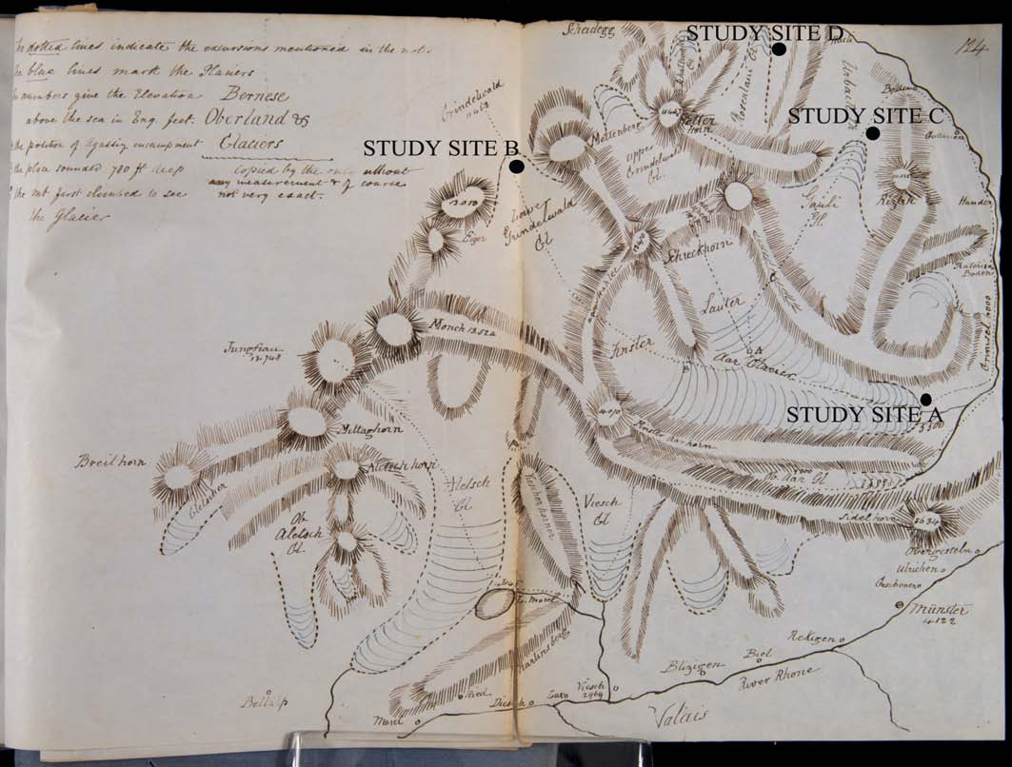

Agassiz’s and Buckland’s Alpine Expedition Map from Agassiz’s 1847 Boston Lecture Source: University of Oklahoma History of Science Collection
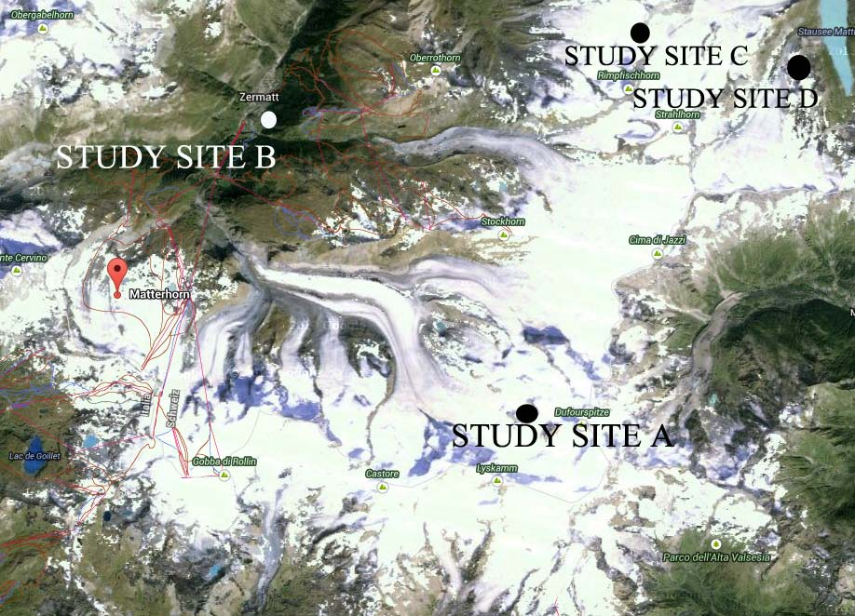

Modern day satellite image of map region Source: Google Maps

