Name_________________________________________________________&__________________________________________________________
DRAGON DELIVERY
You have been given 5 Popsicle sticks. These represent your dragon chromosomes for this activity. The chromosomes involved are the green autosome, red autosome, orange autosome, yellow autosome, and sex chromosomes. Each chromosome has genes on it which code for different traits, some of your genes will be dominant and some will be recessive.

- Record your genotype and your partner’s genotype on each chromosome table. For example: if on your green stick you have A on one side and A on the other side then you record your genotype as AA. [NOTE: underlined letters mean the letter is capitalized]
- You and your partner toss your sticks onto the table. This represents gamete formation because only half of the genotype will be face up.
- Record the allele that is face up. This allele is your contribution to the baby dragon.
- Use the table called “Decoding the Dragon” to determine the traits of your baby dragon.
- Draw and color your baby dragon.
- Name your baby.

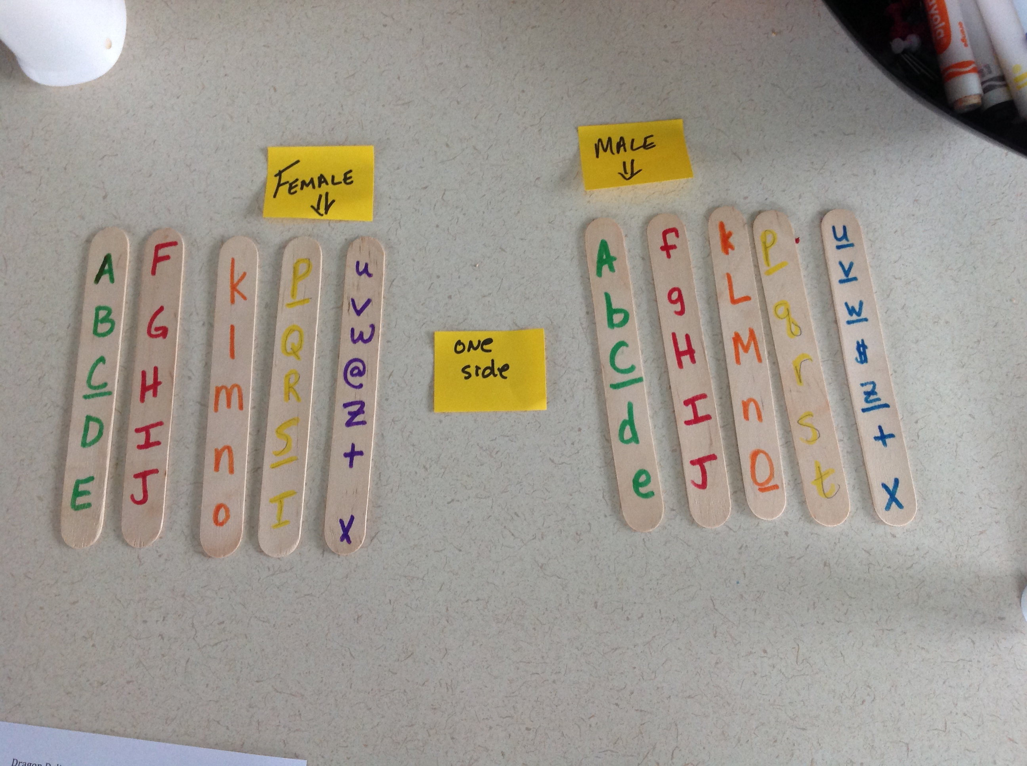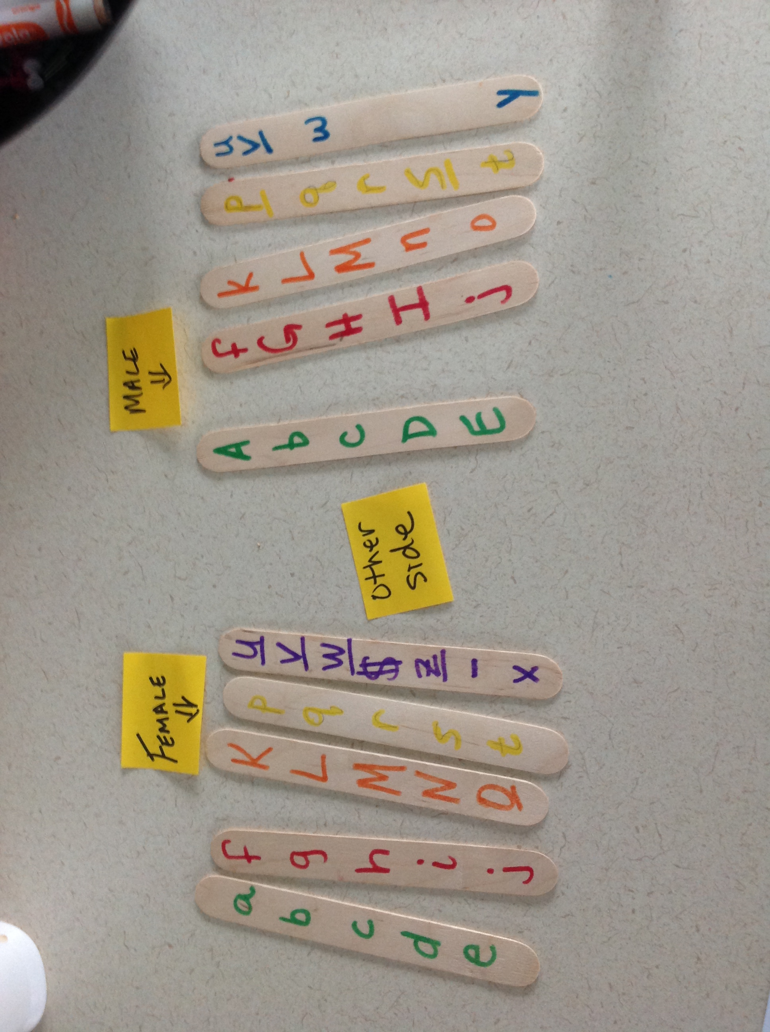

DECODING THE DRAGON

CHROMOSOME | DOMINANT GENES | RECESSIVE GENES
GREEN AUTOSOME | A: no chin spike | a: chin spike
 | B: nose spike | b: no nose spike
 | C: three head flaps | c: four head flaps
 | D: no visible ear hole | d: visible ear hole
 | E: eyes see codominant below | e: eyes see codominant below
RED AUTOSOME | F: long neck | f: short neck
 | G: no back hump | g: back hump
 | H: no back spikes | h: back spikes
 | I: long tail | i: short tail
 | J: flat feet | j: arched feet
ORANGE AUTOSOME | K: red eyes | k: yellow eyes
 | L: neck moles | l: no neck moles
 | M: wings – see sex-influenced below | m: no wings – see sex-influenced below
 | N: no fangs | n: fangs
 | O: back moles | o: no back moles
YELLOW AUTOSOME | P: thigh moles | p: no thigh moles
 | Q: green body | q: purple body
 | R: small comb on head – see sex-limited below | r: large comb on head – see sex-limited below
 | S: spots – see codominant below | s: spots – see codominant below
 | T: no elbow spikes – see sex-influenced below | t: elbow spikes – see sex-influenced below
SEX CHROMOSOMES | U: regular thigh | u: pointed thigh
 | V: four toes | v: three toes
 | W: no chest plate | w: chest plate
X CHROMOSOME ONLY | $: no tail spike | @: tail spike
 | Z: long arms | z: short arms
 | + non-fire breather | - fire-breather
Y CHROMOSOME ONLY | Y: male sex

CODOMINANT TRAITS:
EE eye pointed at both ends ee eye rounded at both ends Ee eye round at front only

SS red spots ss yellow spots Ss orange spots

SEX-INFLUENCED TRAITS:
M wings m no wings (dominant in presence of male hormone)
T no elbow spike t elbow spike (dominant in presence of male hormone)

SEX-LIMITED TRAITS:
R or r only males have the comb on the head.

GREEN AUTOSOMES
GENOTYPES |  | ALLELES IN |  | BABY DRAGON - TRAITS
Mom | Dad | Egg | Sperm | Genotype | Phenotype

RED AUTOSOMES
GENOTYPES |  | ALLELES IN |  | BABY DRAGON - TRAITS
Mom | Dad | Egg | Sperm | Genotype | Phenotype

ORANGE AUTOSOMES
GENOTYPES |  | ALLELES IN |  | BABY DRAGON - TRAITS
Mom | Dad | Egg | Sperm | Genotype | Phenotype

YELLOW AUTOSOMES
GENOTYPES |  | ALLELES IN |  | BABY DRAGON - TRAITS
Mom | Dad | Egg | Sperm | Genotype | Phenotype

SEX CHROMOSOMES
GENOTYPES |  | ALLELES IN |  | BABY DRAGON - TRAITS
Mom | Dad | Egg | Sperm | Genotype | Phenotype

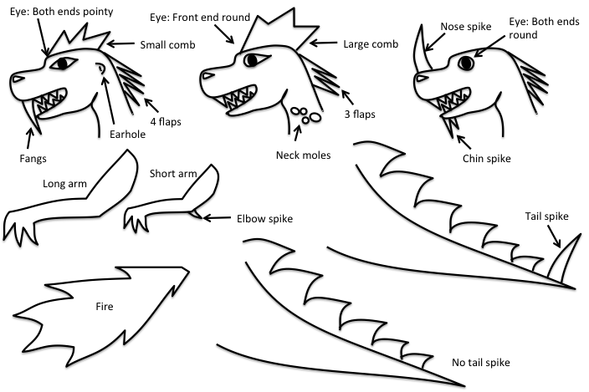
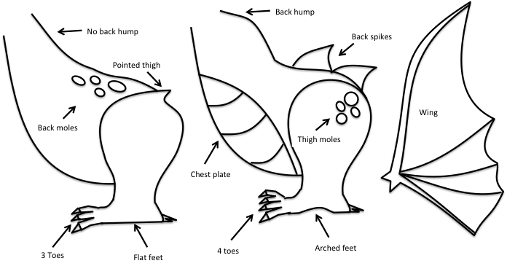

Name: _____________________________________
Dragon name:

Name: ____________________________________

USING YOUR INFO PACKET, TRY YOUR HAND AT ANSWERING THE FOLLOWING QUESTIONS.

- Define Mendel’s Law of Segregation:

- Define Mendel’s Law of Independent Assortment:

- Relate Mendel’s Laws to the activity (when and how did you model Laws of Segregation and Independent Assortment during the activity).

- What is the difference between sex-influenced traits, sex-limited traits, and sex-linked traits (what chromosome do they occur on and how are they expressed)?

- What are codominant traits and how are they expressed?

- Fangs are a recessive trait and yet most dragons have fangs, why?

- Make a poster.
- Picture of baby dragon
- Name of baby dragon
- Punnett squares for every trait
- Highlight the square that represents your baby’s genotype
- Write the ratio and percentage for the outcome possibility (frequency) of your baby’s genotype.

