LAW OF SEGREGATION

The Law of Segregation states that each individual has two factors that contribute to a phenotype and that separate when gametes are formed.

SmartNotes
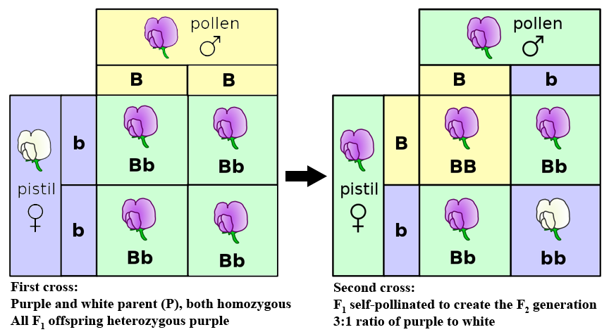

INHERITANCE PATTERNS OVER TWO GENERATIONS IN A PEA PLANT CROSS
This figure is an example of Mendel's experiments on pea plant inheritance patterns using flower color. These experiments were published in 1866. True-breeding plants (P generation) with white flowers and purple flowers were crossed, and all of the F1 hybrids had purple flowers. The F1 hybrids were self-pollinated or cross-pollinated to generate a second filial generation (F2). The F2 generation had both purple-flowered plants and white-flowered plants, and the ratio of purple-flowered plants to white-flowered plants was approximately 3:1. Based on these results, Mendel concluded the "heritable factor" for purple flowers was dominant over the "heritable factor" for white flowers.

https://www.boundless.com/biology/mendelian-inheritance/mendel-s-laws-of-inheritance/law-of-segregation--2/

LAW OF INDEPENDENT ASSORTMENT

Mendel's Law of Independent Assortment states that alleles of different genes assort independently of one another during gamete formation.

SmartNotes
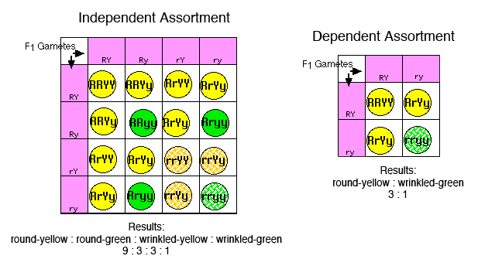

INDEPENDENT ASSORTMENT OF ALLELES FOR MULTIPLE TRAITS
Mendel's experiment published in 1866 demonstrated that alleles for different traits behave according to independent assortment. In this experiment, Mendel considered two characteristics of pea plants, seed color (yellow Y or green y) and seed shape (round R or wrinkled r). In the P generation, he crossed a pure-breeding plant with round yellow seeds (YYRR) and a pure-breeding plant with wrinkled green seeds (yyrr). This resulted in an F1 generation heterozygous for two alleles (YyRr), which he then self-crossed to create the F2 generation. Mendel recognized two possible outcomes from the F1 cross: either the two traits were dependent (passed on together) or they were independent (passed on independent of one another). In the case of dependent assortment, combinations of Y/y and R/r alleles would be restricted to those observed in the previous parent generation (YR or yr). In the case of independent assortment, any combination of Y/y and R/r alleles were possible (YR, Yr, yR, or yr). To determine the mechanism acting in pea plants, Mendel compared the results to predictions from Punnett Squares. For dependent assortment, both parents would produce half gametes YR and half gametes yr. The phenotypic ratio from this cross is 3 yellow round to 1 green wrinkled. For independent assortment, both parents would produce four types of gametes in equal ratios: (YR, Yr, yR, or yr). The phenotypic ratio for this cross is 9 yellow round to 3 green round to 3 yellow wrinkled to 1 green wrinkled. Mendel found that the resulting cross had a 9:3:3:1 ratio, suporting the hypothesis of independent assortment for these loci.

https://www.boundless.com/biology/mendelian-inheritance/mendel-s-laws-of-inheritance/law-of-independent-assortment--2/

SEX-INFLUENCED TRAITS are dominant in one sex but recessive in the other.
SEX-LIMITED TRAITS affect a structure or function of the body that is present in only males or females.

SEX-LINKED TRAITS
CO-DOMINANT TRAITS:
Both of our colors are dominant!

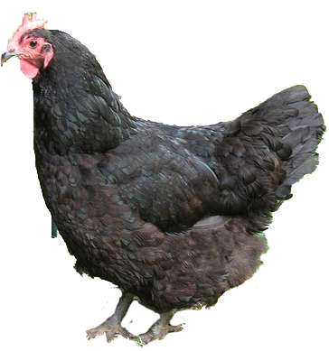
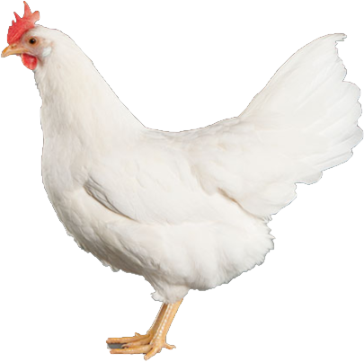
BB
WW
(Black)
(White)

Example:
Dorset-Suffolk Sheep
Example:
Milk Production

Dorset sheep have horns (HH)
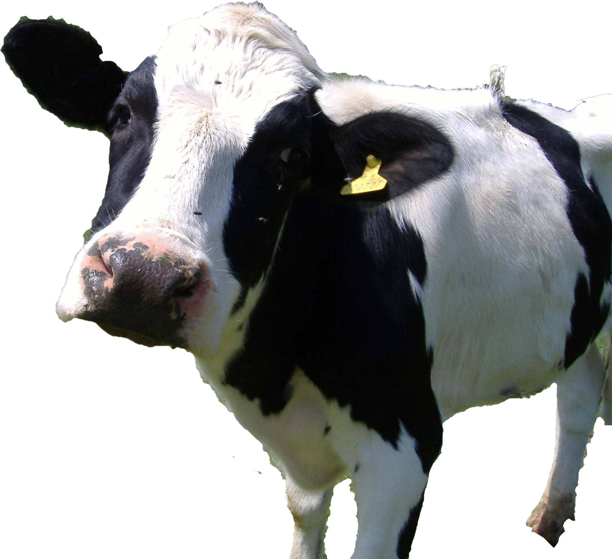
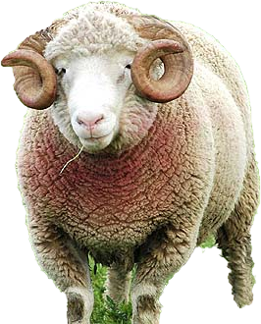
(Bessy) I have a mutation that makes my milk high in saturated fat
Suffolk sheep no horns (hh)
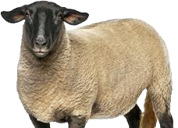

(Bessy) My son carries the mutation even though he doesn’t produce milk.

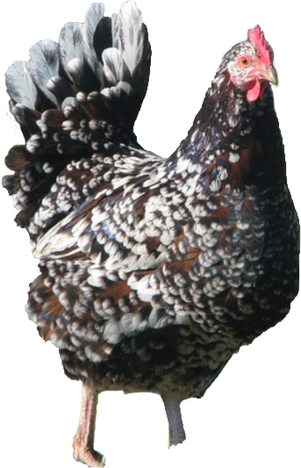
BW
(Black and White)
Males have horns (Hh)
Females no horns (Hh)

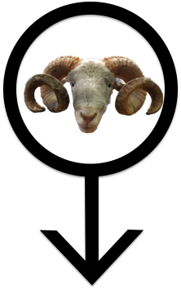
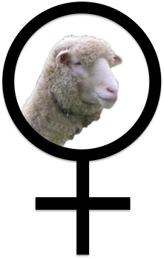

(Bessy’s granddaughter: I inherited the mutation from my dad so I also produce high fat milk.

WHEN GENDER MATTERS:
SEX LINKED, SEX LIMITED AND SEX INFLUENCED TRAITS

For most inherited traits, the gender of the bearer of the genes is immaterial. Characteristics like free earlobes, fur color, etc., generally operate the same in males as they do in females.

But there are exceptions. These fall into three primary categories.

Sex Linked Traits are traits whose loci are literally on the sex chromosomes, so their transmission from generation to generation is affected by the sex chromosome complement of the individual. In any species with non-homologous sex chromosomes, these traits can be significant.

The first demonstration of sex linkage was the white eye gene in Drosophila, the fruit fly which has become so important to the study of classical genetics. Normal fruit fly eye color is a dull brick red. Mutations in this gene cause the eyes to be white. The white allele is recessive, but it was quickly determined that the inheritance pattern for this gene was different from those of other genes being studied. In some kinds of matings, reciprocal crosses produced different results, something which had never been observed to happen with other genes. Not only that, but in some kinds of matings, the results for the male offspring would be different from the results for the female offspring. For instance, if a white-eyed female was mated to a red-eyed male, all of the female offspring would be red eyed, but all of the male offspring would be white eyed.

It turned out that this particular eye color gene was literally located on the X chromosome. Since females have two X chromosomes and males have only one, genetic effects in the two genders are different. And since females contribute an X to each offspring, male or female, and males contribute X chromosomes only to female offspring, naturally transmission patterns were different in different kinds of matings.

“Linkage” refers to the physical connection that exists between genes whose loci are on the same chromosome. Genes on the X chromosome are all linked to each other—thus they are X-linked.

X-linked traits have a number of interesting aspects. First, because females possess two X chromosomes and males possess only one, X-linked recessive traits appear far more commonly in males than in females. This is clear from simple statistics. A male will show the X-linked recessive trait due to receiving only a single copy of the allele, because he has no second X chromosome to carry a dominant allele which might hide the recessive. Females must inherit the recessive trait twice to show it, just as they do for any other recessive trait. This is a much more unlikely outcome. This is the source of the misconception that only males can display X-linked traits like color blindness.

Another interesting observation about X-linked traits is that males always receive their X chromosomes from their mothers, so they also receive any X-linked traits from their mothers. Their fathers have no contribution for those genes (though, of course, they do for the genes on all of the other chromosomes). Daughters inherit one X from each parent. And of course, the one X they inherit from their fathers will be the only X he has.

There are also a very few genes which are Y-linked (or holandric). Y-linked genes are carried on the Y chromosome, and are thus passed directly from father to son. Every son has a copy of his father’s Y chromosome. In any pedigree showing unbroken lines of male descent, all of the connected males have copies of the same Y chromosome, and thus share any Y-linked characteristics.

One final note about that very significant white-eyed Drosophila gene. In combination with a strange chromosomal anomaly called attached-X, this gene also produced the first direct evidence that genes were literally carried on chromosomes. Useful little gene.

Gender matters for a couple of other kinds of traits as well.

Sex limited traits are generally autosomal, meaning that they are not found on the X or Y chromosomes. The genes for these traits behave exactly the same way that any autosomal gene behaves. The difference here comes in the expression of the genes in the phenotype of the individual. Sex-limited traits are expressed in only one gender. The traits are generally associated with primary or secondary sexual characteristics, and thus are expressed only in the gender which utilizes those characteristics. For example, there are genes which influence how much milk a lactating mother produces when she’s nursing a baby. These genes are carried by both males and females, but only females ever express them. Another example is the condition cryptorchidism (undescended testicles). In development, the primary sexual organs of males (testicles) and females (ovaries) develop from the same embryonic tissue. This tissue is located low in the abdomen, in roughly the same position ovaries are located in fully developed females. But in fully developed males, the testicles are not located in the abdomen. Late in development, they move from their abdominal position, through the inguinal canal into the scrotum, which is essentially a small skin bag which hangs outside the body. This voyage is important, because the temperature inside the abdomen is too high for the development of viable sperm. Cryptorchidism is a genetically determined condition in which one or both testicles fail to make this voyage, and remain in the abdomen. (This is generally surgically corrected very early, because not only is a cryptorchid male sterile, but the undescended testicles are at increased risk for testicular cancer). The genes for this condition are autosomal; males and females each carry two alleles. But only males can possible exhibit the condition, because only males show the normal condition for testicle behavior and position.

Sex influenced traits are also autosomal, meaning that their genes are not carried on the sex chromosomes. Again, what makes these traits unusual is the way they are expressed phenotypically. In this case, the difference is in the ways the two genders express the genes.

One classic example of a sex influenced trait is pattern baldness in humans (sometimes called “male pattern baldness,” though the condition isn’t restricted to males). This gene has two alleles, “bald” and “non-bald.” The behaviors of the products of these genes are highly influenced by the hormones in the individual, particularly by the hormone testosterone. In the presence of high levels of testosterone, the baldness allele has a very powerful influence. In the presence of low levels of testosterone, this allele is quite ineffectual. All humans have testosterone, but males have much higher levels of this hormone than females do. The result is that in males, the baldness allele behaves like a dominant allele, while in females it behaves like a recessive allele. As in all cases, dominance only matters in the heterozygote, so this means that heterozygous males will experience hair loss and heterozygous females will not. Even homozygous females may experience no more than a thinning of their hair, but many develop bald spots or have receding hairlines.

An interesting note about this gene is that it is often incorrectly identified as X-linked because of an illusion that males inherit it from their mothers. Males can inherit baldness from either parent, but if a son gets it from his father, both father and son will be bald, and nobody really notices, as we expect sons to look reasonably like their fathers. But if a son loses his hair and his father doesn’t, that’s noteworthy, and the conclusion people have drawn (correctly) is that Junior inherited baldness from his mother. But recall that with X-linkage sons always inherit traits from their mothers and never from their fathers. In the case of baldness, a son can inherit from either parent. It’s just that we notice it more in the case of inheritance from the mother. This is a kind of casual “sampling error,” in which we subconsciously only “count” the surprising cases and conveniently forget the more ordinary ones.

Another instance of a sex influenced trait is in singing voice. The genetic influences that determine whether a person will have a high singing voice or a low one are autosomal, but the effects of the alleles are opposite in the two genders. The same allelic combination which produces a high soprano in a woman causes a male to be a low bass. And the combination that producers a high tenor in males produces a low contralto in females.

www.cod.edu/people/faculty/fancher/genetics/WhenGenderMatters.doc‎

INCOMPLETE DOMINANCE & CODOMINANCE
Not all traits are controlled by single genes with simple dominant - recessive alleles:
Multiple alleles
Polygenic traits
Incomplete dominance
Codominance
Multiple alleles = trait that is determined by more than two alleles (ex. Human blood types)
Polygenic traits = trait influenced by several genes; genes may be on same chromosome or on different one (ex. Human eye color, weight, skin tone)
Incomplete dominance = one allele is not completely dominant over the other (blend) heterozygous condition somewhere in between (flowers…red, white, pink)
Codominance= condition in which both alleles for a gene are expressed when present (cattle…red, white, roan coat)

Solving Genetics Problems
There is no dominant or recessive, the heterozygous condition results in a "blending" of the two traits. Example: Snapdragons can be red, white, or pink (heterozygous)
Incomplete dominance - neither allele is dominant, red x white = pink
Codominance - both are expressed in some way, red x white = white/red spots
http://www.biologycorner.com/bio2/genetics/notes_incomplete_dominance.html

