DISTRIBUTION AND DENSITY MAPS
WORLD DISTRIBUTION MAP 2013
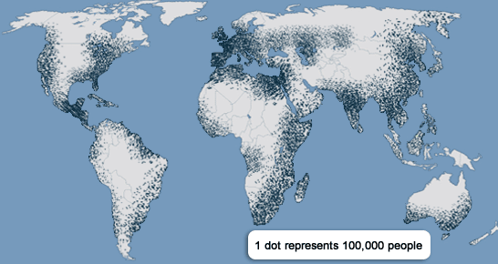
WORLD DENSITY MAP 2013
