FERTILITY AND LIFE EXPECTANCY MAPS
WORLD FERTILITY RATE 2013

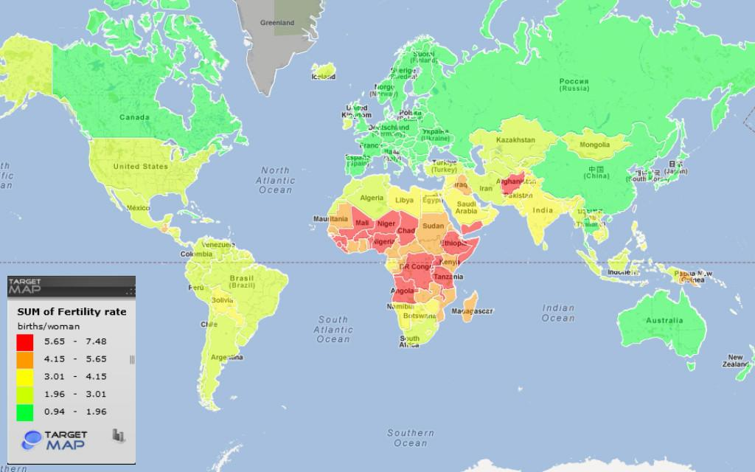
WORLD LIFE EXPECTANCY RATE 2012

