**FERTILITY AND LIFE EXPECTANCY MAPS**

**WORLD FERTILITY RATE 2013**

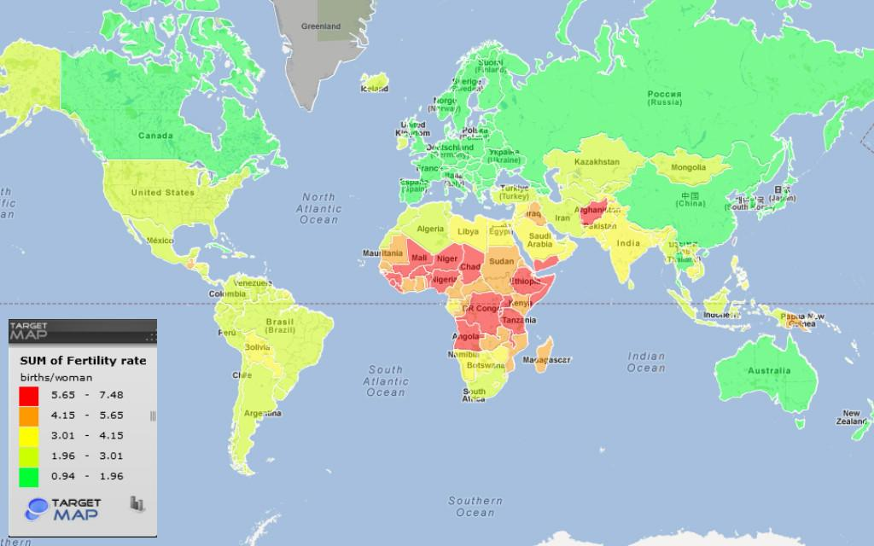

**WORLD LIFE EXPECTANCY RATE 2012**

