Year | 2013 | 2014 | 2015 | 2016 | 2017 | 2018 | 2019 | 2020 | 2021 | 2022
Resident | $7,341 | $7,695 | $8,065 | $8,631 | $11,762 | $11,762 | $11,762 | $11,762 | $12,011 | $9,311
Non-Resident | $19,530 | $19,469 | $21,451 | $22,953 | $26,918 | $27,143 | $27,143 | $27,143 | $27,815 | $25,879

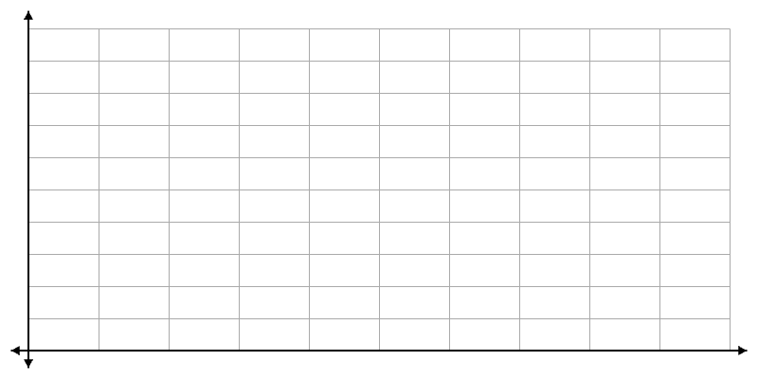
Resident
Year | Cost

Non- Resident
Year | Cost

- Are these graphs functions? How do you know?

- What is the average tuition cost for residents over this time period?

- What is the average tuition cost for non-residents over this time period?

Use the resident data to answer questions 4 and 5.
- Find the slope of the line that connects 2013 to the following years:
  - 2015

  - 2017

  - 2022

- Is the graph for resident tuition linear? How do you know?

- Is the graph for non-resident tuition linear? How do you know?

