|  |  |  |  |  |  |  |  |  |  |  |
| --- | --- | --- | --- | --- | --- | --- | --- | --- | --- | --- |
| **Year** | **2013** | **2014** | **2015** | **2016** | **2017** | **2018** | **2019** | **2020** | **2021** | **2022** |
| Resident | $7,341 | $7,695 | $8,065 | $8,631 | $11,762 | $11,762 | $11,762 | $11,762 | $12,011 | $9,311 |
| Non-Resident | $19,530 | $19,469 | $21,451 | $22,953 | $26,918 | $27,143 | $27,143 | $27,143 | $27,815 | $25,879 |

# graphResident

|  |  |
| --- | --- |
| **Year** | **Cost** |
|  |  |
|  |  |
|  |  |
|  |  |
|  |  |
|  |  |
|  |  |
|  |  |
|  |  |
|  |  |

# Non- Resident

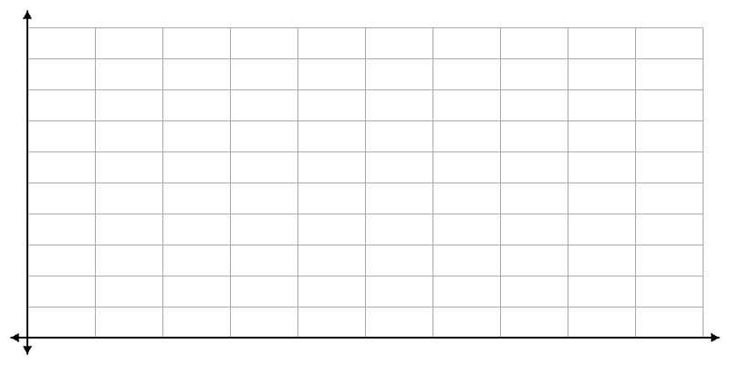

|  |  |
| --- | --- |
| **Year** | **Cost** |
|  |  |
|  |  |
|  |  |
|  |  |
|  |  |
|  |  |
|  |  |
|  |  |
|  |  |
|  |  |

1. Are these graphs functions? How do you know?
2. What is the average tuition cost for residents over this time period?
3. What is the average tuition cost for non-residents over this time period?

Use the resident data to answer questions 4 and 5.

1. Find the slope of the line that connects 2013 to the following years:
   1. 2015
   2. 2017
   3. 2022
2. Is the graph for resident tuition linear? How do you know?
3. Is the graph for non-resident tuition linear? How do you know?