RETURN ON INVESTMENT
Return on investment (ROI) is a way to see how much money you will make in the future compared to how much money you invest now. College is an investment in your future. You are going to determine the ROI for a college degree. Find a college major you are interested in, and a college or university you would like to attend that offers that major.
Major/Concentration:

College/University:

Current Tuition and Fees for a Bachelor’s Degree at your university:

Total amount you would pay over 4 years:

Go to https://k20.ou.edu/careerearnings/ and find your major in the dropdown list under Bachelor’s Degrees. Hover over the line on the graph showing Annual Earnings.
The formula to calculate ROI is: (annual income x 100) / (total cost of education). The answer is your ROI percentage. An ROI of 100% means that you are making exactly as much money each year as you paid for your degree. As another example, if your total education expenses were $40,000 and your new career pays $50,000 per year, then your ROI would be:
$\frac{\$50,000 × 100}{\$40,000}=125$%

Basically, this means you are earning 25 percent more than paid for your degree.

Create a One-Pager with the following criteria. You can use this page to draft ideas, but transfer to a piece of paper for the final product.
- Title of your One-Pager
- Identify the following:
  - Major
  - College/University
  - Current tuition
- Scatterplot representing the ROI of your chosen profession for the first 5 years after graduation (You do not need to include the table, but you can.)
- Answer the following three questions:
  - In your own words, what does it mean to find the ROI of a college degree?
  - How many years would you need to work in this area to have an ROI greater than 100%?
  - What is another interesting thing that the data tells you?

Years of Work | Annual Earnings | Total Education Cost | ROI
1
2
3
4
5
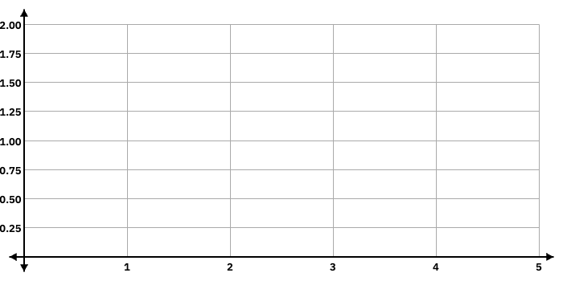

Years of Work
ROI

