TUITION AND FINANCIAL AID
The tables and graphs below show the average tuition and fees for public 4-year colleges over time, as well as the average amount of scholarships and grants that were awarded to students over time. Analyze the data and answer the questions on the back.

Average Tuition and Fees | Year |  | Average Financial Aid | Year
$17,479 | 2013 |  | $14,878 | 2013
$17,823 | 2014 |  | $15,282 | 2014
$18,160 | 2015 |  | $15,695 | 2015
$18,028 | 2016 |  | $15,914 | 2016
$18,099 | 2017 |  | $16,414 | 2017
$18,169 | 2018 |  | $16,672 | 2018
$18,251 | 2019 |  | $16,580 | 2019
$17,806 | 2020 |  | $16,696 | 2020
$17,251 | 2021 |  | $16,336 | 2021
$17,709 | 2022 |  | $15,703 | 2022
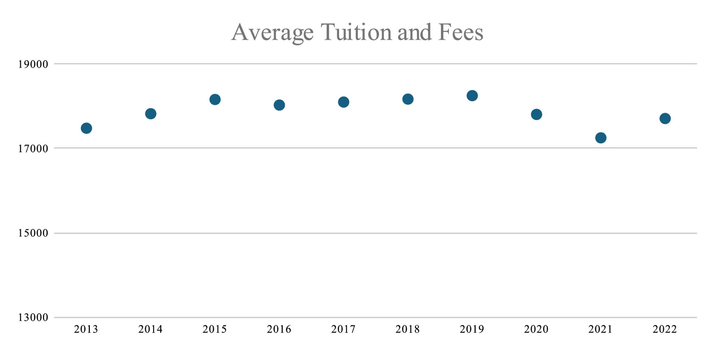
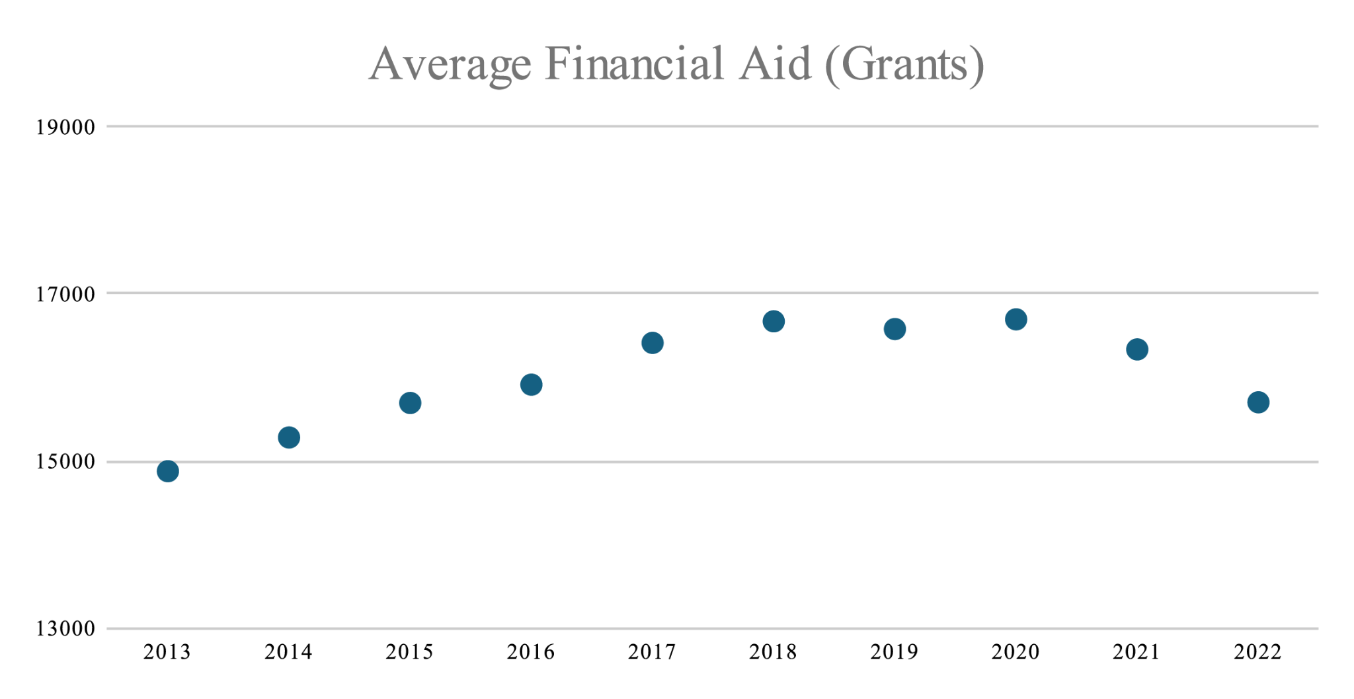

- Describe the trends in both sets of data
  - Tuition and Fees:

  - Financial Aid:

- Between which two years did tuition and financial aid decrease the most? What might explain this decrease?

- How much of tuition and fees is not covered by financial aid in the year
  - 2013

  - 2015

  - 2019

  - 2022

- Name three ways you could make up the difference between tuition and financial aid.

- If you were talking to a friend about planning for college based on this data, what key points would you emphasize? What would you recommend they do to prepare?

