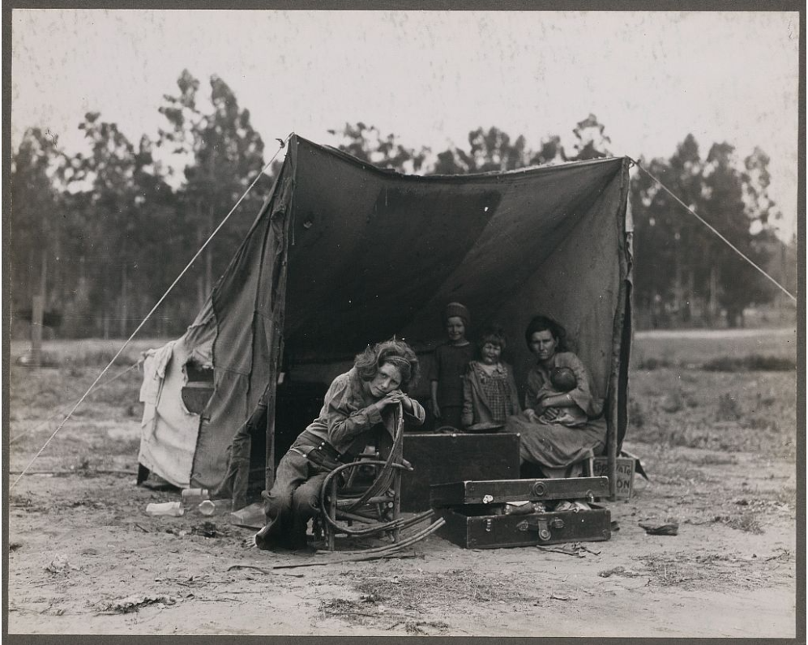

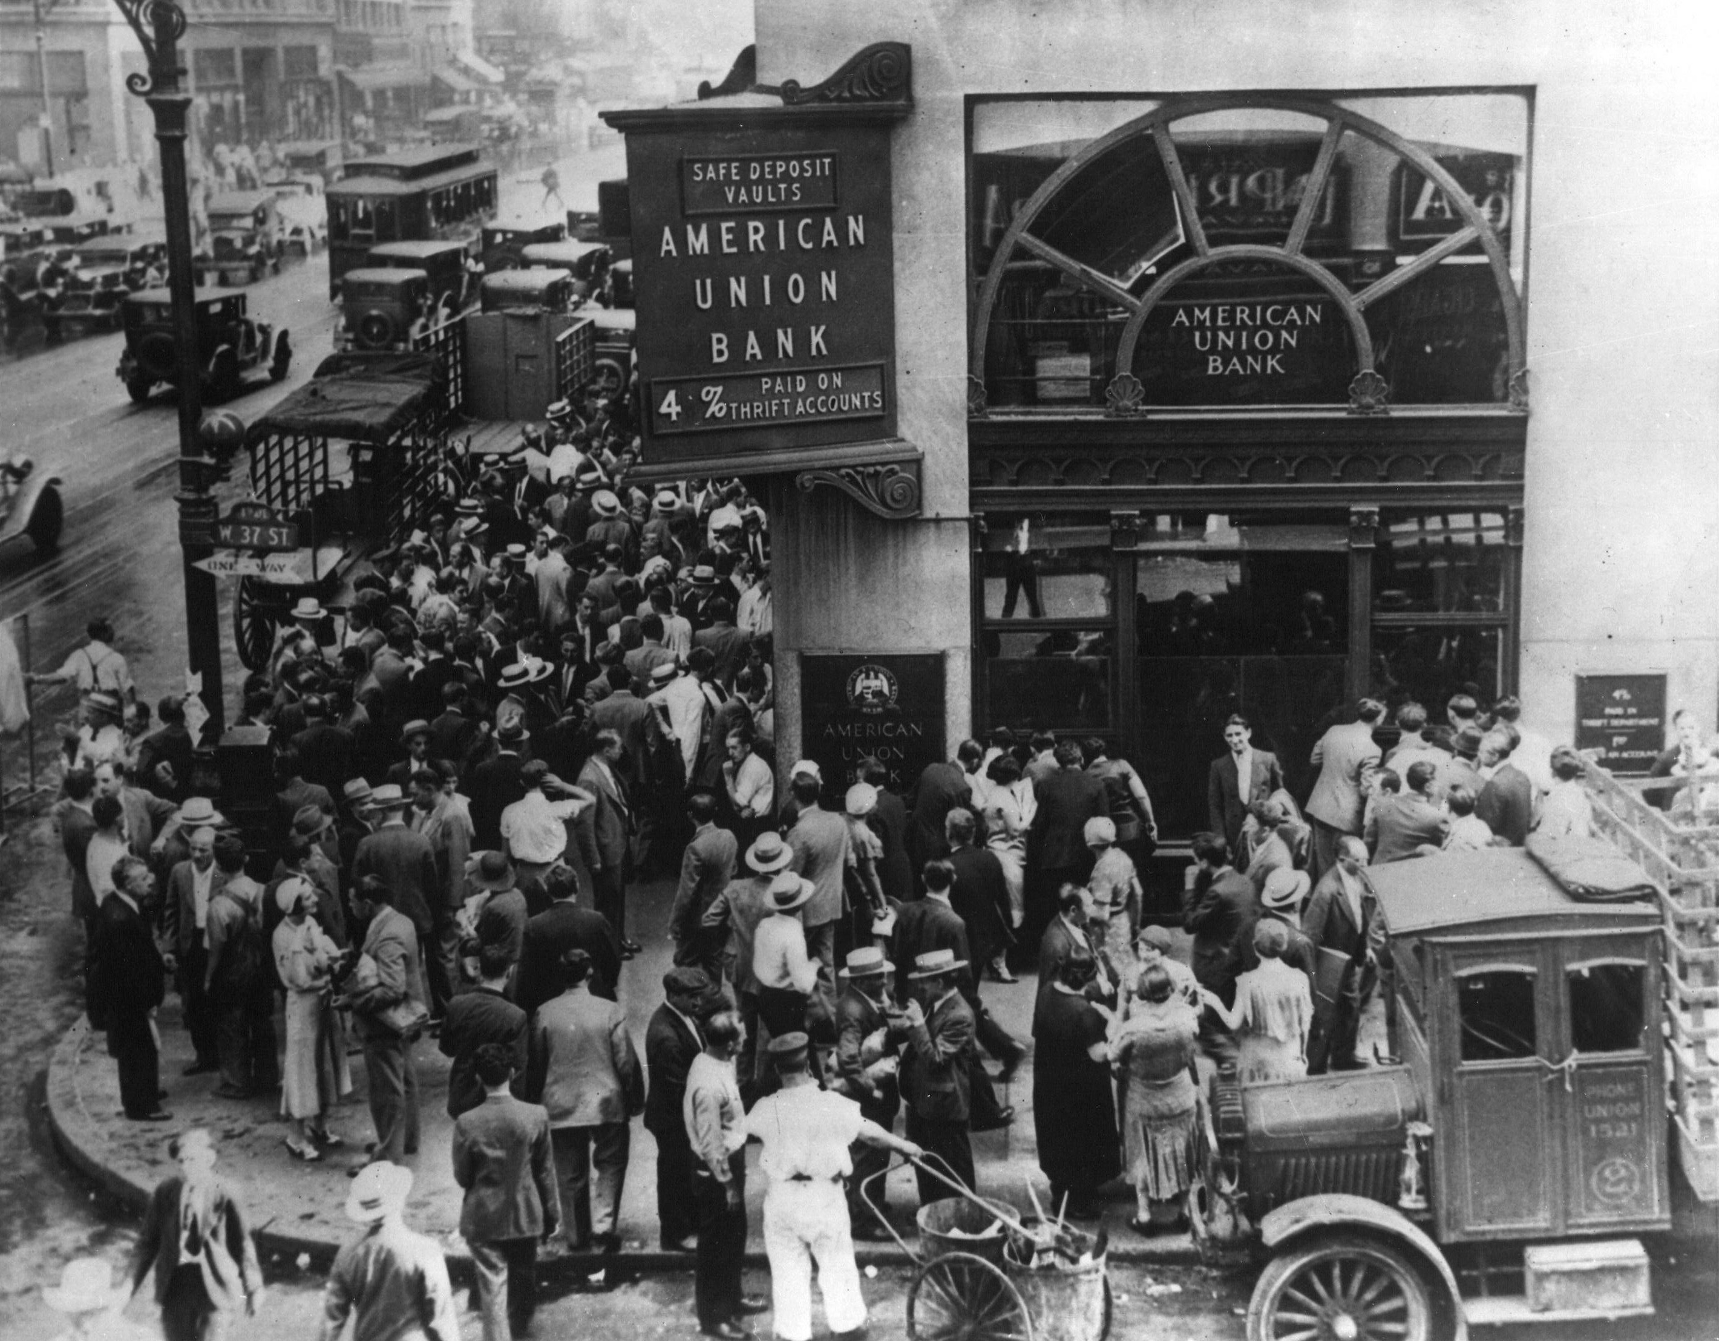
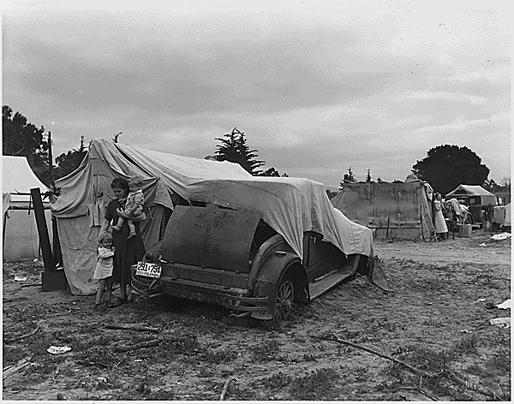

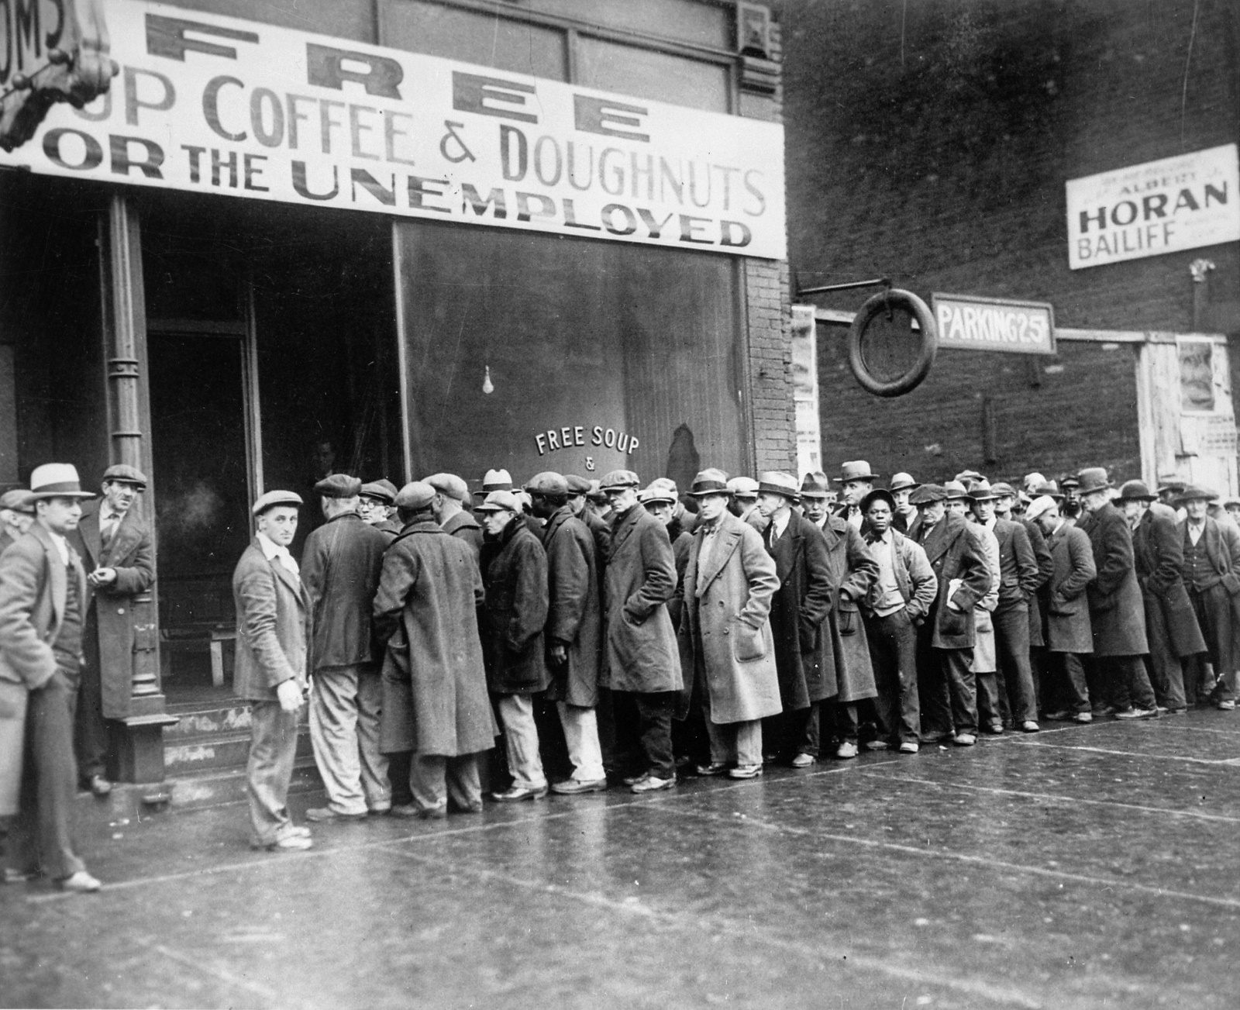
Sources:
Franklin D. Roosevelt Presidential Library and Museum. (2008). Migrant family pea fields California. commons.wikimedia.org. Retrieved October 31, 2023, from https://commons.wikimedia.org/wiki/File:Migrant_family_pea_fields_California.gif
Lange, D., photographer. (1936) Migrant agricultural worker's family. Seven hungry children. Mother aged thirty-two. Father is native Californian. Nipomo, California. United States Nipomo San Luis Obispo County California, 1936. March. [Photograph] Retrieved from the Library of Congress, https://www.loc.gov/item/2017762908/
Lange, D., photographer. (1936) Destitute pea pickers in California. Mother of seven children. Age thirty-two. Nipomo, California. United States Nipomo San Luis Obispo County California, 1936. March. [Photograph] Retrieved from the Library of Congress, https://www.loc.gov/item/2017762891/
National Archives Photo. (2005). Crowd at New York’s American Union Bank during a bank run early in the Great Depression. commons.wikimedia.org. Retrieved October 31, 2023, from https://commons.wikimedia.org/wiki/File:American_union_bank.gif
U.S. National Archives and Records Administration. (2020). Unemployed men queued outside a depression soup kitchen opened in Chicago by Al Capone, 1931. commons.wikimedia.org. Retrieved October 31, 2023, from https://commons.wikimedia.org/wiki/File:Unemployed_men_queued_outside_a_depression_soup_kitchen_opened_in_Chicago_by_Al_Capone,_02-1931_-_NARA_-_541927.jpg

