ALPHABETIC CUNEIFORM
Directions. Use the chart below to analyze and create cuneiform art.
- Not all letters are in Alphabetic Cuneiform; these are the letters not included and their replacements:
E = I O = U C = K F = P J = G V = W Q = GH X = K+S
- It always reads from left to right.
- Signs are written by pressing a stylus into soft clay to make wedge shapes.

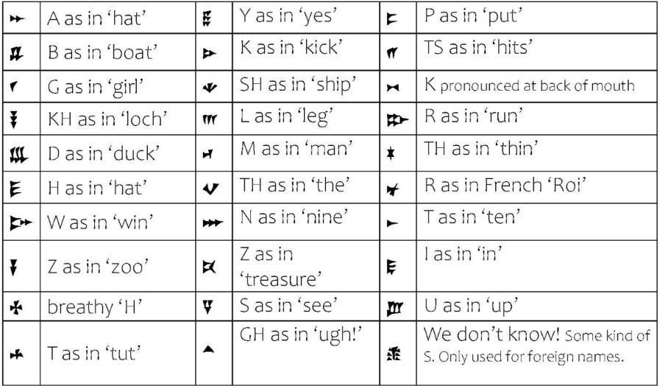
Adapted from CREWS Project at the University of Cambridge.

