CAPTION THIS
Instrucciones. Escribe una descripcion de 3 a 5 oraciones que describa las 4 imágenes del video.
Image | Caption
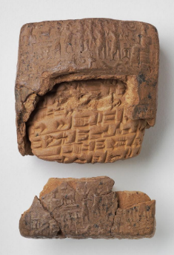
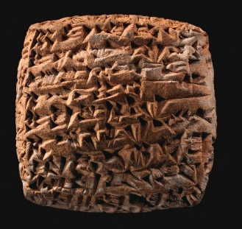
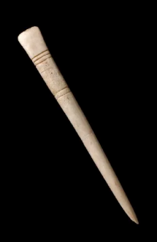
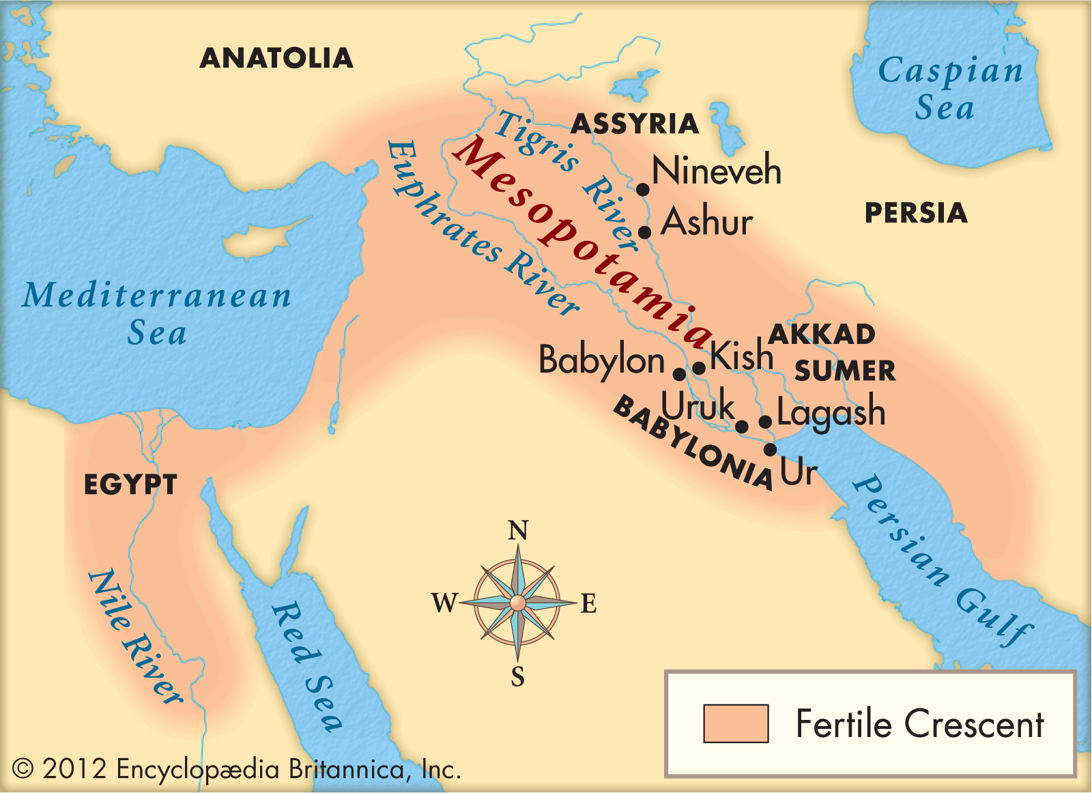
Sources:
Cuneiform tablet. The Metropolitan Museum of Art. (n.d.). https://www.metmuseum.org/art/collection/search/325858
Encyclopædia Britannica, inc. (2025). Mesopotamia. Encyclopædia Britannica. https://kids.britannica.com/kids/article/Mesopotamia/353456
The Harvard Art Museums. (2000). Cuneiform Tablet and Envelope: Old Assyrian Letter. The Harvard Art Museums. Retrieved from https://harvardartmuseums.org/collections/object/146548.
Sumerians. A Brief History of writing. (2019, May 26). http://historyofwriting.learncalligraphy.co.uk/the-sumerians/

