RIDDLES ANSWER KEY

Riddle 1

English translation: I can be cracked, made, told, and played.

English answer to riddle: Joke

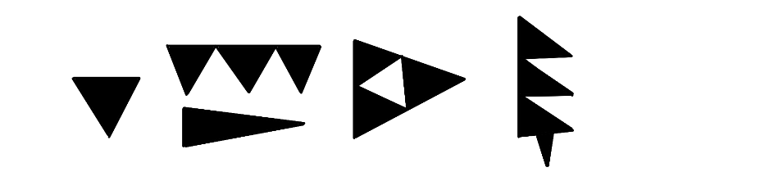
Answer transliterated into cuneiform:

Riddle 2

English translation: I’m not alive, but I can grow. I don’t have lungs, but I need air.

English answer to riddle: Fire
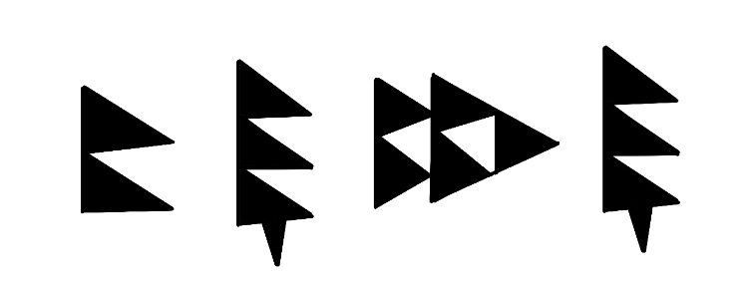
  - Answer transliterated into cuneiform:

