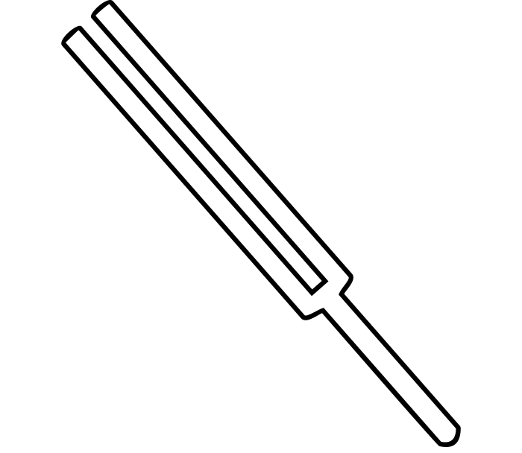
TUNING FORK STATION

Materials:
- Two tuning forks
- Beaker of water

Procedure:
- Take one tuning fork and hold it by the handle. Observe the number listed on the bottom of the tuning fork. Tap the tuning fork lightly on a flat surface, like a table or counter.
- Notice the tuning fork’s vibrations and listen to the sound it makes.
- Again, lightly tap the tuning fork on the table or counter, but this time, observe what happens as you place the tip of the tuning fork against the surface of the water in the beaker.
- Now select a different tuning fork. Repeat steps 1–3 with the new tuning fork.
- Write down your observations on your handout.

BEFORE MOVING ON TO THE NEXT LAB STATION, CLEAN THE LAB STATION AREA AND RETURN MATERIALS TO THEIR ORIGINAL POSITION.

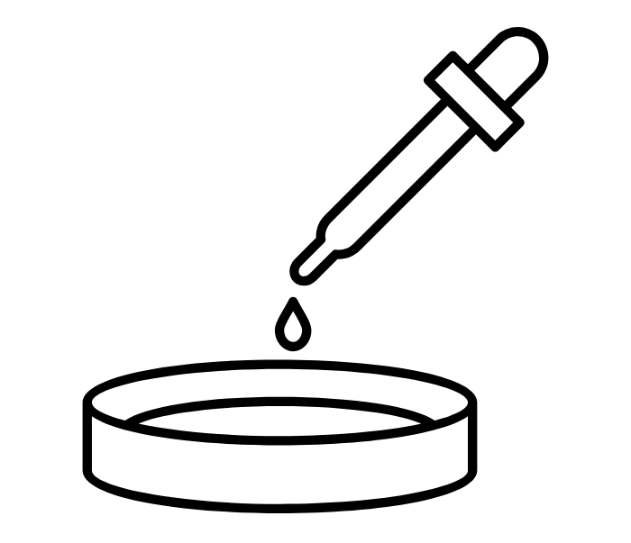
WATER WAVES STATION

Materials:
- Round, shallow dish filled with water
- Eye dropper
- Metric ruler

Procedure:
- Take water up in the eyedropper. Hold the eyedropper about 30 centimeters above the middle of the dish.
- Squeeze to let a drop hit the water in the dish.
- Write down your observations on your handout. Repeat steps 1–2 if necessary.
- Develop a prediction about what will happen if you let a drop of water fall closer to the edge of the dish. Write your prediction on your handout.
- Hold the eyedropper about 30 centimeters above the dish closer to the edge.
- Squeeze to let a drop hit the water in the dish.
- Repeat steps 5–6 a few more times.
- Write down your observations on your handout.

BEFORE MOVING ON TO THE NEXT LAB STATION, CLEAN THE LAB STATION AREA AND RETURN MATERIALS TO THEIR ORIGINAL POSITION.

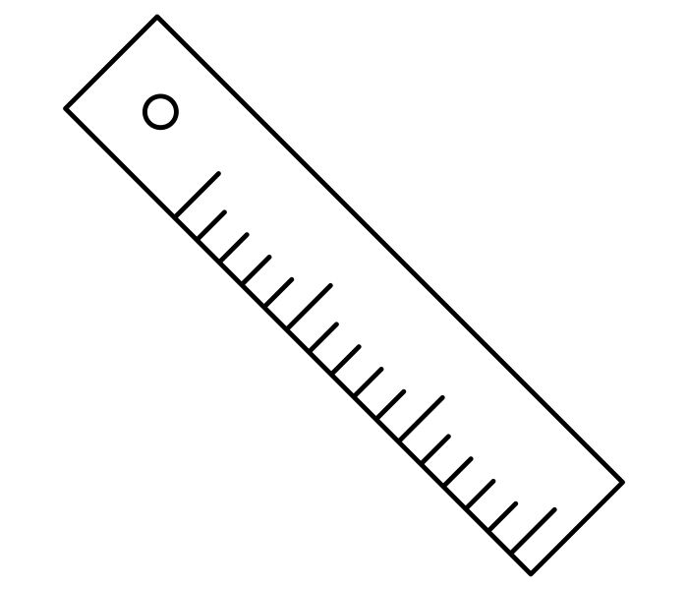
RULER SOUNDS STATION

Materials:
- Ruler
- Table or counter

Procedure:
- Make a prediction on your handout about the sound the ruler will make if you change the amount hanging off the table.
- Place a metric ruler on the edge of the table, letting about 5 centimeters hang off the edge.
- Hold the ruler on the table with one hand. With the other hand, pull up on the edge of the ruler and let go.
- Observe the sound this action makes.
- Move the ruler to where 10 centimeters hang off the table's edge and repeat steps 3–4.
- Repeat with different lengths extending over the table’s edge.
- Compare the sounds the ruler makes at different lengths on your handout.

BEFORE MOVING ON TO THE NEXT LAB STATION, CLEAN THE LAB STATION AREA AND RETURN MATERIALS TO THEIR ORIGINAL POSITION.

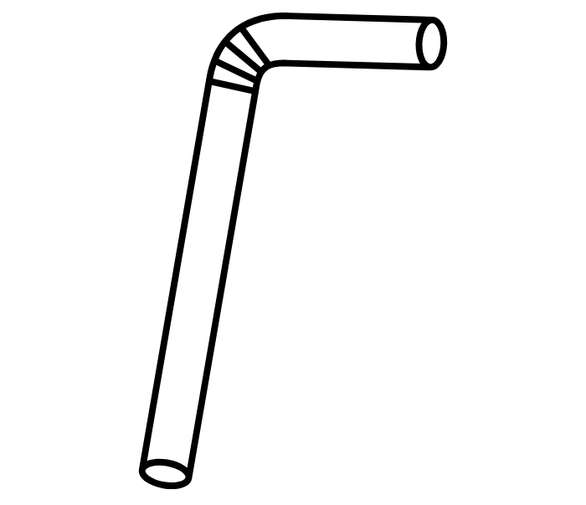
STRAWS STATION

Materials:
- Partners
- One straw
- Scissors

Procedure:
- Flatten one end of the straw. Cut the flattened ends into a point so that the straws look like a flat pencil.
- Very carefully, put the pointed, flattened end between your teeth.
- Tightly wrap your lips around the straw. Stop clenching the straw with your teeth but keep your lips wrapped around it and then blow.
- On your handout, describe the sound produced by the straw.
- Make a prediction of what will happen when you change the length of your straw. Write it on your handout.
- Test the prediction you made by cutting a piece off the end of the straw. Then, blow again to make the sound.
- Repeat two more times cutting off pieces of the straw and making the sound.
- Record your observations on your handout.

BEFORE MOVING ON TO THE NEXT LAB STATION, CLEAN THE LAB STATION AREA AND RETURN MATERIALS TO THEIR ORIGINAL POSITION.

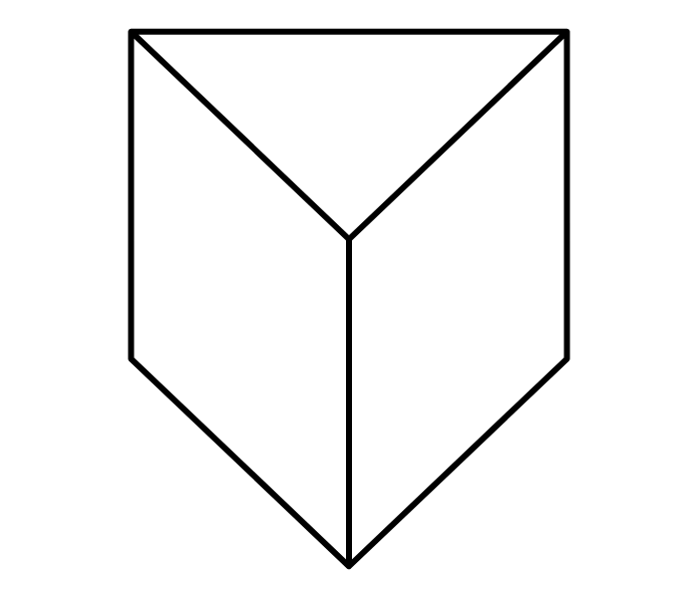
PRISM STATION

Materials:
- Prism
- Flashlight
- Table or countertop
- Sunshine

Procedure:
- Set the prism on the table or counter.
- Using the flashlight, shine light through the prism until you see a rainbow. You may have to try several different angles.
- If sunlight shines into your classroom, try to use the sunlight to make a rainbow too.

BEFORE MOVING ON TO THE NEXT LAB STATION, CLEAN THE LAB STATION AREA AND RETURN MATERIALS TO THEIR ORIGINAL POSITION.

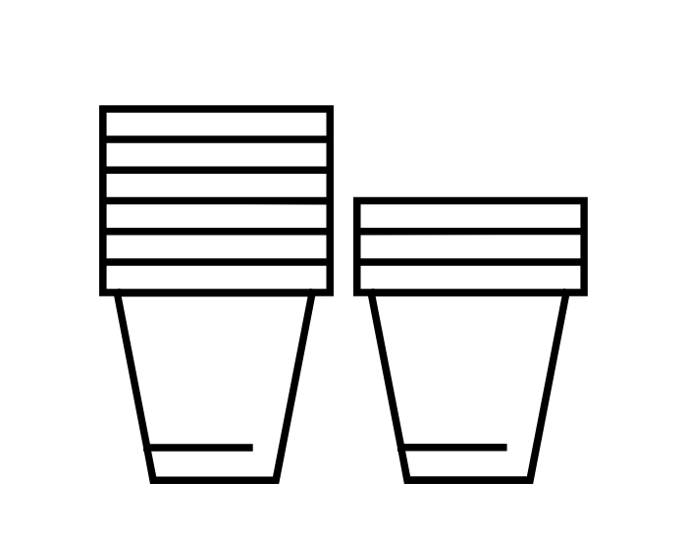
CUP SOUND STATION

Materials:
- Three cups of different material
  - Paper, Styrofoam, and ceramic
- Small metronome or Bluetooth speaker

Procedure:
- Set the metronome or speaker on the table or counter.
- Start the metronome or play a continuous tone through the speaker.
- Cover the metronome with the paper cup.
- Observe the changes in the sound.
- Repeat steps 3–4 with the other cups.
- Write down your observations on your handout.

BEFORE MOVING ON TO THE NEXT LAB STATION, CLEAN THE LAB STATION AREA AND RETURN MATERIALS TO THEIR ORIGINAL POSITION.

