WAVE NOTES
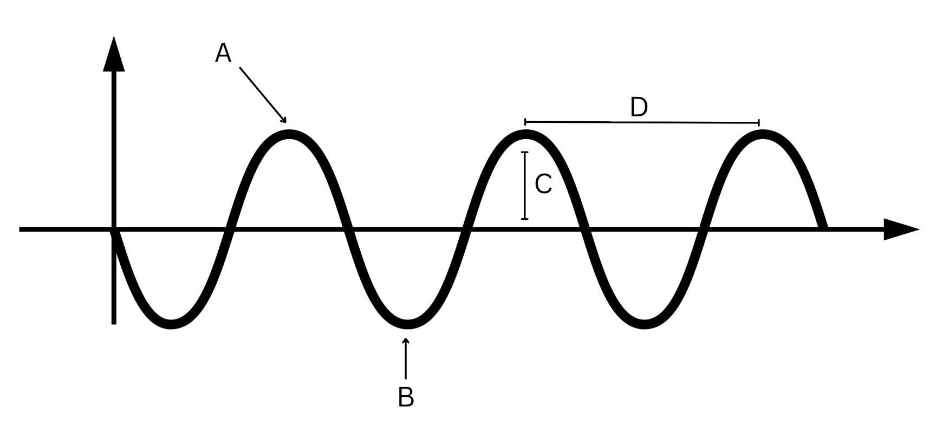
Parts of a wave
A:
B:
C:
D:

Wave behavior
Reflection:

Absorption:

Transmission:

Behavior | Lab Station Example | Evidence/Observations
Reflected
Absorbed
Transmitted

