Closed Helmet with Mask Visor in Form of a Human Face
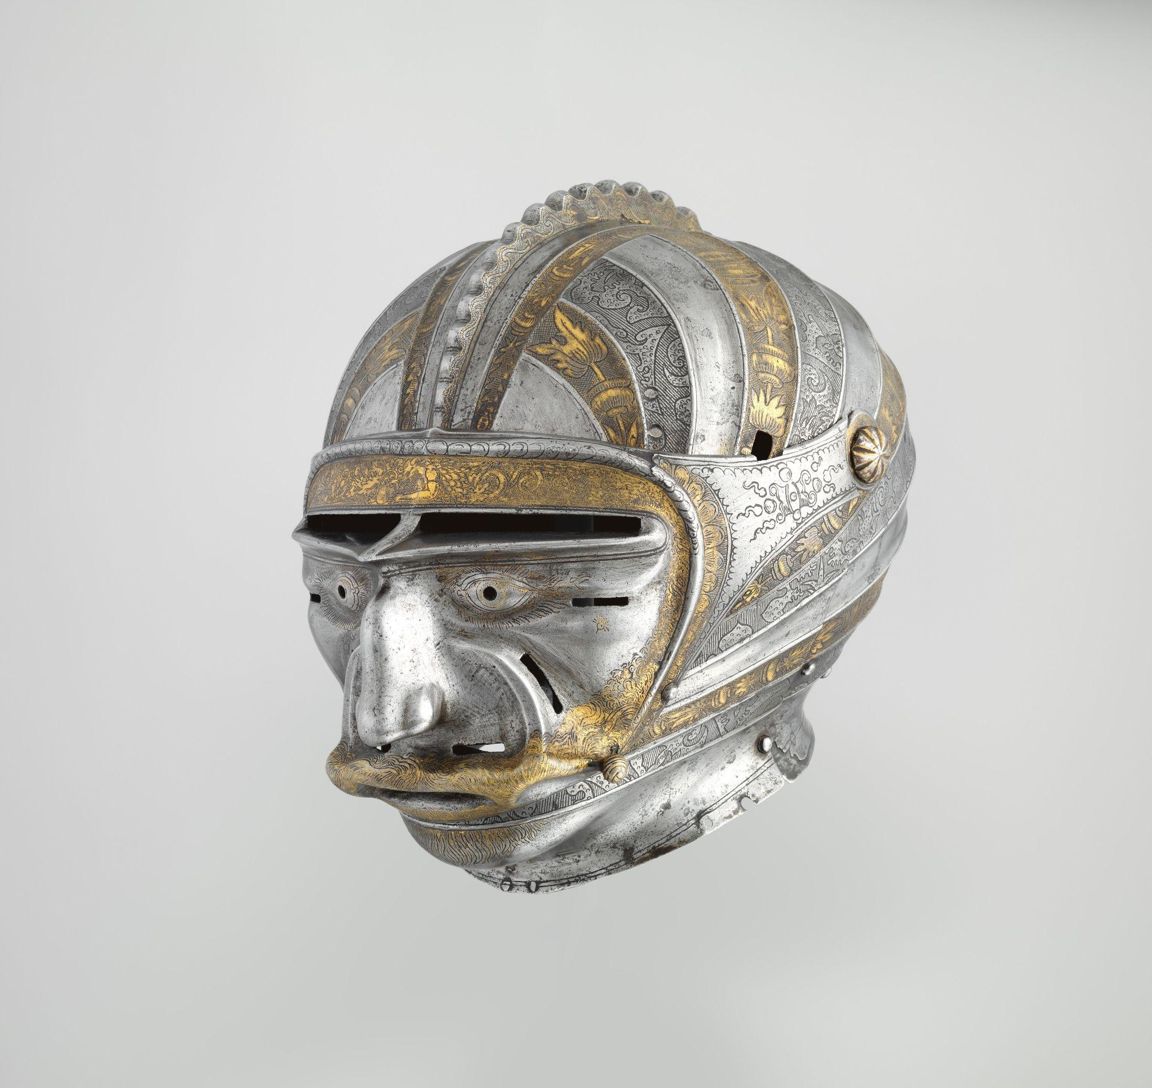

Attributed to Kolman Helmschmid German (ca. 1515)
On view at The Met Fifth Avenue in Gallery 374
Helmets fitted with mask-like visors were a popular German and Austrian fashion about 1510 to 1540. With their visors forged and embossed as humorous or grotesque human masks, such helmets were often worn in tournaments held during the exuberant pre-Lenten (Shrovetide) festivals, celebrations somewhat akin to the modern Mardi Gras. Substitute visors of more conventional type were often provided for everyday use.

Metropolitan Museum of Art. (n.d.). The Collection. https://www.metmuseum.org/art/collection

Bronze Handle Attachment in the Form of a Mask
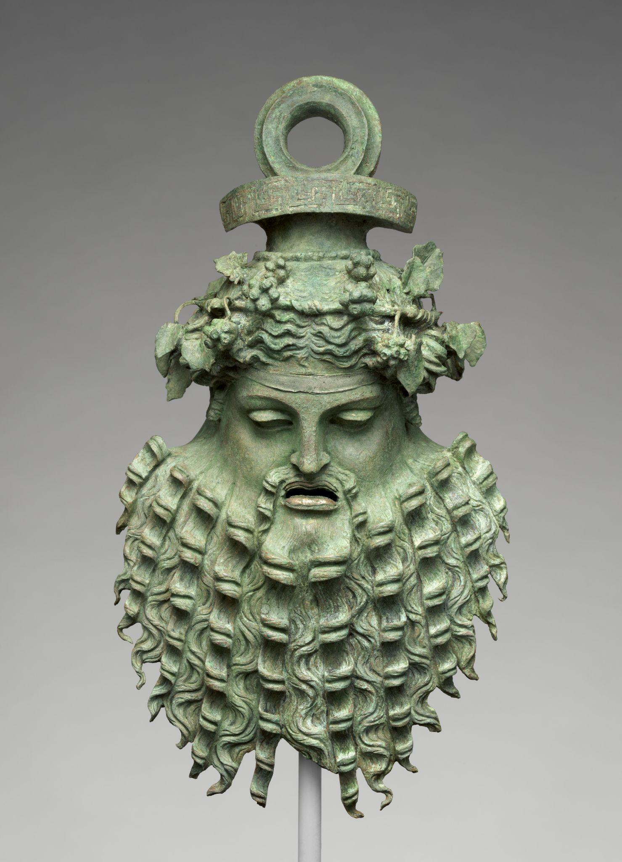

Greek or Roman (1st century BCE–1st century CE)
On view at The Met Fifth Avenue in Gallery 166
Despite all the change and innovation in Hellenistic iconography, there was also continuity. The three masks in this case demonstrate the tendency to perpetuate, if not to revive, styles going back to the Classical and even to the Archaic period, a tendency that gained impetus from the second century B.C. on, as Greek artists were being called upon to cater to the demands of the Roman art market. Images related to Dionysos, Greek god of intoxication and ecstasy, were well suited to the luxurious and hedonistic life that wealthy Romans led in their villas. These handle attachments were for wine buckets. The wreath of ivy leaves and the fillet crossing the forehead are associated exclusively with the god of wine and his followers. The mask brings to mind Archaic images of Dionysos, who until the fifth century B.C. was always shown with long hair and a beard. But the pointed, equine ears on these masks mark them as representations of satyrs or silenoi, the quasi-human woodland creatures in the rowdy entourage of the god.
Metropolitan Museum of Art. (n.d.). The Collection. https://www.metmuseum.org/art/collection
Olmec Mask
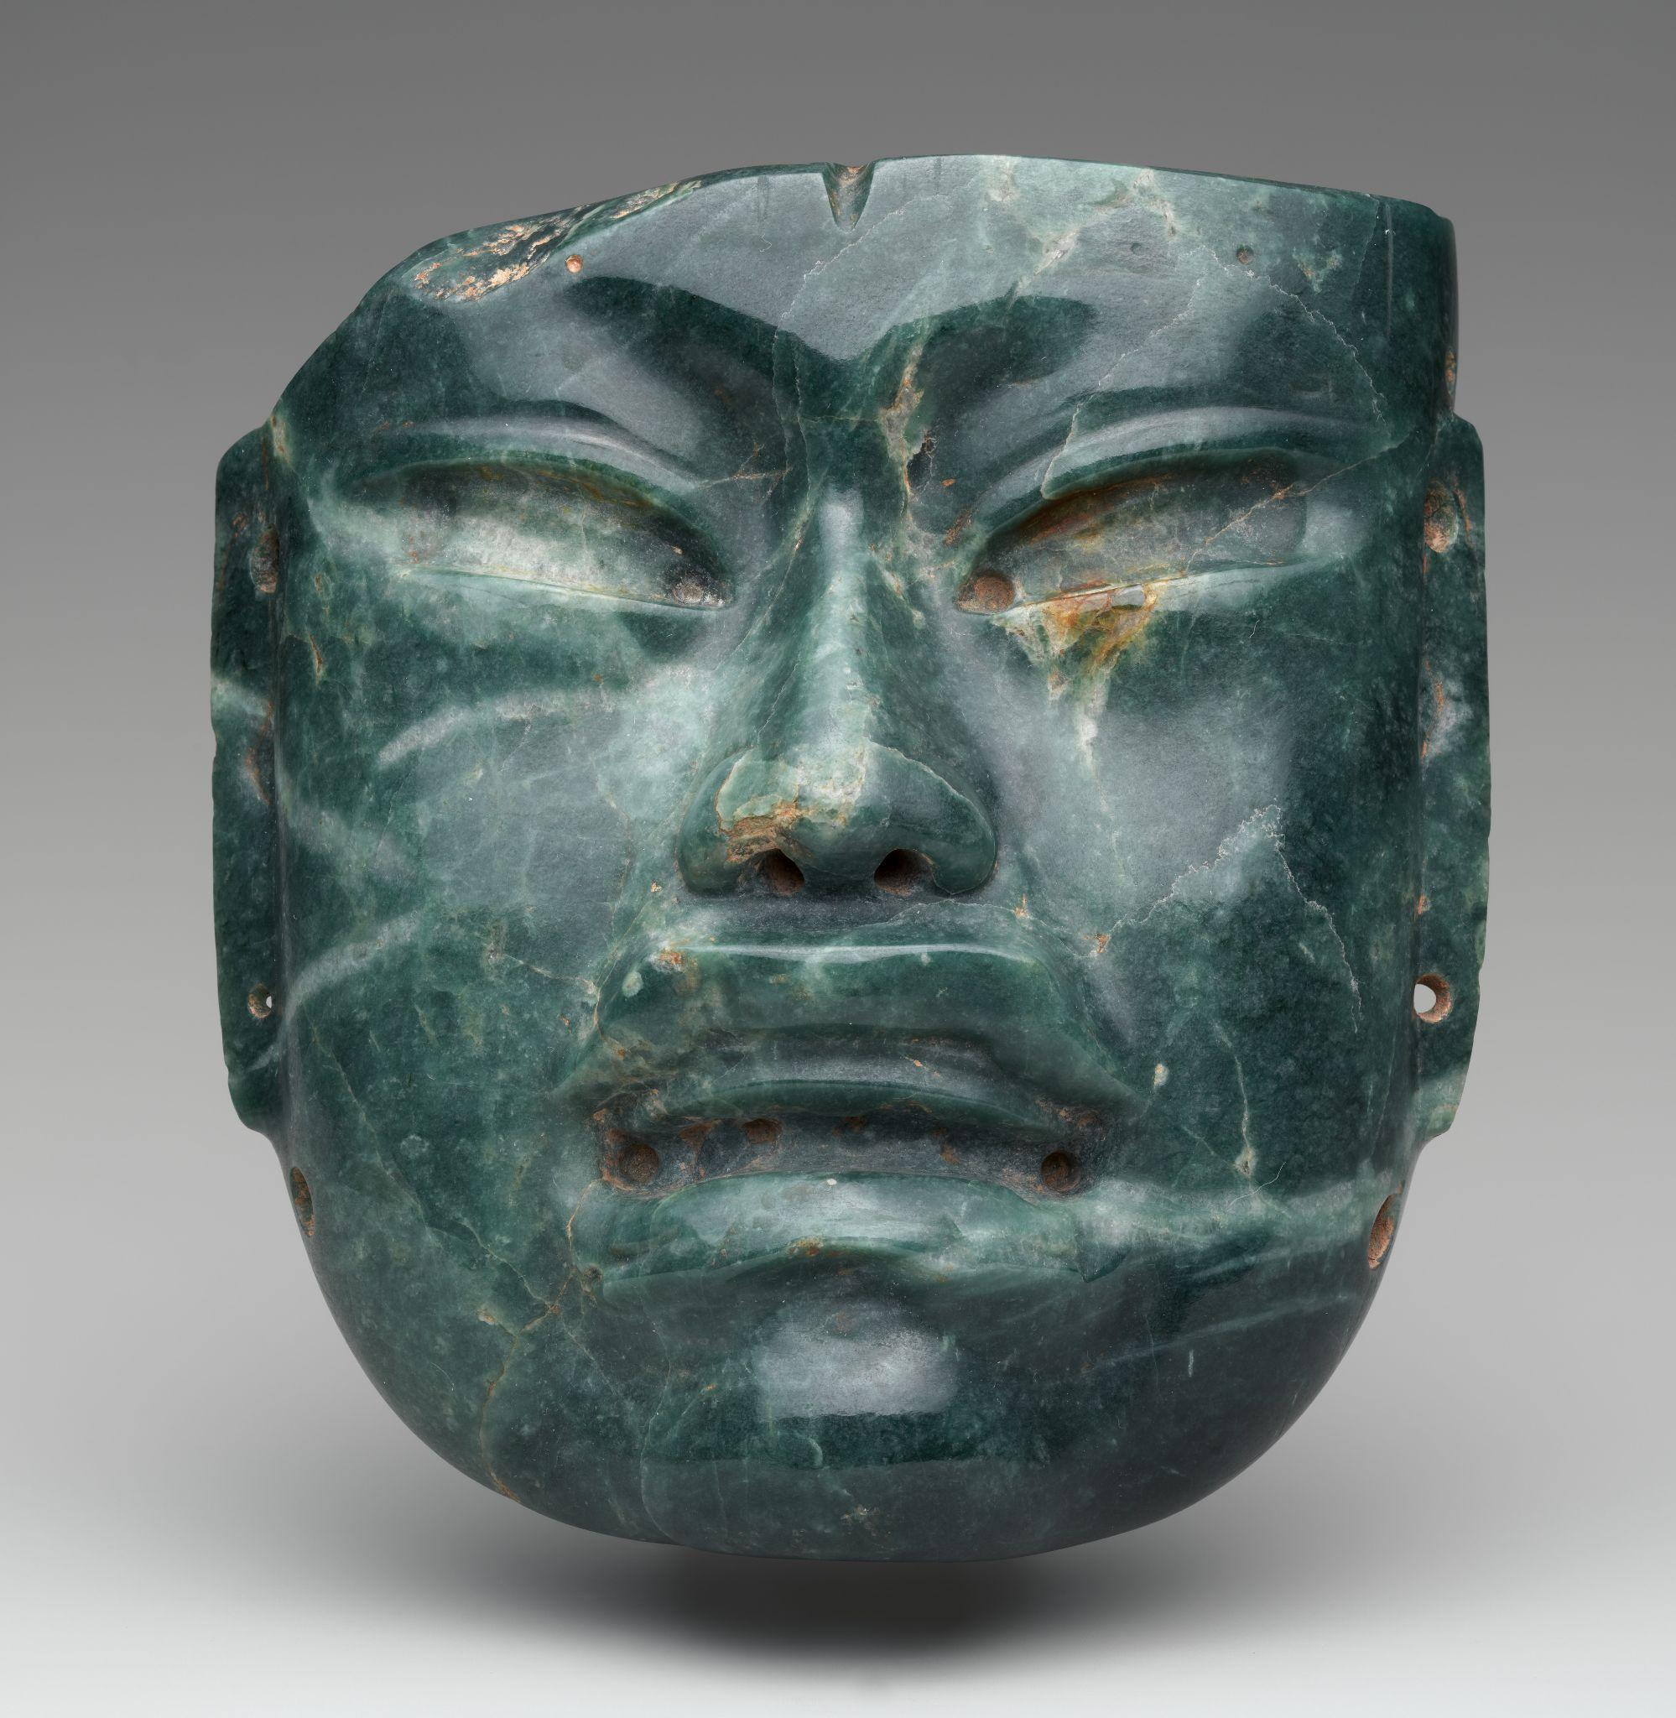
Olmec (900–400 BCE)
Not on view
The Olmec civilization, which thrived in present-day Mexico between 1200 and 400 B.C., was renowned for its refined greenstone sculptures, particularly jadeite masks. These masks, though naturalistic in style, often combined human and supernatural features to depict idealized spiritual beings. For instance, one mask features lifelike details such as parted lips and a fleshy nose, yet includes traits associated with Olmec deities—almond-shaped eyes, a wide nose, and a downturned mouth. A cleft on the forehead likely symbolizes the Olmec Maize God, alluding to the fertile earth from which maize, a sacred and vital crop, springs forth.
Jadeite, the greenstone used for this mask, was a rare and treasured material in Mesoamerica, valued for its translucent, water-like luster and symbolic connection to life, fertility, and agricultural abundance. Though resembling a face, the mask was not designed for wear by the living—there are no openings for the eyes or mouth. Instead, small holes on the edges suggest it was attached to garments, ornaments, or funerary bundles, indicating its use in ceremonial or ritual contexts rather than as a practical mask.

Metropolitan Museum of Art. (n.d.). The Collection. https://www.metmuseum.org/art/collection

Teotihuacan Mask
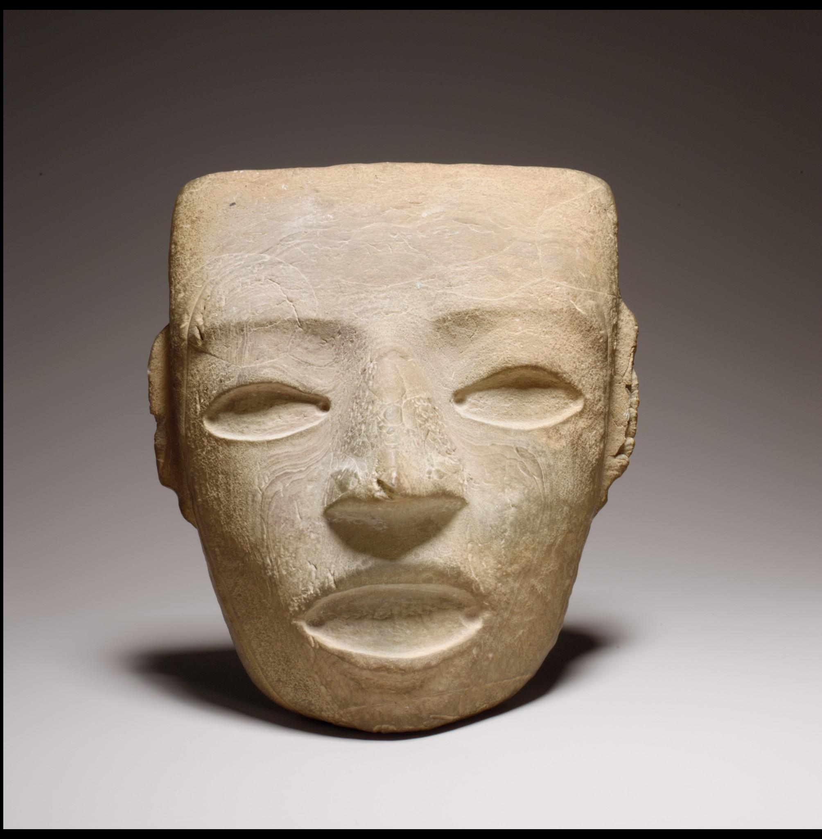

Teotihuacan (3rd–7th century)
Not on view
Three-dimensional stone masks depicting a conventionalized human-like face are abundant in the sculptural style associated with the great Central Mexican city of Teotihuacan. With its geometrically rendered horizontal brow, triangular nose, and oval mouth and eyes, this mask depicts an idealized facial type that seems to function as a symbol, rather than a portrait, similar to other standardized motifs present in the art of Teotihuacan. The depressions of the eyes and the mouth suggest that this whitish onyx mask might have originally possessed inlaid pyrite or shell for the depiction of eyes and teeth. Perforations at the sides on the reverse suggest that it was intended to be attached to another object, but given the weight of the stone and the lack of holes for the eyes and mouth, these masks were probably not worn by living people. Instead, they may have been attached to larger, perishable sculptures of human or deity figures or mounted on or placed within mummy or deity bundles. They may represent a local version of the Mesoamerican maize deity, the stony faces as metaphors for maize seeds to be planted and reborn as tender sprouts.

Metropolitan Museum of Art. (n.d.). The Collection. https://www.metmuseum.org/art/collection

Rain God Mask
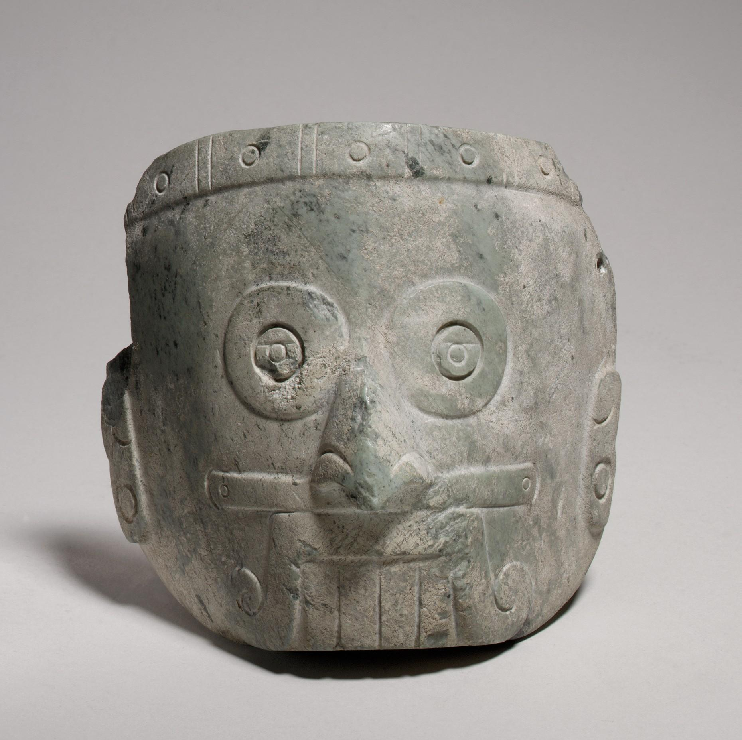

Mixtec (13th–14th century)
Not on view
Many peoples in ancient Mexico made masks of different types and in a variety of materials. Some depict idealized human faces, others animals or supernatural beings. How the masks functioned is not always clear. Only a few have been discovered in archaeological contexts and life-uses are hard to make out. Face-size examples with holes for eyes and mouth were presumably worn in processions or on ceremonial occasions. Masks with no such openings may have been laid upon the dead; or they might have been tied to statuary or deity bundles, as the holes on the sides of the forehead of this mask suggest. Still others are small enough to be worn as pendants or as part of headdresses. This mask, carved from a light green serpentine, depicts the rain god Tlaloc with the characteristic ringed eyes, prominent teeth, and a mouth with an upper lip-moustache that curls on each side. He also wears a nose bar in the nasal septum.

Metropolitan Museum of Art. (n.d.). The Collection. https://www.metmuseum.org/art/collection

Dance Mask
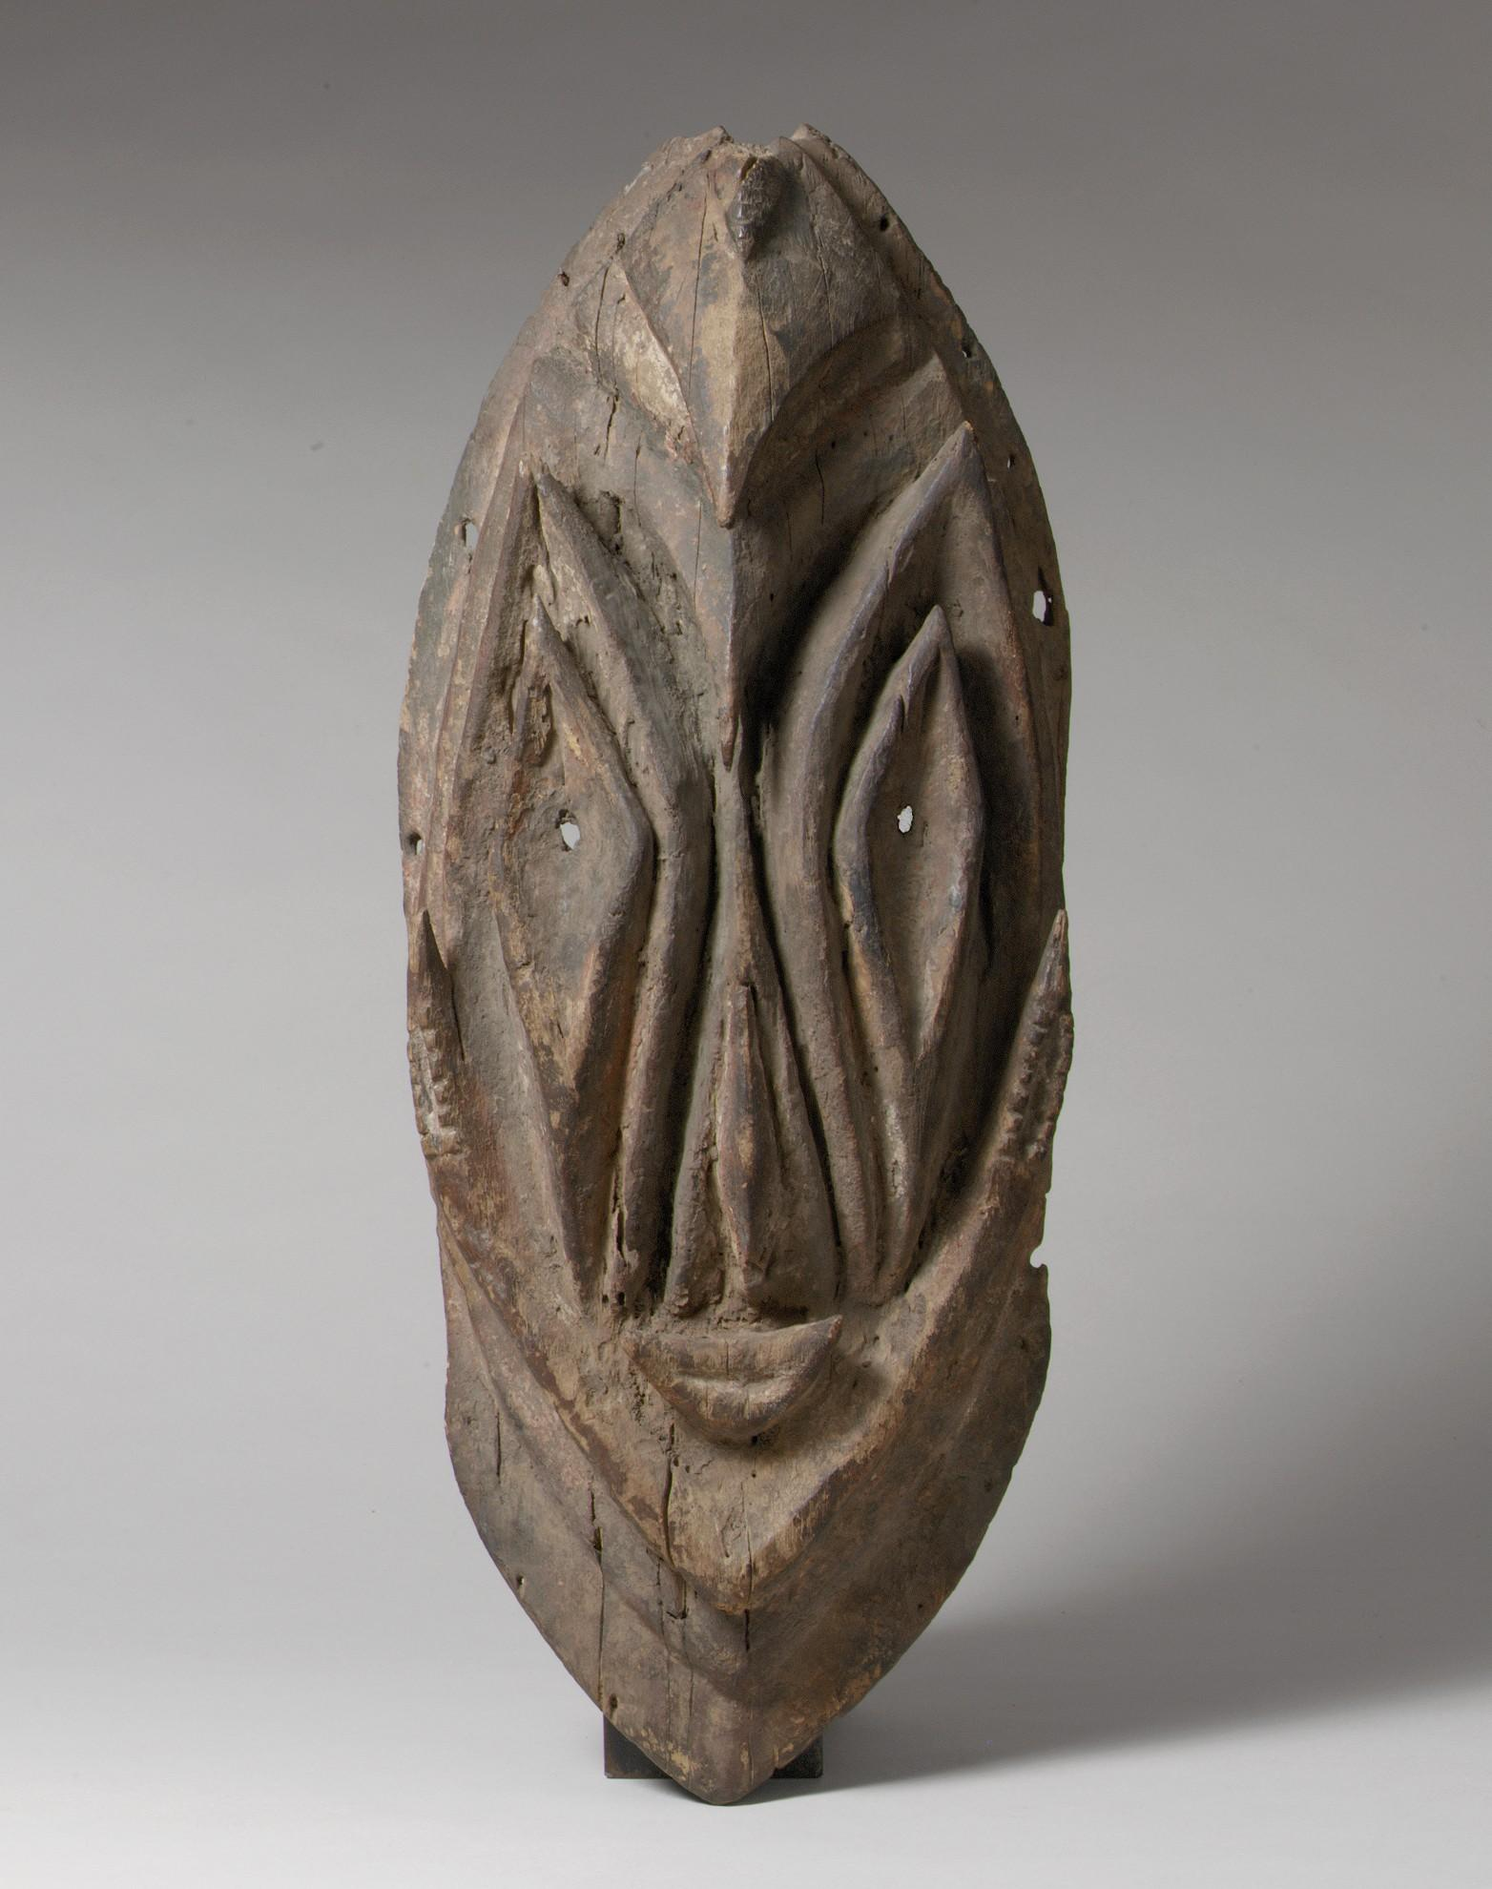

Romkun, Breri, or Igana people (19th century)
Not on view
This mask was probably created by the Romkun, Breri, or Igana peoples of the Ramu and Guam Rivers, whose masking traditions are largely undocumented. The pierced eyes and small holes on its periphery, probably used to secure it to a larger basketry headdress, indicate it was likely a dance mask. Dance masks among the neighboring Kominimung people have similar imagery and possibly served similar functions. Worn by initiated men during ritual performances, Kominimung dance masks depict bwongogo, ancestral spirits responsible for the success of important activities such as gardening, hunting, fishing, and formerly, warfare. Women and children are not allowed to witness the creation of the masks. However, the entire community may watch the performance of the masked dancers.

Metropolitan Museum of Art. (n.d.). The Collection. https://www.metmuseum.org/art/collection

Lion Mask Door Pull
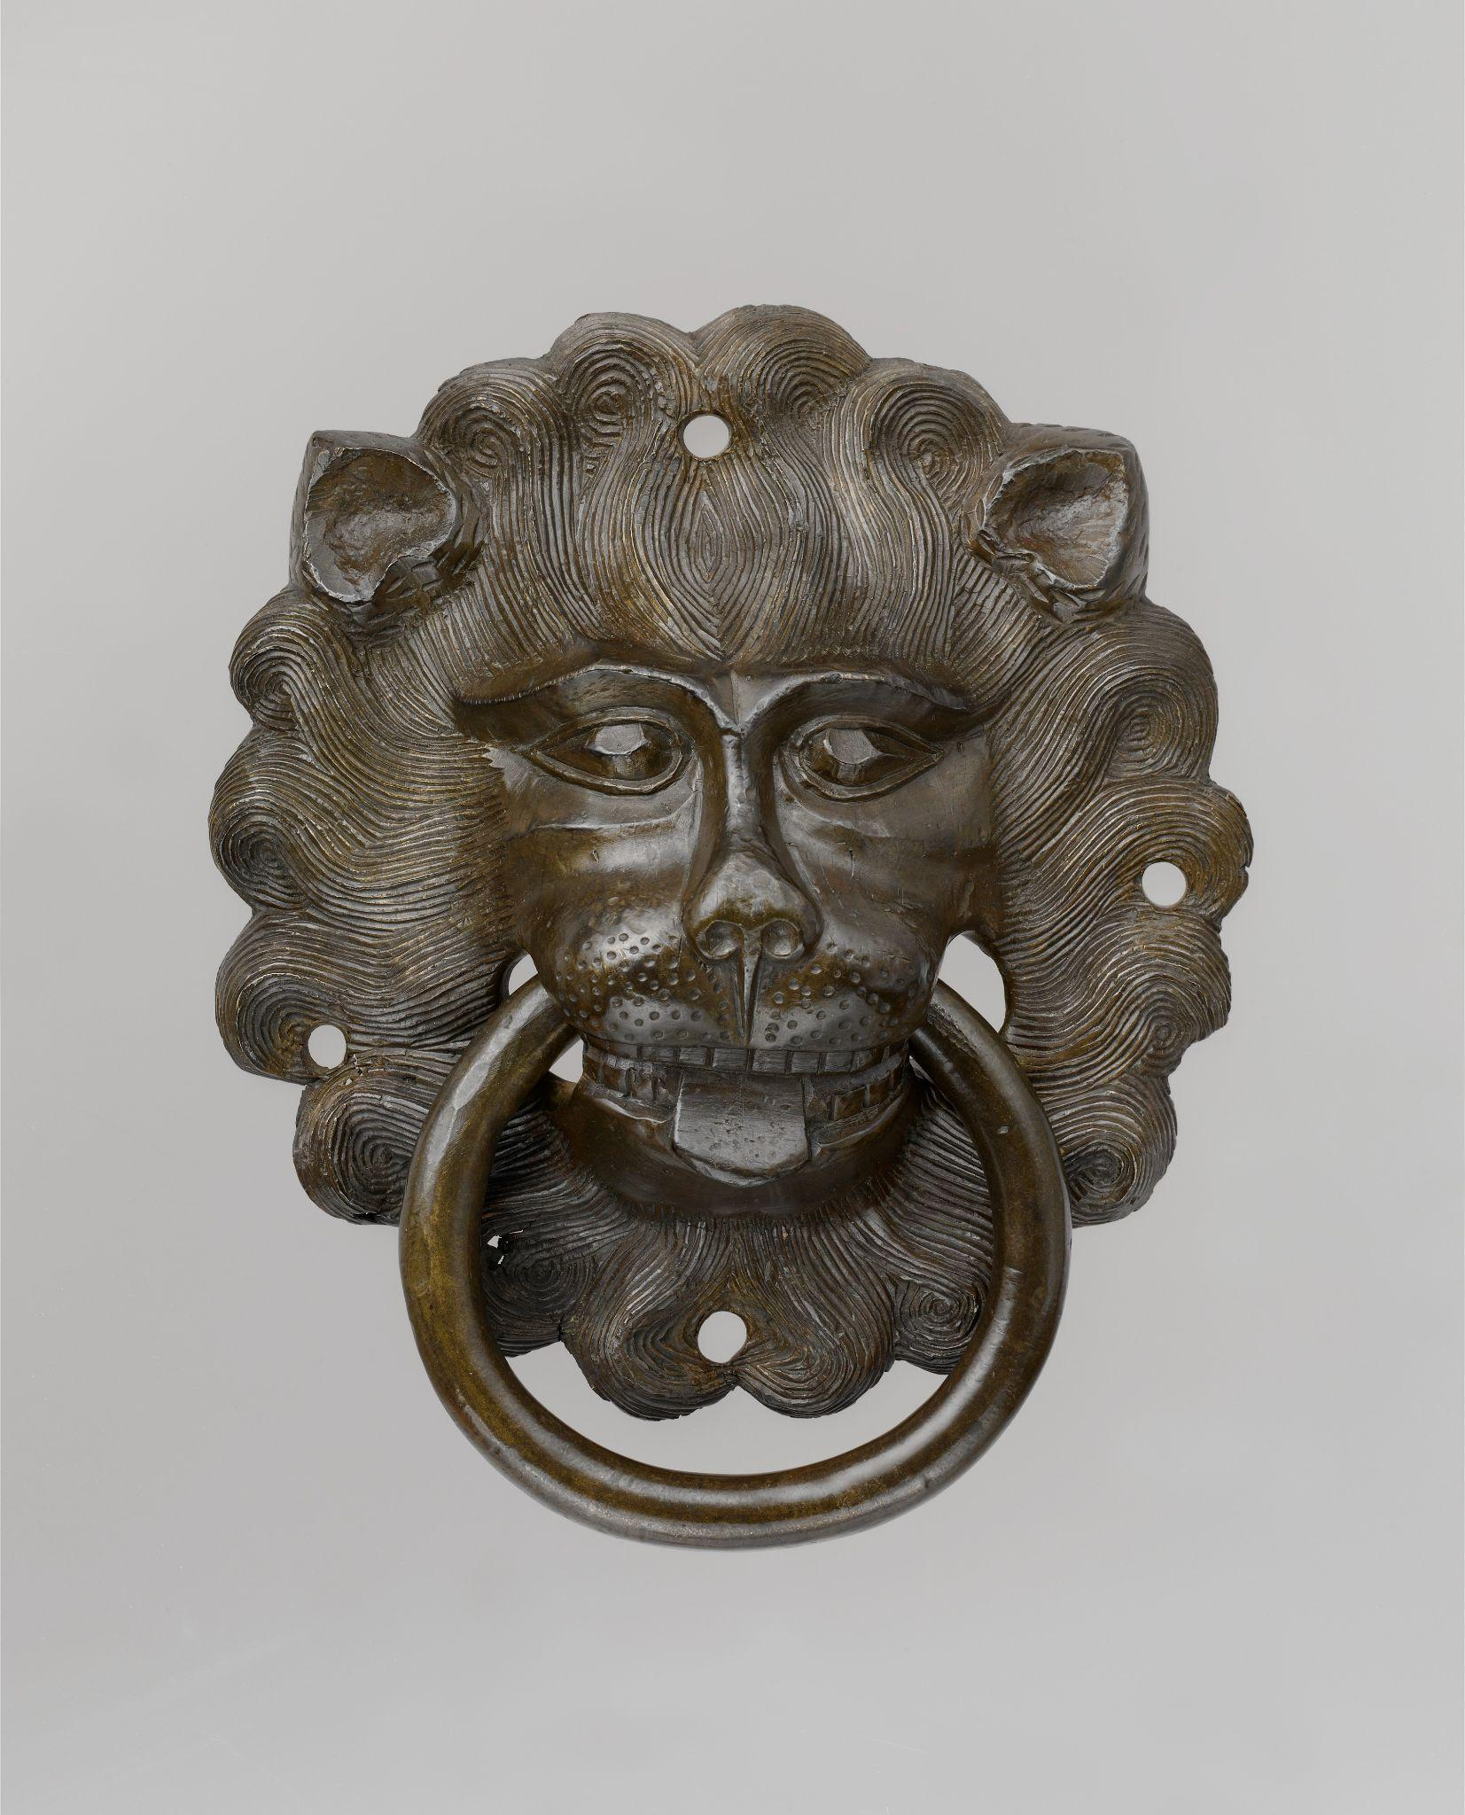

German (ca. 1425–50)
Not on view
Door pulls in the form of lion masks were a feature of many medieval churches throughout the Middle Ages. Such pulls functioned not only as decorative door hardware but also as sanctuary rings, symbols of the protection the church offered to those fleeing legal prosecution and other dangers. This example was cast in copper alloy. Stylistic and elemental analyses reveal that this door pull was likely made in the first half of the fifteenth century in Nuremberg, in southern Germany, where prolific workshops also created impressive aquamanilia (water vessels in animal and human form used for washing hands) and other cast objects. It is strikingly close to a pair of door pulls still found on the doors of the Cathedral of Augsburg, in Bavaria, and another closely related example is in the National Gallery of Art in Washington, D.C. This group of door pulls, and the strong similarities among many aquamanilia made in fifteenth-century Nuremberg, suggest that by the end of the Middle Ages metalwork shops in southern Germany had begun serially producing such objects.

Metropolitan Museum of Art. (n.d.). The Collection. https://www.metmuseum.org/art/collection
Mask (Buk, Krar, or Kara)
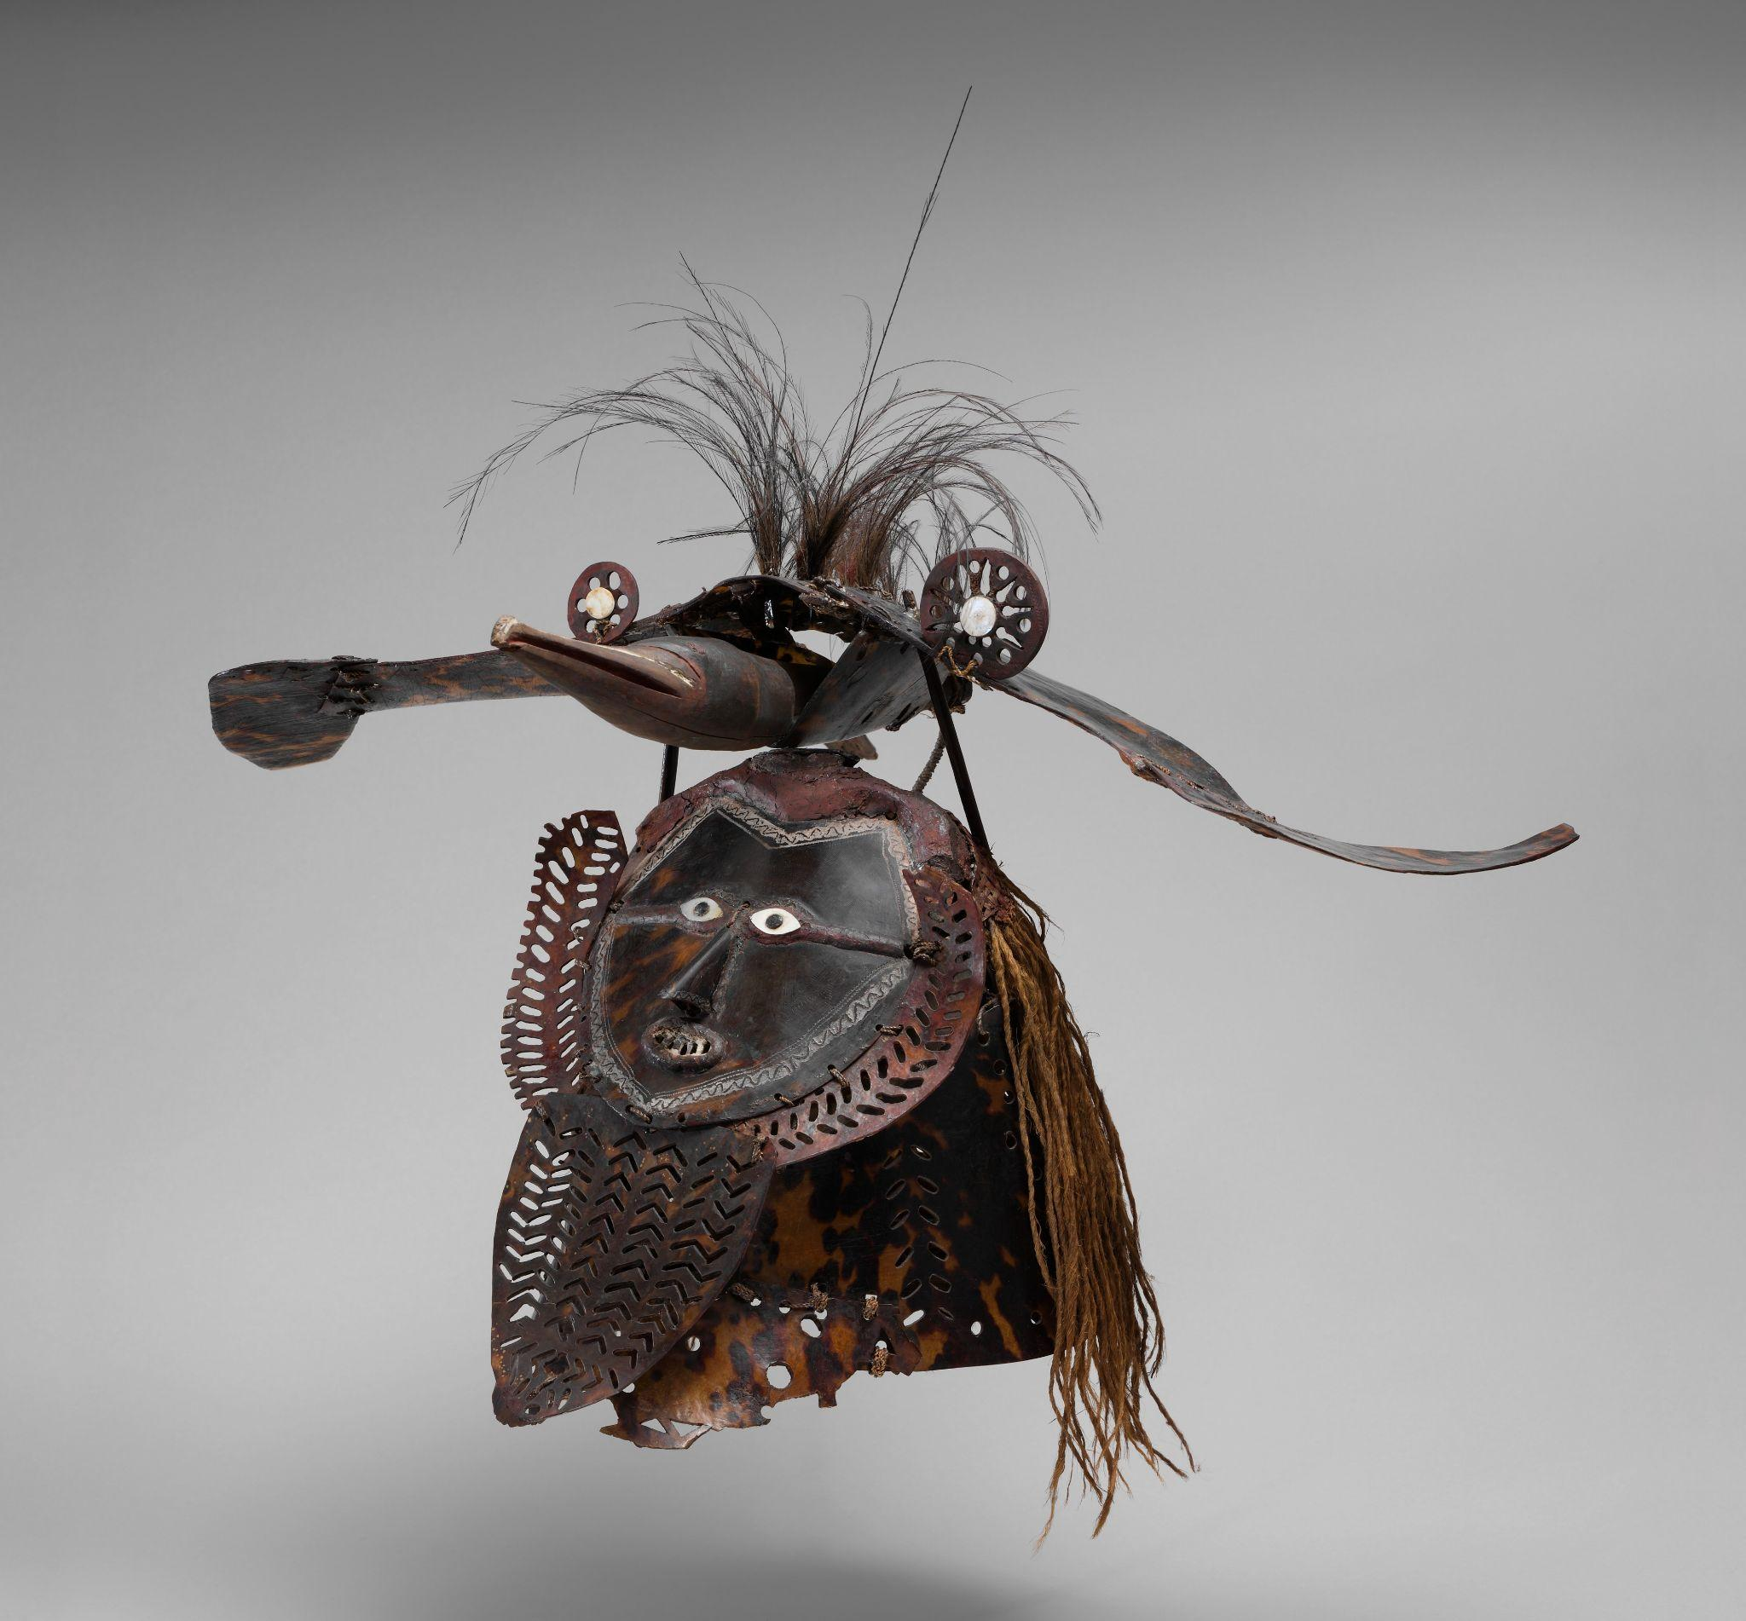

Torres Strait Islander (mid to late 19th century)
Not on view
The unique turtle-shell masks of the Torres Strait Islands that lie between Australia and New Guinea are among the most striking works of Oceanic art. Attributed to Mabuiag Island, this work displays the composite human and animal imagery typical of western Torres Strait masks. Turtle-shell masks in the Western Torres Strait reportedly were used during funerary ceremonies and increase rites. Increase rites were designed to ensure bountiful harvests and an abundance of fish and game. The ceremonies often involved performances in which senior men, wearing the masks and rustling costumes of grass, reenacted events from the lives of culture-heroes, which were drawn from oral tradition. Worn over the head like a helmet, this work depicts a human face, possibly representing once such culture-hero. It is surmounted by a frigate bird, perhaps representing his personal totem.

Metropolitan Museum of Art. (n.d.). The Collection. https://www.metmuseum.org/art/collection
Terracotta Roundels with Theatrical Masks
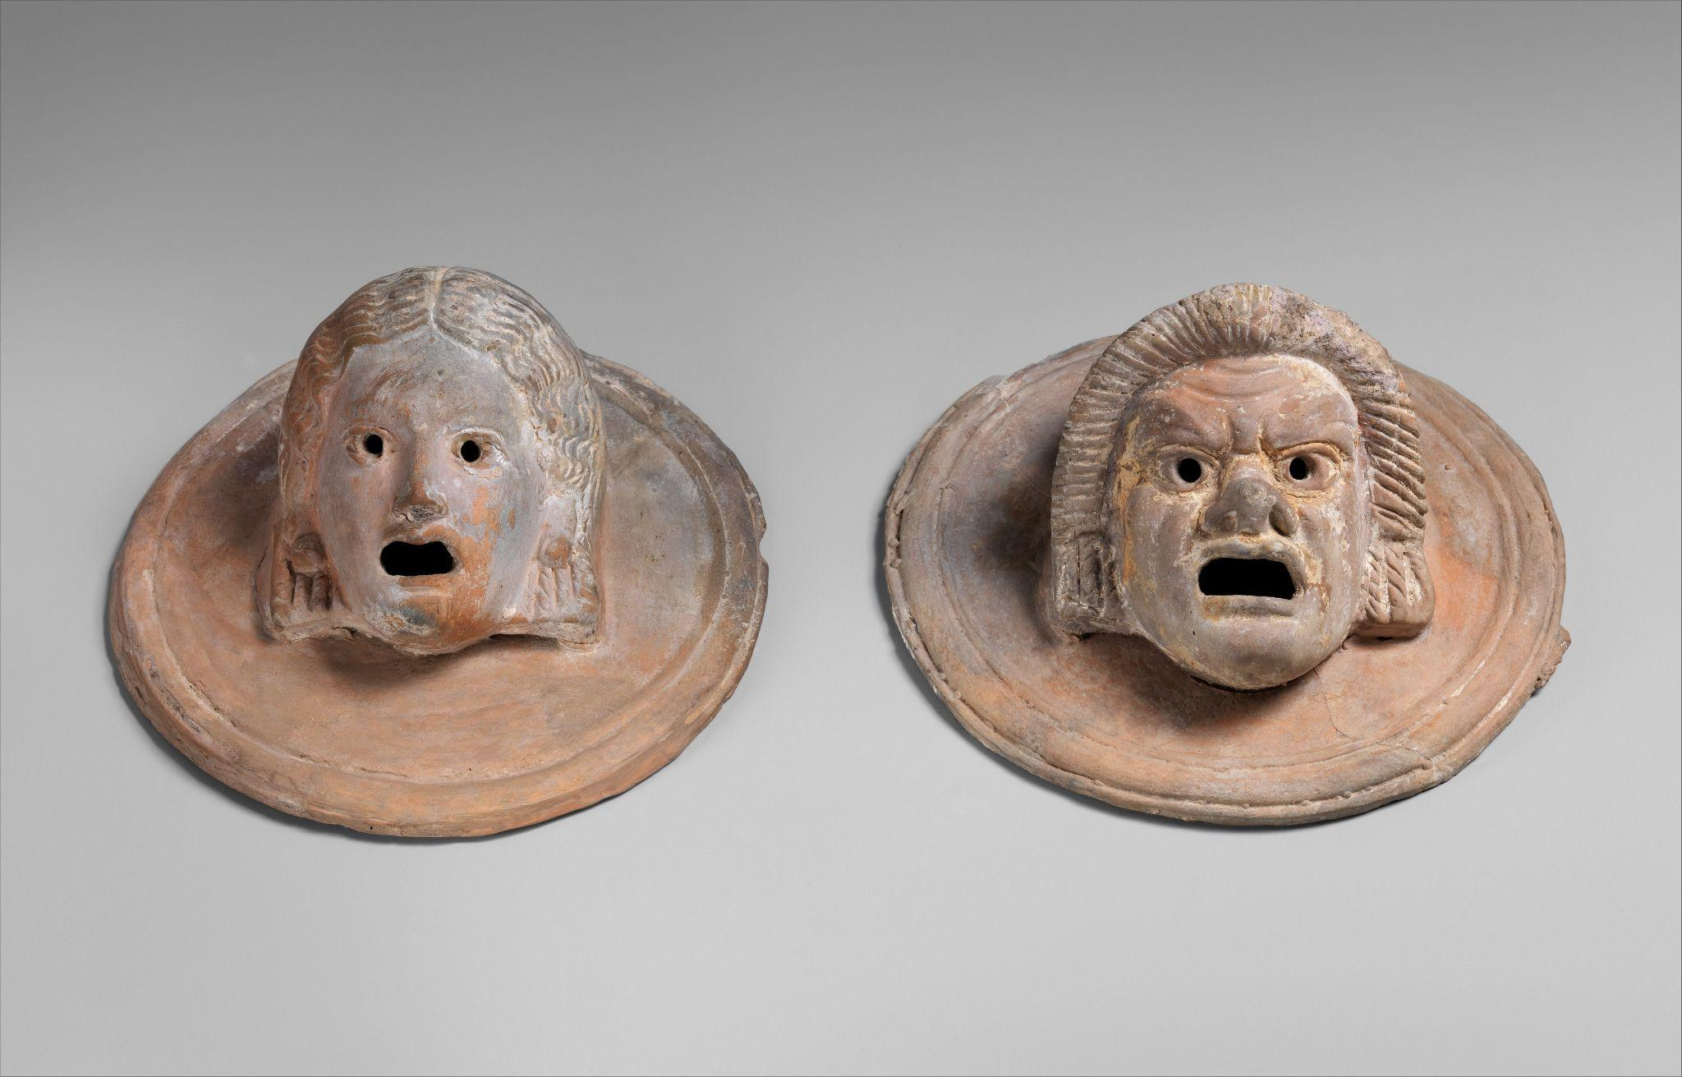

Greek (1st century BCE)
On view at The Met Fifth Avenue in Gallery 161
These two terracotta roundels were created in the 1st century BCE during the Hellenistic period in ancient Greece. Made from terracotta, they each depict theatrical masks—one representing a hetaira (a courtesan) and the other a slave—characters commonly found in Greek theater. Measuring about 5.75 inches in diameter, the roundels likely served a decorative or commemorative function, possibly adorning a domestic or theatrical setting. The expressive features reflect the importance of theater in Greek culture and its role in both entertainment and social commentary.

Metropolitan Museum of Art. (n.d.). The Collection. https://www.metmuseum.org/art/collection

Tlatilco Mask
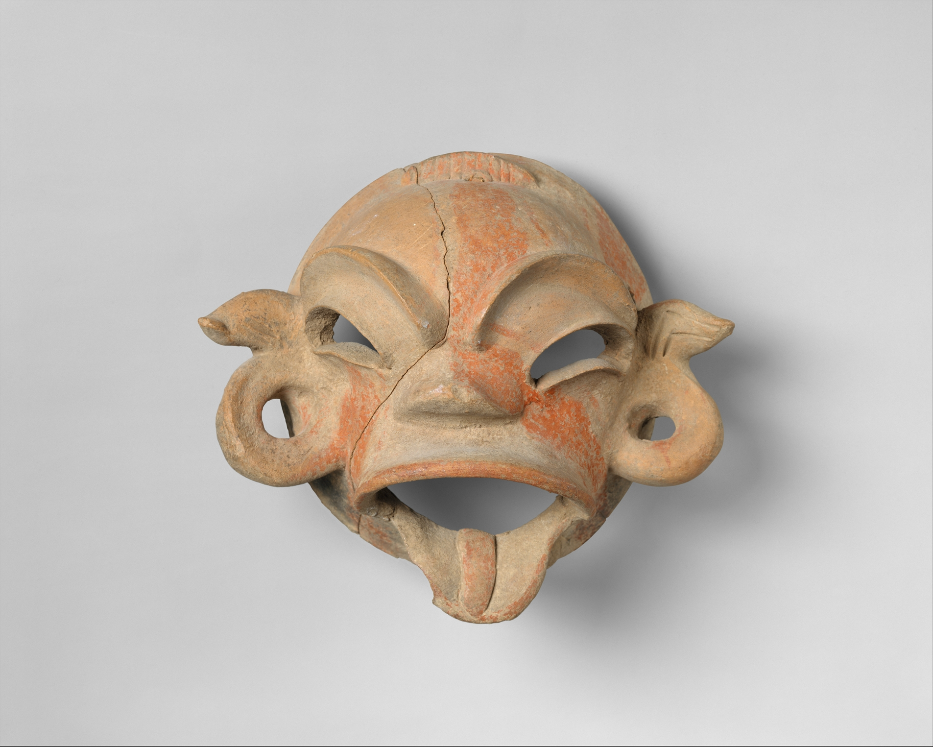

Tlatilco (12th–9th century BCE
Not on view
Masks in ancient Mexico came in all shapes and sizes and ranged from those that clearly depict human faces to those that appear bizarre and/or supernatural. This mask, stylistically associated with the site of Tlatilco in the Basin of Mexico, shows a twisted, simian-like face with simple, serpentine curves for ears, bulging eye sockets with crisply outlined eyelids, and exaggeratedly prominent eyebrows. While the eyes and mouth are pierced, the mask is too small to have covered the entire face. Paired holes at the temples and below the ears suggest that it could have been tied on the lower face or onto a bundle or sculpture, thereby representing a state of transformation.

Metropolitan Museum of Art. (n.d.). The Collection. https://www.metmuseum.org/art/collection

Funerary Mask
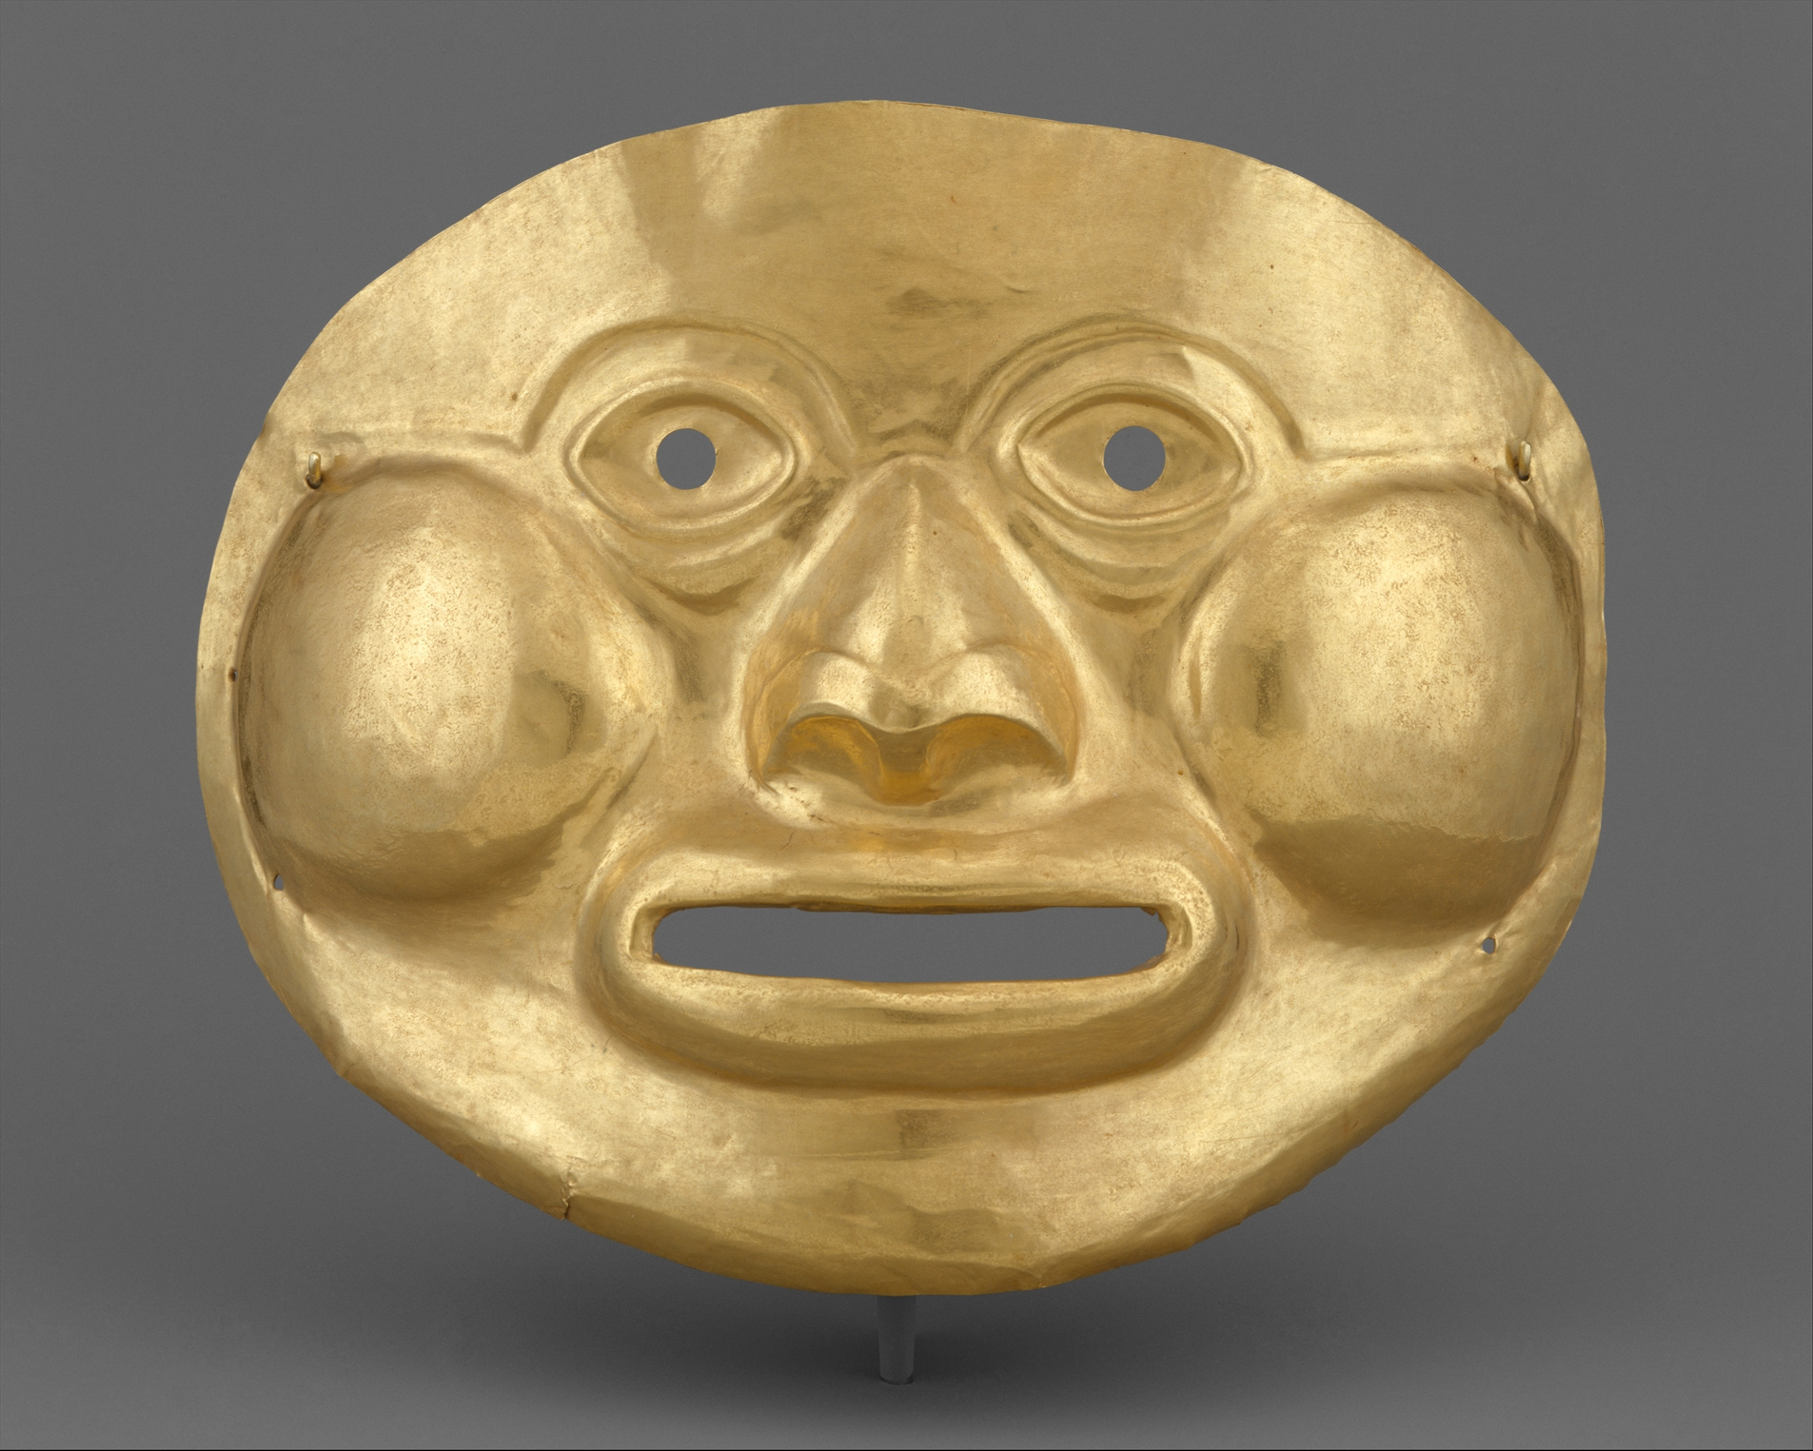

Calima (Ilama) (5th–1st Century BCE)
Not on view
Lifesize hammered masks are the largest objects produced in gold in the ancient Americas. While most masks were presumably made as burial offerings, this example, with its pierced eyes, cutout mouth, and additional holes for tying at the sides, could have been worn by an individual during life in a ritual or ceremony before being placed with his material wealth in a tomb. The mask comes from the Calima River region in southwestern Colombia, where abundant alluvial gold deposits prompted a distinguished gold working tradition that lasted for at least 2,000 years. Hammered from a single sheet of metal of high carat gold (its alloy contains 86 percent gold, 13 percent silver, and one percent copper), Calima masks of the Llama era are often flat, with generic details of the human face. On this example, the features are individualized with puffy bags beneath the eyes, a broad nose with flared nostrils, big, round, bulging cheeks, and a fat-lipped open mouth.

Metropolitan Museum of Art. (n.d.). The Collection. https://www.metmuseum.org/art/collection

Ornamental Mask
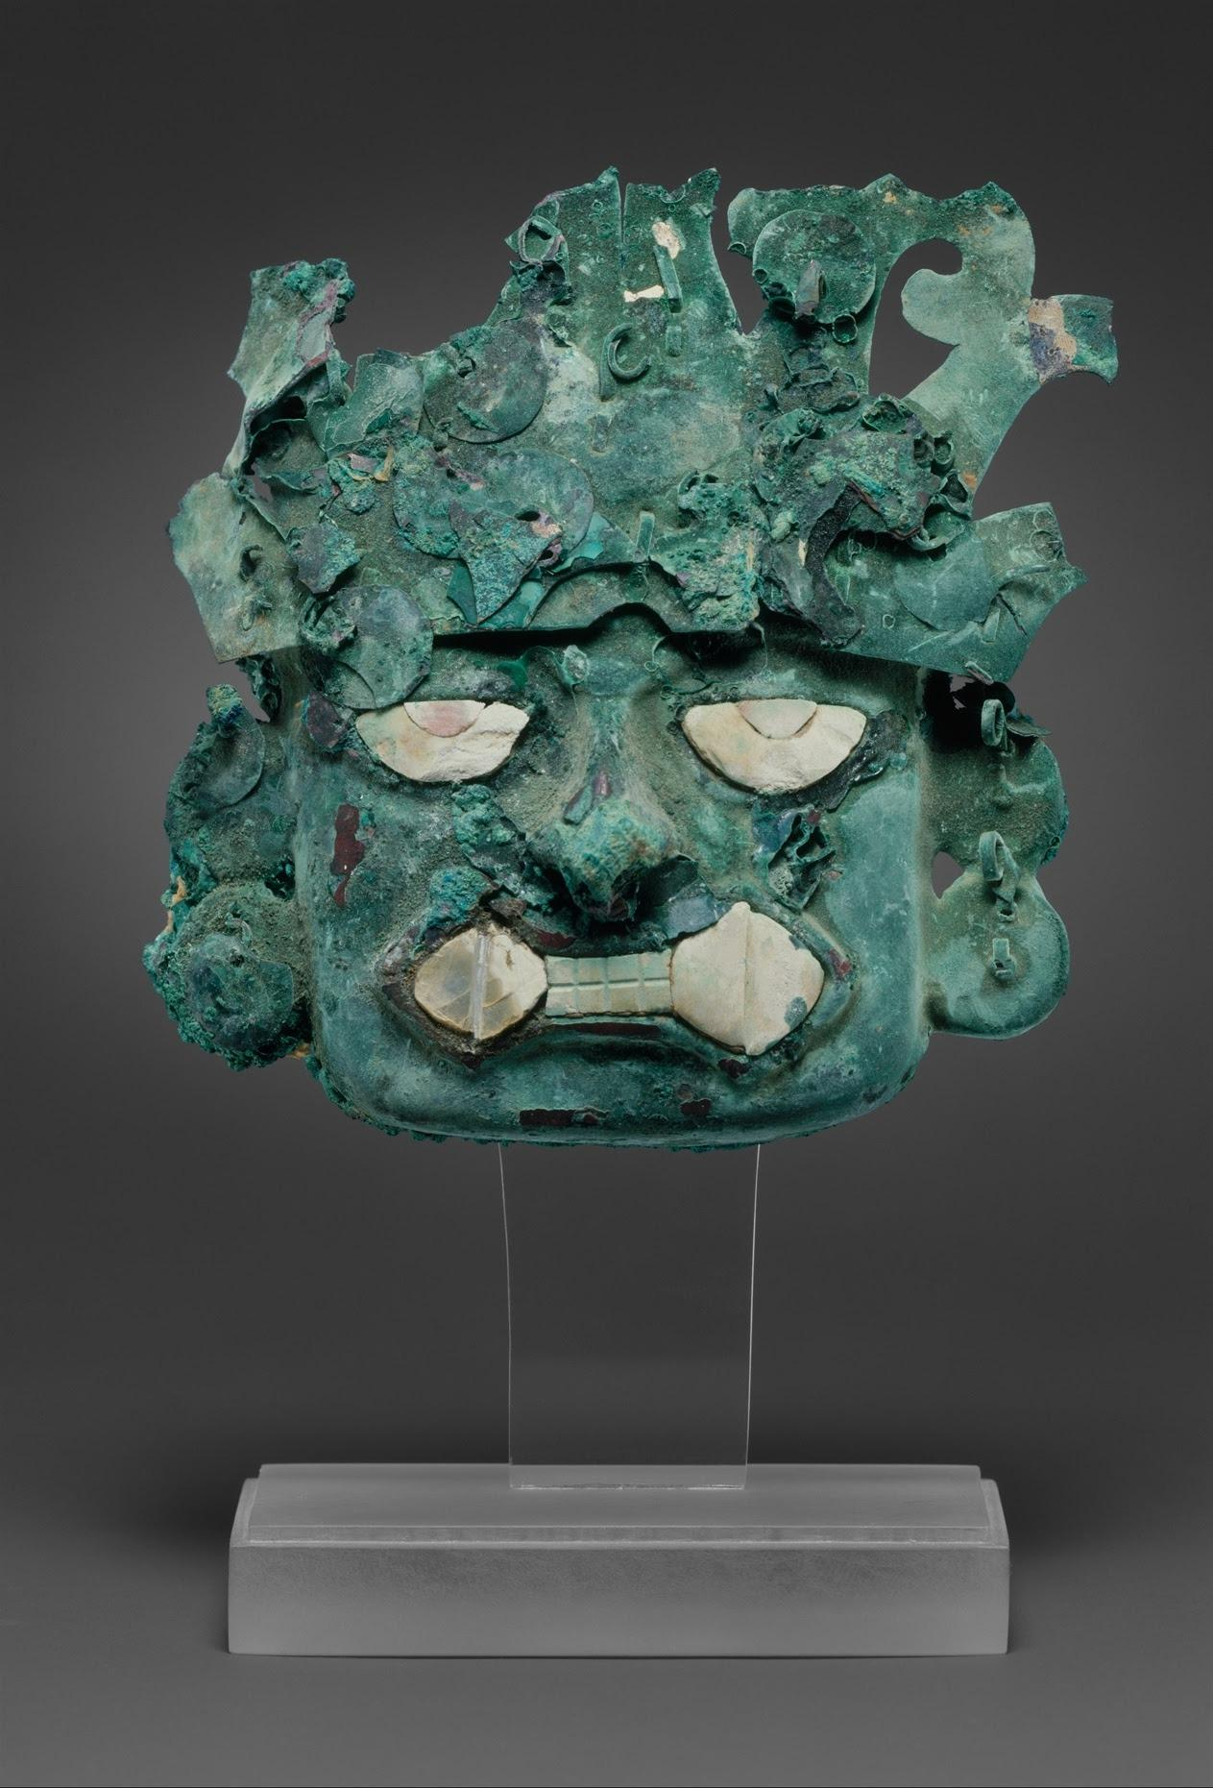

Moche (6th–7th Century)
Not on view
This mask was reportedly found at Loma Negra, an ancient cemetery near Cerro Vicús in the Piura Valley of Peru. Hundreds of tombs were discovered there containing large numbers of burial offerings.Powerful Moche rulers were interred there in the third century, when their control reached almost as far as Ecuador. The mask, made of silvered copper, has small tabs along the back edges that were once fastened to a larger object, probably a crescent-shaped headdress also made of metal. The relief face was raised by hammering a copper sheet over a special form, and the separately shaped headdress—now fragmentary—and the numerous small round dangles—now mostly missing—were originally attached by means of the tabs and staples. Many centuries of burial and exposure to salts in the soil caused corrosion products to form, covering the once brilliant, thin silver surface. “Half-eyes” and the fanged mouth, with its original shell inlay, depict a Moche deity known as the “decapitator.” Full-bodied representations of him on ceramics, textiles, wood, metal, and architectural reliefs show him holding a tumi (ritual cutting knife) in one hand and a severed human head in the other.

Metropolitan Museum of Art. (n.d.). The Collection. https://www.metmuseum.org/art/collection

Mummy Mask
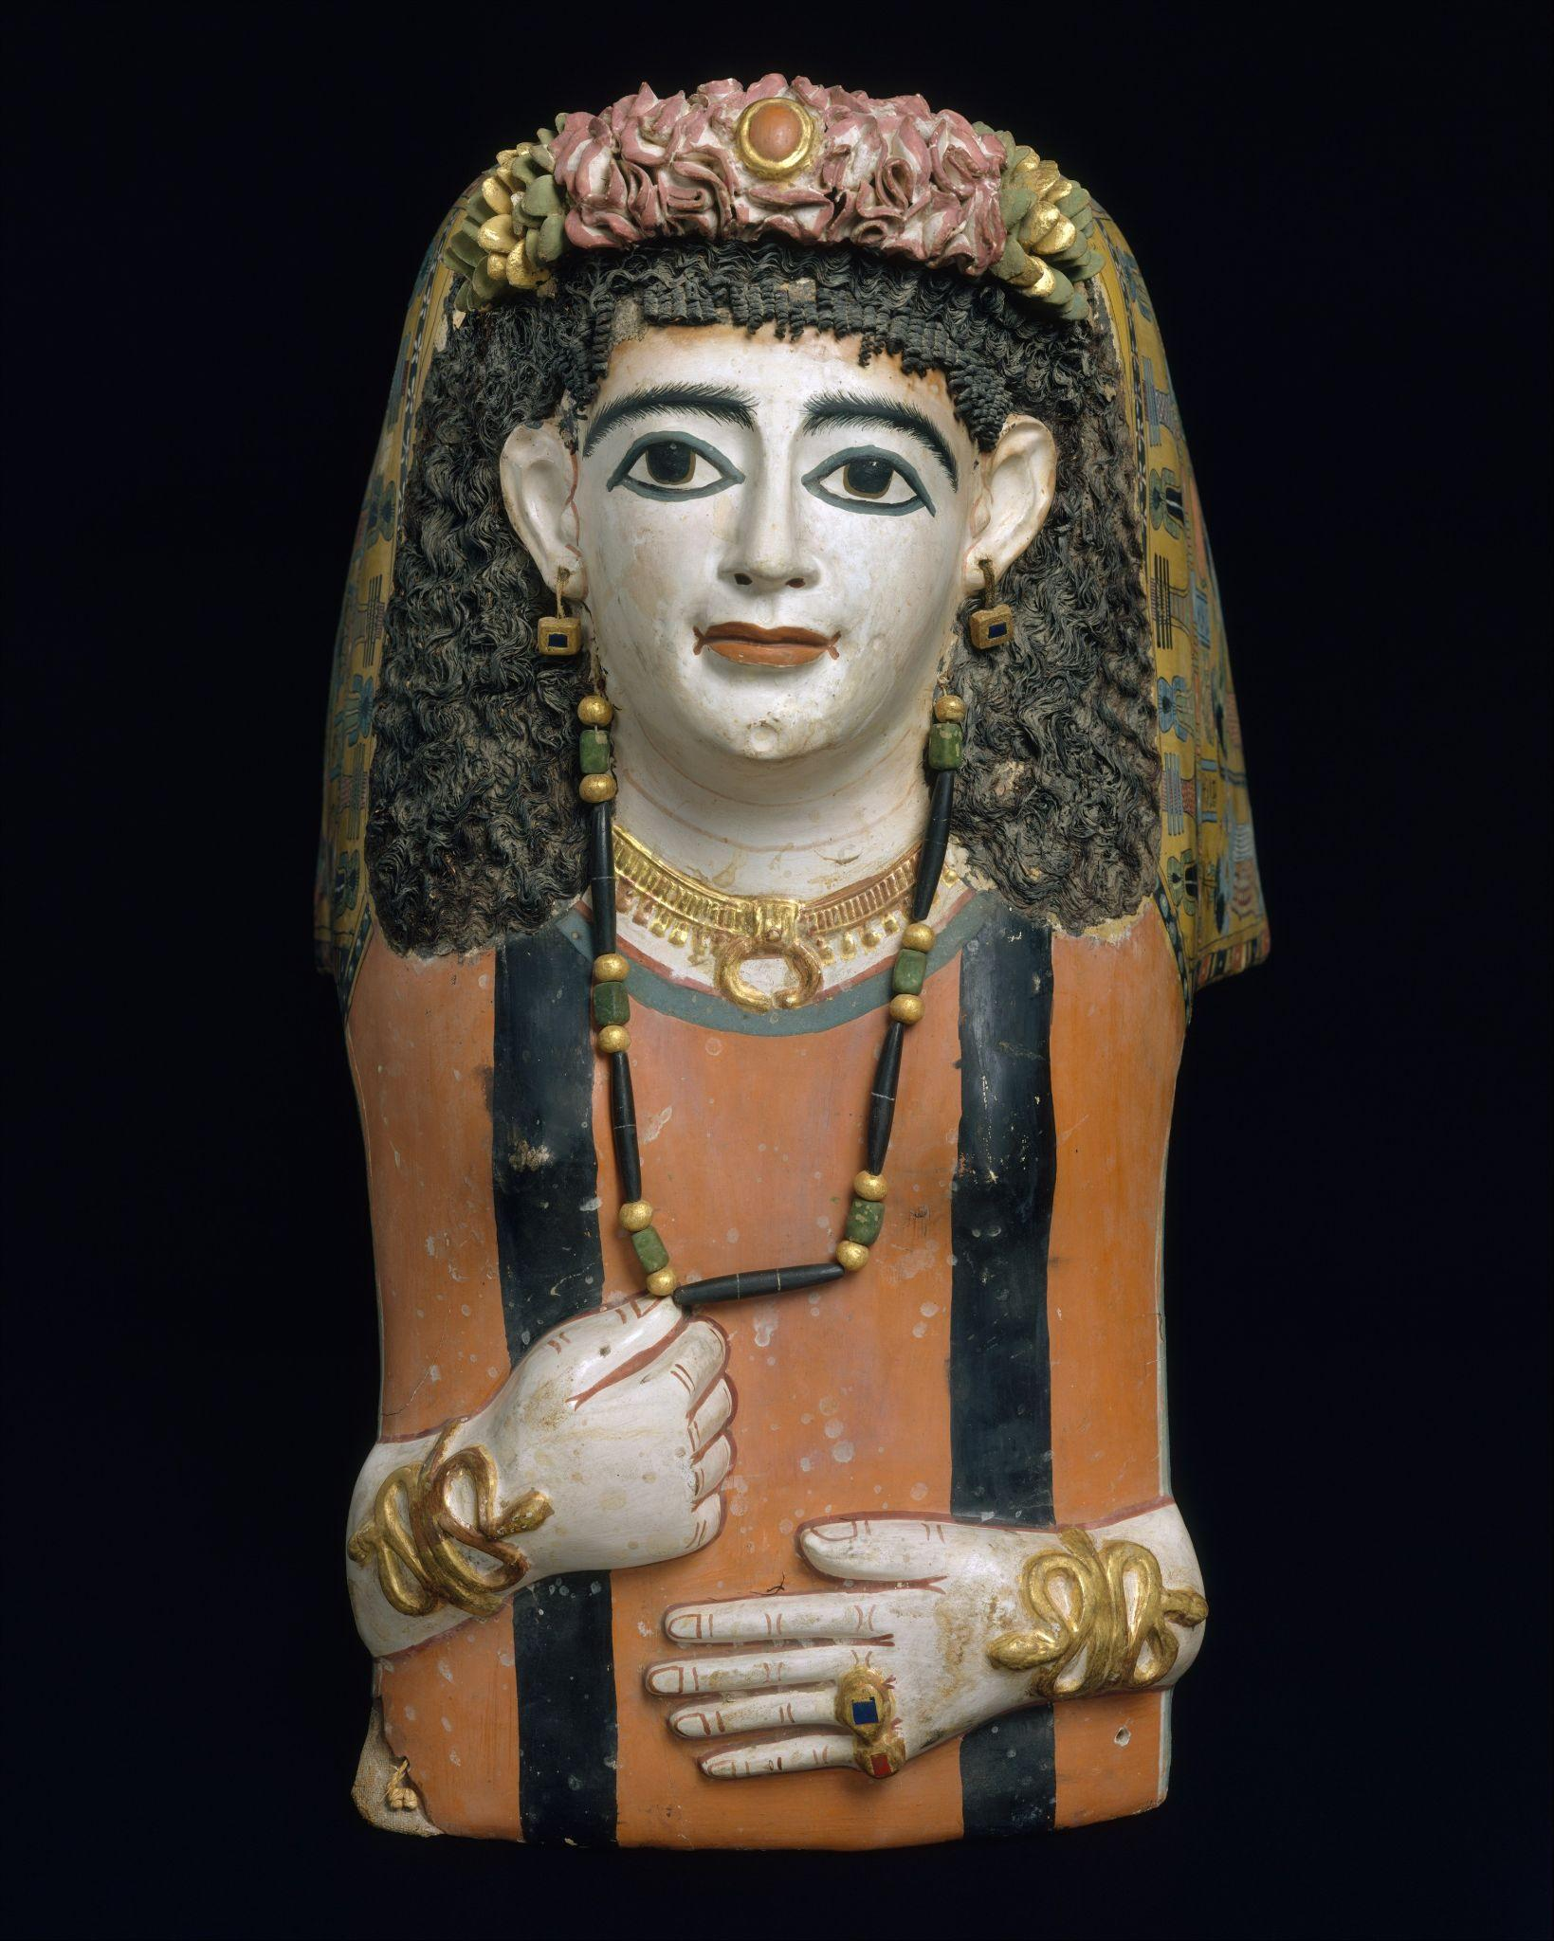
Roman Period (A.D. 60–70)
On view at The Met Fifth Avenue in Gallery 137
Plaster masks develop from Egyptian traditions. Roman fashions of hairstyle, dress and jewelry were followed to varying degrees. This mask is very similar to a group from Meir. The woman is represented as if lying flat upon her bier. She wears a long Egyptian-style wig made of plant fibers, a deep-red tunic with black clavi (stripes), and jewelry that includes a lunula (crescent pendant), and snake bracelets. At the lower edge of her tunic are two holes, which were used for attaching the mask to the mummy.
Over the top of her head is a gilded wreath encircling a scarab beetle that represents the sun appearing at dawn, a metaphor for rebirth. A main register runs around the edge of the mask which centers on the god Osiris, who is flanked by Isis and Nephthys. To the right of Osiris and the two goddesses are Horus, Amun, Thoth, and Re. To the left are Anubis, Tefnut, Hathor, and Seshat. These gods serve as witnesses to the deceased’s resurrection.

Metropolitan Museum of Art. (n.d.). The Collection. https://www.metmuseum.org/art/collection

Mummy Mask of Khonsu
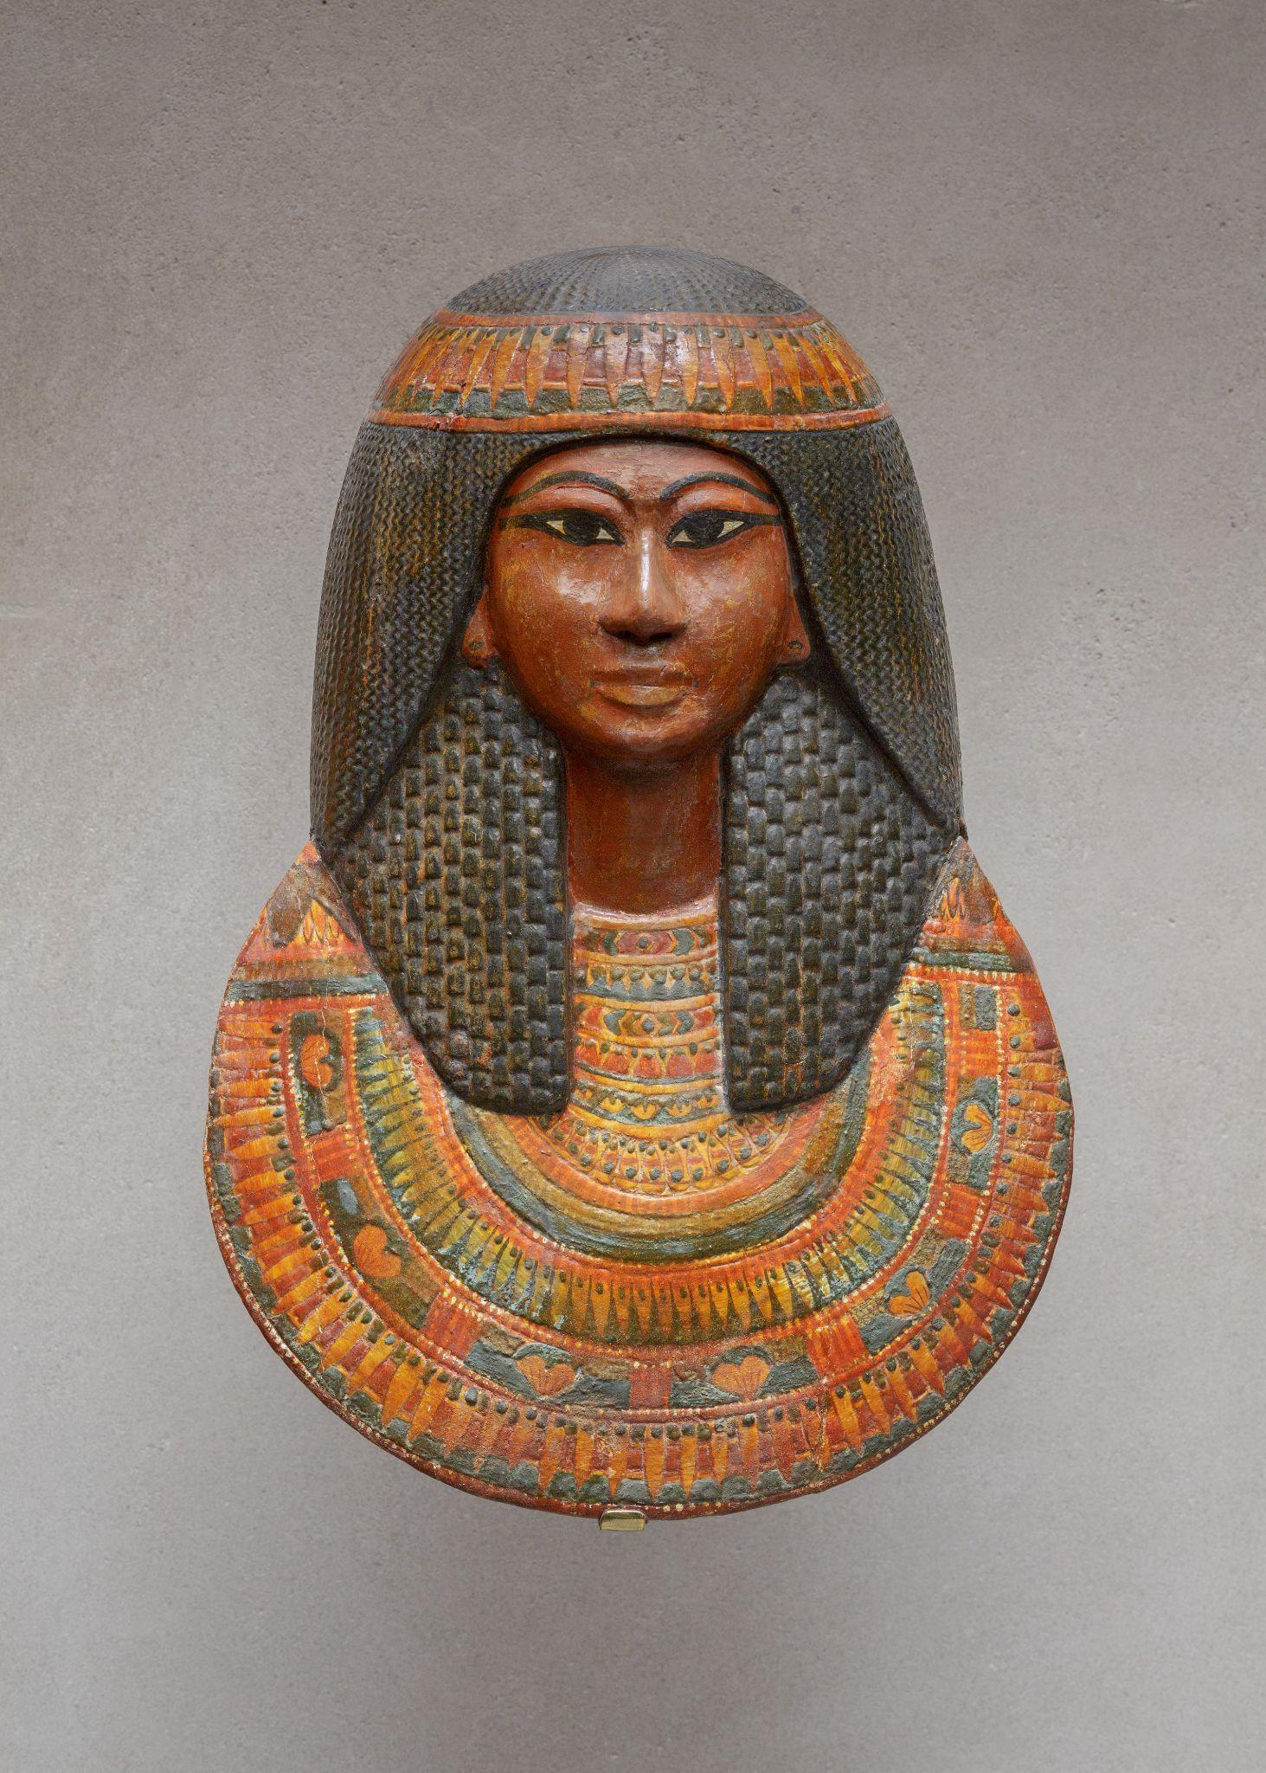

New Kingdom, Ramesside (ca. 1279–1213 B.C.)
On view at The Met Fifth Avenue in Gallery 126
Khonsu was the son of Sennedjem and Lineferty. He was buried in his father’s tomb. His mask was placed over the head and shoulders of his mummy. It is made of a wooden frame and cartonnage, a material made of plaster and linen. The shape is similar to the upper portions of Khonsu's inner coffin. Other objects in the collection were discovered in the same tomb.

Metropolitan Museum of Art. (n.d.). The Collection. https://www.metmuseum.org/art/collection

Japanese Iron Mask
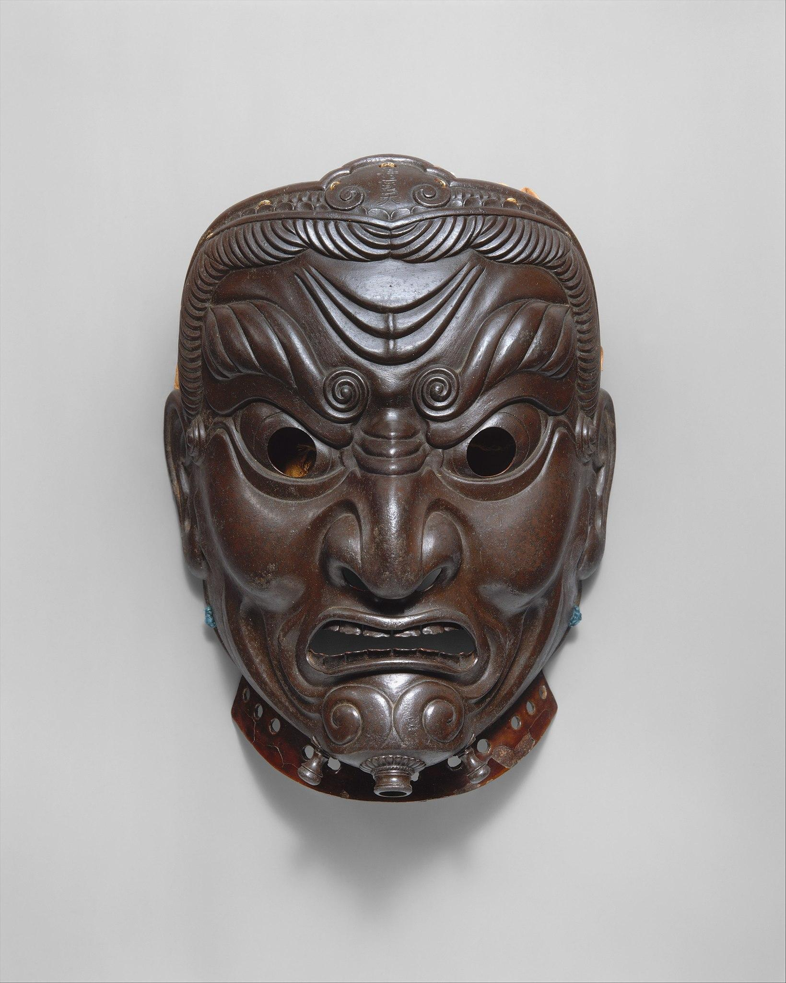

Inscribed by Myōchin Muneakira Japanese (dated 1745)
Not on view
This mask by Muneakira was already famous when it was first published in 1763. Muneakira was considered the most skilled armor maker of Japan. This work, made completely of iron, covers the full face and is unusual for its style. Muneakira learned the art of repousse hammering from his uncle, whom he apprenticed with. He perfected the art of making smooth, curved surfaces into sections that were joined by pins on the interior. This mask represents Jikokuten, guardian of the East, one of the Four Kings of Heaven. The mask is one of the few to retain its original silk head covering sewn to the upper edges.

Metropolitan Museum of Art. (n.d.). The Collection. https://www.metmuseum.org/art/collection
Eharo Mask
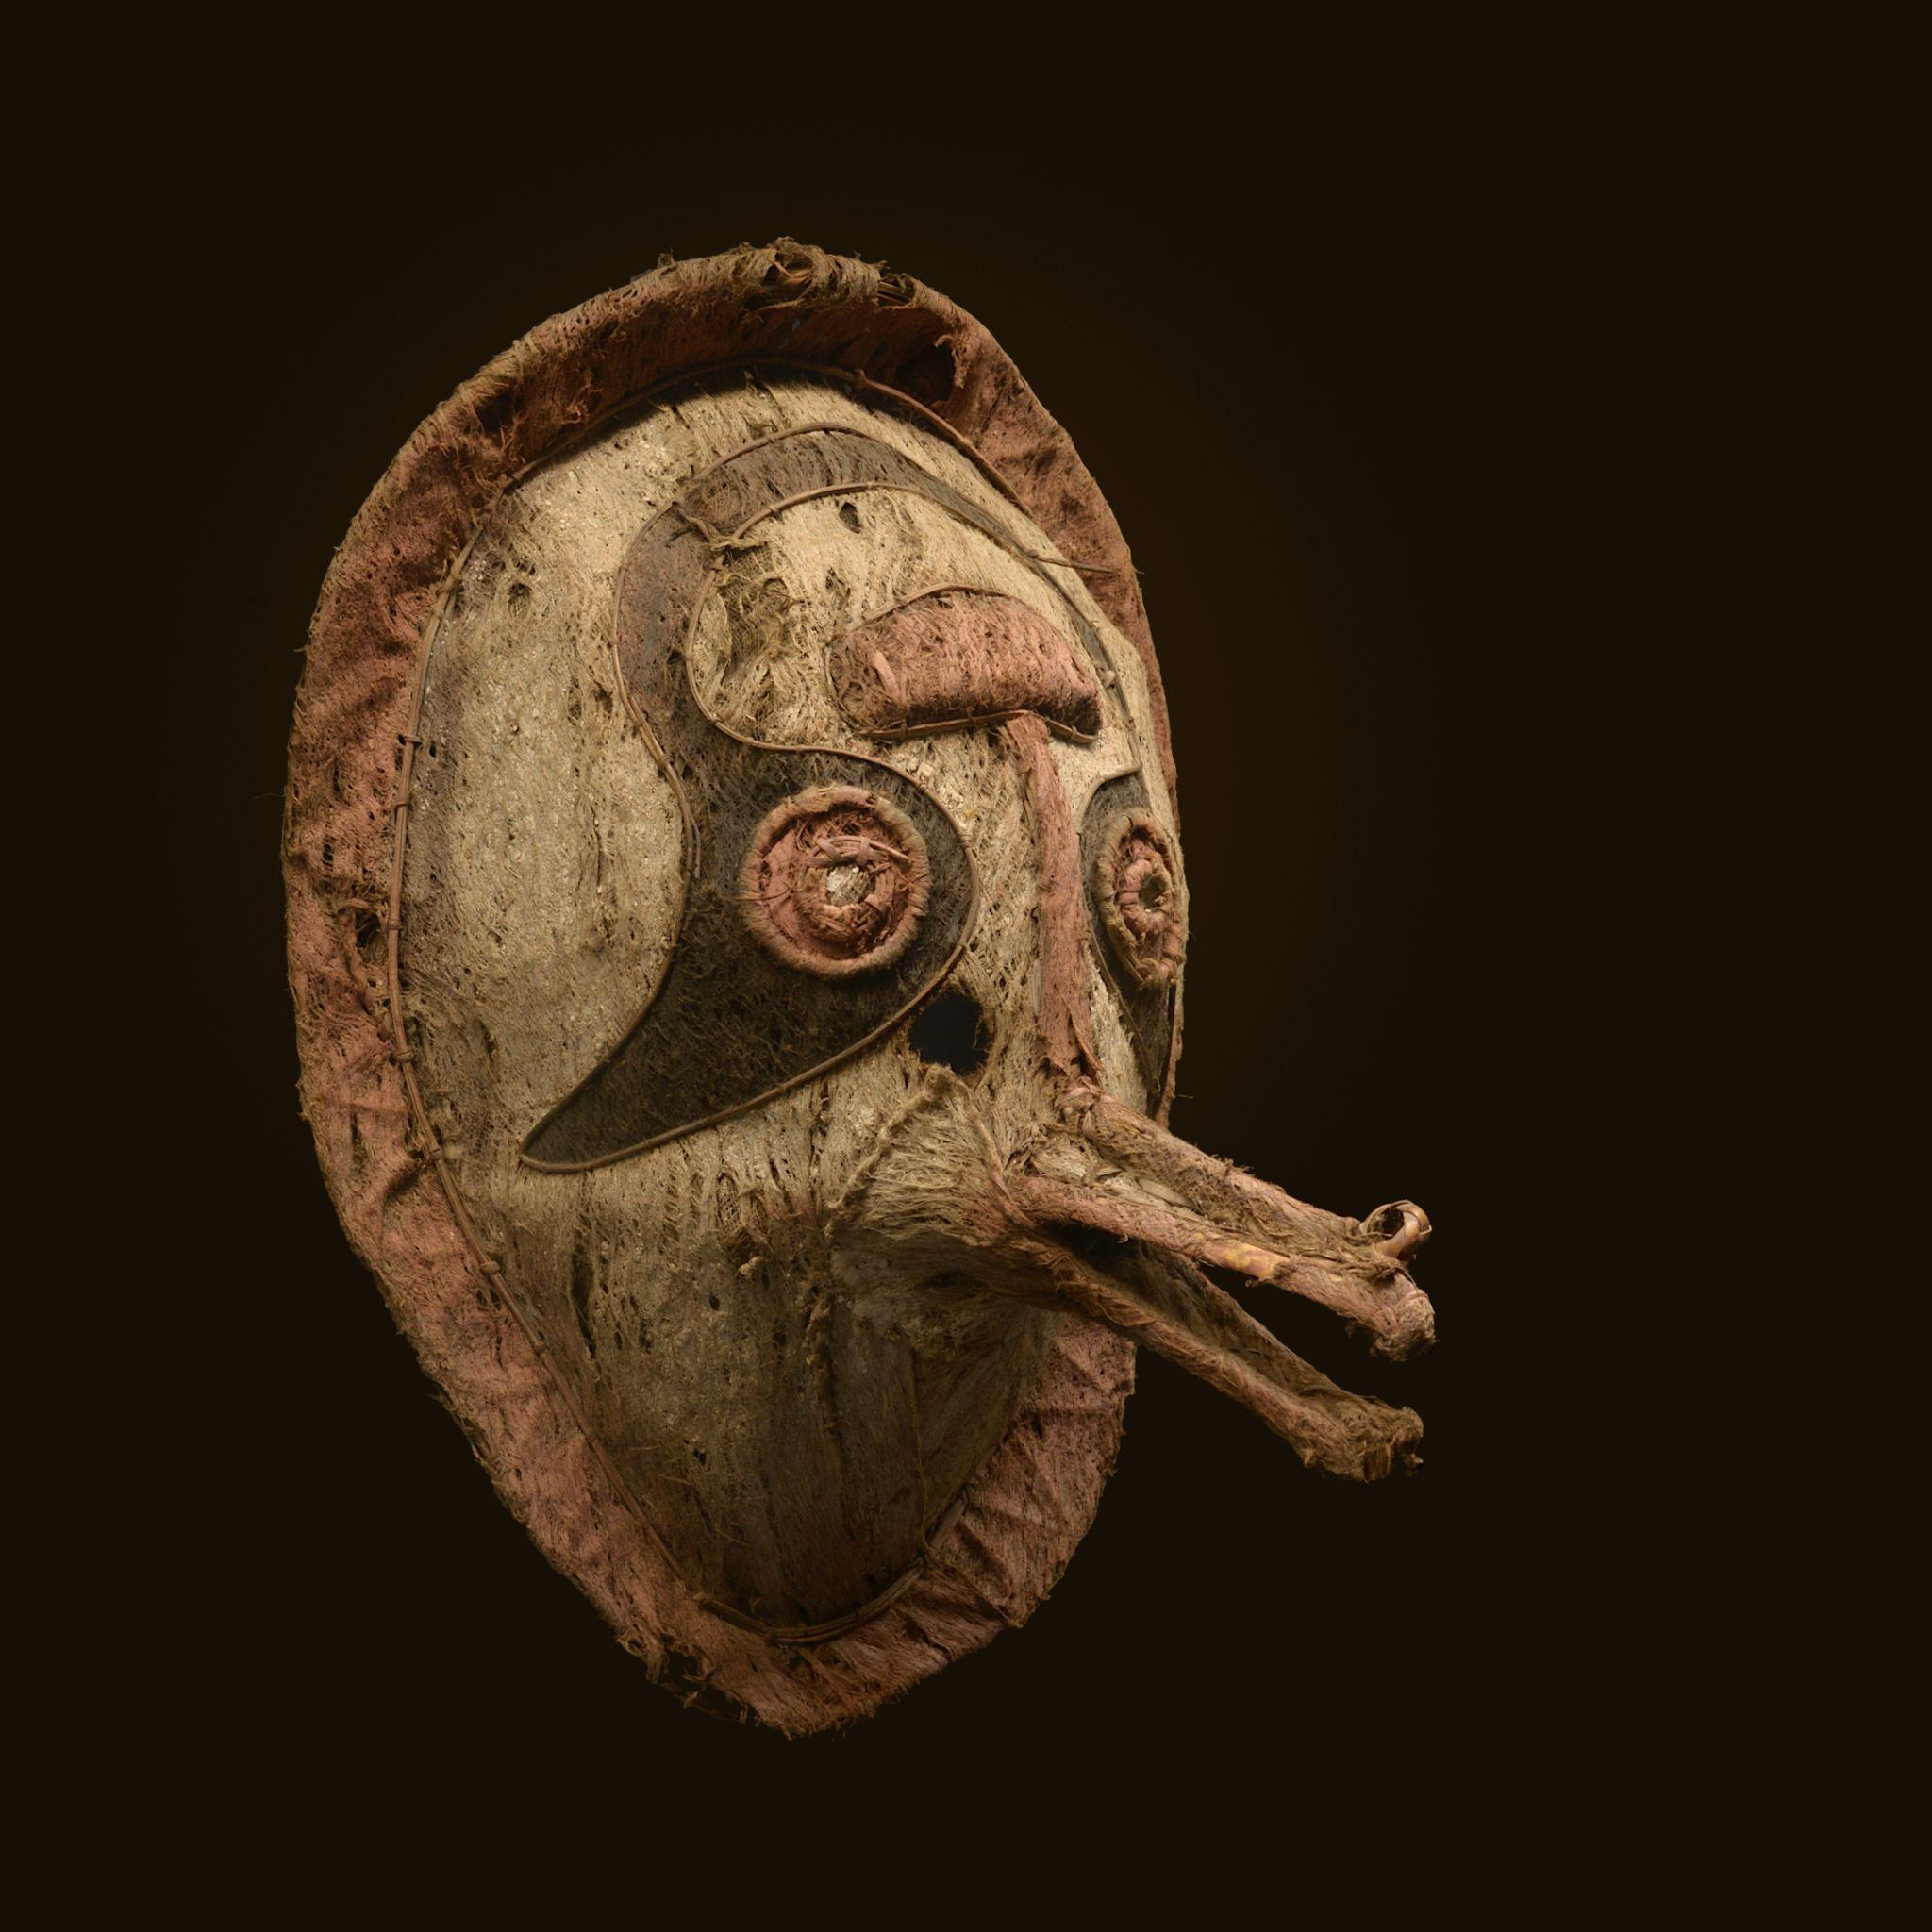

Elema Culture, Papua New Guinea (Dated 1745)
Acquired by the Museum of Toulouse in 1882
Eharo masks (literally "dance head" or "dance mask") were a type of mask used by the Elema people of the eastern Gulf of Papua as part of the "hevehe" cycle of masked rituals. These masks were crafted from barkcloth, vegetable fiber, and various pigments.
In contrast to the large sacred hevehe masks, the smaller eharo masks were meant for amusing the audience and were used at the beginning and end of the hevehe cycle. Some represented specific spirits, while others were simply humorous archetypes from stories. Because they are not as sacred compared to other masks, the women of the village were allowed to observe the mask's construction. These masks would later be burned about a month after the ceremonies, making it difficult to recover samples.
During this time period, many rituals were destroyed and replaced with more European-accepted ones. Despite this suppression, the Papuan Gulf people continued to practice these cycles and display their heritage.
Museum of Toulouse. (1882). Eharo mask [Mask, Elema culture, Papua New Guinea] [Museum artifact]. Museum of Toulouse Collection.
Carved Wooden 'Spirit Mask'
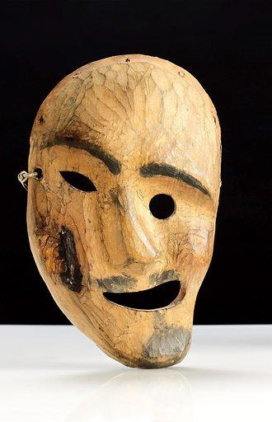

Alaska (1801–1900)
Science Museum, London
A shaman is a religious figure and healer who in times of crisis sometimes calls upon the aid of supernatural forces. This ‘spirit mask,’ depicting the distorted face of a helping spirit, was worn by an Inuit shaman or angakok in Alaska, North America. These masks were used in ritual dances to ensure good hunting and good health. The shaman’s role is to communicate with the spirits and ask their help for the sake of the community.

Look and Learn. (n.d.). Carved wooden ‘spirit mask’, Alaska, 1801–1900 [Photograph]. Look and Learn Archive. Retrieved June 16, 2025, from Look and Learn website: https://www.lookandlearn.com/history-images/YW058729L/Carved-wooden-spirit-mask-Alaska-1801-1900

Mask of Hyena
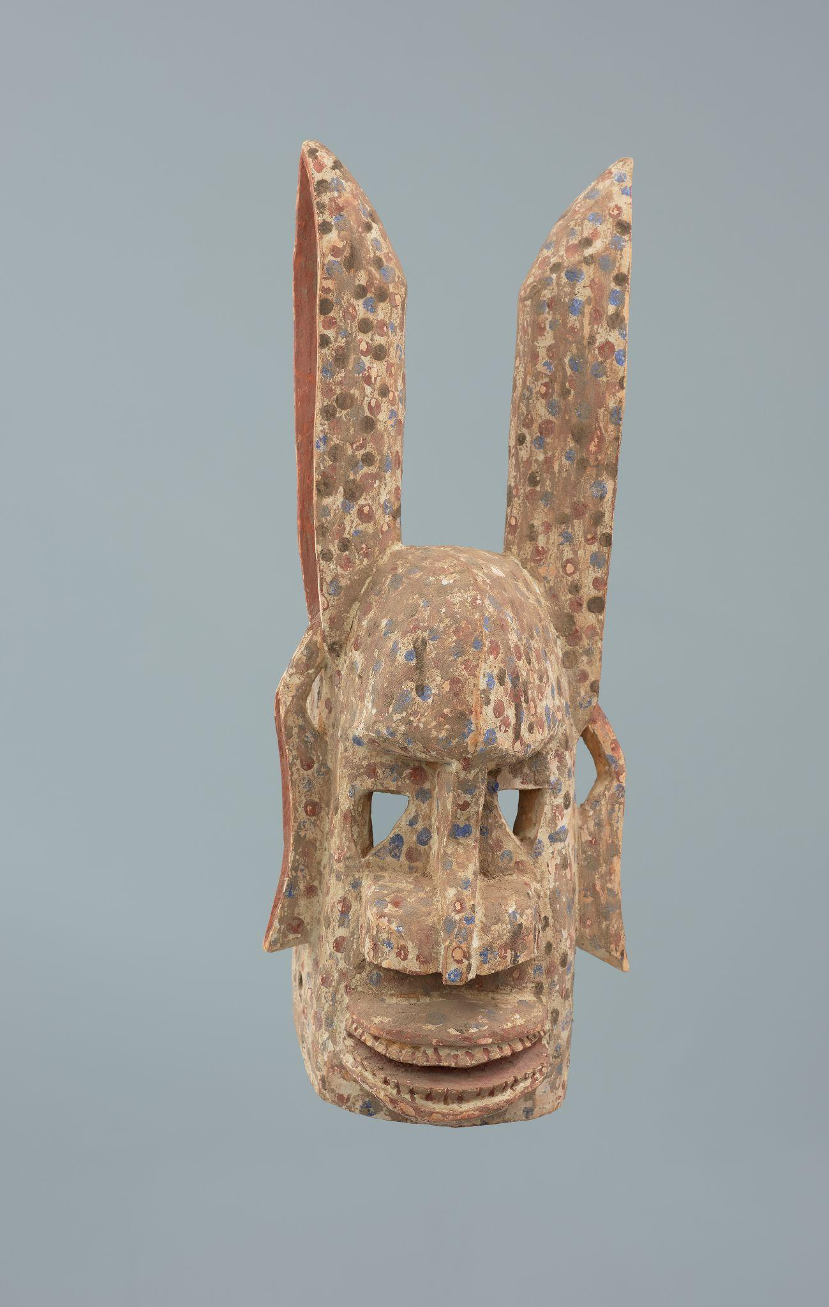

Między (1951—2000)
Part of the Collection of Dogonian art
The hyena mask (tara, tata) depicting the head of the animal was worn during the Dama funeral rituals ending the long period of mourning for the deceased. According to myth, the prototype of the first carved hyena mask was the head of a female left behind by an embittered and angry lion. He devoured the rest of the hyena's body in revenge for the death of his offspring. The instigator of the whole event was a hare (rabbit), who showed the hungry widowed hyena the lion cub's hiding place. The hyena was tempted and killed the cub. The unscrupulous hare blamed her for its death and tricked her out of the cave, where she had hidden from the enraged lion-father. The dancers were exclusively men from the Awa society. The secret of the masks was stolen by a woman from the bush. She brought the mask to the village where it was decided that its power was dangerous for women, and so the mask became the domain of men.

Muzeach, W. (n.d.). Mask of hyena [Photograph of Dogon mask from Mopti region, Mali; national museum object no. MNS/AF/7193]. In Museums collection. National Museum in Szczecin. https://wmuzeach.pl/all‑objects/VvstsEzsjKzW3QkMuLaY_mask‑of‑hyena‑
Face Mask Representing Hevaya, the Soldier from the Kolam

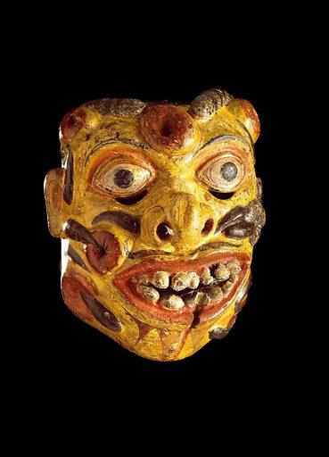

Sri Lanka (Date Unknown)
Science Museum, London
Covered in bites and leeches, this carved wooden mask represents Hevaya, the soldier from the masked kolam plays of Sri Lanka. There are over fifty characters in the plays, and Hevaya represents a figure of fun. ‘Kolam’ literally means appearance or impersonation, and it is thought that the plays began as an ancient fertility ritual. The plays may also be a prelude to the exorcism of demons, which are believed, in parts of Sri Lanka, to be the cause of disease.

Look and Learn. (n.d.). Face mask representing Hevaya, the soldier from the Kolam [Photograph of carved wooden mask, Sri Lanka, 1771–1900]. Science Museum, London. https://www.lookandlearn.com/history-images/YW057484L/Face-mask-representing-Hevaya-the-soldier-from-the-kolam

Hunter’s Mask
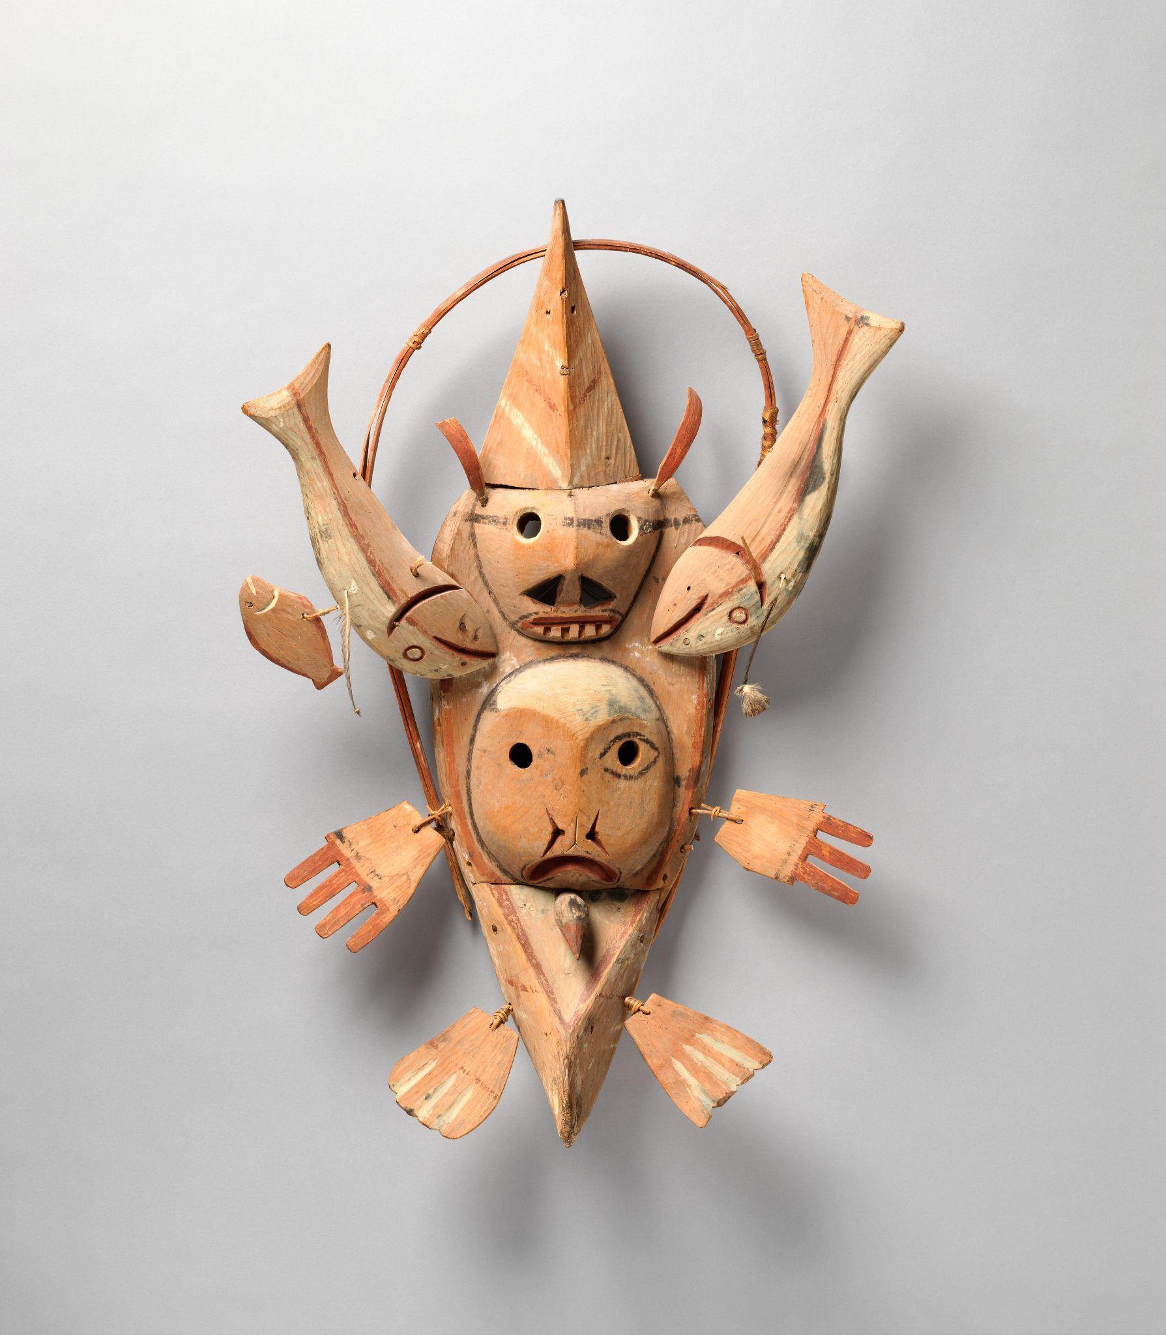

Yup'ik, Native American (ca. 1900)
On view at The Met Fifth Avenue in Gallery 746
Within the bentwood border of this mask, a hunter’s kayak searches for quarry. Near the center of the boat, the face of a humanoid seal spirit emerges with an unidentified spirit visage above. The tiny bird head at the bow may portray the hunter as seen through the eyes of his prey. Fish and flippers surround the vessel, representing the supernatural animals that slip through the thumbless spirit hands and into the physical world to be hunted.

Metropolitan Museum of Art. (n.d.). The Collection. https://www.metmuseum.org/art/collection

Dance Mask
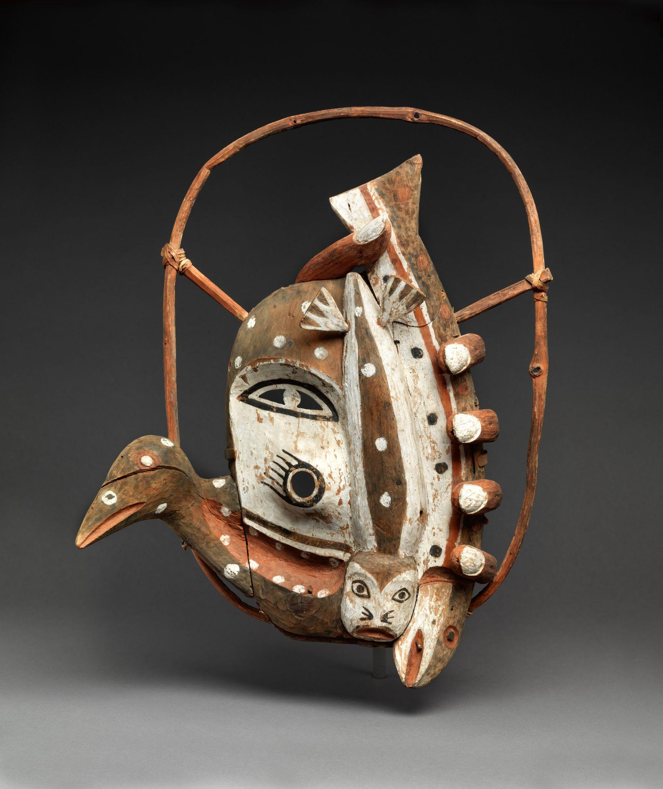

Yup'ik, Native American (ca. 1900)
On view at The Met Fifth Avenue in Gallery 746
Worn during dance ceremonies, this Yup’ik mask depicts the artist’s vision of the universe. The whimsical imagery combines elements drawn from the Arctic realms of earth, sky, and water, such as the face with a black paw motif, the finely rendered fingers of a human hand grasping a fish, the head of a bird, and the seal. The bent willow bow that frames the central image once held feathers or other adornments.

Metropolitan Museum of Art. (n.d.). The Collection. https://www.metmuseum.org/art/collection

Whistling Mask
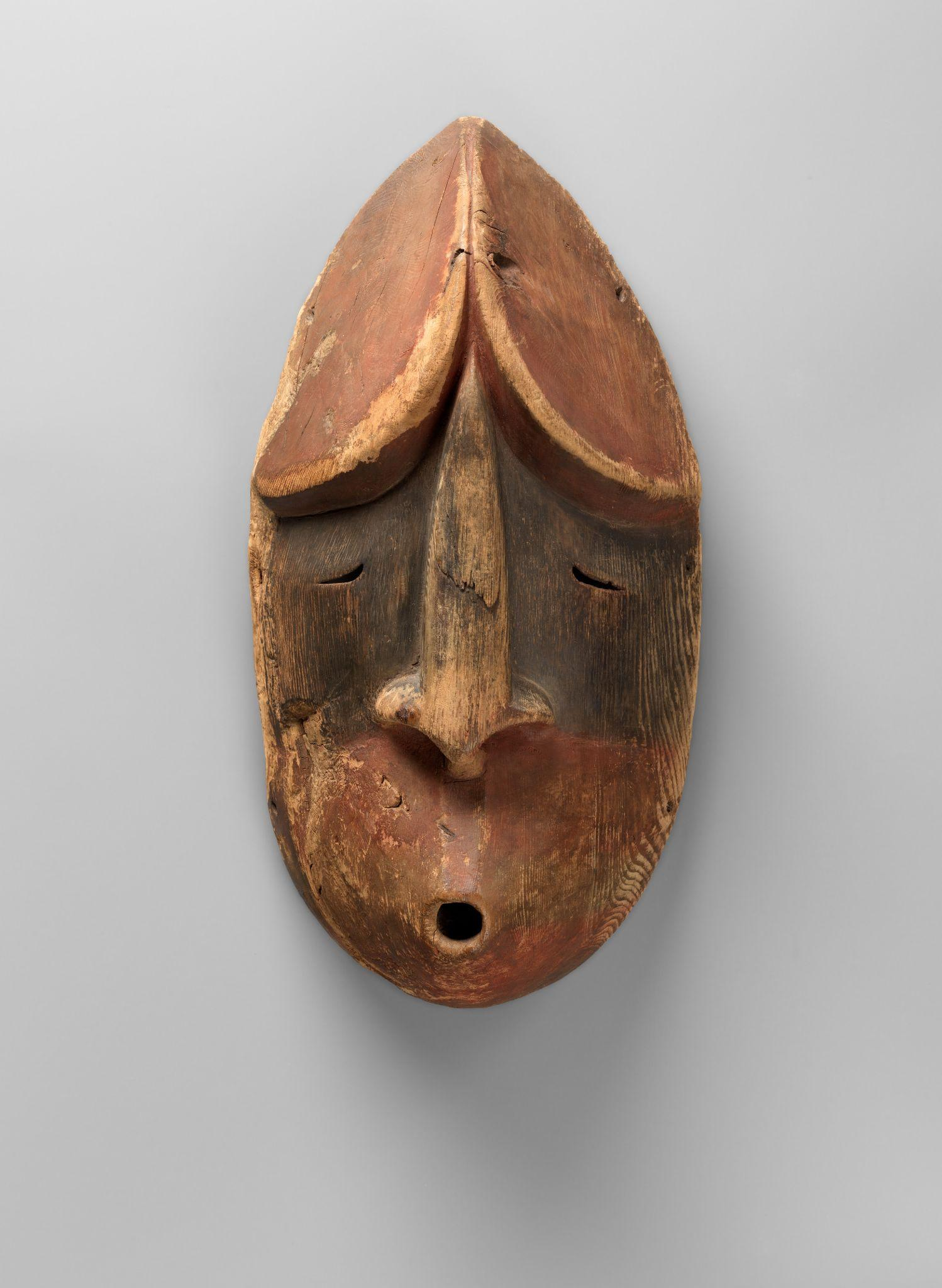

Alutiiq/ Sugpiaq, Native American (ca. 1870)
On view at The Met Fifth Avenue in Gallery 746
The peoples of the Arctic region use music and performance to invoke the spirit realm. According to native Alaskan beliefs, spirits communicate with people through whistling: these masks may be the faces of such supernatural beings, as they appear to whistle at their beholders. The formal resemblance between the pair, including the prominent noses, minimal eyes, and pointed head decorations, may mark them as specific, linked characters in a myth. Early twentieth-century modernist artists and collectors were drawn to the bold simplicity of such works.

Metropolitan Museum of Art. (n.d.). The Collection. https://www.metmuseum.org/art/collection
Theatrical Mask for Offering to Dionysus
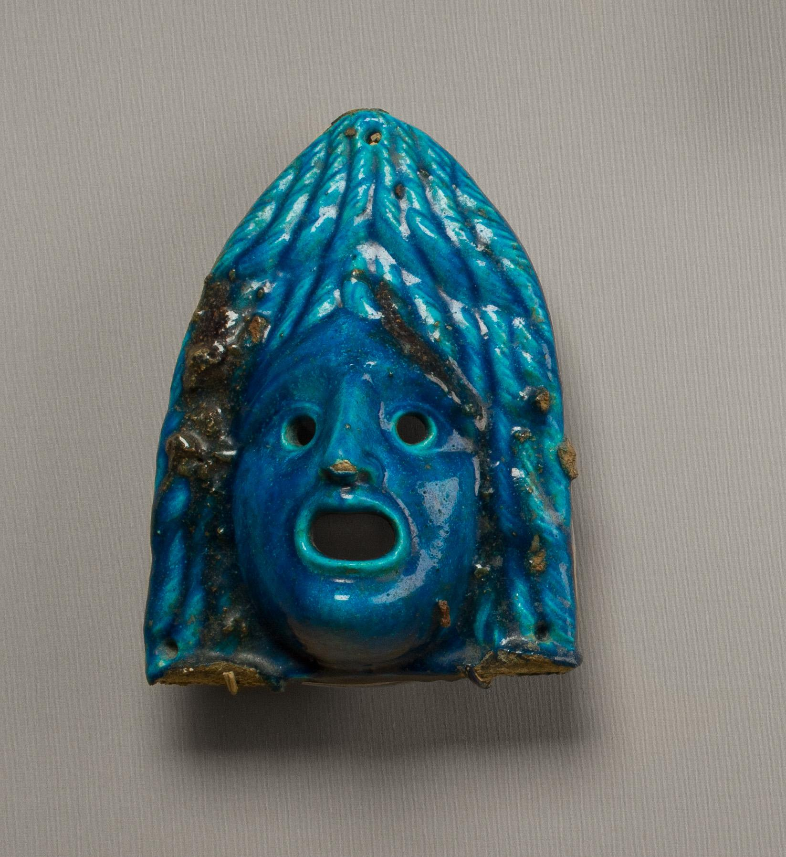

Dionysus (A.D. 2nd century)
Not on view
This mask is too small and brittle to have served as actual theater masks. They refer to the god Dionysus, patron of the theater and god of rebirth. In Egypt he was equated with Osiris. Terracotta theater masks are found in burials and sanctuaries in Greece, in sanctuaries and as garden decorations in Italy. In Egypt, they are known only from burials, as offerings to Osiris/Dionysus. Terracotta masks from Antinoöpolis in Middle Egypt probably originate in tombs, and a terracotta theater mask was found in a Roman Period chapel over a burial at Hawara. The masks are said to have been part of a find of numerous faience (ceramic) objects at Arsinoe, capital of the Fayum region.

Metropolitan Museum of Art. (n.d.). The Collection. https://www.metmuseum.org/art/collection

Netsuke of Noh Mask: One-Eyed Hyottoko

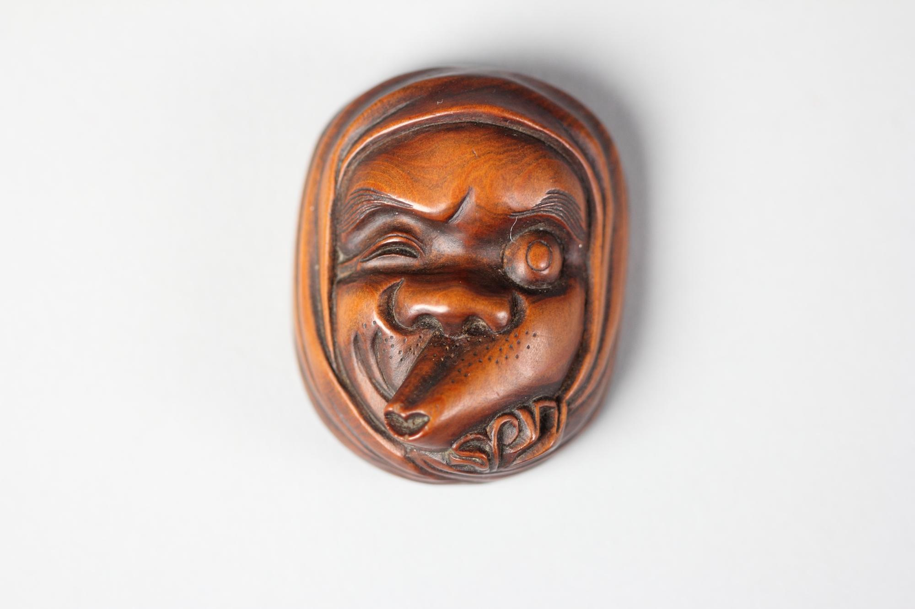

Japan (19th century)
Carved in 19th‑century Japan during the Edo or early Meiji period, this small netsuke represents the comical Hyottoko mask, distinguished by its misaligned mouth and one‑eyed expression. Crafted from wood, the piece measures roughly 2 × 1⅝ × ¾ inches and originally functioned as a traditional netsuke—a toggle used to anchor a pouch or small container to a kimono sash. While Hyottoko masks are typically associated with jest and festive performances in Japanese folklore, this netsuke distilled that theatrical humor into a compact, finely carved ornament—serving a practical purpose while also reflecting cultural charm.

Metropolitan Museum of Art. (n.d.). The Collection. https://www.metmuseum.org/art/collection

Face Mask Ornament
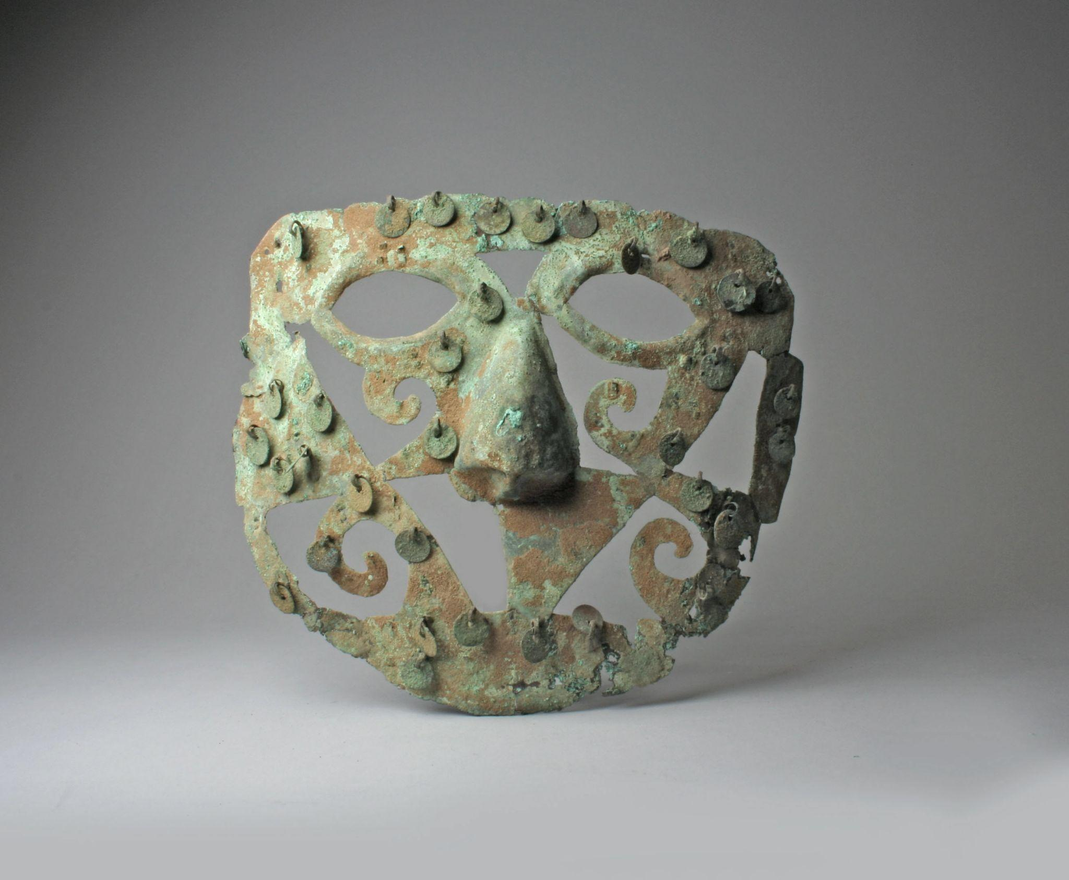

Moche (6th–7th century)
This gilded copper Face Mask Ornament was crafted by the Moche culture in Peru—and dates from the 6th–7th century CE. Measuring approximately 6⅜ × 7½ inches (16 × 19 cm), this lavishly decorated piece likely served as a ceremonial ornament, perhaps attached to a headdress, ritual attire, or a funerary object to signify status and spiritual power. Its striking mask design evokes the visage of a supernatural being or ancestor, reflecting the Moche’s deep connection between art, authority, and ritual practice. Though not currently on view, the mask ornament remains an exceptional example of metallurgy and symbolic expression in Pre-Columbian culture.

Metropolitan Museum of Art. (n.d.). The Collection. https://www.metmuseum.org/art/collection
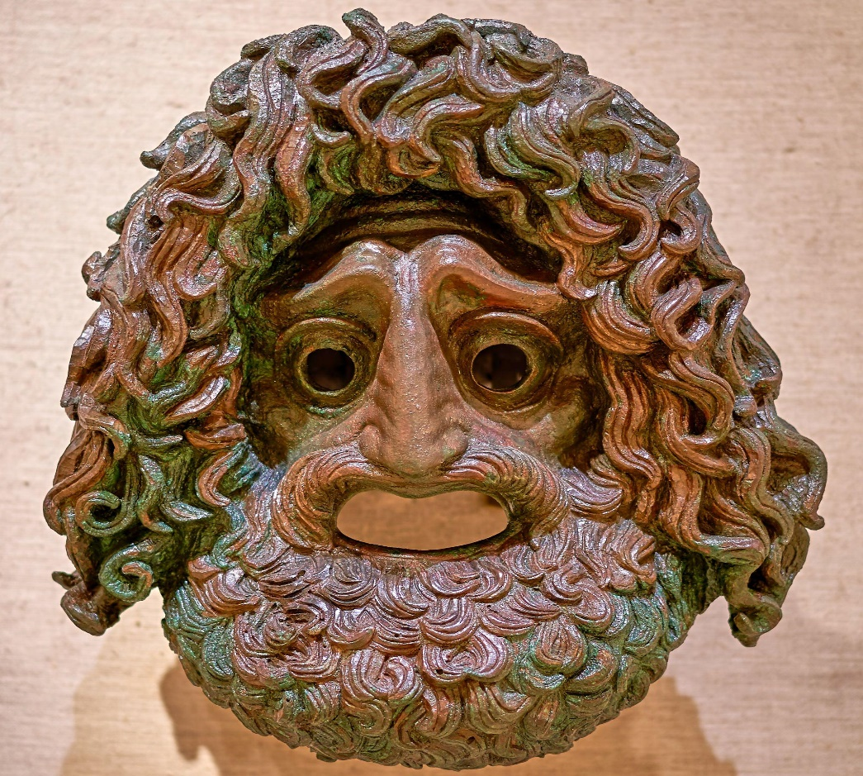
Tragedy Mask

Greek (4th Century B.C.)
Archaeological Museum of Piraeus
This imposing bronze mask, dating from the 4th century BCE, was unearthed in Piraeus and now resides in the Archaeological Museum of Piraeus. Crafted from sheet bronze, it depicts a tragic theatrical mask—complete with wide-open mouth and eye apertures—designed not for actual performance but likely as a votive offering or decorative display piece. In ancient Greek theater, such larger-than-life masks symbolized key dramatic archetypes and were believed to enhance voice resonance, projecting emotion and character to audiences in large amphitheaters. Its bold features, dramatic expression, and durable materials reflect both the cultural importance of theater and the spiritual reverence Greeks held for Dionysus—the god of drama—who was honored in these performances.

Zde, P. (2020, January 6). Greek tragedy mask, 4th cent. B.C. (PAM 4640, 1-6-2020) [Photograph]. Wikimedia Commons. https://commons.wikimedia.org/wiki/File:Greek_tragedy_mask,_4th_cent._B.C._(PAM_4640,_1-6-2020).jpg
Shang Bronze Mask

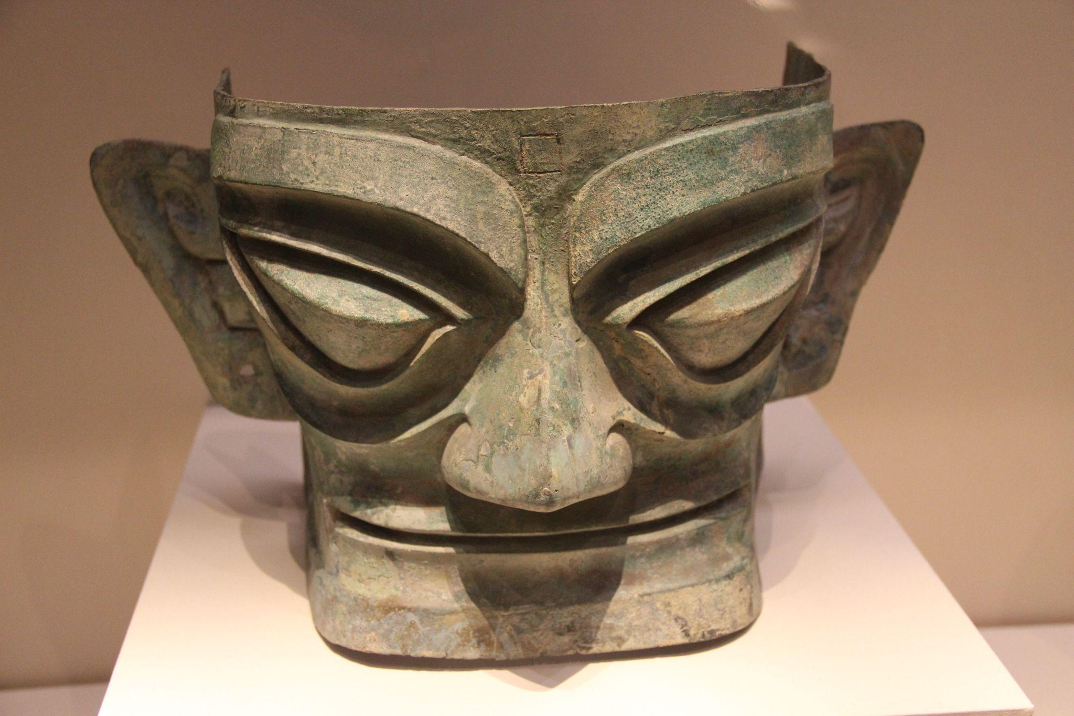

Sanxingdui Culture, Sichuan (1600–1046 BCE)
National Museum: China through the Ages, Exhibit 2
This mask originates from the Sanxingdui archaeological site in Guanghan, Sichuan Province, China, and dates to the late Shang Dynasty. Cast in separate pieces and riveted together—including the face, eyes, cheeks, and ears. The mask is made of bronze, with remnants of paint and possible gold foil—red hues on lips and black on eyes—and even traces of silk found on the surface. Unearthed from a sacrificial pit, these large-scale masks were likely used in ritual offerings, possibly mounted on pillars or temple structures, and represented deities, supernatural beings, or mythic ancestors such as the legendary Shu King Can Cong. Their exaggerated features—protruding almond-shaped eyes, enormous ears, and stylized facial forms—symbolize superhuman vision and hearing, underscoring their ceremonial importance within ancient Shu spirituality.

Shizhao. (2007, November 16). Shang Bronze Mask, Sanxingdui [Photograph]. Wikimedia Commons. https://commons.wikimedia.org/wiki/File:Shang_Bronze_Mask,_Sanxingdui.jpg

