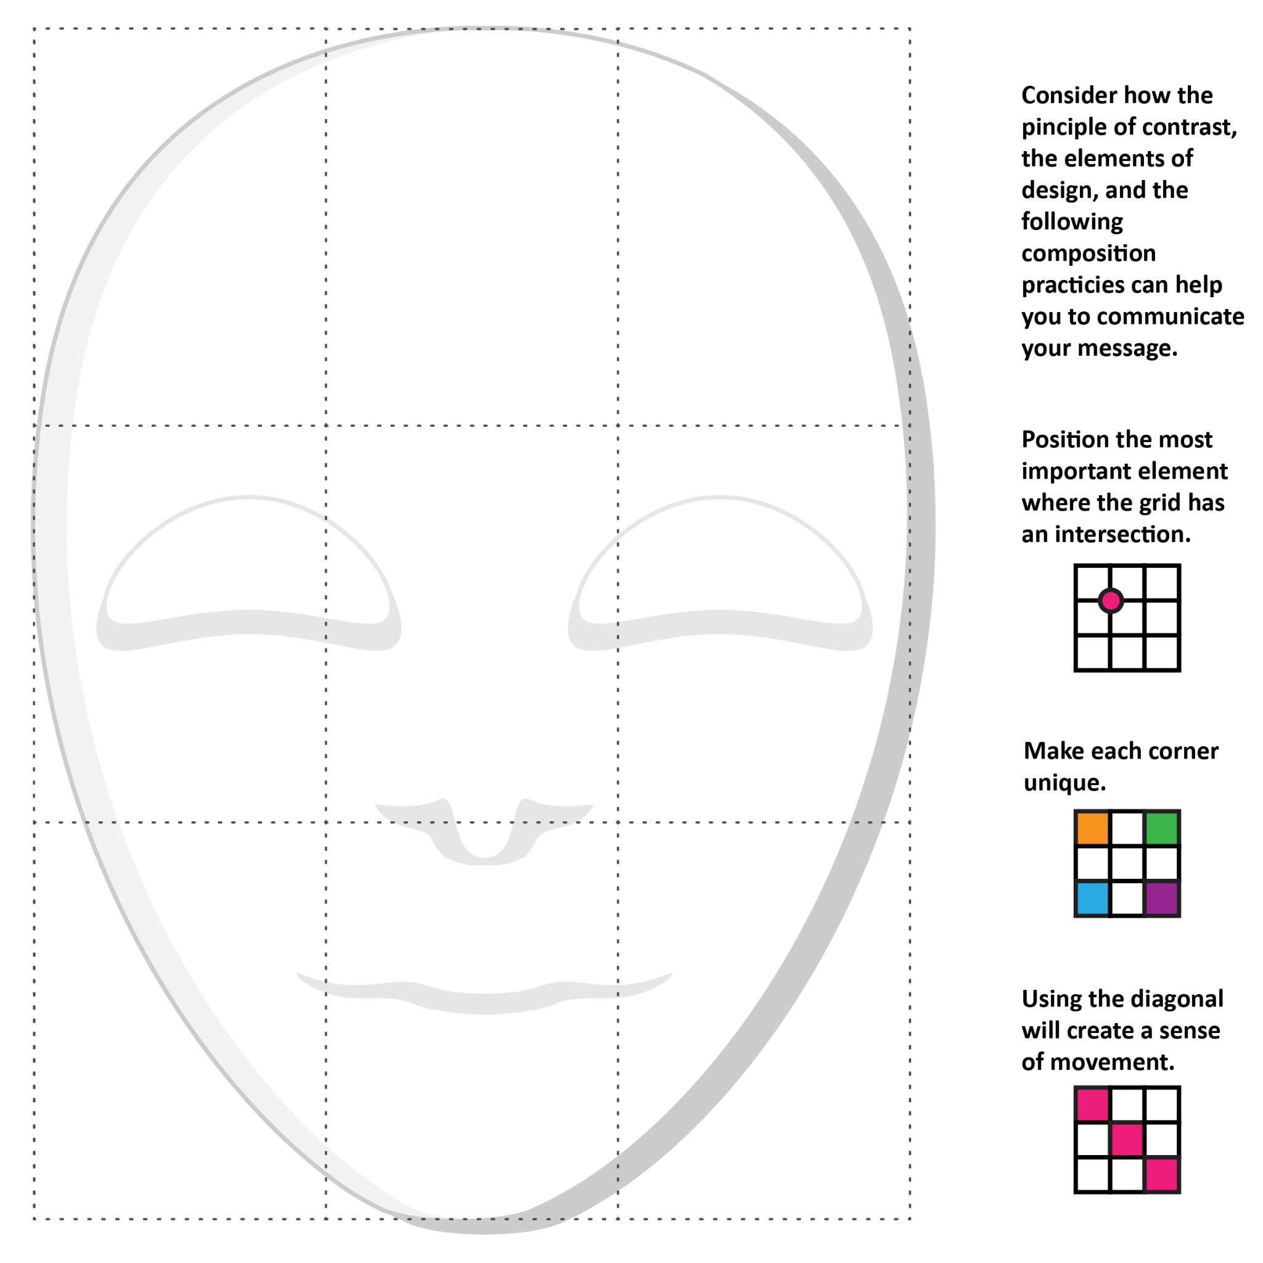

Element/s of Design | What are you trying to say with the use of this element?
Colors Available: white, pink, red, yellow, orange, grey, light green, dark green, peach, purple, brown, light blue, blue, black

