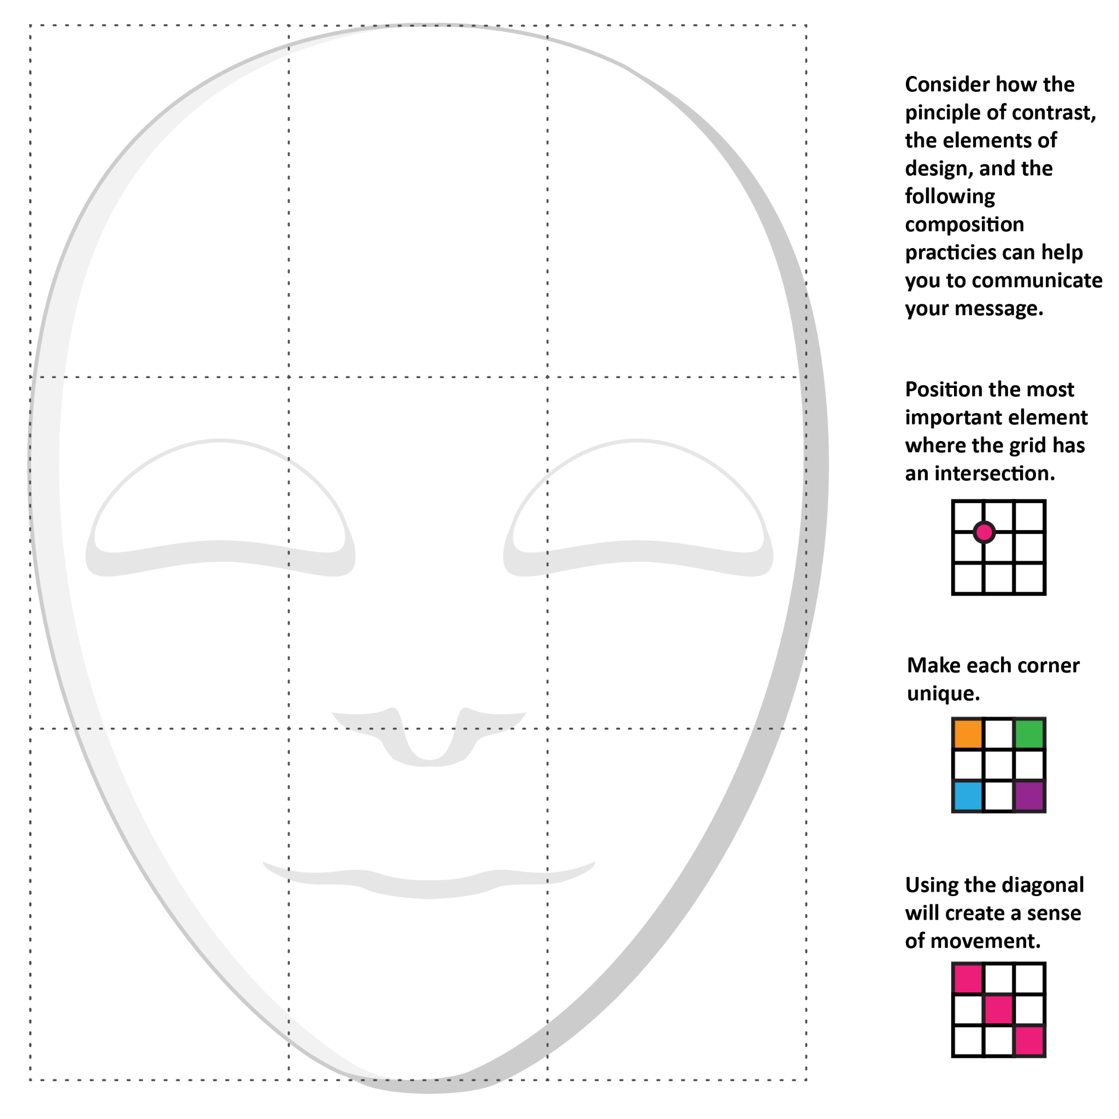

| **Element/s of Design** | **What are you trying to say with the use of this element?** |
| --- | --- |
|  |  |
|  |  |
| Colors Available: white, pink, red, yellow, orange, grey, light green, dark green, peach, purple, brown, light blue, blue, black |  |