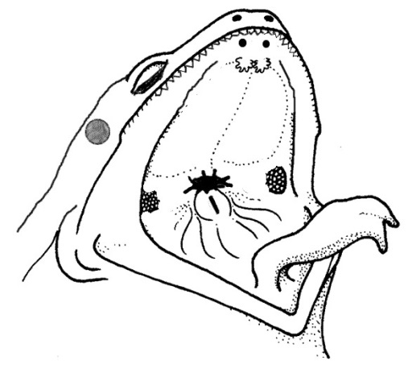
FROG DISSECTION

Dissection: External Anatomy
1. Observe the dorsal and ventral sides of the frog.
Dorsal side color ___________ Ventral side color ____________
2. Examine the hind legs.
How many toes are present on each foot? ________
Are the toes webbed? ______
3. Examine the forelegs.
How many toes are present? _________Are the toes webbed? _______
4. Use a ruler to measure your frog, measure from the tip of the head to the end of the frog's backbone (do not include the legs in your measurement).
5. Locate the frog's eyes, the nictitating membrane is a clear membrane that attached to the bottom of the eye. Use tweezers to carefully remove the nictitating membrane. You may also remove the eyeball.
What color is the nictitating membrane? _________________ What color is the eyeball? __________________________
6. Just behind the eyes on the frog's head is a circular structure called the tympanic membrane. The tympanic membrane is used for hearing. Measure the diameter (distance across the circle) of the tympanic membrane.
Diameter of tympanic membrane _______cm
7. Feel the frog's skin. Is it scaly or is it slimy? ____________

Anatomy of the Frog's Mouth
Procedure: Pry the frog's mouth open and use scissors to cut the angles of the frog's jaws open. Cut deeply enough so that the frog's mouth opens wide enough to view the structures inside.
1. Locate the tongue. Play with the tongue. Does it attach to the front or the back of the mouth? __________ (You may remove the tongue). Draw a sketch of the tongue, paying attention to its shape.
Tongue Sketch:
2. In the center of the mouth, toward the back is a single round opening. This is the esophagus. This tube leads to the stomach. Use a probe to poke into the esophagus.
3. Close to the angles of the jaw are two openings, one on each side. These are the Eustachian tubes. They are used to equalize pressure in the inner ear while the frog is swimming. Insert a probe into the Eustachian tube.
To what structure does the Eustachian tube attach? _____________________
4. Just behind the tongue, and before you reach the esophagus is a slit like opening. (You may need to use your probe to get it to open up). This slit is the glottis, and it is the opening to the lungs. The frog breathes and vocalizes with the glottis. Use your probe to open the glottis and compare that opening to the esophagus.
5. The frog has two sets of teeth. The vomarine teeth are found on the roof of the mouth. The maxillary teeth are found around the edge of the mouth. Both are used for holding prey, frogs swallow their meals whole and do NOT chew. Run you finger over both sets of teeth and note the differences between them.
6. On the roof of the mouth, you will find the two tiny openings of the nostrils, if you put your probe into those openings, you will find they exit on the outside of the frog

Name: _______________________________________

Dissection: Internal Anatomy
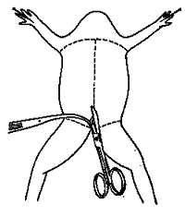
1. Place the frog in the dissecting pan ventral side up.
2. Use forceps to lift the abdominal muscles away from the body cavity. Cut along the midline of the body from the pelvic to the pectoral girdle.
3. Make transverse (horizontal) cuts near the arms and legs.
4. Lift the flaps of the body wall and pin back.
*If your specimen is a female, the body may be filled with eggs and an enlarged ovary. You may need to remove these eggs to view the organs.

Locate each of the organs below. Check the box to indicate that you found the organs.
1. Fat Bodies -- Spaghetti shaped structures that have a bright orange or yellow color, if you have a particularly fat frog, these fat bodies may need to be removed to see the other structures. Usually they are located just on the inside of the abdominal wall.
2. Peritoneum -- A spider web like membrane that covers many of the organs, you may have to carefully pick it off to get a clear view
3. Liver -- The largest structure of the the body cavity. This brown colored organ is composed of three parts, or lobes. The right lobe, the left anterior lobe, and the left posterior lobe. The liver is not primarily an organ of digestion, it does secrete a digestive juice called bile. Bile is needed for the proper digestion of fats.
4. Heart -- at the top of the liver, the heart is a triangular structure. The left and right atriumcan be found at the top of the heart. A single ventricle located at the bottom of the heart. The large vessel extending out from the heart is the conus arteriosis.
5. Lungs -- Locate the lungs by looking underneath and behind the heart and liver. They are two spongy organs.
6. Gall Bladder -- Lift the lobes of the liver, there will be a small green sac under the liver. This is the gall bladder, which stores bile. (hint: it kind of looks like a booger)
7. Stomach -- Curving from underneath the liver is the stomach. The stomach is the first major site of chemical digestion. Frogs swallow their meals whole. Follow the stomach to where it turns into the small intestine. The pyloric sphincter valve regulates the exit of digested food from the stomach to the small intestine.
8. Small Intestine -- Leading from the stomach. The first straight portion of the small intestine is called the duodenum, the curled portion is the ileum. The ileum is held together by a membrane called the mesentery. Note the blood vessels running through the mesentery, they will carry absorbed nutrients away from the intestine. Absorption of digested nutrients occurs in the small intestine.
9. Large Intestine -- As you follow the small intestine down, it will widen into the large intestine. The large intestine is also known as the cloaca in the frog. The cloaca is the last stop before wastes, sperm, or urine exit the frog's body. (The word "cloaca" means sewer)
10. Spleen -- Return to the folds of the mesentery, this dark red spherical object serves as a holding area for blood.
11. Esophagus -- Return to the stomach and follow it upward, where it gets smaller is the beginning of the esophagus. The esophagus is the tube that leads from the frogs mouth to the stomach. Open the frogs mouth and find the esophagus, poke your probe into it and see where it leads.
STOP! If you have not located each of the organs above, do not continue on to the next sections!
Removal of the Stomach: Cut the stomach out of the frog and open it up. You may find what remains of the frog's last meal in there. Look at the texture of the stomach on the inside.
What did you find in the stomach?
Measuring the Small intestine: Remove the small intestine from the body cavity and carefully separate the mesentery from it. Stretch the small intestine out and measure it. Now measure your frog. Record the measurements below in centimeters.
Frog length: _______ cm Intestine length ________ cm

Urogenital System
The frog's reproductive and excretory system is combined into one system called the urogenital system. You will need to know the structures for both the male and female frog
Kidneys - flattened bean shaped organs located at the lower back of the frog, near the spine. They are often a dark color. The kidneys filter wastes from the blood. Often the top of the kidneys have yellowish stringy fat bodies attached.
Testes - in male frogs, these organs are located at the top of the kidneys, they are pale colored and roundish.
Oviducts - females do not have testes, though you may see a curly-q type structure around the outside of the kidney, these are the oviducts. Oviducts are where eggs are produced. Males can have structures that look similar, but serve no actual purpose. In males, they are called vestigial oviducts.
Bladder - An empty sac located at the lowest part of the body cavity. The bladder stores urine.
Cloaca - mentioned again as part of the urogenital system - urine, sperm and eggs exit here.

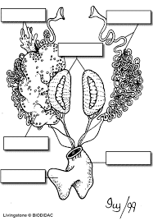
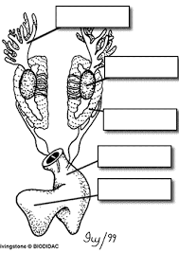

Lab Questions
1. The membrane holds the coils of the small intestine together: ___________________
2.This organ is found under the liver, it stores bile: ______________________
3. Name the 3 lobes of the liver: ________________, ____________________, ____________________
4. The organ that is the first major site of chemical digestion: _______________________
5. Eggs, sperm, urine and wastes all empty into this structure: _____________________
6. The small intestine leads to the: __________________________
7. The esophagus leads to the: _________________________
8. Yellowish structures that serve as an energy reserve: ____________________
9. The first part of the small intestine(straight part): _______________________
10. After food passes through the stomach it enters the: ____________________
11. A spiderweb like membrane that covers the organs: ______________________
12. Regulates the exit of partially digested food from the stomach: ________________
13. The large intestine leads to the __________________
14. Organ found within the mesentery that stores blood: _____________________
15. The largest organ in the body cavity: _____________________
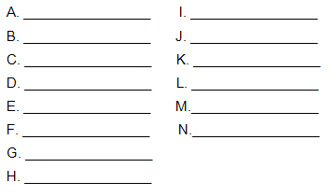
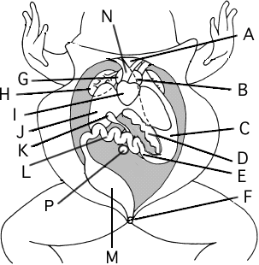
Label the Diagram

