WHO’S COMING TO DINNER PACKET
Sensory Writing

- What makes writing appealing to a reader?

- How can we, as writers, paint a picture in our readers’ minds?

3. List the five senses in the graphic below:

Sensory Language
Using the examples below, compose at least 5 descriptive words or phrases to describe each featured sense.

TASTE
SIGHT
SMELL
TOUCH
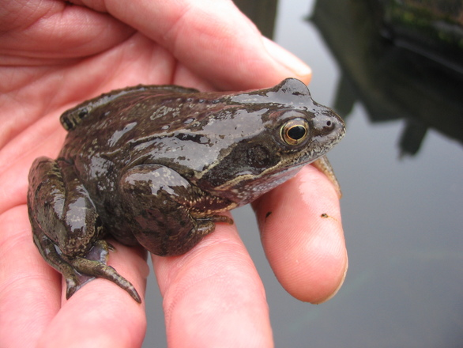
SOUND

Sensory Rewriting, Part 1

In the space provided below, rewrite each sentence from the left column into one or more sentences to richly recreate the scene. Think of word choice that involves the senses (sight, sound, touch, taste, smell); use this language to show the scene in more detail. Feel free to invent new descriptive details.

Example:  The old man stood in the grass and relaxed as the sun went down. | The grass caressed his feet and smile softened his eyes. A hot puff of air brushed against his wrinkled cheek as the sky paled yellow, then crimson, and within a breath, electric indigo.
The country is India. The colonel and his wife are giving a large dinner party.
The American does not join in the argument but looks at the other guests
As he looks, he sees a strange expression come over the face of the hostess.
He realizes there must be a cobra in the room.
A faint smile lights up the woman’s face as she replies.

The Dinner Party
By Mona Gardner

The country is India. A colonial official and his wife are giving a large dinner party. They are seated with their guests—army officers and government attachés and their wives, and a visiting American naturalist—in their spacious dining room, which has a bare marble floor, open rafters and wide glass doors opening onto a veranda.
A spirited discussion springs up between a young girl who insists that women have outgrown the jumping-on-a-chair-at-the-sight-of-a-mouse era and a colonel who says that they haven’t.
“A woman’s unfailing reaction in any crisis,” the colonel says, “is to scream. And while a man may feel like it, he has that ounce more of nerve control than a woman has. And that last ounce is what counts.”
The American does not join in the argument but watches the other guests. As he looks, he sees a strange expression come over the face of the hostess. She is staring straight ahead, her muscles contracting slightly. With a slight gesture she summons the native boy standing behind her chair and whispers to him. The boy’s eyes widen: he quickly leaves the room.
Of the guests, none except the American notices this or sees the boy place a bowl of milk on the veranda just outside the open doors.
The American comes to with a start. In India, milk in a bowl means only one thing—bait for a snake. He realizes there must be a cobra in the room. He looks up at the rafters—the likeliest place—but they are bare. Three corners of the room are empty, and in the fourth the servants are waiting to serve the next course. There is only one place left—under the table.
His first impulse is to jump back and warn the others, but he knows the commotion would frighten the cobra into striking. He speaks quickly, the tone of his voice so arresting that it sobers everyone. During the time this story takes place, India was a British colony. The colonial official works for the British government in India. The government attachés work for another country’s embassy in India. Finally, a naturalist is someone who studies animals and plants.
“I want to know just what control everyone at this table has. I will count to three hundred—that’s five minutes—and not one of you is to move a muscle. Those who move will forfeit fifty rupees. Ready!”
The twenty people sit like stone images while he counts. He is saying “. . . two hundred and eighty. . .” when, out of the corner of his eye, he sees the cobra emerge and make for the bowl of milk. Screams ring out as he jumps to slam the veranda doors safely shut.
“You were right, Colonel!” the host exclaims. “A man has just shown us an example of perfect control.”
“Just a minute,” the American says, turning to his hostess. “Mrs. Wynnes, how did you know that cobra was in the room?”
A faint smile lights up the woman’s face as she replies: “Because it was crawling across my foot.”

After reading “The Dinner Party” by Mona Gardner, answer the following questions:

- What makes the style of this short story either appealing and/or not appealing to the reader?

- How could you, as a writer, paint a clearer picture of specific elements in the story?

Sensory Rewriting, Part 2
On the blank paper provided, use the descriptive sentences you wrote on pg. 3 as inspiration to rewrite “The Dinner Party” by Mona Gardner. You may take creative license with this rewritten story, choosing to keep as much or as little of the original descriptions and adding your own where you see fit. For this rewritten version, there are two requirements: the basic plot structure should remain similar and the length should be comparable. You may use the space below to plan your rewritten version.

