**ARTIFACTS FOR TAXES**

**Artifact 1**

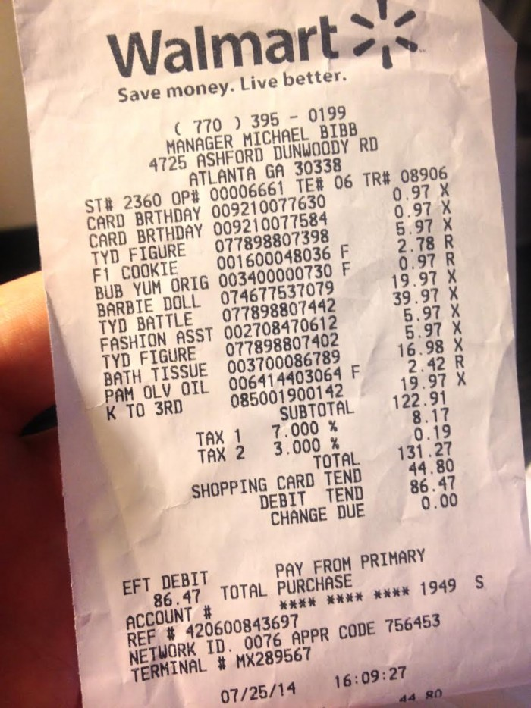

**Artifact 2**

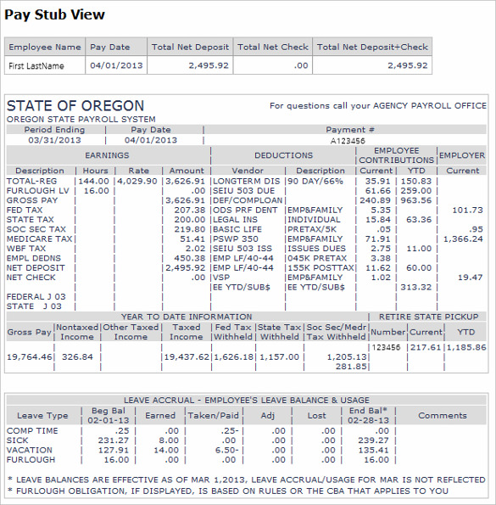

**Artifact 3**

