SOCIAL MEDIA DEBATE: ALEXANDER HAMILTON AND GEORGE MASON
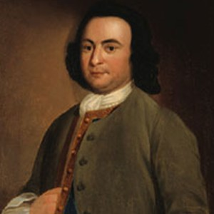
George Mason
@GMason

Seriously, does this new Constitution even protect individual rights? #BOR

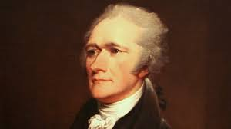
Alexander Hamilton
@Publius

@GMason Before I even address this, what is #BOR?

George Mason
@GMason

@Publius BILL OF RIGHTS. There has to be something that protects my freedom of speech and press, rights for those accused of a crime! #BOR

George Mason
@GMason

@Publius w/o more limitations to this “new government,” we’ll have another King George situation on our hands. #iwillsendafullyarmedbattalliontoremindyouofmylove

Alexander Hamilton
@Publius

@GMason the AOC can hardly protect us now...we need a stronger national government. #newconstitution #liftingweights #ratifynow

George Mason
@GMason

@Publius a stronger national government will lead to direct TYRANNY! #noKG3 #toomuchpower #liftlessweights

Alexander Hamilton
@Publius

@GMason The CONST. includes FEDERALISM. #statepower #nationalpower #powerlimited #notyranny

Alexander Hamilton
@Publius

@George Mason not to mention the 3 branches (leg, exec, jud.) have #separatepowers in the Nat’l. Gov. #limitedgovernment #ratifynow

George Mason
@GMason

@Publius shouldn’t power be given to those at the local level? Gov. can only be beneficial if it knows the problems of the people. #powertotheppl #statesrights #individualrights

Alexander Hamilton
@Publius

@George Mason the state government and people will still have power because of systems like checks and balances that ensure no branch becomes too powerful. #ratifynow

George Mason
@GMason

@Publius that is not enough. We need a #BOR to protect individual freedoms. #freedom #morechecks #notyranny

Alexander Hamilton
@Publius

@George Mason no BOR needs to be added. LIBERTY is defended enough through the Constitution and to ensure that FREEDOM we must ratify it! #newconstitution #ratifynow

