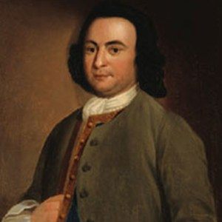
George Mason
@GMason

@Publius

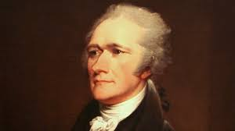
Alexander Hamilton
@Publius

@GMason

