Tweetup
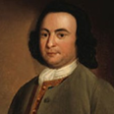
George Mason

@GMason

@Publius

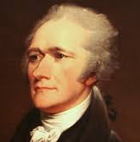
Alexander Hamilton

@Publius

@GMason

