Experimental Ball Drop

Materials

- meter stick
- golf ball
- calculator



Experiment
1) Determine who is Partner A and who is Partner B.
2) Partner A: Hold the meter stick against the wall, with the base on the floor.
3) Partner B: Hold the golf ball such that the bottom of the ball is at a height of 40 cm.
4) Partner B: Drop the ball.
5) Estimate the height the ball bounces after it hits the floor. If the height cannot be agreed upon, repeat steps 3 & 4.
6) Repeat steps 2–5, taking turns dropping the golf ball from the following heights:
50 cm, 60 cm, 70 cm, 80 cm, 90 cm, and 100 cm.

Results
Height (cm) | 40 | 50 | 60 | 70 | 80 | 90 | 100
Height of
Bounce (cm)

Data Analysis
1) Use your calculator (using linear regression) to find the equation for the line of best fit.

2) Identify and interpret the correlation coefficient (r-value).

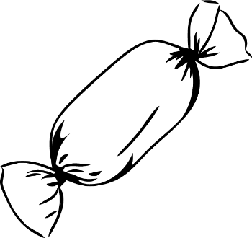
Experimental Candy Drop

Materials

- 20 candies
- calculator

Experiment
1) Define the “heads” (top) and “tails” (bottom) of the candy.
2) Determine who is Partner A and who is Partner B.
3) Partner A: Collect candies in your hands and gently drop them onto the table.
4) Partner B: Count and record the number of candies that land heads-up.
Set those (heads-up) candies aside.
5) Partner B: Collect candies tails-up in your hands and gently drop them onto the table.
6) Repeat steps 4 & 5, taking turns dropping the candies until either:
(a) all candies have landed heads-up or
(b) a total of 10 drops have been completed.

Results
Drop # | 1 | 2 | 3 | 4 | 5 | 6 | 7 | 8 | 9 | 10
Number of
Candies Heads-Up

Data Analysis
1) Use your calculator (using linear regression) to find the equation for the line of best fit.

2) Identify and interpret the correlation coefficient (r-value).

